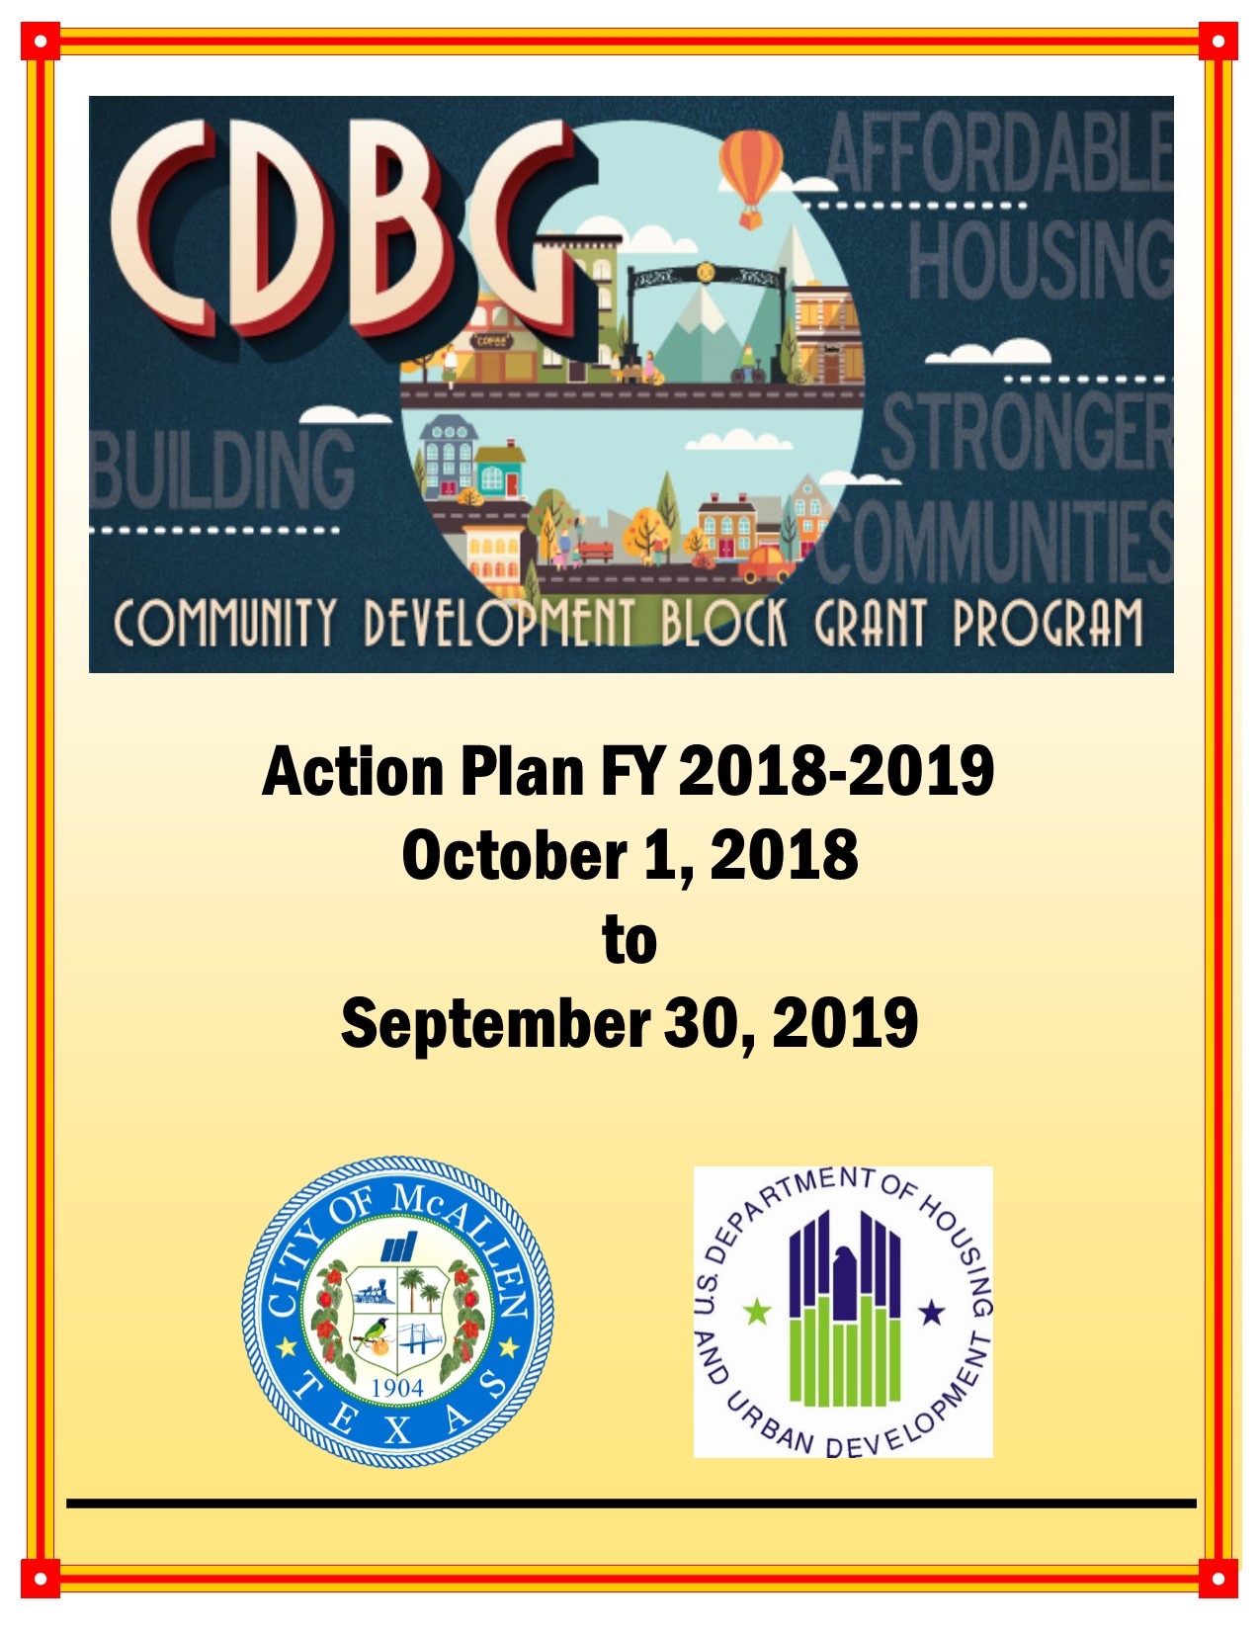

Executive Summary

ES-05 Executive Summary - 24 CFR 91.200(c), 91.220(b)
1. Introduction
The U.S. Department of Housing and Urban Development (HUD) requires local jurisdictions to prepare a 3-5 year Consolidated Plan and Strategy (CPS) in order to receive federal funds through the Community Development Block Grant (CDBG), HOME Investment Partnerships (HOME), and Emergency Solutions Grants (ESG) Programs. The Consolidated Plan and Strategy serves the following functions:
- A planning document for local jurisdictions, which builds upon a participator process at the grassroots level;
- An application for federal funds under HUD's formula grant programs;
- A strategy to be followed in carrying out HUD programs for 3-5 years; and
- An action plan that provides a basis for assessing performance.
This five-year (FY 2018-2022) Consolidated Plan and Strategy is the result of an extensive needs assessment and community outreach process which includes the processes conducted during the development of the Assessment of Fair Housing by the entitlement communities (and public housing authorities) in Hidalgo County including:
- Hidalgo County - Urban County Program (including the Cities of Alamo, Alton, Donna, Edcouch, Elsa, Granjeno, Hidalgo, La Joya, La Villa, Mercedes, Palmhurst, Palmview, Penitas, Progreso, Progreso Lakes, San Juan, Sullivan City, Weslaco and the unincorporated parts of the County
- City of Edinburg
- City of McAllen
- City of Mission
- City of Pharr
While the communities approached the consultation collectively, each community assessed their individual needs, goals, objectives and outcomes. This assessment produced an independent Consolidated Plan and Strategy document. As had been done under the previous Consolidated Plans, independent Action Plan and CAPER documents will also be composed and remitted by each community. No aggregated data is intended to be reported under this Consolidated Plan.
It is worth noting that while the Assessment of Fair Housing document (AFH) was not accepted, the document, in accordance with the Interim Rule, is the basis for the development of the Analysis of Impediments (AI). The reader should note that any reference to the AFH is for demonstrative purposes only. It helps to underscore the partnership between the entitlement communities and the respective public housing authorities in Hidalgo County as well as note the complexities of consultations with varied public and private stakeholders.
2. Summary of the objectives and outcomes identified in the Plan Needs Assessment Overview
Three national goals/objectives serve as the overall framework for the use of Consolidated Plan funds. The goals are (1) to provide decent housing, (2) create a suitable living environment and (3) expand economic opportunities, to principally benefit extremely low-, low-, and moderate-income individuals and families. Income categories are calculated on an annual basis by HUD. Extremely low-income households have an income of 0-30% of Area Median Income (AMI). Low-income households have an income of 30-50% AMI and Moderate income is defined as 50-80% AMI. All income levels are adjusted for family size.
Further, Consolidated Plan funded programs and projects must meet one of the following outcomes: (1) Availability/Accessibility, (2) Sustainability and (3) Affordability. These outcomes were developed by HUD in its Performance Measurement System.
Also, HUD has established a listing of Matrix Codes for projects funded with Consolidated Plan dollars. These Matrix Codes are prioritized at the local level based on the community needs assessment. Matrix Codes are categorized as either "High" or "Low" priorities. Priority designations are referenced throughout this document.
In summary, the following broadly defined activities are designated as "High" priorities:
- Housing - Construction, Counseling, Rehabilitation of Single and Multi-Unit Properties, Homeowner Assistance and Public Housing Modernization
- Infrastructure - Street Improvements, Water/Sewer Improvements, Sidewalk Construction, Flood/Drain Improvements and Repayments of Section 108 Loans
- Public Facilities - Youth Centers, Senior Centers, Homeless Facilities/Operating Costs, Neighborhood Facilities, Parks and Recreational Facilities, Fire Stations/Equipment and Health Centers
- Public Services - Social/support Services for qualified individuals and families including services for seniors, children, youth, general population, handicapped persons, abused and neglected children and battered and abused spouses as well as transportation, health services and subsistence payments
- Economic Development - Financial resources/infrastructure upgrades intended to improve the business community including micro-enterprise loans, revolving loan funds and/or building acquisition, construction or rehabilitation
Additional information regarding "High" Priority activities may be viewed in the Action Plan Sections and within "SP-25 Priority Needs".

3. Evaluation of past performance
The City recognizes the need to achieve as many of its enumerated goals as financially viable. However, it was noted that some goals established in the previous Consolidated Plan and Strategy did not materialize due to (1) decreases in CDBG and/or HOME funding, (2) the low number or lack of viable projects, (3) increase in need for other services and/or (4) accomplishment data was entered into another more appropriate matrix code. In order to comply with the City’s Citizen Participation Plan, the City deleted the following goals:
- 03A: Senior Centers
- 03B: Handicapped Centers
- 03C: Homeless Facilities
- 03I: Flood/Drain Improvements
- 03K: Street Improvements
- 03L: Sidewalks
- 03O: Fire Station/Equipment
- 03T: Operating Costs of Homeless/AIDS Pgms
- 05H: Employment Services
- 05L: Child Care Services
- 05T: Security Deposits
- 05U: Housing Counseling
- 14B: Rehab: Multi-Unit Residential
- 14C: Rehab: Public Housing Modernization
- 14E: Rehab: Publicly/Privately Owned Commercial/Industrial
- 16B: Non-Residential Historic Preservation
- 17B: Commercial/Industrial Infrastructure
- 17C: C/I Building Acquisition, Construction/Rehab
- 18A: Economic Development: Direct Assistance
- 18C: Economic Development: Micro-Enterprise
In addition, the City reduced proposed beneficiaries for the following projects:
- 03: Other Public Facilities and Improvements
- 03D: Youth Centers
- 03J: Water/Sewer Improvements
- 03P: Health Facilities
- 05: Other Public Services
- 05D: Youth Services
- 05E: Transportation Services
- 05F: Substance Abuse Services
- 05G: Services for Battered and Abused Spouses
- 05M: Health Services
- 05Q: Subsistence Payments
- 05W: Food Banks
- 12: Construction of Housing
- 13: Direct Homeownership Assistance
- 14A: Rehab: Single-Unit Residential
- 14G: Rehab: Acquisition (Homeowner Housing Added)
- ESG –funded Homeless Services
Further, the City amended some goals for projects that were listed in the FY 2016-2017 Annual Action Plan and whose completion were subsequently reported in the Consolidated Annual Performance and Evaluation Report (CAPER). These actions served to form the basis for the ennumeration of the FY 2018-2022 Consolidated Plan and Strategy goals and projects. Nonetheless, some Matrix Codes continue to represent "High" Priorities and will be funded, when appropriate.

4. Summary of citizen participation process and consultation process
As an entitlement community, a Citizen Participation Plan (CPP) has been adopted. Adherence to its particulars is detailed within this document in the section entitled "PR-15 Citizen Participation". Of note, the CPP mandates a minimum 15-day notification prior to holding a public hearing. The City held five public hearings regarding the development of this document.
In addition, this document was made available for public review for no less than 30-days as mandated by HUD. The City's comment period began on Wednesday, May 23, 2018 and expired on Friday, June 29, 2018.
A summary of the efforts to broaden citizen participation including a listing of public hearings, comments received and reasons for not accepting are further detailed in "PR-15 Citizen Participation". Efforts to engage citizen participation were made through traditional means such as publications in the newspaper and postings outside City Hall as well as less traditional means included utilizing social media and online/internet postings and notices.
Consultations with interested parties were coordinated through staff from the entitlement communities. Consultation tools were developed and utilized when contacting the various interested parties/stakeholders. Of note, some of the consultations were done in conjunction with the development of the Assessment of Fair Housing (AFH). The AFH served as a planning document to be composed in advance of the development of the Consolidated Plan and Strategy. Although the AFH was not adopted, the value of the consultations remain and are utilized within this document. The listings of agencies who were contacted and results are also detailed in "PR-10 Consultation". Copies of the consultation tools and notices are provided in the "Grantee Unique Appendices".
In brief, comments and consultations suggested a need for:
- Housing - Construction, Counseling, Rehabilitation of Single and Multi-Unit Properties, Homeowner Assistance and Public Housing/Rental Assistance
- Infrastructure - Street Improvements, Water/Sewer Improvements and Sidewalk Construction
- Public Facilities - Centers for Youth/Child and Health Care, Homeless Facilities/Operating Costs, Neighborhood Facilities, and Parks and Recreational Facilities
- Public Services - Social/Support Services for seniors, children, youth/children, general population, handicapped persons, abused and neglected children and battered and abused spouses, transportation, health, provision of food and subsistence payments
5. Summary of public comments
In order to solicit input, various public hearings were held throughout the County during the development of the Assessment of Fair Housing (AFH). In addition, and as was previously noted, McAllen held five public hearings within its jurisdiction during the period of January - May 2018. Three public hearings were held before the Community Development Advisory Council, one was held during a regularly scheduled City Commission meeting and the final was held at the McAllen Public Housing Authority. Eighty persons attended the various hearings. All comments were considered and their effect on this Consolidated Plan may be viewed in the Section entitled "PR-15 Citizen Participation". Further, the draft of the Consolidated Plan was made available for public comment on Wednesday, May 23, 2018 through an announcement in The Monitor, the newspaper of largest circulation, and in El Periodico, a Spanish-written newspaper . The comment period expired on June 29, 2018.
Posting of notices were placed in the City's outside bulletin board which is readily accessible 24-hours a day. All public hearings held in conjunction with the solicitation of public comment occurred in handicapped accessible facilities.

6. Summary of comments or views not accepted and the reasons for not accepting them
The jurisdiction accepted all comments; however, with limited resources, not all comments/projects can be funded. Nonetheless, all comments contributed to project's priority designation.

7. Summary
While this document is a compilation of information obtained by the entitlement communities, each jurisdiction developed its owned priorities and completed its own Action Plan. Of note, when feasible, source documentation and data extrapolated the entitlement communities from Hidalgo County boundaries/service area; however, this separation was not always possible. Where applicable, it is noted whether data is based on Hidalgo County information (inclusive of the Cities of Edinburg, McAllen and Mission), is applicable to the MSA (McAllen-Mission-Edinburg) or is applicable only to the City of McAllen.

The Process

PR-05 Lead & Responsible Agencies 24 CFR 91.200(b)
1. Describe agency/entity responsible for preparing the Consolidated Plan and those responsible for administration of each grant program and funding source
The following are the agencies/entities responsible for preparing the Consolidated Plan and those responsible for administration of each grant program and funding source.
Agency Role | Name | Department/Agency
Lead Agency | MCALLEN

CDBG Administrator | MCALLEN | Community Development
HOPWA Administrator
HOME Administrator | MCALLEN | Community Development
ESG Administrator
HOPWA-C Administrator | MCALLEN | Community Development
Table 1 – Responsible Agencies

Narrative
The City of McAllen - Community Development (CD) Department assumed the lead in the development of the FY 2018-2022 Consolidated Plan and Strategy (CPS) document. The CD Department administers the housing and community development programs covered by the CPS including those funded by Community Development Block Grant (CDBG) and HOME Investment Partnership Program (HOME). As the lead agency, staff coordinated the development and implementation of the Consolidated Plan and Strategy with input from a broad range of stakeholders, including a fourteen member panel which serve as the Community Development Advisory Council (CDAC). The CDAC is tasked with evaluating proposed projects, establishing timelines, conducting public hearings and broadly reviewing project expenditures. The CD Department and CDAC, in order to obtain input and solicit from interested parties, public agencies and community organizations, held several public hearings. Consultation instruments and survey tools were distributed by staff from the City as well as the other entitlement communities in Hidalgo County in an effort to solicit input. Public notices were announced in the newspaper, posted on the City's notice board (physical and electronic) and the draft of the CPS was made available for the minimum 30-day comment period.
Consolidated Plan Public Contact Information
Yvette Balderas, Asst. CD Director
City of McAllen - Community Development Department
Physical: 1300 Houston Ave.
McAllen, TX 78501
Mailing: P.O. Box 220
McAllen, TX 78505-0220
Phone: (956) 681-3200
Fax: (956) 681-3213
Email: ybalderas@mcallen.net

PR-10 Consultation - 91.100, 91.200(b), 91.215(l)
1. Introduction
The City of McAllen formed a working group with staff from the Hidalgo County - Urban County Program and the cities of Edinburg and Mission to coordinate the development of this Consolidated Plan and Strategy. With input from a broad range of stakeholders, staff sought to assess the housing and community development needs and priorities of the jurisdiction. From these consultations and assessments, this document was composed and serves to guide programs to be funded during the Five-Year Consolidated Plan, FY 2018 - 2022.

Provide a concise summary of the jurisdiction’s activities to enhance coordination between public and assisted housing providers and private and governmental health, mental health and service agencies (91.215(I)).
The City coordinates its activities with a variety of organizations involved in the delivery of housing, homeless, non-homeless special needs, and community development activities. They include a designated Community Housing Development Organization (CHDO), the local Public Housing Authority, and various other community organizations whose fields of interest and services may include: seniors, handicapped persons, health/mental health, domestic violence/prevention, youth/children, persons with HIV/AIDS and homelessness.
Staff distributed various consultation instruments as well as held in-person meetings to collect information about housing and community development activities and needs. These consultations addressed:
- Housing Needs
- Housing Market Analysis/Substandard Housing
- Public Housing Needs and Strategy
- Continuum of Care (Homeless)
- Non-Homeless Special Needs
- Lead-Based Paint Hazards
- Community Development
The listing of organizations with whom the City consulted is included in this Section: Question 2 -Agency/Group/Organization.
To enhance the coordination between public and assisted housing providers, the City entered into an Interlocal agreement with Hidalgo County - Urban County Program (lead agency), the Cities of Edinburg, Mission and Pharr and all of the Public Housing Authorities in Hidalgo County for the development of the Assessment of Fair Housing (AFH). As previously noted, the AFH is the basis for the Analysis of Impediments and the cooperative discussion helped to form this Consolidated Plan. Further, health and mental health providers were contacted to determine gaps in services. Such providers include HOPE Family Health Center, Lower Rio Grande Health Management Corp., Inc. (El Milagro Clinic), and Tropical Texas MHMR (state-funded institution). McAllen also continues to nurture relationships in an effort to identify gaps in essential services. The City often receives requests for letters of support in attempts to leverage HUD funds.
Further, the Department has an on-going relationship with personnel from the U.S. Census Bureau. Collaboration has focused on informing program beneficiaries and service providers about services/gaps, the needs of immigrants and strategizing for Census 2020. Although the entitlement communities opted to not create a regional Consolidated Plan, staff often assist one another in the development of programs. Coordination among these different levels of local government, community organizations, and the public are essential to addressing the needs identified in the CPS.
Lastly, much of the information utilized was downloaded from state and local governmental websites. Where applicable, citations have been noted to link the source documentation.
Describe coordination with the Continuum of Care and efforts to address the needs of homeless persons (particularly chronically homeless individuals and families, families with children, veterans, and unaccompanied youth) and persons at risk of homelessness
Hidalgo County is served by the Texas Homeless Network's (THN) Balance of State (BoS) for Continuum of Care (CoC) services. THN has a subcommittee designed to review CoC activities for the areas served under the BoS. Annually, the City participates in the Point-in-Time study which is coordinated by the THN.
With regards to the Consolidated Plan, the City of McAllen participated in a teleconference with the other jurisdictions and THN staff regarding outreach the City undertook in order to gauge and address homelessness/prevent homelessness. And, although the City coordinates with Hidalgo County-Urban County Program and the Continuum of Care in efforts to identify the needs of the homeless persons (particularly chronically homeless individuals and families, families with children, veterans, and unaccompanied youth) and persons who are at risk of becoming homeless, the City also makes funding available for homeless assistance and prevention programs. Services for chronically homeless individuals and families are most likely provided by The Salvation Army with its emergency shelter located within the City limits. Services for families with children, particularly those fleeing domestic violence, are most likely served by Women Together Foundation, Inc. Women Together operates an emergency shelter and a transitional housing complex for female victims of domestic violence and their children; both are also found within the City's limits. Veterans and unaccompanied youth as well as persons affected by the immigration crisis are served by Catholic Charities of the RGV. Persons threatened with homlessness are often assisted by The Salvation Army or Silver Ribbon Community Partners. All four organizations were consulted during the development of the Consolidated Plan and will receive CDBG support from the City of McAllen. Lastly, the City of McAllen staff was tasked with developing an additional consultation tool regarding homelessness. The City distributed the secondary tool in order to ascertain gaps in services and descriptive characteristics of the homeless population in the area.

Describe consultation with the Continuum(s) of Care that serves the jurisdiction's area in determining how to allocate ESG funds, develop performance standards and evaluate outcomes, and develop funding, policies and procedures for the administration of HMIS
Consultation with the Continuum of Care began May 2018. City of McAllen staff, along with staff from the Cities of Mission, Edinburg and Hidalgo County-Urban County Program, spoke with Texas Homeless Network (THN) staff regarding the development and implementation of programs from sheltered and unsheltered homeless individuals and families as well as homeless prevention programs. Representatives from the Texas Homeless Network provided comment on the Consolidated Plan document.
The City of McAllen does not anticipate receiving ESG funds for the Consolidated Plan and Strategy timeframe. However, if funds are awarded, Standard Operating Procedures governing the award of HUD-awarded grants will require staff to prepare an application and publish a Notice of Funding Availability. Once received, applications will be presented to the Community Development Advisory Committee (CDAC). The CDAC is composed of fourteen residents who make recommendations to the City Commission regarding Community Development/HUD-awarded programs.
As with the other HUD programs, the City has established a berth for evaluation of performance and outcomes. The City allows for a 25% range in expected versus actual outcomes and expenditures in order to determine the success of a project. Along with this evaluation, staff considers the amount leveraged, monitoring/auditing reports and project's impact to determine future funding.
The Homeless Management Information System (HMIS) is operated by the THN. This system provided the most accurate assessment of unduplicated homeless persons/families and persons threatened with homelessness to date. While not all homeless service providers have access to the system/are required to use the system, Urban County Program requires the use of HMIS for homeless service providers using ESG, exclusive of those serving victims of domestic violence. If funded with ESG, the City will implement this requirement as well. Costs associated with maintaining HMIS will be eligible for reimbursement with ESG funds to the extent that they are available.
Because the oversight of HMIS falls on THN, the City will implement THN's policies and procedures for the use of HMIS. In particular, City staff and ESG recipients will execute user agreements that outline rules of behavior. HMIS will remain the primary means to maintain client and agency level data regarding homeless issues. Information will be extracted and reported in HUD's Integrated Disbursement and Information System (IDIS) either at the project level or as part of the CAPER narrative.
2. Describe Agencies, groups, organizations and others who participated in the process and describe the jurisdictions consultations with housing, social service agencies and other entities

Table 2 – Agencies, groups, organizations who participated
1 | Agency/Group/Organization | AFFORDABLE HOMES OF SOUTH TEXAS, INC.
 | Agency/Group/Organization Type | Housing  Services - Housing  Services-Elderly Persons  Services-Persons with Disabilities  Service-Fair Housing  Regional organization  Community Development Financial Institution  Neighborhood Organization
 | What section of the Plan was addressed by Consultation? | Housing Need Assessment  Lead-based Paint Strategy  Non-Homeless Special Needs  Market Analysis
 | How was the Agency/Group/Organization consulted and what are the anticipated outcomes of the consultation or areas for improved coordination? | Agency provided input during public hearings. Outcomes: Housing (Construction of Housing, Rehabilitation; Single-Unit Residential and Direct Homeownership Assistance) - High Priorities; provide decent affordable housing by increasing availability/accessibility, and sustainability of affordable housing stock
2 | Agency/Group/Organization | City of McAllen
 | Agency/Group/Organization Type | Other government - Local  Planning organization  Engineering  Grantee Department
 | What section of the Plan was addressed by Consultation? | Infrastructure Needs
 | How was the Agency/Group/Organization consulted and what are the anticipated outcomes of the consultation or areas for improved coordination? | Municipal department provided input during public hearings. Outcomes: Street, Water/Sewer and Sidewalks - High Priorities; provide a suitable living environment by increasing availability /accessibility of infrastructure
3 | Agency/Group/Organization | AMIGOS DEL VALLE, INC.
 | Agency/Group/Organization Type | Housing  Services - Housing  Services-Elderly Persons  Services-Persons with Disabilities  Services-Health  Regional organization
 | What section of the Plan was addressed by Consultation? | Non-Homeless Special Needs  Anti-poverty Strategy  Public Service Assessment
 | How was the Agency/Group/Organization consulted and what are the anticipated outcomes of the consultation or areas for improved coordination? | Agency provided input during public hearings. Outcomes: Senior Services - High Priority; provide a suitable living environment by increasing availability/accessibility of senior services
5 | Agency/Group/Organization | McAllen Public Utilities
 | Agency/Group/Organization Type | Other government - Local  Grantee Department
 | What section of the Plan was addressed by Consultation? | Infrastructure Needs
 | How was the Agency/Group/Organization consulted and what are the anticipated outcomes of the consultation or areas for improved coordination? | Municipal Public Utilities Department provided input during public hearings. Outcomes: Water/Sewer Improvements - High Priority; provide a suitable living environment by increasing availability/accessibility of water/sewer improvements
6 | Agency/Group/Organization | Access Esperanza Clinics, Inc.
 | Agency/Group/Organization Type | Services-homeless  Services-Health  Services-Education  Health Agency
 | What section of the Plan was addressed by Consultation? | Non-Homeless Special Needs  Anti-poverty Strategy  Public Service Assessment
 | How was the Agency/Group/Organization consulted and what are the anticipated outcomes of the consultation or areas for improved coordination? | Agency provided input during public hearings. Outcomes: Health Services - High Priority; provide a suitable living environment by increasing availability/accessibility of health services
7 | Agency/Group/Organization | BOYS AND GIRLS CLUB OF MCALLEN
 | Agency/Group/Organization Type | Services-Children  Neighborhood Organization
 | What section of the Plan was addressed by Consultation? | Non-Homeless Special Needs  Anti-poverty Strategy  Public Service Assessment
 | How was the Agency/Group/Organization consulted and what are the anticipated outcomes of the consultation or areas for improved coordination? | Agency provided input during public hearings. Outcomes: Child and Youth Services - High Priorities; provide a suitable living environment by increasing availability/accessibility of child and youth services
8 | Agency/Group/Organization | C.A.M.P. University
 | Agency/Group/Organization Type | Services-Persons with Disabilities
 | What section of the Plan was addressed by Consultation? | Non-Homeless Special Needs  Anti-poverty Strategy  Public Service Assessment
 | How was the Agency/Group/Organization consulted and what are the anticipated outcomes of the consultation or areas for improved coordination? | Agency provided input during public hearings. Outcomes: Handicapped Services - High Priority; provide a suitable living environment by increasing availability/accessibility of handicapped services
9 | Agency/Group/Organization | Catholic Charities of RGV
 | Agency/Group/Organization Type | Housing  Services - Housing  Services-Children  Services-Elderly Persons  Services-Persons with Disabilities  Services-Persons with HIV/AIDS  Services-Victims of Domestic Violence  Services-homeless  Services-Health  Services - Victims  Regional organization
 | What section of the Plan was addressed by Consultation? | Housing Need Assessment  Homelessness Strategy  Homeless Needs - Chronically homeless  Homeless Needs - Families with children  Homelessness Needs - Veterans  Homelessness Needs - Unaccompanied youth  Non-Homeless Special Needs  Anti-poverty Strategy  Public Service Assessment
 | How was the Agency/Group/Organization consulted and what are the anticipated outcomes of the consultation or areas for improved coordination? | Agency provided input during public hearings. Outcomes: Homeless Services (prevention and subsistence payments) - High Priorities; provided decent housing by increasing affordability of housing stock and provide a suitable living environment by increasing availability/accessibility of public services
10 | Agency/Group/Organization | Children's Advocacy Center of Hidalgo County -Estrella's House
 | Agency/Group/Organization Type | Services-Children  Services-Victims of Domestic Violence  Services - Victims  Child Welfare Agency
 | What section of the Plan was addressed by Consultation? | Non-Homeless Special Needs  Public Service Assessment
 | How was the Agency/Group/Organization consulted and what are the anticipated outcomes of the consultation or areas for improved coordination? | Agency provided input during public hearings. Outcomes: Abused and Neglected Children Services - High Priority; provide a suitable living environment by increasing availability/ accessibility of services for abused and neglected children
11 | Agency/Group/Organization | Community Hope Projects, Inc. dba Hope Family Health Center
 | Agency/Group/Organization Type | Housing  Services - Housing  Services-Children  Services-Elderly Persons  Services-Persons with Disabilities  Services-homeless  Services-Health  Health Agency
 | What section of the Plan was addressed by Consultation? | Homelessness Strategy  Homeless Needs - Chronically homeless  Homeless Needs - Families with children  Homelessness Needs - Unaccompanied youth  Non-Homeless Special Needs  Public Service Assessment
 | How was the Agency/Group/Organization consulted and what are the anticipated outcomes of the consultation or areas for improved coordination? | Agency provided input during public hearings. Outcomes: Health Services - High Priority; provide a suitable living environment by increasing availability/accessibility of health services
12 | Agency/Group/Organization | COURT APPOINTED SPECIAL ADVOCATES (CASA) OF HIDALGO COUNTY
 | Agency/Group/Organization Type | Services-Children  Services-Victims of Domestic Violence  Services-homeless  Services - Victims  Child Welfare Agency  Publicly Funded Institution/System of Care
 | What section of the Plan was addressed by Consultation? | Homelessness Needs - Unaccompanied youth  Non-Homeless Special Needs  Anti-poverty Strategy  Public Service Assessment
 | How was the Agency/Group/Organization consulted and what are the anticipated outcomes of the consultation or areas for improved coordination? | Agency provided input during public hearings. Outcomes: Abused and Neglected Children Services - High Priority; provide a suitable living environment by increasing availability/accessibility of services for abused and neglected children
13 | Agency/Group/Organization | EASTER SEALS RGV
 | Agency/Group/Organization Type | Services-Children  Services-Elderly Persons  Services-Persons with Disabilities  Services-Health  Health Agency  Regional organization
 | What section of the Plan was addressed by Consultation? | Non-Homeless Special Needs  Public Service Assessment
 | How was the Agency/Group/Organization consulted and what are the anticipated outcomes of the consultation or areas for improved coordination? | Agency provided input during public hearings. Outcomes: Health Services - High Priority; provide a suitable living environment by increasing availability/accessibility of health services
14 | Agency/Group/Organization | First United Methodist Church Shoe Bank
 | Agency/Group/Organization Type | Services-Children
 | What section of the Plan was addressed by Consultation? | Non-Homeless Special Needs  Public Service Assessment
 | How was the Agency/Group/Organization consulted and what are the anticipated outcomes of the consultation or areas for improved coordination? | Agency provided input during public hearings. Outcomes: Child Services - High Priority; provide a suitable living environment by increasing accessibility/availability of child services
15 | Agency/Group/Organization | Lower Rio Grande Valley Development Council
 | Agency/Group/Organization Type | Housing  Services - Housing  Services-Elderly Persons  Services-Persons with Disabilities  Services-homeless  Services-Health  Other government - Local  Regional organization  Planning organization
 | What section of the Plan was addressed by Consultation? | Housing Need Assessment  Non-Homeless Special Needs  Market Analysis  Public Service Assessment
 | How was the Agency/Group/Organization consulted and what are the anticipated outcomes of the consultation or areas for improved coordination? | Agency provided input during public hearings. Outcomes: Senior Services - High Priority; provide a suitable living environment by providing senior services
16 | Agency/Group/Organization | MCALLEN FOOD PANTRY
 | Agency/Group/Organization Type | Services-Children  Services-Elderly Persons  Services-Persons with Disabilities  Services-homeless
 | What section of the Plan was addressed by Consultation? | Homelessness Strategy  Homeless Needs - Chronically homeless  Homeless Needs - Families with children  Homelessness Needs - Veterans  Non-Homeless Special Needs  Anti-poverty Strategy  Public Service Assessment
 | How was the Agency/Group/Organization consulted and what are the anticipated outcomes of the consultation or areas for improved coordination? | Agency provided input during public hearings. Outcomes: Public Services (General) and Food Banks - High Priorities; provide a suitable living environment by increasing availability/accessibility of general public services and food distribution services
17 | Agency/Group/Organization | MCALLEN HOUSING AUTHORITY
 | Agency/Group/Organization Type | PHA  Services - Housing  Services-Children  Services-Elderly Persons  Services-Persons with Disabilities  Services-Education  Publicly Funded Institution/System of Care
 | What section of the Plan was addressed by Consultation? | Housing Need Assessment  Public Housing Needs  Anti-poverty Strategy  Public Service Assessment
 | How was the Agency/Group/Organization consulted and what are the anticipated outcomes of the consultation or areas for improved coordination? | Agency provided information on public housing/services. Outcomes: Housing (multi-family, public housing modernization), Employment Training Services and Public Services (General)- High Priorities; provide decent housing by increasing availability/accessibility and sustainability of housing/public housing and provide a suitable living environment by increasing availability/accessibility of general public services and employment training services
18 | Agency/Group/Organization | Silver Ribbon Community Partners
 | Agency/Group/Organization Type | Housing  Services - Housing  Services-Elderly Persons  Services-Persons with Disabilities  Services-homeless  Services-Health
 | What section of the Plan was addressed by Consultation? | Housing Need Assessment  Homeless Needs - Chronically homeless  Homelessness Needs - Veterans  Non-Homeless Special Needs  Anti-poverty Strategy  Public Service Assessment
 | How was the Agency/Group/Organization consulted and what are the anticipated outcomes of the consultation or areas for improved coordination? | Agency provided input during public hearings. Outcomes: Homeless Services (prevention and subsistence payments), Health Services, and Senior Services - High Priorities; provide decent housing by increasing availability/accessibility, affordability and sustainability of housing stock and provide a suitable living environment by increasing availability/accessibility of public services, health services, and senior services
19 | Agency/Group/Organization | THE SALVATION ARMY
 | Agency/Group/Organization Type | Housing  Services - Housing  Services-Children  Services-Elderly Persons  Services-Persons with Disabilities  Services-Persons with HIV/AIDS  Services-homeless  Services-Employment  Regional organization
 | What section of the Plan was addressed by Consultation? | Housing Need Assessment  Homelessness Strategy  Homeless Needs - Chronically homeless  Homeless Needs - Families with children  Homelessness Needs - Veterans  Homelessness Needs - Unaccompanied youth  Non-Homeless Special Needs  Anti-poverty Strategy  Pubic Service Assessment
 | How was the Agency/Group/Organization consulted and what are the anticipated outcomes of the consultation or areas for improved coordination? | Agency provided input during public hearings. Outcomes: Housing (homeless facilities) operating costs of homeless and HIV/AIDS facilities, homeless services (prevention and subsistence payments), and other public services - High Priorities; provide decent housing by increasing availability/accessibility, affordability and sustainability of housing stock and provide a suitable living environment by increasing availability/accessibility of operational costs and general public services
20 | Agency/Group/Organization | United Way of South Texas
 | Agency/Group/Organization Type | Housing  Services-Children  Services-Elderly Persons  Services-Persons with Disabilities  Services-Persons with HIV/AIDS  Services-Victims of Domestic Violence  Services-homeless  Services-Health  Services-Education  Services-Employment  Services - Victims  Regional organization  Planning organization  Business and Civic Leaders  Foundation
 | What section of the Plan was addressed by Consultation? | Homelessness Strategy  Homeless Needs - Chronically homeless  Homeless Needs - Families with children  Non-Homeless Special Needs  Anti-poverty Strategy  Public Service Assessment
 | How was the Agency/Group/Organization consulted and what are the anticipated outcomes of the consultation or areas for improved coordination? | Agency provided input during public hearings. Outcomes: Transportation Services - High Priority; provide a suitable living environment by increasing availability/accessibility of transportation services
21 | Agency/Group/Organization | Women Together Foundation, Inc.
 | Agency/Group/Organization Type | Housing  Services - Housing  Services-Children  Services-Victims of Domestic Violence  Services-homeless  Services-Education  Services - Victims
 | What section of the Plan was addressed by Consultation? | Homelessness Strategy  Homeless Needs - Families with children  Non-Homeless Special Needs  Anti-poverty Strategy  Public Service Assessment
 | How was the Agency/Group/Organization consulted and what are the anticipated outcomes of the consultation or areas for improved coordination? | Agency provided input during public hearings. Outcomes: Housing (homeless facilities), Operating Costs of Homeless and HIV/AIDS Facilities, Homeless Services (prevention and subsistence payments), Services for Battered and Abused Spouses - High Priorities; provide decent housing by increasing availability /accessibility, and sustainability of emergency and transitional housing for battered and abused spouses
22 | Agency/Group/Organization | Food Bank of the Rio Grande Valley
 | Agency/Group/Organization Type | Services-Elderly Persons  Services-Persons with Disabilities  Regional organization
 | What section of the Plan was addressed by Consultation? | Non-Homeless Special Needs  Anti-poverty Strategy  Public Service Assessment
 | How was the Agency/Group/Organization consulted and what are the anticipated outcomes of the consultation or areas for improved coordination? | Agency provided input during public hearings. Outcomes: Public Services (General) and Food Banks - High Priorities; provide a suitable living environment by increasing availability/accessibility of general public services and food distribution services
23 | Agency/Group/Organization | Valley Alliance of Mentors for Opportunities and Scholarships (VAMOS)
 | Agency/Group/Organization Type | Services-Education  Business and Civic Leaders
 | What section of the Plan was addressed by Consultation? | Public Service Assessment
 | How was the Agency/Group/Organization consulted and what are the anticipated outcomes of the consultation or areas for improved coordination? | Agency provided input during public hearings. Outcomes: Youth Services - High Priority; provide a suitable living environment by increasing availability/accessibility of youth services
24 | Agency/Group/Organization | McAllen ISD
 | Agency/Group/Organization Type | Services-Children  Services-Persons with Disabilities  Services-homeless  Services-Education  Other government - Local  Independent School District  Major Employer
 | What section of the Plan was addressed by Consultation? | Non-Homeless Special Needs  Anti-poverty Strategy  Public Service Assessment
 | How was the Agency/Group/Organization consulted and what are the anticipated outcomes of the consultation or areas for improved coordination? | Agency provided input during public hearings. Outcome: Parks and Recreational Facilities - High Priority; provide a suitable living environment by increasing availability/accessibility of parks and recreational facilities

Identify any Agency Types not consulted and provide rationale for not consulting
No agencies were intentionally omitted. To compile the contact list, staff utilized listings of organizations that had previously been funded or had inquired about funding.Â Further, public notices were posted on the municipal bulletin board, within the newspaper of largest general circulation and within a Spanish-written newspaper soliciting comments from interest parties and the general public.

Other local/regional/state/federal planning efforts considered when preparing the Plan
Name of Plan | Lead Organization | How do the goals of your Strategic Plan overlap with the goals of each plan?
Continuum of Care | Texas Homeless Network | Community needs assessment related to housing (emergency, transitional, and/or permanent supportive) and homeless services. Priorities are given to homeless and precariously housed populationAddress homelessness, chronic homelessness and homeless prevention
Analysis of Impediments | City of McAllen | Community needs assessment related to fair housing/choice and impediments; Address access to areas of opportunity as they relate to housing, economic opportunity, transportation, poverty, education, environmental health and persons with special needs
Point-In-Time Study | Texas Homeless Network | Homeless needs assessment related to the January 2018 enumeration of homeless individuals in the County; address homelessness, chronic homelessness and homeless prevention
Strategic Plan 2015-2019 | Texas Workforce Commission | Address economic and socio-economic factors within the State of Texas
Workforce Development Board Plan 2017-2020 | Workforce Solutions - Texas Workforce Commission | Address economic and socio-economic factors focusing on Hidalgo, Willacy and Starr Counties
2017-2022 Lower Rio Grande Valley Regional Strateg | Lower Rio Grande Valley Development Council | Address local economic and socio-economic factors
Table 3 – Other local / regional / federal planning efforts
Describe cooperation and coordination with other public entities, including the State and any adjacent units of general local government, in the implementation of the Consolidated Plan (91.215(l))
City staff undertook planning efforts with staff from the cities of Edinburg, and Mission (adjacent communities), as well as staff from Hidalgo County (City is located within County's boundaries). Participants reviewed local planning documents and researched relevant information during the composition of the Assessment of Fair Housing (AFH). Specifically, local regional plans such as those developed by/for the Lower Rio Grande Valley Development Council, State of Texas (General Land Office, Department of Agriculture and Department of Housing and Community Affairs) and the Texas WorkForce Commission formed much of this planning document. In addition, fourteen (14) local independent school districts (including McAllen Independent School District), four (4) charter schools, the major university, University of Texas Rio Grande Valley (located in the city of Edinburg with a satellite in McAllen), the community college, South Texas College (main and one satellite campus located in McAllen), a vocational trade school and early education institution (Hidalgo County Head Start) were contacted.
While the FY 2018-2022 Consolidated Plan is not a regional submission, the compilation of this document represents the fourth instance in which entitlement communities coordinated their efforts to address the gaps in housing, infrastructure, services, facilities and other community development needs. In addition, McAllen and the other entitlement communities scheduled a meeting on Friday, June 15, 2018 with federal and state elected officials to inform them of the document and solicit comments on the proposed goals and objectives, as was discussed during the comment period of the AFH.
Narrative (optional):
Additional consultations
- McAllen Crimestoppers - correction programs and institutions
- Business and Civic Leaders - representatives on the CD Advisory Council
- Code Enforcement/Health Department - Lead-Based Paint, Revitalization Areas
- McAllen Housing Authority/Finance Corp. - Resident Self-Sufficiency Programs, Public Housing Units/Section 8 portfolio and waitlists, LIHTC projects
- Fair Housing Council of Greater South Texas - Fair Housing concerns
Planning Process to Narrow Digital Divide
McAllen ISD provides IPads or Chromebooks to its students. Wi-Fi internet is available at MISD campuses and at City facilities. However, in order to further narrow the digital divide, the Office of the Mayor began discussion with Spectrum to provide low-cost internet services. After deliberation, ATT was selected to provide low-cost internet services to qualified residences. For convenience, the press release and advertisement is attached in the "Grantee Unique Appendices".
Increased Resilience to Natural Hazards
As the City saw during the disasterous flooding in June 2018, drainage improvement projects are a necessary component of the City's services. Each year, the City Engineer and/or the City's Drainage Engineer present the CD Council with applications based on the previous year's calls for assistance, street closures, property damage assessments and/or other variables. The City Engineer is a key staff member in the City's Emergency Management Plan and also serves as the local flood plain administrator. Within her purview lies services complementary to the provision of drainage such as street improvements, traffic assessments, sidewalk improvments (curb and gutter) and GIS planning and mapping. In an effort to the increase community resiliency, the CDBG program annually funds water/sewer improvements projects and, during severe weather, CD staff serves as a liaison with residents and service organizations providing support in low and moderate-income areas.
Further, the McAllen Public Utilities is responsible for the provision of safe drinking water and sanitary sewer services. Recently, MPU upgraded or constructed new facilities for these services. CDBG funds are often used to assist in low-income areas to replace aging water and sewer infrastructure. Through upgrades/new construction, the now stable infrastructure is less likely to be negatively impacted during hazardous weather/situations.
Also, outdoor recreational space is used by the City as part of the drainage system. City/school parks at Jackson Elementary and McAuliffe Elementary serve as detention ponds to retain water during heavy rain events. The joint use of land serves to showcase the partnership between the City and McAllen school district and provide for natural hazard mitigation.
Staff from the Engineering Department, McAllen Public Utilities, and McAllen school district were consulted during the development of the Consolidated Plan.

PR-15 Citizen Participation
1. Summary of citizen participation process/Efforts made to broaden citizen participation
Summarize citizen participation process and how it impacted goal-setting

The City of McAllen adopted a Citizen Participation Plan which will:
- Provide for and encourage citizen participation, with particular emphasis on participation by persons of low and moderate income, residents of slum and blight areas and/or residents of low and moderate income neighborhoods;
- Provide citizens with reasonable and timely access to local meetings, information and records relating to the grantee’s proposed use of HUD funds;
- Provide for technical assistance to groups or persons of low and moderate income that request assistance in developing proposals;
- Provide for public hearings to obtain citizen views and to respond to proposals and questions at all stages of the community development program;
- Provide for timely written responses to written complaints; and
- Identify how the needs of the non-English speaking residents will be met where a significant number of non-English speaking residents can be reasonably expected to participate.
During the composition of the Consolidated Plan, five public hearings and a 30-day comment period were instituted to solicit comments. Comments included need for:
- Child Care Services/Facilities
- Food Banks
- Handicapped Services
- Health Centers
- Health Services
- Homeless Facilities
- Housing - Construction and Rehabilitation
- Neighborhood Facilities
- Operating costs of Homeless and HIV/AIDS Patient Programs
- Other Public Facilities and Improvements
- Other Public Services
- Parks and Recreational Facilities
- Senior Services
- Services for Abused and Neglected Children
- Services for Battered and Abused Spouses
- Subsistence Payments
- Substance Abuse Services
- Street ImprovementsTransportation Services
- Water/Sewer Improvements
- Youth Services and Facilities
The above-listed activities impacted goal setting through their identification as "high" priorities; in addition, the following were also identified as priorities:
- Economic Development
- Employment Training
- Fire Station/Equipment
- Flood/Drainage Improvements
Efforts made to broaden citizen participation include the use of the 14-member Community Development Advisory Council, notices placed online, notices placed in Spanish-written newspapers, draft documents available at the main library and two branch libraries as well as traditional means of announcement/notices such as the use of the external bulletin board and advertisements in The Monitor. Also, the Citizen Participation Plan was revised to increase the length of time (from 10 days to 15 days) between the notice of a public hearing and said hearing.

Citizen Participation Outreach
Sort Order | Mode of Outreach | Target of Outreach | Summary of  response/attendance | Summary of  comments received | Summary of comments not accepted and reasons | URL (If applicable)
1 | Public Hearing | Minorities  Non-English Speaking - Specify other language: Spanish  Persons with disabilities  Non-targeted/broad community | Community Development Advisory Council (CDAC) held a public hearing on Thursday, February 15, 2018. Notice published in The Monitor and in El Periodico on January 24, 2018. No one attended. | N/A | N/A | www.mcallen.net; www.mypublicnotices.com/TheMonitor/publicnotice.asp
2 | Public Hearing | Minorities  Non-English Speaking - Specify other language: Spanish  Persons with disabilities  Non-targeted/broad community | CDAC held a public hearing on Wednesday, March 28, 2018. Notice published in The Monitor on March 13, 2018 and in El Periodico on March 14, 2018; twenty-four persons attended. | Requests for consideration of emergency shelter, transitional housing, parks and recreational facilities, housing and water/sewer improvement projects; no written comments received. | Jurisdiction accepted all comments. | www.mcallen.net; www.mypublicnotices.com/TheMonitor/publicnotice.asp
3 | Public Hearing | Minorities  Non-English Speaking - Specify other language: Spanish  Persons with disabilities  Non-targeted/broad community | CDAC held a public hearing on Thursday, April 5, 2018. Notice published in The Monitor on March 13, 2018 and in El Periodico on March 14, 2018; fifty-nine persons attended. | Requests for consideration of senior services, services for abused and neglected children, health services, youth/child care services, food distribution, homeless programs (prevention and subsistence payments), handicapped services, general public services and transportation services; no written comments were received. | Jurisdiction accepted all comments. | www.mcallen.net; www.mypublicnotices.com/TheMonitor/publicnotice.asp
4 | Newspaper Ad | Minorities  Non-English Speaking - Specify other language: Spanish  Persons with disabilities  Non-targeted/broad community | Draft document available beginning May 23, 2018 upon publication in The Monitor and in El Periodico. Comment period through June 29, 2018. | None received. | N/A | www.mcallen.net; www.mypublicnotices.com/TheMonitor/publicnotice.asp
5 | Public Hearing | Minorities  Non-English Speaking - Specify other language: Spanish  Persons with disabilities  Non-targeted/broad community | City Commission held a public hearing during their regularly scheduled meeting on Tuesday, May 29, 2018. Notice posted in The Monitor and in El Periodico on May 9, 2018. Agenda was also posted on City website. | None received | N/A | www.mcallen.net; www.mypublicnotices.com/TheMonitor/publicnotice.asp
6 | Public Hearing | Minorities  Non-English Speaking - Specify other language: Spanish  Persons with disabilities  Non-targeted/broad community  Residents of Public and Assisted Housing | Community Development Staff held a public hearing on Friday, June 15, 2018 at the McAllen Housing Authority - Family Development Center. Notice published in The Monitor and in El Periodico on May 23, 2018; one person attended. | Continued partnership between McAllen Housing Authority and the City of McAllen | Jurisdiction accepted comment. | www.mcallen.net; www.mypublicnotices.com/TheMonitor/publicnotice.asp
Table 4 – Citizen Participation Outreach

Needs Assessment

NA-05 Overview
Needs Assessment Overview
The City of McAllen utilized consultation tools and outreach efforts to define "high" and "low" priorities. It is the intent of the Program to fund "High" priorities; however, as economic times are changing and funding may increase or decrease, programs and projects may need to be redefined and reclassified during the Consolidated Plan timeframe. Nonetheless, the City will attempt to expend public funds in a manner that addresses "High" priorities.
The consultation and subsequent annual assessments help ensure that projects address the most significant needs as identified by the issues brought forward by public agencies, community organizations and residents during the community-wide consultation and citizen participation processes. Additionally, whenever possible, the City encourages leveraging from other public and private resources.
In addition to the consultation tools and public hearings, staff used the following information to assign priorities:
- South Texas is one of the fastest growing regions in the country, and its population growth threatens to outstrip the existing capacity of local housing and community development organizations. In particular, the City of McAllen had population increases of approximately 9.9% from April 2010 to July 2018.
- The area has a higher number of persons living below the poverty level than the rest of the State. Approximately 25.7% of McAllen households (32.8% of Hidalgo County) are living below the poverty line, compared with 16.7% statewide based on 2012-2016 American Community Survey (ACS) 5-Year Estimates.
- Few extremely low- and low-income residents can afford a median priced home ($117,500, 2012-2016 American Community Survey 5-Year Estimates) or the fair market rent for a two-bedroom apartment ($758, FY 2018 - huduser.gov).
- The area continues to struggle with unemployment. The unemployment rate for the McAllen-Edinburg-Mission MSA was 6.7% for June 2018. The State of Texas was 4.0% during the same period.
- A major contributor to the region's unemployment and high poverty is the region's low educational attainment levels. According to 2012-2016 ACS 5-Year Estimates, 74.6% of McAllen residents are a high school graduate or higher compared to 63.3% of residents in the Hidalgo County and 82.3% of State residents. Approximately 28.2% McAllen residents graduated from college, compared with 17.4% in Hidalgo County and 28.1% statewide.
- Homeownership rate is lower in McAllen than in Hidalgo County or the State, 60.6% versus 67.8% and 61.95%, respectively. Further, the City's average number of persons per household (3.23) is less than in Hidalgo County (3.60) but greater than the State of Texas (2.84) based on 2012-2016 ACS 5-Year Estimates.
These facts support a need to address public facilities, public services, infrastructure, housing and other community development needs using Consolidated Plan funds.

NA-10 Housing Needs Assessment - 24 CFR 91.205 (a,b,c)
Summary of Housing Needs
The following tables have been pre-populated. To ensure more recent information, the City utilized data from the U.S. Census Bureau website. The 2010 Census reported that City’s population was 129,877; the estimated population for 2017 is 142,696, a 10% growth. Further, the 2016 total housing unit estimate is 48,352 and median income is $45,568. With an estimated 22.5% of (all) families below the poverty level, the City estimates a housing need of 10,880 units; in other terms, 25.7% of persons are below the poverty level. Hidalgo County is double the state rate of persons below the poverty level, 31.2% and 15.6% respectively (2012-2016 ACS 5-Year Estimates).
Affordable housing continues to remain a "High" priority for Consolidated Plan funds. Consultation results show new home construction, quality affordable rental housing, homeowner rehabilitation and homebuyer financing will assist to assuage the current housing needs of low income persons and households. Based on current funding trends, the City proposes housing assisting for 20 households each year over the next 5-year period.
Based on the 2012-2016 American Community Survey (ACS) 5-Year Estimates, the City supposes the following data which is noted by population size then by need:
- Extremely Low –Income: 7,695 Housing Units/1,978 Housing Units
- Low-Income: 9,948 Housing Units/2,556 Housing Units
- Moderate-Income: 5,101 Housing Units/1,311 Housing Units
- Middle-Income: 7,312 Housing Units/1,879 Housing Units
- Renter-occupied: 16,742 Housing Units/4,303 Housing Units
- Owner-occupied: 25,570 Housing Units/6,571 Housing Units
- Elderly: 10,854 Households/2,789 Households
- Single Person: 8,332 Households/2,141 Households
- Large Family: 7,728 Households (2016 ACS 1-Year Estimates)/1,986 Households
- Persons with Disability: 21,236 People (2016 ACS 1-Year Estimates)/5,457 People
The City estimates the following enumeration based on consultations with stakeholders (persons in need, annually)
- Victims of Domestic Violence, Dating Violence, Sexual Assault and Stalking: 812 Persons- 95% are female headed-households- Nearly 85% of these households are comprised of women and children (families) - Approximately 15% are single person households.
- Formerly Homeless Persons receiving Rapid Re-Housing Assistance Nearing Termination: 10 Persons
The reader is cautioned that this data is duplicative; persons/households may fall into more than one category.
Demographics | Base Year: 2000 | Most Recent Year: 2013 | % Change
Population | 106,414 | 132,796 | 25%
Households | 37,922 | 42,061 | 11%
Median Income | $33,641.00 | $41,163.00 | 22%
Table 5 - Housing Needs Assessment Demographics

Data Source: | 2000 Census (Base Year), 2009-2013 ACS (Most Recent Year)

Number of Households Table
 | 0-30% HAMFI | >30-50% HAMFI | >50-80% HAMFI | >80-100% HAMFI | >100% HAMFI
Total Households | 6,065 | 5,680 | 6,560 | 3,210 | 20,545
Small Family Households | 2,585 | 2,335 | 2,735 | 1,390 | 10,960
Large Family Households | 955 | 920 | 1,525 | 570 | 3,020
Household contains at least one person 62-74 years of age | 1,080 | 1,230 | 1,085 | 765 | 3,550
Household contains at least one person age 75 or older | 815 | 900 | 665 | 350 | 1,220
Households with one or more children 6 years old or younger | 1,550 | 1,280 | 1,530 | 625 | 3,784

Table 6 - Total Households Table
Data Source: | 2009-2013 CHAS

Housing Needs Summary Tables
1. Housing Problems (Households with one of the listed needs)
 | Renter |  |  |  |  | Owner
 | 0-30% AMI | >30-50% AMI | >50-80% AMI | >80-100% AMI | Total | 0-30% AMI | >30-50% AMI | >50-80% AMI | >80-100% AMI | Total
NUMBER OF HOUSEHOLDS
Substandard Housing - Lacking complete plumbing or kitchen facilities | 190 | 55 | 60 | 40 | 345 | 75 | 30 | 15 | 0 | 120
Severely Overcrowded - With >1.51 people per room (and complete kitchen and plumbing) | 215 | 125 | 70 | 20 | 430 | 40 | 0 | 80 | 25 | 145
Overcrowded - With 1.01-1.5 people per room (and none of the above problems) | 180 | 265 | 295 | 110 | 850 | 55 | 175 | 230 | 20 | 480
Housing cost burden greater than 50% of income (and none of the above problems) | 2,260 | 1,180 | 160 | 25 | 3,625 | 980 | 985 | 790 | 255 | 3,010
Housing cost burden greater than 30% of income (and none of the above problems) | 410 | 915 | 1,105 | 220 | 2,650 | 335 | 690 | 825 | 365 | 2,215
Zero/negative Income (and none of the above problems) | 395 | 0 | 0 | 0 | 395 | 415 | 0 | 0 | 0 | 415
Table 7 – Housing Problems Table
Data Source: | 2009-2013 CHAS

2. Housing Problems 2 (Households with one or more Severe Housing Problems: Lacks kitchen or complete plumbing, severe overcrowding, severe cost burden)
 | Renter |  |  |  |  | Owner
 | 0-30% AMI | >30-50% AMI | >50-80% AMI | >80-100% AMI | Total | 0-30% AMI | >30-50% AMI | >50-80% AMI | >80-100% AMI | Total
NUMBER OF HOUSEHOLDS
Having 1 or more of four housing problems | 2,845 | 1,625 | 585 | 190 | 5,245 | 1,155 | 1,190 | 1,115 | 300 | 3,760
Having none of four housing problems | 820 | 1,375 | 2,250 | 1,125 | 5,570 | 435 | 1,490 | 2,610 | 1,590 | 6,125
Household has negative income, but none of the other housing problems | 395 | 0 | 0 | 0 | 395 | 415 | 0 | 0 | 0 | 415
Table 8 – Housing Problems 2
Data Source: | 2009-2013 CHAS

3. Cost Burden > 30%
 | Renter |  |  |  | Owner
 | 0-30% AMI | >30-50% AMI | >50-80% AMI | Total | 0-30% AMI | >30-50% AMI | >50-80% AMI | Total
NUMBER OF HOUSEHOLDS
Small Related | 1,640 | 1,295 | 700 | 3,635 | 415 | 640 | 750 | 1,805
Large Related | 590 | 450 | 85 | 1,125 | 250 | 230 | 555 | 1,035
Elderly | 520 | 355 | 115 | 990 | 625 | 655 | 285 | 1,565
Other | 420 | 365 | 450 | 1,235 | 150 | 230 | 165 | 545
Total need by income | 3,170 | 2,465 | 1,350 | 6,985 | 1,440 | 1,755 | 1,755 | 4,950
Table 9 – Cost Burden > 30%
Data Source: | 2009-2013 CHAS

4. Cost Burden > 50%
 | Renter |  |  |  | Owner
 | 0-30% AMI | >30-50% AMI | >50-80% AMI | Total | 0-30% AMI | >30-50% AMI | >50-80% AMI | Total
NUMBER OF HOUSEHOLDS
Small Related | 1,420 | 725 | 40 | 2,185 | 330 | 345 | 345 | 1,020
Large Related | 545 | 135 | 0 | 680 | 220 | 205 | 230 | 655
Elderly | 335 | 205 | 15 | 555 | 385 | 325 | 160 | 870
Other | 385 | 215 | 105 | 705 | 150 | 190 | 55 | 395
Total need by income | 2,685 | 1,280 | 160 | 4,125 | 1,085 | 1,065 | 790 | 2,940
Table 10 – Cost Burden > 50%
Data Source: | 2009-2013 CHAS

5. Crowding (More than one person per room)
 | Renter |  |  |  |  | Owner
 | 0-30% AMI | >30-50% AMI | >50-80% AMI | >80-100% AMI | Total | 0-30% AMI | >30-50% AMI | >50-80% AMI | >80-100% AMI | Total
NUMBER OF HOUSEHOLDS
Single family households | 335 | 345 | 270 | 75 | 1,025 | 40 | 160 | 235 | 25 | 460
Multiple, unrelated family households | 95 | 60 | 95 | 10 | 260 | 55 | 15 | 90 | 20 | 180
Other, non-family households | 25 | 0 | 0 | 45 | 70 | 0 | 0 | 0 | 0 | 0
Total need by income | 455 | 405 | 365 | 130 | 1,355 | 95 | 175 | 325 | 45 | 640
Table 11 – Crowding Information – 1/2
Data Source: | 2009-2013 CHAS

 | Renter |  |  |  | Owner
 | 0-30% AMI | >30-50% AMI | >50-80% AMI | Total | 0-30% AMI | >30-50% AMI | >50-80% AMI | Total
Households with Children Present | 1 | 0 | 0 | 1 | 0 | 0 | 0 | 0
Table 12 – Crowding Information – 2/2

Data Source Comments:

Describe the number and type of single person households in need of housing assistance.
Single persons in need of housing assistance are most frequently faced with homelessness. They represent the greatest number of chronically homeless persons. Traditionally, single persons represent the fewest number of persons who receive homebuyer assistance through the City's HOME Program. According to the 2012-2016 ACS Estimates, there are 8,332 single-person households in the City. With a poverty rate of 25.7%, it may be extrapolated that a minimum of an estimated 2,141 single person households would be in need of housing assistance.
Estimate the number and type of families in need of housing assistance who are disabled or victims of domestic violence, dating violence, sexual assault and stalking.
Victims of domestic violence, dating violence, sexual assault and stalking are most likely to seek services from Women Together Foundation, Inc. They provide services to approximately 600 women and children seeking housing at the emergency shelter. They also operate a transitional housing complex of 15-apartment style units; annually, approximately 180 persons reside at the transitional housing complex. A significant demographic characteristic of persons seeking assistance is the high percentage of women with children. The estimated 812 victims of domestic violence, dating violence, sexual assault and stalking are all in need of housing assistance. Of these, an estimated 95% are female headed-households. Nearly, 85% of these households are comprised of women and children (families) and approximately 15% are single person households. Historic data shows the number of victims receiving services is likely to continue.
What are the most common housing problems?
According to the 2009-2013 CHAS housing data, households (renters and owners) at or below 30% Area Median Income (AMI) are most frequently affected by one of the four housing problems. Specifically, they are more likely to be severely cost burdened. Being severely cost burdened is the next most frequently occurring housing problems for owners and renters at 30-50% AMI. For both owners and renters at 50-80% AMI and 80-100% AMI, being cost burdened is the most frequently occurring housing problem. Further, it should be noted that overcrowding and severe overcrowding affect significantly more renters than homeowners within the City.
Are any populations/household types more affected than others by these problems?
Substandard Housing (lacking complete plumbing or kitchen facilities) most often affect 0-30% AMI renter and owner households. Severely Overcrowded homes (more than 1.51 people per room) most often affect 0-30% AMI renter and 50-80% AMI owner households. Overcrowded homes (1.01-1.5 people per room most often affect 50-80% AMI renter and owner households. Housing cost burden greater than 50% of income most often affects 0-30% renter and 0-30% and 30-50% owner households. Housing cost burden greater than 30% of income most often affects 50-80% renter and owner households. As expected, zero/negative income only affects 0-30% renter and owner households.
Having one or more of the four housing problems most often affect 0-30% AMI renter and 30-50% AMI owner households.
0-30% AMI renter households who are small related, large related and elderly are most cost burdened (30%). For “Other”, renter households at 50-80% are most cost burdened (30%). Small related and large related owner households are most cost burdened (30%) when incomes are 50-80% AMI. Elderly and Other owner households are most cost burdened (30%) when incomes are 30-50% AMI.
All 0-30% AMI renter households (small related, large related, elderly and other) are severely cost burdened (50%). Small related households whose incomes are 30-50% AMI and 50-80% AMI are most severely cost burdened. Large related owner households are most severely cost burdened (50%) when incomes are 50-80% AMI. Elderly owner households are most severely cost burdened (50%) when incomes are 0-30% AMI. Other owner households are most severely cost burdened (50%) when incomes are 30-50% AMI.
Single family renter households whose income are 30-50% AMI are most affected by overcrowding. Multiple unrelated family renter households whose income are 0-30 AMI and 50-80% AMI are most affected by overcrowding. Other non-family renter households whose income are 50-80% AMI are most affected by overcrowding. Single family and Multiple unrelated family owner households whose income are 50-80% AMI are most affected by overcrowding.
Describe the characteristics and needs of Low-income individuals and families with children (especially extremely low-income) who are currently housed but are at imminent risk of either residing in shelters or becoming unsheltered 91.205(c)/91.305(c)). Also discuss the needs of formerly homeless families and individuals who are receiving rapid re-housing assistance and are nearing the termination of that assistance
No reliable information exists regarding the number of individuals and families who are "at-risk" of homelessness due to fluxuations in causal relationships. Individuals and families at-risk of homelessness are persons who may lose permanent housing due to mental illness, alcohol or drug abuse, domestic violence, overcrowded living conditions, because the household is earning less than 30% of the median income or is paying more than 50% of their income on housing expenses as well as external economic factors such as rising housing costs or tighter job markets. There are numerous individuals or families who are in potential jeopardy of becoming homeless should proper preventive assistance not be provided. Based on the Public Housing Authorities' waiting lists and requests for homeless prevention and assistance funds, it may be extrapolated that a substantial number of households are in jeopardy of losing/not obtaining permanent housing and may face homelessness. These individuals and families not only face financial constraints, but, they may also require supportive services not found near the available affordable housing stock.
ESG is now the primary funding source to assist in homeless prevention. Nonetheless, persons who are nearing the termination of rental housing assistance still face considerable obstacles in obtaining self-sufficiency. In particular, quality affordable rental housing is more difficult to find. And, most rental properties have one- and two-bedroom units which creates a barrier for multi-generational and large related/unrelated households. Adding to the difficulties of formerly homeless individual and families are the costs associated with utilities. Year-round hot to extremely hot temperatures force the constant need to run air conditioning/cooling mechanisms for both health and comfort. When the City of McAllen mandates water restrictions because of the need to conserve local resources, water bills and fines for non-compliance with local codes may also become a reason for loss of housing.
The needs of extremely low-income families and formerly homeless families and individuals mirror each other. They may require supportive housing, often transitional housing, financial assistance with utilities and other housing costs as well as ample number of bedrooms in their residences.
If a jurisdiction provides estimates of the at-risk population(s), it should also include a description of the operational definition of the at-risk group and the methodology used to generate the estimates:
For purposes of this document, households who are precariously housed are comprised of:
- Those who are severely cost overburdened and whose income is less than 30% of AMI
- Those who are overcrowded and whose income is less than 30% AMI
- Those who are victims of domestic violence, are fleeing their residences and for whom no other housing has been secured
- Those who are nearing the end of subsidized housing/voucher programs
According to the National Coalition of the Homeless, 1-2% of the population is precariously housed. Using the City's population, the City estimates that between 1,400-2,800 individuals are precariously housed; however, based on Census data and the City's operational definition, a range of 3,000-4,000 households may be a better assessment of the at-risk population. In order to provide this assessment, the methodology included the summation of the noted households.
Specify particular housing characteristics that have been linked with instability and an increased risk of homelessness
A person is at imminent risk of becoming homeless when they have either recently experienced a period of housing instability or are concerned that they may lose their safe and stable living situation in the next 90 days. The estimate of the at risk population is determined by looking at the various factors that could cause a person to become homeless; for example, the reduction or loss of income, changes in subsidy policies/availability, the potential/planned loss of public housing units, and other factors.
Based on the January 2018 Point-in-Time study of homelessness, participants self-selected the following as reasons for their homelessness:
- Unemployment (21.54%)
- Domestic Violence (17.5%)
- Evicted (15.8%)
- Unable to Pay Rent/Mortgage (11.0%)
- Other (8.3%)
- Divorce/Parenting (6.6%)
Discussion
Due to the large population affected by the four housing problems, the number of homeless persons and the public housing authority's waitlist, the City has designated housing programs as "High" priorities. In particular, new home construction (via CHDOs), homebuyer assistance programs, and owner-occupied rehabilitation programs will continue to be funded with CDBG and/or HOME funds. Nonetheless, consideration will be given if the City is provided viable proposals for rehabilitation and/or new development of rental units.
Process to Narrow the Digital Divide
The 2017 American Community Survey 1-year estimates show that 80.9% of housing units in McAllen have an internet subscription. 19.1% of households, or 8,903 units, have no internet subscription. Of the households without internet, 5,631 households (12%) have incomes of less than $20,000. Most households with internet services access those services through broadband connections. Only 43 households indicated they have dial-up services.
As previously noted, narrowing the digital divide has been a priority in McAllen. McAllen ISD has been issuing IPads or Chromebooks to students to assist with schoolwork. Students may take these devices home during the school year. Free Wi-Fi is provided on campus and is available in most City facilities. Further, the City entered into negotiations with several internet service providers to provide the services at a low-cost. ATT was chosen as the entity that makes these services available to qualifying households.
Specifically, homes built through Affordable Homes of South Texas, Inc, the City's CHDO, are equipped with wiring and connections readily available for internet connection. Also, it should be noted that residents of the public housing authority have access to computers and internet services at the McAllen Housing Authority - Family Development Center.

NA-15 Disproportionately Greater Need: Housing Problems – 91.205 (b)(2)
Assess the need of any racial or ethnic group that has disproportionately greater need in comparison to the needs of that category of need as a whole.
Introduction
HUD defines disproportionately greater need as existing when the percentage of persons in a category of need who are members of a particular racial or ethnic group is at least ten percent higher than the percentage of persons in the category as a whole.
0%-30% of Area Median Income
Housing Problems | Has one or more of four housing problems | Has none of the four housing problems | Household has no/negative income, but none of the other housing problems
Jurisdiction as a whole | 4,750 | 510 | 810
White | 235 | 40 | 100
Black / African American | 20 | 0 | 0
Asian | 10 | 0 | 0
American Indian, Alaska Native | 15 | 0 | 0
Pacific Islander | 0 | 0 | 0
Hispanic | 4,470 | 475 | 710
Table 13 - Disproportionally Greater Need 0 - 30% AMI
Data Source: | 2009-2013 CHAS

*The four housing problems are:
1. Lacks complete kitchen facilities, 2. Lacks complete plumbing facilities, 3. More than one person per room, 4.Cost Burden greater than 30%

30%-50% of Area Median Income
Housing Problems | Has one or more of four housing problems | Has none of the four housing problems | Household has no/negative income, but none of the other housing problems
Jurisdiction as a whole | 4,420 | 1,260 | 0
White | 395 | 95 | 0
Black / African American | 30 | 0 | 0
Asian | 20 | 0 | 0
American Indian, Alaska Native | 0 | 0 | 0
Pacific Islander | 0 | 0 | 0
Hispanic | 3,980 | 1,175 | 0
Table 14 - Disproportionally Greater Need 30 - 50% AMI
Data Source: | 2009-2013 CHAS

*The four housing problems are:
1. Lacks complete kitchen facilities, 2. Lacks complete plumbing facilities, 3. More than one person per room, 4.Cost Burden greater than 30%

50%-80% of Area Median Income
Housing Problems | Has one or more of four housing problems | Has none of the four housing problems | Household has no/negative income, but none of the other housing problems
Jurisdiction as a whole | 3,635 | 2,930 | 0
White | 370 | 375 | 0
Black / African American | 34 | 0 | 0
Asian | 45 | 55 | 0
American Indian, Alaska Native | 0 | 0 | 0
Pacific Islander | 0 | 0 | 0
Hispanic | 3,180 | 2,500 | 0
Table 15 - Disproportionally Greater Need 50 - 80% AMI
Data Source: | 2009-2013 CHAS

*The four housing problems are:
1. Lacks complete kitchen facilities, 2. Lacks complete plumbing facilities, 3. More than one person per room, 4.Cost Burden greater than 30%
80%-100% of Area Median Income
Housing Problems | Has one or more of four housing problems | Has none of the four housing problems | Household has no/negative income, but none of the other housing problems
Jurisdiction as a whole | 1,080 | 2,135 | 0
White | 210 | 310 | 0
Black / African American | 4 | 0 | 0
Asian | 45 | 19 | 0
American Indian, Alaska Native | 0 | 0 | 0
Pacific Islander | 0 | 0 | 0
Hispanic | 820 | 1,785 | 0
Table 16 - Disproportionally Greater Need 80 - 100% AMI
Data Source: | 2009-2013 CHAS

*The four housing problems are:
1. Lacks complete kitchen facilities, 2. Lacks complete plumbing facilities, 3. More than one person per room, 4.Cost Burden greater than 30%
Discussion
Within the 0-30% income range, Black/African American, Asian and American Indian/Alaskan Native persons show a disproportionate need in having one or more of the four housing problems; white persons show a disproportionate need in having no or negative income but none of the four housing problems.
Within the 30-50% income range, Black/African American and Asian persons show a disproportionate need in having one or more of the four housing problems.
Within the 50-80% income category, Black/African American persons show a disproportionate need in having one or more of the four housing problems.
Within the 80-100% AMI, Black/African American and Asian persons show a disproportionate need in having one or more of the four housing problems.
Disproporate needs category cases total 178 of jurisdiction's 13,885 households who have one or more of the four housing problems and 100 of the jurisdiction's 810 households who have no/negative income but none of the other housing problems.

NA-20 Disproportionately Greater Need: Severe Housing Problems – 91.205 (b)(2)
Assess the need of any racial or ethnic group that has disproportionately greater need in comparison to the needs of that category of need as a whole.
Introduction
HUD defines disproportionately greater need as existing when the percentage of persons in a category of need who are members of a particular racial or ethnic group is at least ten percent higher than the percentage of persons in the category as a whole.
0%-30% of Area Median Income
Severe Housing Problems* | Has one or more of four housing problems | Has none of the four housing problems | Household has no/negative income, but none of the other housing problems
Jurisdiction as a whole | 4,000 | 1,255 | 810
White | 175 | 95 | 100
Black / African American | 20 | 0 | 0
Asian | 10 | 0 | 0
American Indian, Alaska Native | 15 | 0 | 0
Pacific Islander | 0 | 0 | 0
Hispanic | 3,780 | 1,160 | 710
Table 17 – Severe Housing Problems 0 - 30% AMI
Data Source: | 2009-2013 CHAS

*The four severe housing problems are:
1. Lacks complete kitchen facilities, 2. Lacks complete plumbing facilities, 3. More than 1.5 persons per room, 4.Cost Burden over 50%

30%-50% of Area Median Income
Severe Housing Problems* | Has one or more of four housing problems | Has none of the four housing problems | Household has no/negative income, but none of the other housing problems
Jurisdiction as a whole | 2,815 | 2,865 | 0
White | 300 | 185 | 0
Black / African American | 30 | 0 | 0
Asian | 20 | 0 | 0
American Indian, Alaska Native | 0 | 0 | 0
Pacific Islander | 0 | 0 | 0
Hispanic | 2,460 | 2,680 | 0
Table 18 – Severe Housing Problems 30 - 50% AMI
Data Source: | 2009-2013 CHAS

*The four severe housing problems are:
1. Lacks complete kitchen facilities, 2. Lacks complete plumbing facilities, 3. More than 1.5 persons per room, 4.Cost Burden over 50%

50%-80% of Area Median Income
Severe Housing Problems* | Has one or more of four housing problems | Has none of the four housing problems | Household has no/negative income, but none of the other housing problems
Jurisdiction as a whole | 1,700 | 4,860 | 0
White | 140 | 600 | 0
Black / African American | 4 | 30 | 0
Asian | 35 | 65 | 0
American Indian, Alaska Native | 0 | 0 | 0
Pacific Islander | 0 | 0 | 0
Hispanic | 1,520 | 4,160 | 0
Table 19 – Severe Housing Problems 50 - 80% AMI
Data Source: | 2009-2013 CHAS

*The four severe housing problems are:
1. Lacks complete kitchen facilities, 2. Lacks complete plumbing facilities, 3. More than 1.5 persons per room, 4.Cost Burden over 50%

80%-100% of Area Median Income
Severe Housing Problems* | Has one or more of four housing problems | Has none of the four housing problems | Household has no/negative income, but none of the other housing problems
Jurisdiction as a whole | 490 | 2,715 | 0
White | 70 | 450 | 0
Black / African American | 0 | 4 | 0
Asian | 45 | 19 | 0
American Indian, Alaska Native | 0 | 0 | 0
Pacific Islander | 0 | 0 | 0
Hispanic | 375 | 2,220 | 0
Table 20 – Severe Housing Problems 80 - 100% AMI
Data Source: | 2009-2013 CHAS

*The four severe housing problems are:
1. Lacks complete kitchen facilities, 2. Lacks complete plumbing facilities, 3. More than 1.5 persons per room, 4.Cost Burden over 50%

Discussion
Within the 0-30% income range, Black/African American, Asian and American Indian/Alaskan Native persons show a disproportionate need in having one or more of the four severe housing problems; white persons show a disproportionate need in having no or negative income but none of the four severe housing problems.
Within the 30-50% income range, White, Black/African American and Asian persons show a disproportionate need in having one or more of the four severe housing problems.
Within the 50-80% income category, no disproprortionate greater need exists.
Within the 80-100% AMI, Asian persons show a disproportionate need in having one or more of the four housing problems.
Disproporate needs category cases total 440 of jurisdiction's 8,999 households who have one or more of the four housing problems and 100 of the jurisdiction's 810 households who have no/negative income but none of the other housing problems.

NA-25 Disproportionately Greater Need: Housing Cost Burdens – 91.205 (b)(2)
Assess the need of any racial or ethnic group that has disproportionately greater need in comparison to the needs of that category of need as a whole.
Introduction:
HUD defines disproportionately greater need as existing when the percentage of persons in a category of need who are members of a particular racial or ethnic group is at least ten percent higher than the percentage of persons in the category as a whole.
Housing Cost Burden
Housing Cost Burden | <=30% | 30-50% | >50% | No / negative income (not computed)
Jurisdiction as a whole | 26,895 | 6,830 | 7,465 | 870
White | 5,205 | 835 | 680 | 100
Black / African American | 190 | 35 | 54 | 0
Asian | 960 | 140 | 115 | 0
American Indian, Alaska Native | 15 | 0 | 15 | 0
Pacific Islander | 0 | 0 | 0 | 0
Hispanic | 20,410 | 5,830 | 6,595 | 770
Table 21 – Greater Need: Housing Cost Burdens AMI
Data Source: | 2009-2013 CHAS

Discussion:
No disproprortionate greater need exists for cost burdened persons; however, American Indian/Alaskan Native persons show a disproportionate need in severe housing cost burden.
Disproporate needs category cases total 15 of the jurisdiction's 14,299 cost burden/severe cost burdened households.

NA-30 Disproportionately Greater Need: Discussion – 91.205(b)(2)
Are there any Income categories in which a racial or ethnic group has disproportionately greater need than the needs of that income category as a whole?
Approximately 15% of McAllen’s households are not of Hispanic origin. In line with the City’s population, Hispanics represent the most frequent number of cases of housing problems.
In summary, disproprotionate needs exists:
- In the 0-30% income categories,
- Black/African American, Asian and American Indian/Alaskan Native persons have one or more of the four housing problems
- White persons have no/negative income but none of the other housing problems
- Black/African American, Asian and American Indian/Alaskan Native persons have one or more of the four severe housing problems
- White persons have no/negative income but none of the other severe housing problems
- In the 30-50% income categories,
- Black/African American and Asian persons have one or more of the four housing problems
- White, Black/African American and Asian persons have one or more of the four severe housing problems
- In the 50-80% income categories,
- Black/African Americans persons have one or more of the four housing problems
- In the 80-100% income categories,
- Black/African American and Asian persons have one or more of the four housing problems
- Asian persons have one or more of the four severe housing problems
No disproportionate greater needs occur for cost burdened (30%); however, a disproportionate greater needs for severe cost burden (50%) occur for American Indian/Alaskan Native persons.
Based on reported cases, within the 0-30%, 30-50%, 50-80% and 80-100% AMI categories, White persons are the largest non-Hispanic group with one of the four housing and severe problems. For the 0-30% AMI, White persons are the largest non-Hispanic group with no/negative income but none of the other four housing problems. Non-Hispanic Whites are more frequently cost burdened and severely cost burdened than any other non-Hispanic racial category.
If they have needs not identified above, what are those needs?
Information obtained only reviewed the 4 housing problems, lack of kitchen facilities, lack of plumbing, overcrowding, and cost burden as reported. It must be noted that many households, particularly those with persons who may not be in the Country legally, those who cannot understand written language, do not speak or read English or have a distrust of government, are underrepresented in Census counts.

Are any of those racial or ethnic groups located in specific areas or neighborhoods in your community?
All Census Tracts and Block Groups demonstrate predominately Hispanic neighborhoods; therefore, any projects undertaken with HUD funds will positively affect minority populations.

NA-35 Public Housing – 91.205(b)
Introduction
As part of the joint development of the Assessment of Fair Housing, all of the public housing authorities in Hidalgo County participated/were consulted. They include:
- Alamo Housing Authority
- Donna Housing Authority
- Edcouch Housing Authority
- Edinburg Housing Authority
- Elsa Housing Authority
- Hidalgo Housing Authority
- Hidalgo County Housing Authority
- La Joya Housing Authority
- McAllen Housing Authority
- Mercedes Housing Authority
- Mission Housing Authority
- Pharr Housing Authority
- San Juan Housing Authority
- Weslaco Housing Authority
Totals in Use
Program Type
 | Certificate | Mod-Rehab | Public Housing | Vouchers
 |  |  |  | Total | Project -based | Tenant -based | Special Purpose Voucher
 |  |  |  |  |  |  | Veterans Affairs Supportive Housing | Family Unification Program | Disabled  *
# of units vouchers in use | 0 | 0 | 138 | 1,216 | 9 | 1,180 | 4 | 0 | 0

Table 22 - Public Housing by Program Type
*includes Non-Elderly Disabled, Mainstream One-Year, Mainstream Five-year, and Nursing Home Transition

Data Source: | PIC (PIH Information Center)

Characteristics of Residents

Program Type
 | Certificate | Mod-Rehab | Public Housing | Vouchers
 |  |  |  | Total | Project -based | Tenant -based | Special Purpose Voucher
 |  |  |  |  |  |  | Veterans Affairs Supportive Housing | Family Unification Program
Average Annual Income | 0 | 0 | 10,711 | 9,829 | 9,529 | 9,734 | 4,435 | 0
Average length of stay | 0 | 0 | 3 | 5 | 6 | 5 | 0 | 0
Average Household size | 0 | 0 | 3 | 2 | 1 | 2 | 1 | 0
# Homeless at admission | 0 | 0 | 0 | 0 | 0 | 0 | 0 | 0
# of Elderly Program Participants (>62) | 0 | 0 | 36 | 412 | 9 | 402 | 1 | 0
# of Disabled Families | 0 | 0 | 15 | 146 | 0 | 142 | 1 | 0
# of Families requesting accessibility features | 0 | 0 | 138 | 1,216 | 9 | 1,180 | 4 | 0
# of HIV/AIDS program participants | 0 | 0 | 0 | 0 | 0 | 0 | 0 | 0
# of DV victims | 0 | 0 | 0 | 0 | 0 | 0 | 0 | 0
Table 23 – Characteristics of Public Housing Residents by Program Type

Data Source: | PIC (PIH Information Center)

Race of Residents
Program Type
Race | Certificate | Mod-Rehab | Public Housing | Vouchers
 |  |  |  | Total | Project -based | Tenant -based | Special Purpose Voucher
 |  |  |  |  |  |  | Veterans Affairs Supportive Housing | Family Unification Program | Disabled  *
White | 0 | 0 | 138 | 1,211 | 9 | 1,175 | 4 | 0 | 0
Black/African American | 0 | 0 | 0 | 4 | 0 | 4 | 0 | 0 | 0
Asian | 0 | 0 | 0 | 1 | 0 | 1 | 0 | 0 | 0
American Indian/Alaska Native | 0 | 0 | 0 | 0 | 0 | 0 | 0 | 0 | 0
Pacific Islander | 0 | 0 | 0 | 0 | 0 | 0 | 0 | 0 | 0
Other | 0 | 0 | 0 | 0 | 0 | 0 | 0 | 0 | 0

*includes Non-Elderly Disabled, Mainstream One-Year, Mainstream Five-year, and Nursing Home Transition
Table 24 – Race of Public Housing Residents by Program Type
Data Source: | PIC (PIH Information Center)

Ethnicity of Residents
Program Type
Ethnicity | Certificate | Mod-Rehab | Public Housing | Vouchers
 |  |  |  | Total | Project -based | Tenant -based | Special Purpose Voucher
 |  |  |  |  |  |  | Veterans Affairs Supportive Housing | Family Unification Program | Disabled  *
Hispanic | 0 | 0 | 130 | 1,182 | 7 | 1,150 | 2 | 0 | 0
Not Hispanic | 0 | 0 | 8 | 34 | 2 | 30 | 2 | 0 | 0

*includes Non-Elderly Disabled, Mainstream One-Year, Mainstream Five-year, and Nursing Home Transition
Table 25 – Ethnicity of Public Housing Residents by Program Type
Data Source: | PIC (PIH Information Center)

Section 504 Needs Assessment: Describe the needs of public housing tenants and applicants on the waiting list for accessible units:
Staff surveyed the area's public housing authorities regarding number of units, number of vouchers, waiting list information and Section 504-accessible units. For the McAllen Housing Authority, there are 26 504-applicants on the public housing authority waitlist. The most immediate need is to increase the number of units.

Most immediate needs of residents of Public Housing and Housing Choice voucher holders
The public housing waitlist is 225 units. It includes 101 elderly households, 64 handicapped or disabled households and 60 multi-family units. For the Housing Choice Voucher program, the waitlist is 417. It includes 48 elderly households, 45 handicapped/disabled households and 324 multi-family households.
The most immediate need of the residents of public housing authorities, after increase in number of units, is supportive services. In FY 2018-2019, it is proposed to use CDBG funds to provide food delivery to elderly complexes in an effort to prevent hunger. Municipal transportion is readily available but follows a fixed and limited schedule. Curb-to-curb transportation services are also available for persons with special needs. Educational scholarships and information aiding in the transition to homeownership is available from the staff at the McAllen Housing Authority.
How do these needs compare to the housing needs of the population at large
Lack of sufficient affordable housing is of concern for persons on the public housing authority waiting list as well as the population at large. This concern may be exacerbated for large related households who may face additional time in locating an appropriately-sized safe unit. Residents of the local housing authorities mirror the population at large in regards to race and ethnicity.

Discussion
The average annual income of public housing residents is slightly below $11,000. This computation places this population in the extremely low income category. This income category are most often precariously housed. They are particularly vulnerable to loss of permanent housing, especially if they do not access/maintain subsidized housing.
It is important to note that persons who apply to the various housing authorities are often willing to relocate from one community to the next within the county. This fluidity influences the duplicative results within the waiting lists as reported by the local housing authorities.

NA-40 Homeless Needs Assessment – 91.205(c)
Introduction:
City staff examined various aspects of homeless service providers' strategies to address homelessness and prevent episodic homelessness. In the past, formal plans have been developed to ensure that services are well coordinated. They convened all of the necessary stakeholders, including organizations that provide outreach, emergency shelter, health care and behavioral health care, rental and utility assistance, food and clothing, and other homeless services to individuals and families. This process allowed organizations to identify how homelessness has affected their communities, and the role they can play in alleviating homelessness and chronic homelessness. Rising housing costs, high unemployment, lower educational attainment, newness to the Country/area, increases in the number of people whose incomes are below the federal poverty level, and steep reductions in public programs are just some of the many factors that contribute to the incidence of homelessness.
In addition to housing units for the homeless population, homeless prevention activities including rental/mortgage assistance, medical assistance, down payment and utilities, social services, food and clothing, and emergency housing are needed to prevent future episodes of homelessness among low-income individuals and families. The Texas Homeless Network oversees the administration of the Homeless Management Information System (HMIS). This system allows agencies to better communicate and coordinate resources to aid homeless persons and persons at-risk of homelessness better access their networks of homeless services and resources.
Homeless Needs Assessment
Population | Estimate the # of persons experiencing homelessness on a given night |  | Estimate the # experiencing homelessness each year | Estimate the # becoming homeless each year | Estimate the # exiting homelessness each year | Estimate the # of days persons experience homelessness
 | Sheltered | Unsheltered
Persons in Households with Adult(s) and Child(ren) | 248 | 66 | 500 | 140 | 240 | 15
Persons in Households with Only Children | 20 | 29 | 150 | 50 | 75 | 7
Persons in Households with Only Adults | 224 | 31 | 500 | 150 | 300 | 21
Chronically Homeless Individuals | 5 | 2 | 50 | 25 | 25 | 30
Chronically Homeless Families | 3 | 2 | 15 | 15 | 10 | 30
Veterans | 7 | 3 | 50 | 15 | 15 | 30
Unaccompanied Child | 29 | 6 | 100 | 25 | 50 | 15
Persons with HIV | 5 | 2 | 40 | 10 | 10 | 15
Table 26 - Homeless Needs Assessment

Data Source Comments: | Data extrapolated from 2017 & 2018 Point-in-Time reporting tool, SAGE/CAPER data, 2017 & 2018 Housing Inventory Count (HIC) data reports and consultation with Texas Homeless Network/Consultation lead Texas Balance of State (CoC)

Indicate if the homeless population is: | Has No Rural Homeless

If data is not available for the categories "number of persons becoming and exiting homelessness each year," and "number of days that persons experience homelessness," describe these categories for each homeless population type (including chronically homeless individuals and families, families with children, veterans and their families, and unaccompanied youth):

Nature and Extent of Homelessness: (Optional)
Race: | Sheltered: | Unsheltered (optional)
White | 29 | 20
Black or African American | 0 | 0
Asian | 0 | 0
American Indian or Alaska Native | 0 | 0
Pacific Islander | 0 | 0
Ethnicity: | Sheltered: | Unsheltered (optional)
Hispanic | 29 | 13
Not Hispanic | 0 | 7

Data Source Comments: | Data extrapolated from 2018 Point-in-Time (PIT) report and consultation with Texas Homeless Network/Consultation lead Texas Balance of State (CoC)

Estimate the number and type of families in need of housing assistance for families with children and the families of veterans.
Families with children are most likely to seek housing services, including emergency shelter and public housing assistance. From the January 2018 Point-in-Time study results, 16% of those surveyed indicated their households included at least one adult and one child. This included 12 households comprised of 49 persons.
Veteran households are less likely to seek housing services than are households with children present. Ten male veteran responders of the Point-In-Time survey identified they were single-person households (without children). They were also asked in which tours of duty they served. It is notable that 89% of veteran respondents indicated they are not receiving full VA Benefits. Results of veteran service were:
- Afghanistan – 1
- Iraq – 2
- Korea – 0
- Kuwait – 0
- Vietnam – 3
- Other – 4
These figures are similar to previous results. The City estimates, at minimum, 12 households with children present and 10 veteran households are in need of assistance each year.
Describe the Nature and Extent of Homelessness by Racial and Ethnic Group.
- 96% of Point-In-Time responders were White
- 3% of Point-In-Time responders were Black or African American
- 1 respondent was American Indian or Alaskan Native
- 1 respondent was of multiple races
- 97% of Point-In-Time responders were Hispanic/Latino
- 2% of Point-In-Time responders were Chronically Homeless
- 3 Respondents were homeless due to Hurricane Harvey
- 3 Youth had stayed overnight (or longer) in jail, prison or juvenile detention facilities
- 8 Youth have stayed in overnight (or longer) treatment or healthcare facilities
Describe the Nature and Extent of Unsheltered and Sheltered Homelessness.
The homeless, both sheltered and un-sheltered, are in need of permanent, affordable, and decent housing, and may need other supportive services such as food, subsidized child care, housing search assistance, mental health services, and employment training. Emergency and transitional housing assistance with supportive services are also necessary to meet the growing numbers of homeless individuals and families. Some causes of homelessness have been noted as due to mental illness, alcohol or drug abuse, domestic violence, overcrowded living conditions, or because the household is earning less than 30% of the median income and paying more than 50% of their income on housing expenses (severely cost burdened). In addition, episodic homelessness is also of concern. With staggering waitlists at the public housing authorities within the area and no transitional housing for the general population, few options for stable housing exist for persons experiencing homelessness. Often times, their reasons for becoming homeless and/or continuing their homeless status is a multitude of life events including unemployment, divorce/separation, domestic violence, mental/physical disabilities, addiction or incarceration.

Discussion:
Chronically homeless individuals represent a significant concern for homeless service providers even though they represent a small percentage of cases. The cost of the needs of chronically homeless persons is a catalyst in trying to assuage homelessness and prevention episodic or a single long-term period of homelessness. Nonetheless, homeless services and homeless prevention activities remain a “high” priority.

NA-45 Non-Homeless Special Needs Assessment - 91.205 (b,d)
Introduction:
The Consolidated Plan guidelines require that plans include a description of the housing and supportive services needs that may exist in the community for special needs populations, including the elderly and frail elderly, people with severe mental illnesses, people with disabilities (mental, physical, and developmental), people with alcohol or other drug addictions, and people with HIV/AIDS or other related diseases. These special populations are defined as:
1. Elderly and Frail Elderly: an elderly person is at least 62 years of age. Frail Elderly have one or more limitations to "activities of daily living".
2. Severely Mentally Ill: chronic (in existence for more than one year) mental illness, including such diagnoses and major affective disorders as schizophrenia and major depression.
3. Developmentally Disabled: are persons with severe, chronic mental and/physical impairment, which are likely to continue indefinitely and cause serious problems in language, learning, mobility, and capacity for independent living.
4. Physically Disabled: persons with one or more physical impairments impeding their ability to function independently.
5. Persons with Alcohol/Other Drug Addictions: are defined as excessive and impairing use of alcohol or other drugs, including addiction.
6. Persons with HIV/AIDS and Related Diseases: anyone diagnosed with AIDS or is HIV-positive.
For the purposes of the Consolidated Plan, the City considered Public Housing Residents and Veterans as special populations:
7. Public Housing Residents - very low-income persons receiving public housing assistance; there are a total of 138 households assisted through the public housing program and 1,269 households assisted by the Secion 8 Program.Â Â
8. Veterans -Â Persons who served in the active military service and who was discharged or released under conditions other than dishonorable; there are a total of 4.6% (4,500) of Veterans in the City.Â Vietnam VeteransÂ represent the most populousÂ (31.6%); the second most populous are Gulf War Veterans (8/1990 to (8/2001)Â 22.0% (2012-2016 ACS 5-Year estimates).

Describe the characteristics of special needs populations in your community:
1. Elderly and Frail Elderly -Persons age 62 to 74 represent 14.8% of the City's population; persons aged 75 and older represent 5.4% of the City's population (2012-2016 ACS)
2. Severely Mentally Ill (SMI) - In 2016, the National Alliance on Mental Illness estimated 10.4 million (4.2%) adults have a SMI. The prevalence was higher among women (5.3%) than men (3.0%); young adults (18-25) years had the highest prevalence (5.9%) compared to 26-49 (5.3%) and adults 50 and older (2.7%). The City estimates 4,117 adults with SMI; 3,759 females and 2,026 males, 600 youth, 2,000 adults and 800 adults aged 50 and older
3. Developmentally Disabled - According Center for Disease Control and Prevention , "Trends in the Prevalence of Developmental Disabilities in Us Children 1997-2008" showed 1 in 6 children had a developmental disability. Learning disability prevalence was 7.66%; attention deficit hyperactivity disorder -6.69%; other developmental delays - 3.65% and 0.47%. The City estmates 3,683 children with developmental disability. Of those, children a with learning disability - 282; attention deficit hyperactivity disorder - 246; other developmental delay - 134; Autism -17
4. Physically Disabled- Persons with disabilities account for 13.3% (18,237) of the City's population. Estimates are persons with hearing difficulty 4.1% (5,655); vision difficulty 3.8% (5,179); cognitive difficulty 5.35% (6,616); ambulatory difficulty 7.2% (9,024); self-care difficulty 4.2% (5,260); independent living difficulty 6.9% (6,640)
5. Persons with Alcohol/Other Drug Addictions - According to the U.S. Dept. of Health and Human Services (Substance Abuse and Mental Health Administration) reports by region for Texas/Hidalgo County, in the past month among individuals 12 and older, alcohol use - 262,259 (33.85%), marijuana use - 40,365 (5.21%) and cocaine use - 5,036; the State had the highest prevalence of cocaine use (12-17) in the country. The rates of unmet treatment needs have remained at or below the national level for all ages.
6. Persons with HIV/AIDS and Related Diseases According to Texas HIV 2016 Surveillance Report, (TX Dept of State Health Services), McAllen had 15 persons diagnosed with HIV and 12 persons diagnosed with AIDS.
What are the housing and supportive service needs of these populations and how are these needs determined?
1. Elderly and Frail Elderly-The organization that provides the greatest housing and services for elderly persons throughout the area is Amigos Del Valle., Inc.; however, residential rehabiliation and reconstruction may be done by Affordable Homes of South Texas, Inc. or Lower Rio Grande Valley Development Council - Area Agency on Aging. Two elderly complexes exist in McAllen.
2. Severely Mentally Ill -Due to stigmatism and lack of funds, person who suffer from severe mental illness (or their support system) are most likely to seek services from Tropical Texas Mental Health and Mental Retardation, a state supported agency. Housing, support services, transportation and assistance with the daily tasks of living are needed for severely mentally ill persons.
3. Developmentally Disabled -Before the age of 21, most developmentally disabled persons receive services from the local school district. After the age of 21, services may be sought at elder day care centers or with C.A.M.P. University. Housing and support services are needed for persons with a developmental disability. No non-profit housing facilites have been identified within the area.
4. Physically Disabled- Depending on the severity of the disability, persons may be able to fully access mainstream services. While some housing, support services and transportation are available, additional units/services continue to be needed for persons with physical disabilities.
5. Persons with Alcohol/Other Drug Addictions -Limited free assistance is available for persons with alcohol and other drug addictions. Housing and support services are needed for persons with substance abuse issues.
6. Persons with HIV/AIDS and Related Diseases-The organization that provides the greatest housing and services throughout the area is Valley AIDS Council. Housing, support services, and transportation are needed for persons with HIV/AIDS and related diseases.
7.Public Housing Residents- Although Self-sufficiency programs and information on homeownership opportunities is available, waitlists for public housing and Section 8 program continue to demonstrate the need. Additional financial support, including means to access post-high school education, are necessary to enable participants to move beyond subsidized housing.
8. Veterans - While the office of Veteran's Affairs is located in McAllen, additional housing and support services is necessary for the region.
It is estimated that an additional more than $1 Million annually is needed to address the issues associated with these populations. Federal/state grants are the major funding sources used to address these concerns.
Discuss the size and characteristics of the population with HIV/AIDS and their families within the Eligible Metropolitan Statistical Area:
Neither the City of McAllen nor any of the entitlement communities in Hidalgo County are anticipated to be recipients of Housing Opportunities for People with AIDS (HOPWA) grants.
According to the most recent data available from the State Department of Health Texas (2016) HIV Surveillance Report, the number of people living with HIV was 968 and 1,389 were living with cumulative diagnosis in Hidalgo County through December 2018. The report further indicates the number of HIV diagnosis was 76 (down from 85 in 2017), AIDS diagnosis was 53 (up from 48) within the county. Specifically McAllen had 24 HIV infection cases and 14 AIDS cases diagnosed; Edinburg rates were 14 and 8, respectively. The state case rate decreased from 10.9 in 2010 to 9.6 in 2016 per 100,000 population. Statewide males represented 76.8% of AIDS diagnosis, whites were 22% and Hispanics were 34.1%. Hidalgo County was the 7th highest county in both HIV infection and AIDS diagnosis. It fell to 8th for people living with HIV.
The communities collectively estimate a need for 1,400 units for persons with HIV/AIDS and their families; however, some of the units currently occupied by families with at least one member who has HIV/AIDS are being subsidized through various programs. As such, it is difficult to make an assessment of the actual gaps in housing units for this population. Nonetheless, the County and entitlement communities estimated the need for supportive services for persons with HIV/AIDS and their families; while as with the other respondents, most of the capacity is contingent upon maintaining their current levels of state and federal assistance.
Discussion:
The City of McAllen assigned priorities for their non-homeless special needs population based on input gathered during the community-wide consultation and citizen participation processes. Staff reviewed the need for supportive services including medical, mental health, substance use recovery, vocational and employment, money management, case management, and life skill services, that allow people with special needs to live more independently. Non-homeless Special Needs will continue to remain a "High" Priority.

NA-50 Non-Housing Community Development Needs – 91.215 (f)
Describe the jurisdiction’s need for Public Facilities:
New construction or rehabilitation of single-family homes is not sufficient to improve a neighborhood. Improvements to the physical, social and economic environment are also necessary. Well-designed public spaces and infrastructure must be combined with decent affordable housing to ensure that the quality of life continues to improve for our residents. A wide range of community development public facilities and improvement activities (neighborhood facilities and infrastructure) including water/sewer construction, streets and sidewalks, drainage facilities, park improvements, community centers, and senior centers are the necessary components for community improvement. Aside from housing needs, the needs cited by local residents and service providers specific to public facilities were:
- Park and Recreational Facilities
- Youth/Child Care Services/Centers
- Senior Services/Centers
- Neighborhood Facilities
- Homeless Facilities
The top priorities for non-housing community development needs in the City for the FY 2018-2022 include:
- Public Facilities
- Infrastructure Improvements (Drainage, Streets, Sidewalks, Parks);
- Public Services
- Economic Development
How were these needs determined?
In determining the need for public facilities, the entitlement communities distributed consultation instruments to collect vital information about the County's and jurisdictional cities' housing and community development activities and needs during the development of the Assessment of Fair Housing document and during the Consolidated Plan and Strategy process. Additionally, the City held a series of public hearings to solicit input on the needs and priorities. Based on the information gathered, the City determined that the priority projects continue to be neighborhood facilities, youth/child care centers, homeless shelters/facilities, and parks/recreational facilities. Although these activities have traditionally been funded, these activities continue to represent underserved needs primarily due to insufficient funding to fully complete an activity. In order to address these needs, the City proposes to undertake these activities using funds expected from HUD as well as other resources. These "High" priority activities meet the goal of "establishing and maintaining a suitable living environment".

Describe the jurisdiction’s need for Public Improvements:
A wide range of community development public improvement activities (infrastructure) including water/sewer construction, streets and sidewalks, and drainage facilities are the necessary components for community improvement and sustainability. The needs cited by local residents and service providers were improvements to:
- Flood/Drainage Improvements
- Street Improvements
- Water/Sewer Improvements
- Sidewalk Improvements
- Lighting for Improved Safety (Street)
How were these needs determined?
In determining the need for public improvements, the entitlement communities distributed consultation instruments to collect vital information about the County's and jurisdictional cities' housing and community development activities and needs during the development of the Assessment of Fair Housing document and during the Consolidated Plan and Strategy process. Additionally, the City held a series of public hearings to solicit input on the needs and priorities. Based on the information gathered, the City determined that the priority projects continue to be street improvements, water/sewer improvements, flood/drainage improvements and streets and lighting. Although these activities have traditionally been funded, these activities continue to represent underserved needs primarily due to insufficient funding to fully complete an activity. In order to address these needs, the City proposes to undertake these activities using funds expected from HUD as well as other resources. These "High" priority activities meet the goal of "establishing and maintaining a suitable living environment".

Describe the jurisdiction’s need for Public Services:
A wide range of public service activities are necessary components for community development. The needs cited by local residents and service providers for public services were:
- Senior Services
- Youth/Child Care Services
- General Public Services
- Transportation Services
- Abused and Neglected Children
- Battered and Abused Spouses
- Health Services (including Mental Health and HIV/AIDS)
- Handicapped/Disabled Services
- Homeless Services (including Prevention)
- Substance Abuse Services
- Employment Opportunities
- Food Banks
- Operational Costs of Homeless Facilities
- Subsistence Payments
How were these needs determined?
In determining the need for public services, the entitlement communities distributed consultation instruments to collect vital information about the housing and community development activities and needs during the development of the Assessment of Fair Housing document and during the Consolidated Plan and Strategy process. Additionally, the City held a series of public hearings to solicit input on the needs and priorities. Based on the information gathered, City staff determined that the priority projects are services to special population such as the elderly, persons with special needs, youth, victims of domestic violence, persons with HIV/AIDS, and homeless individuals and families as well as health services, and general public services. These services remain a priority within the City. Existing services can be enhanced with the assistance of CDBG funds and those from other sources. To date, these activities have been rated a "High" priority and continue to receive funding. These priority activities meet the goal of "establishing and maintaining a suitable living environment".

Housing Market Analysis

MA-05 Overview
Housing Market Analysis Overview:
City staff identified an unmet need for all categories of housing. This includes:
- Shortage of affordable homeownership units for low- and moderate-income households
- Extremely low-, low- and moderate-income households lack funds for needed rehabilitation of housing conditions that threaten health and safety
- Shortage of affordable rental housing for extremely low-, low- and moderate-income households

MA-10 Number of Housing Units – 91.210(a)&(b)(2)
Introduction
According the 2012-2016 American Community Survey 5-Year Estimates, the City of McAllen has a total of 48,352 housing units. It is worth noting that the preponderance of homes (60.6%) are owner-occupied and 39.4% are renter-occupied. While the large number of bedrooms (4 or more) may alleviate one of the issues faced by multi-generational or households with a large family size, it should not be presumed that these units are affordable to these households; four or more bedrooms are approximately 20% of the City's housing stock. The City's homeowner vacancy rate is 2.4% while the renter vacancy rate is 8.0%. This shows a tight demand market for the community. Further, the most frequently occuring monthly housing cost range is $500-$799 for both owners and renters, 20.4% and 40.3%, respectively
All residential properties by number of units
Property Type | Number | %
1-unit detached structure | 31,556 | 65%
1-unit, attached structure | 1,745 | 4%
2-4 units | 4,814 | 10%
5-19 units | 3,695 | 8%
20 or more units | 3,922 | 8%
Mobile Home, boat, RV, van, etc | 2,454 | 5%
Total | 48,186 | 100%
Table 27 – Residential Properties by Unit Number
Data Source: | 2009-2013 ACS

Unit Size by Tenure
 | Owners |  | Renters
 | Number | % | Number | %
No bedroom | 484 | 2% | 370 | 2%
1 bedroom | 319 | 1% | 3,432 | 21%
2 bedrooms | 2,829 | 11% | 6,749 | 42%
3 or more bedrooms | 22,183 | 86% | 5,695 | 35%
Total | 25,815 | 100% | 16,246 | 100%
Table 28 – Unit Size by Tenure
Data Source: | 2009-2013 ACS

Describe the number and targeting (income level/type of family served) of units assisted with federal, state, and local programs.
Most of the projects undertaken with CDBG and/or HOME funds are owner-occupied rehabilitation and new construction. Owner-occupied rehabilitation has focused on at or below 50% AMI with special emphasis placed on the elderly or persons with special needs. Much of the new construction has benefited households between 50 and 80% AMI. Approximately half of these homebuyers will be single-parents (45%) and 20% will be two parent households. The remaining 35% will likely be a combination of elderly, single and other. Over the next five years, it anticipated that the City will assist:
- 20 owner-occupied households will be rehabilitated. It is estimated that 10 households will have incomes between 0-30% of Area Median, 6 households will have incomes between 30-50% of Area Median, 4 households will have incomes between 50-80% of Area Median.
- 60 homes will be constructed via Community Housing Development Organization (CHDO) or Community Based Development Organizations (CBDO) activities. It is estimated that 30 households will have incomes between 60-80% AMI, 15 households will have incomes between 50-60% AMI and 15 households will have incomes between 30-50% AMI.
City funds will be used for rehabiliation programs including administration. State and other federal assistance may be used to leverage CDBG or HOME funds, particularly for new construction or acquisition of properties.
Provide an assessment of units expected to be lost from the affordable housing inventory for any reason, such as expiration of Section 8 contracts.
Based on consultations with the McAllen Housing Authority, no public housing units are expected to be lost; however, with changing economics, staff anticipates that a reduction in the usage of Section 8 vouchers may occur within the timeframe of this Consolidated Plan due to increases in the amount of client assistance needed. No rental properties were identified as anticipated being permanently lost from inventory. Conversely, with the approval of LITHC projects within the City, the Hibiscus property will add 148 units and Las Palomas will add 122 rental units.
Does the availability of housing units meet the needs of the population?
A shortage of both affordable rental and homebuyer units exists within the City. During the last consolidated plan, several subdivisions and in-filled lots were acquired and/or developed through the Neighborhood Stabilization Program (NSP). These funds, which helped to alleviate low income housing waitlists, while also strengthening property values and increasing the local tax base, are no longer available.
Census data indicated that 12.1% of housing units were vacant within the City (5,802 units) and more than 1,900 housing units lack complete plumbing facilities, complete kitchen facilities or have no telephone service available according to the 2012-2016 ACS 5-Year Estimates. While there is no estimate to compute whether the available units are accessible and affordable, these conditions presents a hindrance. Further limiting choice is the number of properties for sale that have 3 or more bedrooms, a concern for large related households and families with children. Access to decent affordable rental housing remains limited and continues to be a need specifically by the low-income and extremely-low populations.
While the largest supplier of quality affordable rental housing assistance is provided by the public housing authorities through the Section 8 Program, their waitlist far exceeds the current available units.
Describe the need for specific types of housing:
In summary, affordable homeowner/homebuyer activities and rental activities are "High" priorities for this Consolidated Plan. This includes:
- Shortage of affordable homeownership units
- Decent, safe and sanitary housing for extremely low income
- Housing for low and moderate-income households throughout the jurisdiction
- Need for housing with 3 or more bedrooms due to large family size/families with children
- Shortage of standard owner-occupied units
- Extremely low and low income households lack funds for needed rehabilitation of housing conditions that threaten health and safety
- Moderate income households are less likely to need assistance because they may often seek traditional funding sources to address this need
- Elderly and households that contain a person(s) with a disability are considered "High" priorities within this category
- Shortage of affordable rental housing for extremely low-, low- and moderate-income households
- Needs vary based on proximity to employment opportunities
- Substandard and aging inventory
Discussion
Based on the issues facing homeowners, including accessibility to affordable properties and the limited number of appropriately sized (occupancy standard) units, and, renters who face similar limitations to housing choice due to aging and substandard properties as well as availability of affordable units, housing for households at or below 80% AMI continues to be a "High" priority.

MA-15 Housing Market Analysis: Cost of Housing - 91.210(a)
Introduction
As evidenced by the cost of housing chart below, the City’s housing costs have increased 40-56% since 2000. While the City is often noted as a municipality with nationally low housing costs, it is relative to the lower wages in the area. This increase in cost compounded with higher unemployment rates makes finding/maintaining affordable housing for vulnerable populations a priority.
The 2012-2016 ACS 5-Year Estimate indicates a median home value of $117,500; for homes with a mortgage, the median monthly owner coss is $1,288; for homes without a mortgage, the median monthly owner cost is $458. The number of owner-occupied units with a mortgage and without mortgage are similar, 53.1% and 46.9%, respectively. For renters, the most frequent category of gross rent as a percentage of household income is 35.0% or more. This constitutes 6,507 renter households.
Cost of Housing
 | Base Year: 2000 | Most Recent Year: 2013 | % Change
Median Home Value | 69,800 | 108,900 | 56%
Median Contract Rent | 402 | 560 | 39%
Table 29 – Cost of Housing

Data Source: | 2000 Census (Base Year), 2009-2013 ACS (Most Recent Year)

Rent Paid | Number | %
Less than $500 | 7,128 | 43.9%
$500-999 | 7,802 | 48.0%
$1,000-1,499 | 1,080 | 6.7%
$1,500-1,999 | 153 | 0.9%
$2,000 or more | 83 | 0.5%
Total | 16,246 | 100.0%
Table 30 - Rent Paid
Data Source: | 2009-2013 ACS

Housing Affordability
% Units affordable to Households earning | Renter | Owner
30% HAMFI | 860 | No Data
50% HAMFI | 2,640 | 2,440
80% HAMFI | 9,170 | 6,840
100% HAMFI | No Data | 9,310
Total | 12,670 | 18,590
Table 31 – Housing Affordability
Data Source: | 2009-2013 CHAS

Monthly Rent
Monthly Rent ($) | Efficiency (no bedroom) | 1 Bedroom | 2 Bedroom | 3 Bedroom | 4 Bedroom
Fair Market Rent | 562 | 566 | 734 | 918 | 1,092
High HOME Rent | 562 | 566 | 734 | 918 | 1,066
Low HOME Rent | 475 | 508 | 610 | 705 | 786
Table 32 – Monthly Rent
Data Source: | HUD FMR and HOME Rents

Is there sufficient housing for households at all income levels?
Census data indicates there are 48,352 housing units in the City. It is estimated by the 2012-2016 ACS that roughly 6,000 are zero or one bedroom (12%). There are 12,200 units with two bedrooms (25%), and 30,200 with three or more bedrooms (62%).
Also, the City's housing stock has a much greater proportion of owner-occupied units than renter-occupied units. The disproportionate number of renter housing units might explain some of the housing problems as the limited availability of large rental units could be a contributing factor to overcrowding.
The 2012-2016 ACS 5-Year Estimates provides a breakdown of units per housing type. More than half of the housing stock (66%) is single-family detached units. The second most prominent type of housing structure is 20 or more units (7.2%). Approximately 15,500 units were constructed earlier than 1979. Potential lead-based paint hazards may also impede access to safe housing stock.
Lastly, the percentage of housing units whose costs are greater than 30% are 30.4% (4,148 housing units) for households with a mortgage, 20.6% for households without a mortgage (2,434 housing units) and 51.2% of renter households (7,789 housing units) (2012-2016 ACS 5-Year Estimates). These figures indicate households who are cost burdened. While this assessment cannot be further analyzed related to income, the volume of households indicate there is a shortage of affordable housing, presumably at all income levels. It can be also presumed that these owner and renter households would likely be income-qualified for HUD programs.
As a result of this analysis of the housing market, and the feedback gathered during the community-wide consultation and citizen participation processes, the City has elected to focus much of their affordable housing activities to encourage homeownership among low- and moderate-income households. To a lesser extent, the City will try and focus their activities on expanding affordable rental opportunities for low- and moderate-income households.
How is affordability of housing likely to change considering changes to home values and/or rents?
Continuing higher unemployment rates and a sluggish economy due to lagging trade with Mexico contribute to the local economic condition. In addition, the City has received many of the immigrants seeking asylum. Further, housing costs continue to rise. These scenarios are likely to continue during this consolidated plan period which continue to force the need to provide affordable and/or subsidized housing.
It is worth noting that the City experienced significant persons moving into McAllen from 2000 to 2009 (32.4%) and from 2010 to 2014 (35.4%). While the trend slowed for persons moving into the City from 2015 or later, there has been an upswing in the need for temporary housing. Immigration from other countries and persons displaced due to Hurricane Harvey have ancedotally affected the community's housing needs and provisions.
How do HOME rents / Fair Market Rent compare to Area Median Rent? How might this impact your strategy to produce or preserve affordable housing?
Renters whose income is below 50% of area median income cannot afford to pay the high HOME rent or Fair Market Rent for a three-bedroom unit but are barely able to pay the low HOME rent. It is not until households are at 100% AMI that all rents (Low HOME, High HOME and Fair Market) are affordable (for households with four persons). Presumably for larger families, rent could become a cost burdened depending on the number of bedrooms necessary for the household.
Income RENT: Affordable Fair Market Low HOME High HOME
$16,950 (30% AMI) 424 918 705 918
$28,250 (50% AMI) 706 918 705 918
$33,900 (60% AMI) 848 918 705 918
$45,200 (80% AMI) 1,130 918 705 918
This information continues to support the City's "High" Priority designation for affordable housing through rehabiliation, new construction and rental assistance programs.

Discussion
Owners tend to favor single-unit detached structures. McAllen three-bedroom units account for 42%; two bedroom units are the second most popular type (25%) while four-bedrooms are 18% ; further, vacant housing units in McAllen are 5,840 (12.1%) (2012-2016 ACS 5-Year Estimates). The average household size of owner-occupied units is 3.33 and renters average household size is 3.08.

MA-20 Housing Market Analysis: Condition of Housing – 91.210(a)
Introduction
The City of McAllen utilized ACS data to estimate the number of properties which were vacant and for sale as well as vacant and for rent. Using these estimates, standard and substandard units were quantified and this calculation formed the basis for this section.
Definitions
Standard Condition is defined at the local level as being located on a recorded plat, having the appropriate driveway approach and width, correct elevations, and compliant with Texas Building Energecy Performance Standards which include the International Energy Code, International Residential Code, International Building Code, International Plumbing Code, International Mechanical Code, International Fuel Gas Code, International Fire Code and National Electrical Code, based on time of construction or rehabilitation.
Substandard Condition is defined at the local level after an assessment is performed by a Housing Inspector. To be substandard, a property must be lacking in providing a safe, clean, affordable dwelling, and/or be overcrowded.
Substandard condition suitable for rehabilitation is defined at the local level after an assessment by an Inspector. In particular, a property must be lacking in providing a safe, clean, affordable dwelling, and/or be overcrowded. The inspector must make a determination that the unit is not in proper condition for habitation. In order to qualify for rehabilitation assistance, the unit estimated cost for rehabilitation cannot exceed 50% of the property value or $20,000. Otherwise a determination may be made the property is more suited towards reconstruction.
Condition of Units
Condition of Units | Owner-Occupied |  | Renter-Occupied
 | Number | % | Number | %
With one selected Condition | 7,320 | 28% | 7,397 | 46%
With two selected Conditions | 428 | 2% | 977 | 6%
With three selected Conditions | 0 | 0% | 44 | 0%
With four selected Conditions | 0 | 0% | 13 | 0%
No selected Conditions | 18,067 | 70% | 7,815 | 48%
Total | 25,815 | 100% | 16,246 | 100%
Table 33 - Condition of Units
Data Source: | 2009-2013 ACS

Year Unit Built
Year Unit Built | Owner-Occupied |  | Renter-Occupied
 | Number | % | Number | %
2000 or later | 6,756 | 26% | 4,889 | 30%
1980-1999 | 10,318 | 40% | 5,819 | 36%
1950-1979 | 7,879 | 31% | 4,976 | 31%
Before 1950 | 862 | 3% | 562 | 3%
Total | 25,815 | 100% | 16,246 | 100%
Table 34 – Year Unit Built
Data Source: | 2009-2013 CHAS

Risk of Lead-Based Paint Hazard
Risk of Lead-Based Paint Hazard | Owner-Occupied |  | Renter-Occupied
 | Number | % | Number | %
Total Number of Units Built Before 1980 | 8,741 | 34% | 5,538 | 34%

Housing Units build before 1980 with children present | 6,900 | 27% | 4,130 | 25%
Table 35 – Risk of Lead-Based Paint
Data Source: | 2009-2013 ACS (Total Units) 2009-2013 CHAS (Units with Children present)

Vacant Units
 | Suitable for Rehabilitation | Not Suitable for Rehabilitation | Total
Vacant Units | 0 | 0 | 0
Abandoned Vacant Units | 0 | 0 | 0
REO Properties | 0 | 0 | 0
Abandoned REO Properties | 0 | 0 | 0
Table 36 - Vacant Units
Data Source: | 2005-2009 CHAS

Need for Owner and Rental Rehabilitation
There is a shortage of standard owner-occupied units. City staff assessed the following:
- Extremely low and low income households lack funds for needed rehabilitation of housing conditions that threaten health and safety
- Moderate income households are less likely to need assistance because they may often seek traditional funding sources to address this need
- Elderly and households that contain a person(s) with a disability are considered high priorities within this category because of their limited income and potential lack of physical strength to properly maintain their homes
The shortage for quality affordable rental housing units is particularly cumbersome for extremely low-, low- and moderate-income households. This is based on substandard and aging inventory, particularly in the center part of the City. However, municipal funds, rather than HUD-awarded dollars, may be used to assist the needs of renters.
Estimated Number of Housing Units Occupied by Low or Moderate Income Families with LBP Hazards
According the 2012-2016 ACS data, the City has 15,473 units are older than 1979. This represents 32% of the current units. Staff estimates approximately 5,000 housing units would be subject to lead compliance; an estimated 1,000 of these units could be occupied by low or moderate income families.
Discussion
Vacant Units Table (Information)
The City has 5,840 vacant housing units (2012-2016 ACS 5-Year Estimates). Applying the 2010 percentage of sold or rented but not occupied percentage of 5.7, the City estimates that at least 333 of the vacant units are sold or rented but not occupied. A likely scenerio is that improvements must be made on the structure. Therefore, the City presumes that 333 of the housing units are vacant and suitable for rehabilitation.
Discussion
With regards to lead-based paint concerns, the number of units estimated to be built before 1979 and which are occupied by at least one child under the age of six support the need for a continued focus on rehabilitation and reconstruction programs in which lead compliance is addressed.
Assessment of/Increased Resilience to Natural Hazards
As the City saw during the disasterous flooding in June 2018, drainage improvement projects are a necessary component of the City's services. Each year, the City Engineer and/or the City's Drainage Engineer present the CD Council with applications based on the previous year's calls for assistance, street closures, property damage assessments and/or other variables. The City Engineer is a key staff member in the City's Emergency Management Plan and also serves as the local flood plain administrator. Within her purview lies services complementary to the provision of drainage such as street improvements, traffic assessments, sidewalk improvments (curb and gutter) and GIS planning and mapping. In an effort to the increase community resiliency, the CDBG program annually funds water/sewer improvments projects and, during severe weather, CD staff serves as a liaison with residents and service organizations providing support in low and moderate-income areas.
Further, the McAllen Public Utilities is responsible for the provision of safe drinking water and sanitary sewer services. Recently, MPU upgraded or constructed new facilities for these services. CDBG funds are often used to assist in low-income areas to replace aging water and sewer infrastructure. Through upgrades/new construction, the now stable infrastructure is less likely to be negatively impacted during hazardous weather/situations.
Also, outdoor recreational space is used by the City as part of the drainage system. City/school parks at Jackson Elementary and McAuliffe Elementary serve as detention ponds to retain water during heavy rain events. The joint use of land serves to showcase the partnership between the City and McAllen school district and provide for natural hazard mitigation.
Climate change will likely continue to impact the community through torrential rains/hurricanes and, potentially, affecting immigration patterns, particularly from countries not addressing their local climate change impacts.

MA-25 Public and Assisted Housing – 91.210(b)
Introduction
Hidalgo County’s consultations with the 13 local housing authorities occurred between January 2017 and May 2018. UCP staff surveyed the agencies to determine the number of units, their condition, availability and information on the Section 8 voucher program. Each community reviewed the information obtained by UCP as well as the information that the public housing agencies uploaded to the U.S. Department of Housing and Urban Development website as part of their application process.
Totals Number of Units
Program Type
 | Certificate | Mod-Rehab | Public Housing | Vouchers
 |  |  |  | Total | Project -based | Tenant -based | Special Purpose Voucher
 |  |  |  |  |  |  | Veterans Affairs Supportive Housing | Family Unification Program | Disabled  *
# of units vouchers available |  |  | 138 | 1,179 |  |  | 0 | 0 | 0
# of accessible units

*includes Non-Elderly Disabled, Mainstream One-Year, Mainstream Five-year, and Nursing Home Transition
Table 37 – Total Number of Units by Program Type
Data Source: | PIC (PIH Information Center)

Describe the supply of public housing developments:
Describe the number and physical condition of public housing units in the jurisdiction, including those that are participating in an approved Public Housing Agency Plan:
According to the Public and Indian Housing Public Information Center, McAllen Housing Authority has 138 public housing units available and 1,179 Section 8 vouchers. This information does not include the public housing units and Section 8 vouchers which are located or ported into the City.
The average Section 8 Management Assessment Performance (SEMAP) score for Years 2015-2017 was 100% and the average Public Housing Real Estate Assessment Center (REAC) Score for Years 2015-2017 was 100%. These score earned the McAllen Housing Authority HUD's rating of High Performer.

Public Housing Condition
Public Housing Development | Average Inspection Score
Section 8 Management Assessment Performance (SEMAP) (Years 2015-2017) | 100
Public Housing Real Estate Center (REAC) (Years 2015-2017) | 100
Table 38 - Public Housing Condition

Describe the restoration and revitalization needs of public housing units in the jurisdiction:
The most immediate needs of public housing authority is the renovation of the administrative office since the public housing units have recently been renovated. An improvement to the Section 8/Housing Choice voucher has been the use of technology. By utilizing laptops, wait time to make landlords aware of inspection deficencies has been reduced. Housing inspectors use laptops to document issues in residential properties and can email the landlords instantaneously. This reduces the time compared to when notices were sent via regular mail.
Describe the public housing agency's strategy for improving the living environment of low- and moderate-income families residing in public housing:
The Resident Self-Sufficiency (public housing) and Family Self-Sufficiency (Section 8) programs are well developed. These programs help residents access mainstream services and aid in the ultimate goal of moving persons from subsidized housing. Ashley Pediatrics, DeVine Health Care, Aqua Dental, Behavioral Solutions of South Texas - smoking cessation programs are some of the organizations which provide information to residents. Of note, a policy change which took effect July 2018 will make the Vine Terrace complex smoke-free.
Also, the staff of the McAllen Public Housing Authority has been able to successfully link service providers with residents. Some residents have been able to begin the path to homeownership using Section 8 vouchers, a program that began in July 2004. The last homeowner outreach session brought thirty-five residents into a seminar that had Affordable Homes of South Texas, Inc. and local banks available to discuss the process of utilizing vouchers for homeownership. The seminar served to recharge interest in the availability of the program. Further, the McAllen Housing Authority maintains a memorandum of understanding with Women Together Foundation, Inc., a service provider for victims of domestic violence.
Discussion:
The Housing Authority for the City of McAllen is not a "troubled" housing authority.
Nonetheless, any household who fails to receive public housing support may be threatened with homelessness and, therefore, is of concern.
It should be noted that 10 VASH (Veteran's Affair) vouchers from Harlingen are utilized in McAllen; and, there will be two Low-Income Housing Tax Credit (LIHTC) projects to be developed in the City. The first should be completed in 2019/2020. With HUD's review and approval, the site is intended to have 25 project-based vouchers. The second complex will add an additional 122 units.

MA-30 Homeless Facilities and Services – 91.210(c)
Introduction
The Salvation Army and Women Together Foundation, Inc. provide emergency shelter beds. Transitional housing beds are found at the Women Together Transitional Housing Complex located in McAllen. It is comprised of 14 apartment style units for victims of domestic violence which has 45 beds. The Salvation Army has 60 beds available. No permanent supportive housing units were identified. While these facilities are located within the City, the beds are available County-wide.
Of note, on the Facilities and Housing Targeted to Homeless Households Table, the first three rows are completed using household data while the final two rows list individual persons. Veterans and their families should be captured in the row entitled "Veterans".
Facilities and Housing Targeted to Homeless Households
 | Emergency Shelter Beds |  | Transitional Housing Beds | Permanent Supportive Housing Beds
 | Year Round Beds (Current & New) | Voucher / Seasonal / Overflow Beds | Current & New | Current & New | Under Development
Households with Adult(s) and Child(ren) | 250 | 0 | 275 | 0 | 0
Households with Only Adults | 225 | 0 | 10 | 0 | 0
Chronically Homeless Households | 50 | 0 | 0 | 0 | 0
Veterans | 50 | 0 | 10 | 0 | 0
Unaccompanied Youth | 0 | 0 | 0 | 0 | 0
Table 39 - Facilities and Housing Targeted to Homeless Households

Data Source Comments: | Point in Time Survey report and consultation with the local CoC and HESG program subrecipients inventory count

Describe mainstream services, such as health, mental health, and employment services to the extent those services are use to complement services targeted to homeless persons
Mainstream services in the area are fully used to compliment services targeted to homeless persons. Emergency Solutions Grants from Hidalgo County- Urban County Program is the largest grant that provides direct benefits to the homeless community. Three ESG-funded organizations provide outreach, emergency shelter, health care and behavior health care, rental & utility assistance, food, clothing and other homeless services. These complimentary services exist to provide some support to homeless persons.
Of note, The Salvation Army works closely with Tropical Texas – MHMR to assist with persons with mental illness/mental retardation. A caseworker is assigned an office within The Salvation Army to provide these state-funded mental health services. In addition, The Salvation Army has taken over the function provided by the McAllen Literacy Center. It assumed the clientele and books/workbooks to provide literacy and G.E.D. services when necessary. Most importantly, the Homeless Management Information System (HMIS)/or a comparable system is used by funded-agencies to track progress in accessing mainstream services.
At both shelters, basic medical services are available; for more individualized assessment, most homeless persons find care at Hope Family Health Center, El Milagro Clinic or Nuestra Clinica del Valle. CDBG funds are used to provide services at The Salvation Army, Women Together Foundation, Inc. Catholic Charities of the RGV (the three ESG-funded organizations) and HOPE Medical Services. Municipal funds are used to aid El Milagro Clinic.
List and describe services and facilities that meet the needs of homeless persons, particularly chronically homeless individuals and families, families with children, veterans and their families, and unaccompanied youth. If the services and facilities are listed on screen SP-40 Institutional Delivery Structure or screen MA-35 Special Needs Facilities and Services, describe how these facilities and services specifically address the needs of these populations.
The single emergency shelter for the general population in Hidalgo County is operated by The Salvation Army and located within the City of McAllen. An emergency shelter and a transitional housing complex exist for victims of domestic violence. They are operated by Women Together Foundation, Inc. and are both found within the City's limits.
The City will continue to serve as a referral service to agencies funded by ESG and/or CDBG. The agencies and the number of their anticipated beneficiaries (homeless or persons threatened with homelessness) are listed below:
- Catholic Charities will provide homeless prevention and rapid rehousing services for 7 households/28 persons with an emphasis on veteran households.
- The Salvation Army will use funds to provided homeless prevention, homeless assistance and work clothes/transportation for 17 clients.
- Women Together Foundation, Inc. will use funds primarily to address the needs of residents residing in the emergency shelter or transitional housing. These services are provided to victims of domestic violence, stalking and dating violence. Emergency Shelter project will benefit 200 persons and the transitional housing project will benefit 182 persons.
Unsheltered homeless individuals represent the hardest cases to address. These individuals often have substance abuse, mental illness or other significant concerns which contribute to their homeless status. ESG agencies will attempt to expend a portion of their allocation in compliance with housing unsheltered individuals. Most unsheltered homeless will seek assistance from The Salvation Army. It is anticipated they will have the highest number of persons assisted with rapid rehousing.
Catholic Charities of the RGV is spearheading the assistance for asylum seekers. This subpopulation of homeless persons will most likely receive clothing, food, shelter and transportation from Catholic Charities.

MA-35 Special Needs Facilities and Services – 91.210(d)
Introduction
There is a broad network of public agencies and community organizations within Hidalgo County (and in McAllen) that focus on both the housing and supportive service needs of special needs populations. These agencies include many of the organizations contacted during the community-wide consultation process, including:
- Affordable Homes of South Texas, Inc.
- American Red Cross*
- Amigos Del Valle*
- C.A.M.P University
- CASA of Hidalgo County
- Catholic Charities of the Rio Grande Valley
- Children's Advocacy Center of Hidalgo County
- Comfort House Services, Inc.*
- Easter Seals of Rio Grande Valley
- HOPE Family Health Center
- LRGV Health Management Corp. Inc. dba El Milagro Clinic
- LRGVDC - Area Agency on Aging*
- McAllen Metro (connects with Valley Metro) Bus System
- Palmer Drug Abuse Program
- Silver Ribbon Community Partners*
- The Salvation Army*
- Valley AIDS Council*
These organizations cannot meet all of the needs of their target groups. However, the number of public agencies and community organizations and their diverse funding mechanisms ensure that a substantial portion of the special needs population will be served. Those agencies who assist persons who are not homeless but who require supportive housing are indicated with an *.

Including the elderly, frail elderly, persons with disabilities (mental, physical, developmental), persons with alcohol or other drug addictions, persons with HIV/AIDS and their families, public housing residents and any other categories the jurisdiction may specify, and describe their supportive housing needs
1. Elderly and Frail Elderly-The organization that provides the greatest housing and services for elderly persons throughout the area is Amigos Del Valle., Inc.; however, residential rehabiliation and reconstruction may be done by Affordable Homes of South Texas, Inc. or Lower Rio Grande Valley Development Council - Area Agency on Aging. Two elderly complexes exist in McAllen.
2. Severely Mentally Ill -Due to stigmatism and lack of funds, person who suffer from severe mental illness (or their support system) are most likely to seek services from Tropical Texas Mental Health and Mental Retardation, a state supported agency. Housing, support services, transportation and assistance with the daily tasks of living are needed for severely mentally ill persons.
3. Developmentally Disabled -Before the age of 21, most developmentally disabled persons receive services from the local school district. After the age of 21, services may be sought at elder day care centers or with C.A.M.P. University. Housing and support services are needed for persons with a developmental disability. No non-profit housing facilites have been identified within the area.
4. Physically Disabled- Depending on the severity of the disability, persons may be able to fully access mainstream services. While some housing, support services and transportation are available, additional units/services continue to be needed for persons with physical disabilities.
5. Persons with Alcohol/Other Drug Addictions -Limited free assistance is available for persons with alcohol and other drug addictions. Housing and support services are needed for persons with substance abuse issues.
6. Persons with HIV/AIDS and Related Diseases-The organization that provides the greatest housing and services throughout the area is Valley AIDS Council. Housing, support services, and transportation are needed for persons with HIV/AIDS and related diseases. No jurisdiction in the Valley receives funds under the Housing Opportunities for Persons with AIDS (HOPWA) grant.
7. Public Housing Residents- Although Self-sufficiency programs and information on homeownership opportunities is available, waitlists for public housing and Section 8 program continue to demonstrate the need. Additional financial support, including means to access post-high school education, are necessary to enable participants to move beyond subsidized housing.
8. Veterans - While the office of Veteran's Affairs is located in McAllen, additional housing and support services is necessary for the region. A limited amount of support is available for homeless prevention/assistance services as well as VASH vouchers for veteran housing.
It is estimated that an additional more than $1 Million annually is needed. Federal/state grants are the major funding sources used to address these concerns.
Describe programs for ensuring that persons returning from mental and physical health institutions receive appropriate supportive housing
There is a network of public agencies and community organizations within Hidalgo County that focus on both the housing and supportive service needs of special needs populations. These agencies include many of the organizations contacted during the community-wide consultation process, including:
- Tropical Texas Center for Mental Health and Mental Retardation
- Valley AIDS Council
- Comfort House Services, Inc.
- Texas Department of Aging and Disability Services
- Texas Department of Assistive and Rehabilitative Services
- Texas Department of State Health Services
- Palmer Drug Abuse Program
Overall, these organizations cannot meet all of the needs of their target groups. However, the number of public agencies and community organizations and their diverse funding mechanisms ensure that a portion of the special needs population will be served.
Specify the activities that the jurisdiction plans to undertake during the next year to address the housing and supportive services needs identified in accordance with 91.215(e) with respect to persons who are not homeless but have other special needs. Link to one-year goals. 91.315(e)
The City assigned priorities for the community development needs based on input gathered during the community-wide consultation and citizen participation processes. Based on the information gathered, the City funded the following projects for FY 2018-2022 to address non-homeless special needs:
- Amigos Del Valle –13 elderly homebound residents will have hot noon meals delivered
- C.A.M.P. University - 21 adult persons with special needs will be assisted with life skills training
- Catholic Charities of the RGV - 7 households will be assisted with homeless prevention, with a special emphasis on veteran families
- Children’s Advocacy Center of Hidalgo County – Services will be provided to 85 children (0-17) who have been abused or neglected and their families through emergency care and assessment
- Comfort House Services, Inc. –150 terminally ill patients will receive palliative end-of-life care
- Food Bank of the RGV - food delivery will be available for 67 elderly residents
- Lower Rio Grande Valley Development Council – Area Agency on Aging –22 elderly residents will be assisted with medication, hearing aids and/or dentures
- Silver Ribbon Community Partners –15 Adult Protective Services clients will be assisted with homeless prevention services, medication, doctor’s visits and durable medical equipment, as necessary
- The Salvation Army – 17 shelter residents and qualified persons will receive clothes, homeless prevention and local and long distance transportation
- Women Together Foundation, Inc. - Emergency Shelter - Improvements will be made to the emergency shelter which will benefit 200 women and children fleeing domestic violence
- Women Together Foundation, Inc. - Transitional Housing - Improvements will be made to the transitional housing complex for the benefit of 182 women and children
These existing services are enhanced with the assistance of CDBG funds. Should CDBG funding levels be maintained and social service organizations remain in compliance, one would expect these annual goals to be achieved and multiplied five-fold during the Consolidated Plan timeframe.
For entitlement/consortia grantees: Specify the activities that the jurisdiction plans to undertake during the next year to address the housing and supportive services needs identified in accordance with 91.215(e) with respect to persons who are not homeless but have other special needs. Link to one-year goals. (91.220(2))
The City assigned priorities for the community development needs based on input gathered during the community-wide consultation and citizen participation processes. Based on the information gathered, the City funded the following projects for FY 2018-2022 to address non-homeless special needs:
- Amigos Del Valle –13 elderly homebound residents will have hot noon meals delivered
- C.A.M.P. University - 21 adult persons with special needs will be assisted with life skills training
- Catholic Charities of the RGV - 7 households will be assisted with homeless prevention, with a special emphasis on veteran families
- Children’s Advocacy Center of Hidalgo County – Services will be provided to 85 children (0-17) who have been abused or neglected and their families through emergency care and assessment
- Comfort House Services, Inc. –150 terminally ill patients will receive palliative end-of-life care
- Food Bank of the RGV - food delivery will be available for 67 elderly residents
- Lower Rio Grande Valley Development Council – Area Agency on Aging –22 elderly residents will be assisted with medication, hearing aids and/or dentures
- Silver Ribbon Community Partners –15 Adult Protective Services clients will be assisted with homeless prevention services, medication, doctor’s visits and durable medical equipment, as necessary
- The Salvation Army – 17 shelter residents and qualified persons will receive clothes, homeless prevention and local and long distance transportation
- Women Together Foundation, Inc. - Emergency Shelter - Improvements will be made to the emergency shelter which will benefit 200 women and children fleeing domestic violence
- Women Together Foundation, Inc. - Transitional Housing - Improvements will be made to the transitional housing complex for the benefit of 182 women and children
These existing services are enhanced with the assistance of CDBG funds. Should CDBG funding levels be maintained and social service organizations remain in compliance, one would expect these annual goals to be achieved and multiplied five-fold during the Consolidated Plan timeframe.

MA-40 Barriers to Affordable Housing – 91.210(e)
Negative Effects of Public Policies on Affordable Housing and Residential Investment
The City, through the AFH , identified the following:
1. Limited access to decent, safe & affordable housing - Prevalence of colonias in the County compared with the rest of the state and the number of households lacking plumbing and kitchen facilities raise concern. In addition, rising housing costs and stagnant/low wages inhibit some homeowners and rental providers from readily making improvements. Further, overcrowding situations occur more frequently due to cultural norms.
2. Limited access to publicly supported housing - Shortages in number of publicly supported units compared to waitlists exist for housing authorities. Communities have faced decreasing federal support related to homebuyer and rental subsidies over the past few years. Limited number of qualified low-income housing providers are located within the area. Rents, particularly in the MSA, reflect a steady increase. Private investment in affordable housing is limited or non-existent in some areas.
3. Limited access to transportation - While regional transportation routes have increased, parts of Hidalgo County remain without access or with limited access. Areas of interests, such as health care, social service, educational and commercial facilities are becoming more increasingly accessible; however, the need for reliable and low cost transportation continues.
4. Location & type of affordable housing - The region struggles with lack of appropriately sized units, particularly for families, large size families and multigenerational households. Further, compounding the issue are cost burden/severe cost burden concerns. Inequity exists between urban and rural areas in the availability of affordable housing.
5. Limited access to equitable financial services - In the recent past, predatory lending practices occurred. Households who were victims of these lending practices continue to face ramifications, including poor credit. Also, a lack of financial literacy has posed a hindrance to accessing traditionally available consumer credit. Further, credit agencies often compete for financially uninformed households. A high numberof Spanish-speaking residents face challenges when reviewing and executing English-composed documents.
6. Lack of fair housing resources - Housing practices and enforcement vary by community. Information regarding fair housing and the ability to purchase or access housing where one chooses may be impeded by socio- or economic factors. Further, apathy in fair housing issues exists.
7. Limited access to proficient schools - Educational policies may sway or, conversely, limit a person’s ability to freely choose the location of their home. Educational inequities are most apparent in areas where a higher number of non-English speaking persons reside. Some school districts face dwindling population while others scramble to accommodate the influx of students.
8. Jurisdictional variations - Inequities in infrastructure, quality of buildings and housing construction, and emergency services are apparent between municipalities and rural locales. Social services and access to these services may be hindered by the distance of one’s residence to the MSA. Jurisdictions also vary in implementation of policies (ie., code enforcement, job training, job sites and services for special needs populations).

MA-45 Non-Housing Community Development Assets – 91.215 (f)
Introduction
In assessing the need for economic development activities, the City distributed consultation instruments to collect vital information about the region's housing and community development activities and needs. Additionally, the City held several public hearings to solicit input on needs and priorities.
Based on the information gathered, City determined that economic developement is a "High" Priority; however, most economic development activities will be undertaken with municipal (Development Corporation of McAllen, Inc.) funds.
Economic Development Market Analysis
Business Activity
Business by Sector | Number of Workers | Number of Jobs | Share of Workers  % | Share of Jobs  % | Jobs less workers  %
Agriculture, Mining, Oil & Gas Extraction | 1,365 | 866 | 4 | 1 | -3
Arts, Entertainment, Accommodations | 4,795 | 10,457 | 13 | 16 | 3
Construction | 2,189 | 1,276 | 6 | 2 | -4
Education and Health Care Services | 10,688 | 18,671 | 30 | 28 | -2
Finance, Insurance, and Real Estate | 2,107 | 4,019 | 6 | 6 | 0
Information | 606 | 1,290 | 2 | 2 | 0
Manufacturing | 1,588 | 2,921 | 4 | 4 | 0
Other Services | 899 | 1,554 | 3 | 2 | -1
Professional, Scientific, Management Services | 1,410 | 2,565 | 4 | 4 | 0
Public Administration | 0 | 0 | 0 | 0 | 0
Retail Trade | 6,812 | 16,198 | 19 | 25 | 6
Transportation and Warehousing | 1,552 | 2,192 | 4 | 3 | -1
Wholesale Trade | 1,785 | 3,510 | 5 | 5 | 0
Total | 35,796 | 65,519 | -- | -- | --
Table 40 - Business Activity
Data Source: | 2009-2013 ACS (Workers), 2013 Longitudinal Employer-Household Dynamics (Jobs)

Labor Force
Total Population in the Civilian Labor Force | 60,624
Civilian Employed Population 16 years and over | 56,167
Unemployment Rate | 7.35
Unemployment Rate for Ages 16-24 | 18.34
Unemployment Rate for Ages 25-65 | 4.00
Table 41 - Labor Force
Data Source: | 2009-2013 ACS

Occupations by Sector | Number of People
Management, business and financial | 12,030
Farming, fisheries and forestry occupations | 2,784
Service | 6,848
Sales and office | 15,783
Construction, extraction, maintenance and repair | 3,911
Production, transportation and material moving | 2,043
Table 42 – Occupations by Sector
Data Source: | 2009-2013 ACS

Travel Time
Travel Time | Number | Percentage
< 30 Minutes | 43,211 | 83%
30-59 Minutes | 6,668 | 13%
60 or More Minutes | 2,108 | 4%
Total | 51,987 | 100%
Table 43 - Travel Time
Data Source: | 2009-2013 ACS

Education:
Educational Attainment by Employment Status (Population 16 and Older)
Educational Attainment | In Labor Force
 | Civilian Employed | Unemployed | Not in Labor Force
Less than high school graduate | 7,894 | 813 | 5,598
High school graduate (includes equivalency) | 8,930 | 706 | 3,934
Some college or Associate's degree | 13,929 | 687 | 4,024
Bachelor's degree or higher | 16,532 | 432 | 2,422
Table 44 - Educational Attainment by Employment Status
Data Source: | 2009-2013 ACS

Educational Attainment by Age
 | Age
 | 18–24 yrs | 25–34 yrs | 35–44 yrs | 45–65 yrs | 65+ yrs
Less than 9th grade | 367 | 1,085 | 1,199 | 5,623 | 5,344
9th to 12th grade, no diploma | 2,780 | 1,599 | 2,137 | 2,662 | 1,460
High school graduate, GED, or alternative | 4,488 | 4,094 | 3,682 | 5,794 | 2,713
Some college, no degree | 5,373 | 4,660 | 4,558 | 5,397 | 1,947
Associate's degree | 492 | 1,311 | 1,216 | 1,506 | 360
Bachelor's degree | 933 | 4,159 | 4,341 | 5,638 | 1,424
Graduate or professional degree | 19 | 1,323 | 1,676 | 2,266 | 859
Table 45 - Educational Attainment by Age
Data Source: | 2009-2013 ACS

Educational Attainment – Median Earnings in the Past 12 Months
Educational Attainment | Median Earnings in the Past 12 Months
Less than high school graduate | 14,361
High school graduate (includes equivalency) | 19,892
Some college or Associate's degree | 26,399
Bachelor's degree | 46,412
Graduate or professional degree | 57,640
Table 46 – Median Earnings in the Past 12 Months
Data Source: | 2009-2013 ACS

Based on the Business Activity table above, what are the major employment sectors within your jurisdiction?
The major employment sectors within the City are the following (number of workers in parenthesis):
- Education and Health Care Services (10,688)
- Retail Trade (6,812)
- Arts, Entertainment Accommodations (4,795)4. Construction (2,189) and Finance, Insurance, and Real Estate (2,107)

Describe the workforce and infrastructure needs of the business community:
Staff utilized the Workforce Solutions Lower Rio (WFS) Workforce Development Board Plan (2017-2020) Draft Plan, to aid the description the local workforce and economy. It is work noting:
- The WFS region’s population, in 2016, was estimated at 945,554 persons and is projected to increase 7% or 67,390 more persons by 2026. The workforce service area’s projected growth rate at 7% aligns with the state.
- The Workforce Solutions regional approach includes an analysis of:The economic conditions, including existing and emerging in-demand industry sectors and occupations, as well as target occupationsThe employment needs of employers in existing and emerging in-demand industry sectors and occupations
- To accurately explain the dynamics of the WFS fast-growing regional economy, it is necessary to present how population demographics shape employment trends. The WFS region has a population growth rate that is more than twice the rate of the overall United States. This dynamic is created by high birth rates, as well as inward migration from other regions and countries. The population growth rate creates an increasing demand for Retail, Healthcare, Education, Law Enforcement, and Leisure & Hospitality services.
- The workforce region’s population age 15 to 74, in 2016, is estimated at 639,908 persons and is projected to increase by 48,760 persons by 2026. Within this population, the 40 to 44 years of age group, estimated at 60,154 is projected to decrease 2,235 (-4%) by 2026. The remaining WFS population age 75 to 85 years and older, in 2016, is estimated at 43,234 persons and is projected to increase 16.02% by 2026.
Describe any major changes that may have an economic impact, such as planned local or regional public or private sector investments or initiatives that have affected or may affect job and business growth opportunities during the planning period. Describe any needs for workforce development, business support or infrastructure these changes may create.
With the passage of the merger between the University of Texas Brownsville and the University of Texas Pan American (Edinburg), the University of Texas - Rio Grande Valley was created. A larger medical community will be created through UTRGV. As such, economic development focused on health care, including services for youth, elderly, HIV/AIDS patients and uninsured persons, is expected to exponentially increase. A new hospital is being constructed which will bring in more employment and housing to new and current students.
Hidalgo County will start the construction of a new County court house (in Edinburg) which in return will create new business venture opportunities in the area and construction jobs.
As a border community, trade industries will continue. These employment opportunities will include manufacturing, marketing, transportation, law enforcement including U.S. Customs and Border Protection, Homeland Security and Immigration Staff.
WorkForce Solutions has selected 19 in-demand occupations that fall in the Business, Technology & Professional Services Super sector. There were 10,970 persons employed in 2014, in the WFS’s 19 selected in-demand occupations and are projected to increase 17.64% or by 2,350 employees by 2024. Fourteen of the 19 in-demand occupations require bachelor’s degrees, two occupations require a master and doctorate, two occupations require the employee to hold a high school diploma and no education data was available for Sales Representatives, Wholesale & Manufacturing occupations.Texas A&M University is also building a campus in McAllen. It will house primarily STEM programs, Science, Technology, Engineering and Mathematics.
How do the skills and education of the current workforce correspond to employment opportunities in the jurisdiction?
According to the Workforce Solutions Lower Rio (WFS) Workforce Development Board Plan (2017-2020) Draft Plan, the first of their strategic vision is to “Prepare an Educated and Skilled Workforce, Youth and Individuals with Barriers”. This will be accomplished through:
- Support education and literacy initiatives that promote educational attainment.
- Engage in strategic conversations to open doors to new partnerships and strengthen existing partnerships.
- Provide educational and workforce stakeholders with information reflecting the needs of business and state of the workforce to contribute to a demand-driven system.
- Ensure available customer training responds to business demand and addresses current and future skill and educational gaps.
- Develop a mechanism to disseminate employer skill development training requirements to ensure expectations are met.
- Collaborate with educational and training institutions to promote industry recognized certification attainment.
- Collaborate with community colleges and training institutions to establish career pathways opportunities that include key target occupations.
During the 2016 WFS analysis of labor market trends, as well as the efficacy and presence of workforce development and education/training activities in the region, there were significant findings found regarding workforce challenges including:
• The WFS region’s large population having less than a high school diploma may be the biggest workforce challenge.
• Local employers have communicated the need for job seekers to hold at minimum a high school diploma.
• Employers stress the need for workers to have critical thinking, active listening, time management, customer service, multi-tasking and improved English proficiency skills.
• The service area has made significant improvements in educational attainment; however, there remains a significant number of unskilled workers who lack the language proficiency and workplace required skills to gain employment that pays a self-sufficiency wage.
• WFS must continue to collaborate and work with Adult Basic Education and Literacy Programs and other stakeholders to improve the effectiveness of the literacy programs, which will have a positive impact in the workforce region.
• WFS must continue to provide labor market information, presentations, build awareness and encourage the use of TWC’s Labor Market and Career Information databases that provide tools that align with House Bill 5 initiatives and target occupations.
• Despite the limitations on WIOA Youth funding and the requirement that the bulk of funds be directed toward the out of school youth population, WFS will invest in new initiatives to guide all students towards target careers from an early age (middle –high school).
• WFS’s regional partners must continue the practice of collaborating and communicating regularly to discuss new employment trends, training opportunities and employer workforce skill concerns. WFS’s participation and membership in college advisory committees, and other entities focused on increasing educational attainment, career development and awareness plays a central and pivotal role in meeting local employer’s workforce needs.
Describe any current workforce training initiatives, including those supported by Workforce Investment Boards, community colleges and other organizations. Describe how these efforts will support the jurisdiction's Consolidated Plan.
The Workforce Solutions Lower Rio (WFS) provides assistance to businesses in meeting their needs for skilled workers as well as providing individuals with access to training in Hidalgo County. The Workforce Development Board oversees the Workforce Solutions Lower Rio (WFS) and meets on a quarterly basis or as needed. The workforce initiative involves the collaboration of a variety of agencies and groups focused on workforce improvements in Hidalgo County. Workforce sites are located throughout the Valley to aid persons in their job search.
In particular, with Development Corporation of McAllen, Inc. funds, South Texas College has a department of manufacturing training. The department creates individualized training and outputs to address the needs of the business community.
Actions taken by the University, South Texas College and WorkForce all aid the region in the development of skilled employees.
Does your jurisdiction participate in a Comprehensive Economic Development Strategy (CEDS)?
No
If so, what economic development initiatives are you undertaking that may be coordinated with the Consolidated Plan? If not, describe other local/regional plans or initiatives that impact economic growth.
There is a 2011-2015 CEDS for Hidalgo County, however no recent updates have been made. According to the Hidalgo County website, “Hidalgo County is developing a Comprehensive Economic Development Strategy (CEDS) to enhance its competitive position and support innovation-based growth.”
Municipal funds the primary mechanism to address Economic Development, specifically, through the McAllen Economic Development Corporation and the McAllen Chamber of Commerce.
Discussion
Although unlikely that economic development will be addressed with CDBG funds, economic development remains a “High” Priority for the City.

MA-50 Needs and Market Analysis Discussion
Are there areas where households with multiple housing problems are concentrated? (include a definition of "concentration")
Older parts of town do experience more issues related to maintenance and sustainability of affordable housing including those associated with multiple housing problems. Concentration of households with multiple housing problems was determed/defined due to concerns with aging infrastructure, gentrification of neighborhoods, dwindling populations as well as the age of the structures. Housing assistance, particularly rehabilitation and reconstruction efforts, in these ares are targeted to elderly persons or persons with special needs. The City's area of concentration runs approximately 13 blocks in each direction from the corner of Business 83 and Main Street.
Are there any areas in the jurisdiction where racial or ethnic minorities or low-income families are concentrated? (include a definition of "concentration")
Areas of racial/ethnic minority concentration are defined as Census Tracts where more than 51% of residents are members of a minority group. There are no other major concentrations of racial/ethnic minorities in other than the Hispanic population. All Census Tracts demonstrate they are areas of minority concentraction.
Further, areas of low- and moderate-income concentration are defined as Census Tracts with at least 51% of households whose incomes are at or below 80 percent of median income. Approximately two-thirds of Census Tracts within the City have concentrations of low- and moderate-income households. Traditionally, most of the low income Census Tracts are located South of Pecan Blvd.
What are the characteristics of the market in these areas/neighborhoods?
All residents have access to (even if undersized) water, sewer and drainage lines, police and fire protection and paved roadways. Municipal public transportation, public libraries, parks and recreational facilities are also accessible. Nonetheless, the older areas of the City are faced with aging infrastructure and some deteriorating retail and housing structures.
Are there any community assets in these areas/neighborhoods?
Within CDBG eligible neighborhoods, the following community assets exist:
- Palm View Community Center and Library
- McAllen Boys and Girls Club – Brand Center
- Los Encinos Police Network Center
- Several Fire Substations
- University of Texas Rio Grande Valley Satellite Campus
- South Texas Community College
- Stops along the Municipal Bus System
- Economic opportunities stemming from La Plaza Mall, municipal and private golf courses, airport, Convention Center, hotels and various retail outlets and restaurants
Are there other strategic opportunities in any of these areas?
During the Consolidated Planning process, entitlement staff coordinated their community-wide consultations with public agencies and community organizations, in addition to conducting the citizen participation processes within their communities. Staff then met as a group to analyze the results from these needs assessment activities, and determined the similarities and differences of their resulting priorities.
As a result, the City will attempt to expend public funds in a manner that helps ensure funds make the most significant impact according to the issues brought forward by public agencies, community organizations, and residents during the community-wide consultation and citizen participation processes. Additionally, the City will direct their scarce resources toward projects that will leverage the commitment of other public and private sector support whenever possible.
Within the attachments, the reader may view low income neighborhoods and minority concentraction maps that overlay the the locations of social service entities and public improvement projects.

Strategic Plan

SP-05 Overview
Strategic Plan Overview
The City of McAllen has adopted this five-year Consolidated Plan and Strategy for the fiscal year 2018 -2022, covering October 1, 2018 through September 30, 2022. The preparation of the Consolidated Plan is guided by the following three primary objectives of the CDBG program:
1. Provide decent housing, including:
- Assisting homeless persons to obtain affordable housing;
- Assisting persons at risk of becoming homeless;
- Retaining affordable housing stock;
- Increasing the availability of affordable permanent housing in standard condition to low-income and moderate-income families, particularly to members of disadvantaged minorities without discrimination on the basis of race, color, religion, sex, national origin, familial status, disability or sexual preference;
- Increasing the supply of supportive housing which includes structural features and services to enable persons with special needs (including persons with HIV/AIDS) to live in dignity and independence; and
- Providing affordable housing that is physically accessible to job opportunities.
2. Provide a suitable living environment, including:
- Improving the safety and livability of neighborhoods;
- Increasing access to quality public and private facilities and services;
- Reducing the isolation of income groups within areas through spatial deconcentration of housing opportunities for lower income persons and the revitalization of deteriorating neighborhoods;
- Restoring and preserving properties of special historic, architectural, or aesthetic value; and
- Conserving energy resources.
3. Provide expanded economic opportunities, including:
- Job creation and retention;
- Establishment, stabilization and expansion of small businesses (including micro-businesses);
- Provision of public services concerned with employment;
- Provision of jobs for low-income persons living in areas affected by those programs and activities, or jobs resulting from carrying out activities under programs covered by the plan;
- Availability of mortgage financing for low-income persons at reasonable rates using non-discriminatory lending practices;
- Access to capital and credit for development activities that promote the long-term economic and social viability of the community; and
- Empowerment and self-sufficiency for low-income persons to reduce generational poverty in federally assisted housing and public housing
Long-Term and short-term goals of HUD-funded programs are listed within Sections SP-45 Goals and AP-20 Annual Goals and Objectives. Long- and Short-Term goals should be read as the outcome with the goal indicator for the quantity noted using the UoM, Unit of Measurement. Long-Term goals are noted for the period of the Consolidated Plan (5 years) and may be found in SP-45 Goals. Short-Term (normally One-Year) goals are noted in AP-20 Annual Goal Objectives.

SP-10 Geographic Priorities – 91.215 (a)(1)
Geographic Area
Table 47 - Geographic Priority Areas
1 | Area Name: | CDBG ELIGIBLE CENSUS TRACTS
 | Area Type: | Local Target area
 | Other Target Area Description:
 | HUD Approval Date:
 | % of Low/ Mod:
 | Revital Type: | Housing
 | Other Revital Description:
 | Identify the neighborhood boundaries for this target area. | Areas will vary depending on ACS data. Traditionally, the area is South of Pecan Blvd.
 | Include specific housing and commercial characteristics of this target area. | Areas may have established homes and sporadic commercial buildings
 | How did your consultation and citizen participation process help you to identify this neighborhood as a target area? | The areas were identified based on public hearings and discussions with municipal staff regarding infrastructure
 | Identify the needs in this target area. | Housing, infrastructure, public facilities and public services
 | What are the opportunities for improvement in this target area? | Housing - rehabiliation and new construction  Infrastructure - water/sewer and street/sidewalk improvements  Public facilities - open space and recreational facilities, and general facilities  Public services - senior, youth, child care, and general public services
 | Are there barriers to improvement in this target area? | N/A

General Allocation Priorities
Describe the basis for allocating investments geographically within the jurisdiction (or within the EMSA for HOPWA)
The City of McAllen will not allocate funds geographically; however, area-benefit projects are limited to areas of the City in which the preponderance (51%) of persons are of low and moderate income.
Further, activities undertaken by Community Based Development Organizations (CBDOs) may have geographic constraints. In McAllen, CBDOs may be limited to CDBG-eligible Census Tracts for new home construction; however, if a parcel of land is deemed CDBG-eligible and then falls out of compliance in subequent years, work on the tract may continue. This provision allows CBDOs to continue to provide a positive impact within a neighborhood while recognizing that eligibility may vary due to changes from the results of one 5-year American Community Survey to the next.
Public service agencies also have a concentrated effort to provide services in qualified Census Tracts.
Neighborhood Revitalizaton Strategy Areas (NRSA) are not intended to be identified during this Consolidated Plan timeframe.

SP-25 Priority Needs - 91.215(a)(2)
Priority Needs
Table 48 – Priority Needs Summary
1 | Priority Need Name | Housing
 | Priority Level | High
 | Population | Extremely Low  Low  Moderate  Large Families  Families with Children  Elderly  Chronic Homelessness  Individuals  Families with Children  Mentally Ill  Chronic Substance Abuse  veterans  Persons with HIV/AIDS  Victims of Domestic Violence  Elderly  Frail Elderly  Persons with Mental Disabilities  Persons with Physical Disabilities  Persons with Developmental Disabilities  Persons with Alcohol or Other Addictions  Persons with HIV/AIDS and their Families  Victims of Domestic Violence
 | Geographic Areas Affected
 | Associated Goals | 03C: Homeless Facilities  12: Construction of Housing  13: Direct Homeownership Assistance  14A: Rehab: Single-Unit Residential
 | Description | Funds will be targeted towards housing activities. Activities may include construction, rehabilitation, conversion, direct and indirect homeownership assistance as well as counseling. Beneficiaries may be qualified households, homeless persons and families, persons threatened with homelessness and persons who are not homeless but may require supportive housing. Need may be addressed with Community Development Block Grant, HOME Investment Partnership Program or Emergency Solutions Grant Funds (if available).
 | Basis for Relative Priority | Housing Need has been assigned a "High" priority based on the number of persons on waiting lists at service providers and increasing costs associated with homeownership as well as the difference in affordable and fair market rents. Priority designation made due to consultation with service providers, stakeholders and residents of the City of McAllen during outreach, public hearings or other needs assessments including trends that support the priority need, particularly among beneficiaries who are currently being served and whose income is extremely low-, low- or moderate.
2 | Priority Need Name | Public Facilities
 | Priority Level | High
 | Population | Extremely Low  Low  Moderate  Large Families  Families with Children  Elderly  Chronic Homelessness  Individuals  Families with Children  Mentally Ill  Chronic Substance Abuse  veterans  Persons with HIV/AIDS  Victims of Domestic Violence  Unaccompanied Youth  Elderly  Frail Elderly  Persons with Mental Disabilities  Persons with Physical Disabilities  Persons with Developmental Disabilities  Persons with Alcohol or Other Addictions  Persons with HIV/AIDS and their Families  Victims of Domestic Violence  Non-housing Community Development
 | Geographic Areas Affected | CDBG ELIGIBLE CENSUS TRACTS
 | Associated Goals | 03: Other Public Facilities and Improvements  03D: Youth Centers  03E: Neighborhood Facilities  03F: Parks and Recreational Facilities  03P: Health Facilities
 | Description | Public Facilities Need has been assigned a "High" priority based on the need for recreational activities, quality health and safety provisions, and building and greenspace accessible to residents of all ages. Priority designation made due to consultation with service providers, stakeholders and residents of the City of McAllen during outreach, public hearings or other needs assessments.
 | Basis for Relative Priority | Public Facilities Need has been assigned a "High" priority based on the need for recreational activities, quality health and safety provisions, and building and green space accessible to residents of all ages. Priority designation made due to consultation with service providers, stakeholders and residents of the City of McAllen during outreach, public hearings or other needs assessments including trends that support the priority need, particularly among beneficiaries who are currently being served and whose income is extremely low-, low- or moderate.
3 | Priority Need Name | Infrastructure
 | Priority Level | High
 | Population | Extremely Low  Low  Moderate  Large Families  Families with Children  Elderly  Public Housing Residents  Chronic Homelessness  Individuals  Families with Children  Mentally Ill  Chronic Substance Abuse  veterans  Persons with HIV/AIDS  Victims of Domestic Violence  Elderly  Frail Elderly  Persons with Mental Disabilities  Persons with Physical Disabilities  Persons with Developmental Disabilities  Persons with Alcohol or Other Addictions  Persons with HIV/AIDS and their Families  Victims of Domestic Violence  Non-housing Community Development
 | Geographic Areas Affected | CDBG ELIGIBLE CENSUS TRACTS
 | Associated Goals | 03: Other Public Facilities and Improvements  03J: Water/Sewer Improvements  03L: Sidewalks
 | Description | Funds will be targeted towards infrastructure improvement activities. Activities may include installation, construction, and/or rehabilitation of public and private lines and/or public systems. Need may be addressed with Community Development Block Grant.
 | Basis for Relative Priority | Infrastructure Need has been assigned a "High" priority based on the need for quality health and safety provisions including water/sewer, street, sidewalks and other public improvements, which may become deteriorated or undersized with time. Priority designation made due to consultation with service providers, stakeholders and residents of the City of McAllen during outreach, public hearings or other needs assessments including trends that support the priority need, particularly among beneficiaries who are currently being served and whose income is extremely low-, low- or moderate.
4 | Priority Need Name | Public Services including Homeless Needs
 | Priority Level | High
 | Population | Extremely Low  Low  Moderate  Middle  Large Families  Families with Children  Elderly  Public Housing Residents  Chronic Homelessness  Individuals  Families with Children  Mentally Ill  Chronic Substance Abuse  veterans  Persons with HIV/AIDS  Victims of Domestic Violence  Unaccompanied Youth  Elderly  Frail Elderly  Persons with Mental Disabilities  Persons with Physical Disabilities  Persons with Developmental Disabilities  Persons with Alcohol or Other Addictions  Persons with HIV/AIDS and their Families  Victims of Domestic Violence  Non-housing Community Development
 | Geographic Areas Affected
 | Associated Goals | 05: Other Public Services  05A: Senior Services  05B: Handicapped Services  05D: Youth Services  05E: Transportation Services  05G: Services for Battered and Abused Spouses  05L: Child Care Services  05M: Health Services  05N: Services for Abused and Neglected Children  05Q: Subsistence Payments  05W: Food Banks
 | Description | Funds will be targeted towards public service activities. Activities may include general services as well as targeted/special population assistance such as services for homeless persons or persons with special needs. Need may be addressed with Community Development Block Grant, HOME Investment Partnership Program or Emergency Solutions Grant (if available) Funds.
 | Basis for Relative Priority | Public Services Need has been assigned a "High" priority based on the need for quality health and safety provisions, recreational activities, and increasing human capacity for residents of all age groups, persons with special needs and other targeted classes. Priority designation made due to consultation with service providers, stakeholders and residents of the City of McAllen during outreach, public hearings or other needs assessments including trends that support the priority need, particularly among beneficiaries who are currently being served and whose income is extremely low-, low- or moderate.
5 | Priority Need Name | Economic Development
 | Priority Level | High
 | Population | Extremely Low  Low  Moderate  Large Families  Families with Children  Elderly  Public Housing Residents  Chronic Homelessness  Individuals  Families with Children  Mentally Ill  Chronic Substance Abuse  veterans  Persons with HIV/AIDS  Victims of Domestic Violence  Unaccompanied Youth  Elderly  Frail Elderly  Persons with Mental Disabilities  Persons with Physical Disabilities  Persons with Developmental Disabilities  Persons with Alcohol or Other Addictions  Persons with HIV/AIDS and their Families  Victims of Domestic Violence  Non-housing Community Development
 | Geographic Areas Affected
 | Associated Goals
 | Description | Funds will be targeted towards economic development activities. Activities may include job training, skills development, micro-enterprise assistance and commercial/industrial improvements. Need may be addressed with Community Development Block Grant.
 | Basis for Relative Priority | Economic Development Need has been assigned a "High" priority based on the need for job growth/sustainability, reduction in unemployment and trade/industry development and advancements. Priority designation made due to consultation with service providers, stakeholders and residents of the City of McAllen during outreach, public hearings or other needs assessments.
6 | Priority Need Name | Administration
 | Priority Level | High
 | Population | Other
 | Geographic Areas Affected
 | Associated Goals | 21A: Administration
 | Description | Funds will be used for program oversight.
 | Basis for Relative Priority | Funds to ensure compliance with program goals.

Narrative (Optional)
As a result of their community-wide consultation and citizen participation process, the City of McAllen has identified seven (7) high priorities for targeting resources received from HUD over the next five years:
- To increase opportunities for low- and moderate-income residents (51-80 percent of median income) to attain homeownership, including first time homebuyers, renters, and single heads of households.
- To preserve and rehabilitate the region's existing single family housing stock, primarily for extremely low-, low- and moderate-income owner occupant families (0-80 percent of median income).
- To improve the living conditions for extremely low-, low-, and moderate-income renters (0-80 percent of median income).
- To improve housing and supportive services to residents who are or may become homeless in order to provide these individuals and families with access to emergency, transitional, and permanent housing.
- To preserve, provide and improve social services for residents with special needs, particularly the elderly, the physically disabled, victims of domestic violence, and youth.
- To expand economic opportunities in the community, particularly for minorities and lower income residents at-risk of becoming homeless.
- To provide public facilities and infrastructure improvements, particularly drainage facilities, streets, parks, and sidewalks in low- and moderate-income neighborhoods.

SP-30 Influence of Market Conditions – 91.215 (b)
Influence of Market Conditions
Affordable Housing Type | Market Characteristics that will influence  the use of funds available for housing type
Tenant Based Rental Assistance (TBRA) | - Long waitlist at local housing authorities, including McAllen Housing Authority  - Few standard affordable units  - Homeless prevention activities  - Effects of increasing rent and housing costs, particularly for extremely low and low income persons as well as homeless individuals and families
TBRA for Non-Homeless Special Needs | - Long waitlist at Housing Authorities for Section 504 compliant units  - Few accessible and affordable units  - Effects of increasing rent and housing costs, particularly for extremely low and low income persons as well as homeless individuals and families
New Unit Production | - Utilize qualified CHDOs/CBDOs to undertake projectsWaitlist at CHDO/CBDOs indicates interest Public supportEconomic mobility, particularly for persons of low and moderate income
Rehabilitation | - Waitlist for rehabilitation and reconstruction activities  - Weather phenomenon (hail storms, hurricanes and recent rain event) from which housing stock has not recovered  - Lack of funds for targeted programs/participants (elderly and persons with special needs)  - Public supportEffects of increasing housing maintenance costs, particularly for extremely low and low income persons
Acquisition, including preservation | - Activities primarily pertain homebuyer acquisition; see above "New Unit Production" and rehabilitation  - Projects maybe undertaken for resale of housing
Table 49 – Influence of Market Conditions

SP-35 Anticipated Resources - 91.215(a)(4), 91.220(c)(1,2)
Introduction
The City of McAllen is anticipating entitlement grant resources totaling $2,069,835 during the next fiscal year (October 1, 2018 - September 30, 2019) to address obstacles to meet underserved needs, foster decent housing, and enhance communication between housing and social service agencies. The results of these activities will be reported in the Consolidated Annual Performance Evaluation Report to be remitted to HUD in December 2019.

Anticipated Resources
Program | Source of Funds | Uses of Funds | Expected Amount Available Year 1 |  |  |  | Expected Amount Available Remainder of ConPlan  $ | Narrative Description
 |  |  | Annual Allocation: $ | Program Income: $ | Prior Year Resources: $ | Total:  $
CDBG | public - federal | Acquisition  Admin and Planning  Economic Development  Housing  Public Improvements  Public Services | 1,532,133 | 500,000 | 23,595 | 2,055,728 | 4,800,000 | Funds to be used for community development
HOME | public - federal | Acquisition  Homebuyer assistance  Homeowner rehab  Multifamily rental new construction  Multifamily rental rehab  New construction for ownership  TBRA | 514,107 | 600,000 | 0 | 1,114,107 | 1,600,000 | Funds to be use for housing assistance
Table 50 - Anticipated Resources

Explain how federal funds will leverage those additional resources (private, state and local funds), including a description of how matching requirements will be satisfied
The City of McAllen encourages non-profit subrecipients and municipal departments to leverage HUD funds with other resources. For FY 2018-2019, CDBG funds are expected to leverage approximately $3 for every HUD dollar awarded to the City. The largest source of leverage is expected from federal programs, including other HUD funds.
In summary, the SF-424 details the amounts to be used this fiscal year to address Community Develoment Activities as:
- Federal (Award) - $1,532,133
- Applicant (City of McAllen) - $205,193
- State (Texas) - $458,000
- Local (McAllen ISD) - $25,000
- Other (Other HUD funds, Federal Grants and Private Sources) - $3,878,770Program Income (CBDO Proceeds) - $500,000
- TOTAL: $6,599,096
Specifically, the leveraged funds include:
- Other HUD Funds - $309,691
- Federal Funds - $1,438,932
- State of Texas Funds - $458,000
- Local (City of McAllen/MISD) Funds - $230,193
- Private Funds - $3,170,147
- CBDO Proceeds - $500,000
With the HOME program, the City will use no other forms of investment other than those described in 24 CFR 92.205(b). As an economically distressed area, the City has been waived (50%) from its HOME matching requirement. However, it is the intent of the City to request a 100% match waiver due to the Presidential Disaster Declaration made in response to the June 2018 rain event.
Anticipated leveraging for the HOME Program is:
- Private Funds $1,040,000
- CHDO Proceeds $600,000

If appropriate, describe publically owned land or property located within the jurisdiction that may be used to address the needs identified in the plan
Publicly-owned land, specifically parks and McAllen ISD properties, may be rehabilitated for improvements/increased use as green or open space. It is not anticipated that any other publicly owned land or property will be used to address community development needs. Nonetheless, public property may be used to house public service activities such as using the library or community centers for educational programs, recruitment, fairs, distribution centers, etc.
For FY 2018-2019, ten City/School park projects are scheduled to be improved with CDBG funds.
Discussion
The City's budget for FY 2018-2019 is anticipated to be a total award of $2,069,835 (including reprogrammed funds) with a leverage of $6,706,963 comprised of:
- Community Development Block Grant Funds
- Allocation:$1,532,133
- Re-programmed Funds: $23,595
- Leverage: $4,566,963CBDO Proceeds: $500,000 (Noted on the Priority Table in the Program Income Field)
- Total funds dedicated towards housing and community development needs:$6,622,691
- HOME Investment Partnership Program
- Allocation:$514,107
- Leverage: $1,040,000CHDO Proceeds: $600,000 (Noted on the Priority Table in the Program Income Field)
- Total funds dedicated towards housing needs: $2,154,107
CBDO and CHDO Proceeds are funds which have been generated from the use of previous CDBG or HOME funded activities. These funds remain with Affordable Homes of South Texas, Inc. for the continuation of affordable housing within the City.

SP-40 Institutional Delivery Structure – 91.215(k)
Explain the institutional structure through which the jurisdiction will carry out its consolidated plan including private industry, non-profit organizations, and public institutions.
Responsible Entity | Responsible Entity Type | Role | Geographic Area Served
Access Esperanza Clinics, Inc. | Subrecipient | Homelessness  Non-homeless special needs  public services | Region
AFFORDABLE HOMES OF SOUTH TEXAS, INC. | CHDO | Non-homeless special needs  Ownership  Planning  public services | Region
AMIGOS DEL VALLE, INC. | Subrecipient | Non-homeless special needs  Rental  public services | Region
BOYS AND GIRLS CLUB OF MCALLEN | Subrecipient | Non-homeless special needs  public services | Jurisdiction
Catholic Charities of RGV | Subrecipient | Homelessness  Rental  public services | Region
C.A.M.P. University | Subrecipient | Non-homeless special needs  public services | Region
Children's Advocacy Center of Hidalgo County -Estrella's House | Subrecipient | Homelessness  Non-homeless special needs  public services | Region
COMFORT HOUSE SERVICES, INC. | Subrecipient | Homelessness  Non-homeless special needs  public services | Region
Community Hope Projects, Inc. dba Hope Family Health Center | Subrecipient | Homelessness  Non-homeless special needs  public services | Region
CASA of Hidalgo County, Inc. | Subrecipient | Non-homeless special needs  public services | Region
EASTER SEALS RGV | Subrecipient | Non-homeless special needs  public services | Region
First United Methodist Church Shoe Bank | Subrecipient | Non-homeless special needs  public services | Jurisdiction
Food Bank of the Rio Grande Valley | Subrecipient | Homelessness  Non-homeless special needs  public services | Region
Lower Rio Grande Valley Development Council | Government | Non-homeless special needs  Planning  public services | Region
MCALLEN FOOD PANTRY | Subrecipient | Homelessness  Non-homeless special needs  public services | Jurisdiction
MCALLEN HOUSING AUTHORITY | PHA | Homelessness  Non-homeless special needs  Public Housing  Rental  public services | Jurisdiction
McAllen ISD | Government | Planning  neighborhood improvements  public facilities  public services | Jurisdiction
Silver Ribbon Community Partners | Subrecipient | Homelessness  Non-homeless special needs  Rental  public services | Region
THE SALVATION ARMY | Subrecipient | Homelessness  Non-homeless special needs  Planning  Rental  public services | Nation
United Way of South Texas | Subrecipient | Homelessness  Non-homeless special needs  Planning  public services | Region
Women Together Foundation, Inc. | Subrecipient | Homelessness  Non-homeless special needs  Rental  public services | Region
Valley Alliance of Mentors for Opportunities and Scholarships (VAMOS) | Subrecipient | Non-homeless special needs  public services | Region
Table 51 - Institutional Delivery Structure
Assess of Strengths and Gaps in the Institutional Delivery System
The strength of the City's delivery system is derived from the variety of public agencies and community organizations in South Texas that are working diligently—and in the case of community organizations, often across political boundaries—toward one common goal: to provide affordable housing, supportive services, and community development assistance to benefit low- and moderate income individuals and families. Local agencies, community-based organizations, and social service providers must coordinate their activities in response to the region’s urgent needs. Each stakeholder in the delivery system contributes valuable resources and expertise.
Nonetheless, the City and its stakeholders face a precarious situation in the delivery of goods and services. The fluctuation of federal resources, the violence in Mexico and political rhetoric whcihc has limited trade and the housing crisis have all exacerbated the need for services, particularly for the most vulnerable of population. Specifically, the gaps in the delivery system include the following:
- Local agencies and community organizations are faced with dwindling public resources to fund housing and community development activities. These cutbacks have a severe impact on the performance of the delivery system.
- Several community organizations have the expertise to provide affordable housing and social services successfully, using available public and private resources. In addition, agencies have the opportunity to seek technical assistance from the Community Development Office to assist these non-profits build their organizational capacity and meet the area's challenges.
- Hidalgo County covers a large geographic area with resources generally located in more urbanized areas, including McAllen. Service providers often find themselves trying to coordinate services over multiple municipal and/or county boundaries. In addition, as previously reported, the region lacks the resources to implement cohesive regional plans based on established needs, priorities, and strategies.
Availability of services targeted to homeless persons and persons with HIV and mainstream services
Homelessness Prevention Services | Available in the Community | Targeted to Homeless | Targeted to People with HIV
Homelessness Prevention Services
Counseling/Advocacy | X | X | X
Legal Assistance | X | X | X
Mortgage Assistance | X | X | X
Rental Assistance | X | X | X
Utilities Assistance | X | X | X

Street Outreach Services
Law Enforcement | X | X | X
Mobile Clinics | X | X | X
Other Street Outreach Services | X | X | X

Supportive Services
Alcohol & Drug Abuse | X | X | X
Child Care | X | X | X
Education | X | X | X
Employment and Employment Training | X | X | X
Healthcare | X | X | X
HIV/AIDS | X | X | X
Life Skills | X | X | X
Mental Health Counseling | X | X | X
Transportation | X | X | X

Other
 | X | X | X
Table 52 - Homeless Prevention Services Summary
Describe how the service delivery system including, but not limited to, the services listed above meet the needs of homeless persons (particularly chronically homeless individuals and families, families with children, veterans and their families, and unaccompanied youth)
The homeless strategy for Hidalgo County is coordinated byTexas Balance of State (TxBOS) Continuum of Care (CoC) which consists of a broad network of public agencies and community organizations to provide assistance with each component of the continuum of care homeless strategy—from prevention to outreach to intake/assessment to emergency shelter to transitional housing to permanent housing. The Continuum of Care examined all aspects of homeless strategies, developing formal plans to ensure that services are well coordinated. They convened necessary stakeholders, including organizations that provide outreach, emergency shelter, health care and behavioral health care, rental and utility assistance, food and clothing, and other homeless services to individuals, families with children, veterans, unaccompanied youth, and including persons with HIV. This process allowed organizations to identify how homelessness has affected their communities, and the role they can play in alleviating homelessness and chronic homelessness. However, the CoC has not been able to garner McKinney-Vento Homeless funds during Super NOFA competitions. Nonetheless, aggressive outreach services are undertaken to limit the incidences or reduce the length of homeless episodes.
The Community Council of the Rio Grande Valley operates the area's 211 service, referring clients to service providers in the area. The City has a 311 phone service as well as an "app" to assist in finding municipal services. Relay assistance is available for persons with special needs.
Valley AIDS Council performs regular outreach to the homeless population, particularly in the area of HIV/AIDS screening in our community. Tropical Texas (the area's Community MH/MR service provider) conducts outreach to identify persons who have chronic mental illnesses that might lead to homelessness. The Veteran's Center conducts outreach to identify veterans who are homeless or at-risk of homelessness. Family Endeavors and Silver Ribbon Community Partners work with populations at risk of becoming homeless and homeless persons and families. Women Together provides a crisis hotline and community education programs to enhance awareness of domestic violence.
Catholic Charities provides housing, clothing and food assistance, particularly to persons and unaccompanied youth who arrive in the country, with few belongings. They also have a homeless prevention/assistance program with a special focus on veterans housing.
Describe the strengths and gaps of the service delivery system for special needs population and persons experiencing homelessness, including, but not limited to, the services listed above
The strength of the City's delivery system is derived from the variety of public agencies and community organizations in South Texas that are working diligently—and in the case of community organizations, often across political boundaries—toward one common goal: to provide affordable housing, supportive services, and community development assistance to benefit low- and moderate income individuals and families. Local agencies, community-based organizations, and social service providers must coordinate their activities in response to the region’s urgent needs. Each stakeholder in the delivery system contributes valuable resources and expertise.
Agencies who have a focus is on special needs/homeless populations are:
- Affordable Homes of South Texas, Inc.
- Amigos Del Valle, Inc.
- Catholic Charities of the RGV
- Comfort House Services, Inc.
- Community HOPE Projects
- LRGV Community Health Corp., Inc. dba El Milagro Clinic
- LRGVDC - Area Agency on Aging
- McAllen Food Pantry
- McAllen ISD
- Palmer Drug Abuse Program
- Silver Ribbon Community Partners
- The Salvation Army
- Valley AIDS Council, Inc.
- Women Together Foundation, Inc.
Provide a summary of the strategy for overcoming gaps in the institutional structure and service delivery system for carrying out a strategy to address priority needs
In order to overcome gaps in the institutional structure, the City has:
- Revised its Citizen Participation Plan to encourage additional participation by hard to reach populations as well as increase the time between notices and public hearings as well as required the placement of certain items on the City's website
- Funded additional non-profit agencies
- Coordinated policies and procedures with neighboring CDBG-funded juristictions
- Undertook a regional development of the Assessment of Fair Housing/Analysis of Impediments
- Advertised in Spanish-written newspapers

SP-45 Goals Summary – 91.215(a)(4)
Goals Summary Information
Sort Order | Goal Name | Start Year | End Year | Category | Geographic Area | Needs Addressed | Funding | Goal Outcome Indicator
1 | 03: Other Public Facilities and Improvements | 2018 | 2022 | Non-Housing Community Development | CDBG ELIGIBLE CENSUS TRACTS | Public Facilities  Infrastructure | CDBG: $500,000 | Public Facility or Infrastructure Activities other than Low/Moderate Income Housing Benefit:  300 Persons Assisted
2 | 03C: Homeless Facilities | 2018 | 2022 | Affordable Housing  Homeless |  | Housing | CDBG: $350,000 | Public Facility or Infrastructure Activities other than Low/Moderate Income Housing Benefit:  600 Persons Assisted
3 | 03D: Youth Centers | 2018 | 2022 | Non-Housing Community Development |  | Public Facilities | CDBG: $350,000 | Public Facility or Infrastructure Activities other than Low/Moderate Income Housing Benefit:  400 Persons Assisted
4 | 03E: Neighborhood Facilities | 2018 | 2022 | Non-Homeless Special Needs  Non-Housing Community Development | CDBG ELIGIBLE CENSUS TRACTS | Public Facilities | CDBG: $200,000 | Public Facility or Infrastructure Activities other than Low/Moderate Income Housing Benefit:  100 Persons Assisted
5 | 03F: Parks and Recreational Facilities | 2018 | 2022 | Non-Homeless Special Needs  Non-Housing Community Development | CDBG ELIGIBLE CENSUS TRACTS | Public Facilities | CDBG: $1,000,000 | Public Facility or Infrastructure Activities other than Low/Moderate Income Housing Benefit:  150000 Persons Assisted
6 | 03J: Water/Sewer Improvements | 2018 | 2022 | Non-Housing Community Development | CDBG ELIGIBLE CENSUS TRACTS | Infrastructure | CDBG: $2,000,000 | Public Facility or Infrastructure Activities other than Low/Moderate Income Housing Benefit:  35000 Persons Assisted
7 | 03L: Sidewalks | 2018 | 2022 | Non-Homeless Special Needs  Non-Housing Community Development | CDBG ELIGIBLE CENSUS TRACTS | Infrastructure | CDBG: $75,000 | Public Facility or Infrastructure Activities other than Low/Moderate Income Housing Benefit:  1000 Persons Assisted
8 | 03P: Health Facilities | 2018 | 2022 | Non-Homeless Special Needs  Non-Housing Community Development |  | Public Facilities | CDBG: $125,000 | Public Facility or Infrastructure Activities other than Low/Moderate Income Housing Benefit:  200 Persons Assisted
9 | 05: Other Public Services | 2018 | 2022 | Non-Homeless Special Needs  Non-Housing Community Development |  | Public Services including Homeless Needs | CDBG: $100,000 | Public service activities other than Low/Moderate Income Housing Benefit:  250 Persons Assisted
10 | 05A: Senior Services | 2018 | 2022 | Non-Homeless Special Needs  Non-Housing Community Development |  | Public Services including Homeless Needs | CDBG: $100,000 | Public service activities other than Low/Moderate Income Housing Benefit:  150 Persons Assisted
11 | 05B: Handicapped Services | 2018 | 2022 | Non-Homeless Special Needs  Non-Housing Community Development |  | Public Services including Homeless Needs | CDBG: $75,000 | Public service activities other than Low/Moderate Income Housing Benefit:  75 Persons Assisted
12 | 05D: Youth Services | 2018 | 2022 | Non-Housing Community Development |  | Public Services including Homeless Needs | CDBG: $100,000 | Public service activities other than Low/Moderate Income Housing Benefit:  150 Persons Assisted
13 | 05E: Transportation Services | 2018 | 2022 | Non-Homeless Special Needs  Non-Housing Community Development |  | Public Services including Homeless Needs | CDBG: $75,000 | Public service activities other than Low/Moderate Income Housing Benefit:  500 Persons Assisted
14 | 05G: Services for Battered and Abused Spouses | 2018 | 2022 | Non-Homeless Special Needs  Non-Housing Community Development |  | Public Services including Homeless Needs | CDBG: $35,000 | Public service activities other than Low/Moderate Income Housing Benefit:  200 Persons Assisted
15 | 05L: Child Care Services | 2018 | 2022 | Non-Homeless Special Needs  Non-Housing Community Development |  | Public Services including Homeless Needs | CDBG: $150,000 | Public service activities other than Low/Moderate Income Housing Benefit:  1500 Persons Assisted
16 | 05M: Health Services | 2018 | 2022 | Non-Homeless Special Needs  Non-Housing Community Development |  | Public Services including Homeless Needs | CDBG: $250,000 | Public service activities other than Low/Moderate Income Housing Benefit:  750 Persons Assisted
17 | 05N: Services for Abused and Neglected Children | 2018 | 2022 | Non-Homeless Special Needs  Non-Housing Community Development |  | Public Services including Homeless Needs | CDBG: $100,000 | Public service activities other than Low/Moderate Income Housing Benefit:  400 Persons Assisted
18 | 05Q: Subsistence Payments | 2018 | 2022 | Affordable Housing  Non-Homeless Special Needs  Non-Housing Community Development |  | Public Services including Homeless Needs | CDBG: $30,000 | Homeless Person Overnight Shelter:  10 Persons Assisted  Homelessness Prevention:  150 Persons Assisted
19 | 05W: Food Banks | 2018 | 2022 | Non-Homeless Special Needs  Non-Housing Community Development |  | Public Services including Homeless Needs | CDBG: $200,000 | Public service activities other than Low/Moderate Income Housing Benefit:  10000 Persons Assisted
20 | 12: Construction of Housing | 2018 | 2022 | Affordable Housing | CDBG ELIGIBLE CENSUS TRACTS | Housing | CDBG: $500,000  HOME: $2,250,000 | Homeowner Housing Added:  60 Household Housing Unit
21 | 13: Direct Homeownership Assistance | 2018 | 2022 | Affordable Housing |  | Housing | CDBG: $100,000 | Direct Financial Assistance to Homebuyers:  8 Households Assisted
22 | 14A: Rehab: Single-Unit Residential | 2018 | 2022 | Affordable Housing |  | Housing | CDBG: $600,000 | Homeowner Housing Rehabilitated:  20 Household Housing Unit
23 | 21A: Administration | 2018 | 2022 | Public Housing  Adminstration |  | Administration | CDBG: $1,530,000  HOME: $250,000 | Other:  5 Other
Table 53 – Goals Summary

Goal Descriptions

1 | Goal Name | 03: Other Public Facilities and Improvements
 | Goal Description | Funds will be used for acquisition, construction, or repair of buildings or infrastructure for public use.
2 | Goal Name | 03C: Homeless Facilities
 | Goal Description | Funds will be used for acquisition, construction, or repair of buildings in which services are provided to homeless individuals and families.
3 | Goal Name | 03D: Youth Centers
 | Goal Description | Funds will be used for acquisition, construction, or repair of buildings in which services are provided to children and youth.
4 | Goal Name | 03E: Neighborhood Facilities
 | Goal Description | Funds will be used for acquisition, construction, or repair of buildings in which services are provided to area residents.
5 | Goal Name | 03F: Parks and Recreational Facilities
 | Goal Description | Funds will be used for development of open spaces or facilities primarily intended for recreation.
6 | Goal Name | 03J: Water/Sewer Improvements
 | Goal Description | Funds will be used for installation or replacement of water lines, sanitary sewer, storm sewer and fire hydrants.
7 | Goal Name | 03L: Sidewalks
 | Goal Description | Funds will be used for installation or improvements of sidewalks.
8 | Goal Name | 03P: Health Facilities
 | Goal Description | Funds will be used for acquisition, construction, or repair of buildings in which health care services are provided.
9 | Goal Name | 05: Other Public Services
 | Goal Description | Funds will be used for costs associated with general public services.
10 | Goal Name | 05A: Senior Services
 | Goal Description | Funds will be used for costs associated with services to aid seniors.
11 | Goal Name | 05B: Handicapped Services
 | Goal Description | Funds will be used for costs associated with services to aid persons with special needs.
12 | Goal Name | 05D: Youth Services
 | Goal Description | Funds will be used for costs associated with services to aid youth.
13 | Goal Name | 05E: Transportation Services
 | Goal Description | Funds will be used for costs associated with transportation and mobility services.
14 | Goal Name | 05G: Services for Battered and Abused Spouses
 | Goal Description | Funds will be used for costs associated with services to aid battered and abused spouses and their families.
15 | Goal Name | 05L: Child Care Services
 | Goal Description | Funds will be used for costs associated with services to aid children.
16 | Goal Name | 05M: Health Services
 | Goal Description | Funds will be used for costs associated with health and medical services.
17 | Goal Name | 05N: Services for Abused and Neglected Children
 | Goal Description | Funds will be used for costs associated with services to aid abused and neglected children.
18 | Goal Name | 05Q: Subsistence Payments
 | Goal Description | Funds will be used for costs associated with housing services
19 | Goal Name | 05W: Food Banks
 | Goal Description | Funds will be used to provide food/distribution services.
20 | Goal Name | 12: Construction of Housing
 | Goal Description | Funds will be used for construction (and acquisition, if applicable) and/or financing of housing for qualified households.
21 | Goal Name | 13: Direct Homeownership Assistance
 | Goal Description | Funds will be used to provide down payment assistance, closing cost assistance and principle reduction for qualified homebuyers
22 | Goal Name | 14A: Rehab: Single-Unit Residential
 | Goal Description | Funds will be used for the rehabilitation of privately-owned, single-unit homes.
23 | Goal Name | 21A: Administration
 | Goal Description | Funds will be used for administrative costs related to program oversight including the review of the public housing authority's goals
Estimate the number of extremely low-income, low-income, and moderate-income families to whom the jurisdiction will provide affordable housing as defined by HOME 91.315(b)(2)
HOME funds will be used for new construction. Over the next five years, it anticipated that the City will construct 60 homes via Community Housing Development Organization (CHDO) activities. It is estimated that 30 households will have incomes between 60-80% AMI, 15 households will have incomes between 50-60% AMI and 15 households will have incomes between 30-50% AMI.
No HOME funds will be used to provide housing services for middle income or homeless persons; however, homeless prevention and homeless assistance will be available utilizing CDBG funds.

SP-50 Public Housing Accessibility and Involvement – 91.215(c)
Need to Increase the Number of Accessible Units (if Required by a Section 504 Voluntary Compliance Agreement)
No compliance agreement is currently mandated, however, a need for Section 504 - Accessible Units exists according to the McAllen Housing Authority's waitlist.
Activities to Increase Resident Involvements
The Resident Self-Sufficiency (public housing) and Family Self-Sufficiency (Section 8) programs are well developed. These programs help residents access mainstream services and aid in the ultimate goal of moving persons from subsidized housing. Ashley Pediatrics, DeVine Health Care, Aqua Dental, Behavioral Solutions of South Texas - smoking cessation programs are some of the organizations which provide information to residents. Of note, a policy change which took effect July 2018 will make the Vine Terrace complex smoke-free.
Also, the staff of the McAllen Public Housing Authority has been able to successfully link service providers with residents. Some residents have been able to begin the path to homeownership using Section 8 vouchers, a program that began in July 2004. The last homeowner outreach session brought thirty-five residents into a seminar that had Affordable Homes of South Texas, Inc. and local banks available to discuss the process of utilizing vouchers for homeownership. The seminar served to recharge interest in the availability of the program. Further, the McAllen Housing Authority maintains a memorandum of understanding with Women Together Foundation, Inc., a service provider for victims of domestic violence.
McAllen Housing Authority has a resident council that review policies for the agency. They meet monthly and are nominated by the residents. In addition, one public housing resident sits as a commissioner on the Board of Directors.
Is the public housing agency designated as troubled under 24 CFR part 902?
No
Plan to remove the ‘troubled’ designation
N/A

SP-55 Barriers to affordable housing – 91.215(h)
Barriers to Affordable Housing
The City, through the AFH , identified the following:
1. Limited access to decent, safe & affordable housing - Prevalence of colonias in the County compared with the rest of the state and the number of households lacking plumbing and kitchen facilities raise concern. In addition, rising housing costs and stagnant/low wages inhibit some homeowners and rental providers from readily making improvements. Further, overcrowding situations occur more frequently due to cultural norms.
2. Limited access to publicly supported housing - Shortages in number of publicly supported units compared to waitlists exist for housing authorities. Communities have faced decreasing federal support related to homebuyer and rental subsidies over the past few years. Limited number of qualified low-income housing providers are located within the area. Rents, particularly in the MSA, reflect a steady increase. Private investment in affordable housing is limited or non-existent in some areas.
3. Limited access to transportation - While regional transportation routes have increased, parts of Hidalgo County remain without access or with limited access. Areas of interests, such as health care, social service, educational and commercial facilities are becoming more increasingly accessible; however, the need for reliable and low cost transportation continues.
4. Location & type of affordable housing - The region struggles with lack of appropriately sized units, particularly for families, large size families and multigenerational households. Further, compounding the issue are cost burden/severe cost burden concerns. Inequity exists between urban and rural areas in the availability of affordable housing.
5. Limited access to equitable financial services - In the recent past, predatory lending practices occurred. Households who were victims of these lending practices continue to face ramifications, including poor credit. Also, a lack of financial literacy has posed a hindrance to accessing traditionally available consumer credit. Further, credit agencies often compete for financially uninformed households. A high numberof Spanish-speaking residents face challenges when reviewing and executing English-composed documents.
6. Lack of fair housing resources - Housing practices and enforcement vary by community. Information regarding fair housing and the ability to purchase or access housing where one chooses may be impeded by socio- or economic factors. Further, apathy in fair housing issues exists.
7. Limited access to proficient schools - Educational policies may sway or, conversely, limit a person’s ability to freely choose the location of their home. Educational inequities are most apparent in areas where a higher number of non-English speaking persons reside. Some school districts face dwindling population while others scramble to accommodate the influx of students.
8. Jurisdictional variations - Inequities in infrastructure, quality of buildings and housing construction, and emergency services are apparent between municipalities and rural locales. Social services and access to these services may be hindered by the distance of one’s residence to the MSA. Jurisdictions also vary in implementation of policies (ie., code enforcement, job training, job sites and services for special needs populations).

Strategy to Remove or Ameliorate the Barriers to Affordable Housing
In order to address the barriers, the City will
1. Provide funding for housing rehabilitation and reconstruction services
2. Encourage and support affordable housing developments
3. Consider practices to increase transportation services, particularly to areas of interest including the Texas A&M campus
4. Continue to encourage deconcentration of low-income housing and support a mixed type and varied styles of affordable housing
5. Participate in programs that provide access to equitable financial services, such as are available during the Homebuyer's Fair
6. Assist persons to access fair housing resources, including the completion of forms and provision of pamphlets
7. Continue the partnership with McAllen ISD
8. Utilize municipal departments and resources to ensure quality construction and developments within the City
The City does not believe that planning requirements and code enforcement actions constitute barriers to fair and affordable housing. The majority of these policies or regulations cannot be considered excessive, exclusionary, discriminatory, or duplicative. It is not unreasonable for cities with jurisdictional authority to charge fees for development, especially pertaining to land preparation costs. However, it does need to be acknowledged that for the development of affordable housing these costs can be potentially prohibitive. In order to remove or ameliorate barriers to affordable housing, the City may waive or lower fees for the development of affordable housing. This may serve as an additional incentive to develop affordable housing. Through the inclusion of other federal and non-federal sources of funding, affordable housing may be more easily provided, particularly for extremely-low income households.

SP-60 Homelessness Strategy – 91.215(d)
Reaching out to homeless persons (especially unsheltered persons) and assessing their individual needs
The City will continue to serve as a referral service to agencies who provide homeless prevention and assistance programs. In addition, the following are agencies who will provide services aimed at assuaging homeless situations:
- Catholic Charities will also provide homeless prevention and rapid rehousing services for eligible households.
- The Salvation Army will provide work clothes, transportation and homeless prevention services.
- Women Together Foundation, Inc. will use funds primarily to address the needs of residents residing in the emergency shelter or transitional housing who are victims of domestic violence, dating violence and/or stalking.
Unsheltered homeless individuals represent the hardest cases to address. These individuals often have substance abuse, mental illness or other significant concerns which contribute to their homeless status. Unsheltered homeless will most likely seek assistance from The Salvation Army. It is anticipated they will have the highest number of persons assisted with rapid rehousing/homeless assistance.
Addressing the emergency and transitional housing needs of homeless persons
Hidalgo County - Urban County ESG and CDBG funds will be used to fund the single emergency shelter for the general population in Hidalgo County. It is operated by The Salvation Army and located within the City of McAllen. An emergency shelter and a transitional housing complex exists for victims of domestic violence. They are operated by Women Together Foundation, Inc. and are both found within the City's limits. Both agencies will receive funding for FY 2018-2019.
A transitional housing complex is need for the general population; however, with limited resources, no homeless service provider has actively sought construction of a transitional housing facility.
Helping homeless persons (especially chronically homeless individuals and families, families with children, veterans and their families, and unaccompanied youth) make the transition to permanent housing and independent living, including shortening the period of time that individuals and families experience homelessness, facilitating access for homeless individuals and families to affordable housing units, and preventing individuals and families who were recently homeless from becoming homeless again.
Hidalgo County- ESG Program currently funds the operation of emergency shelters and homeless prevention programs serving individuals and families. Some emergency shelters and homeless prevention programs are designed to focus their services to the needs of specific populations such as chronically homeless persons, families, victims of domestic violence, persons being evicted, persons with severe mental health disorders or substance abuse histories or those suffering from dual or multiple co-occurring disorders.
In response to the HEARTH Act and ESG guidelines, Hidalgo County, in collaboration with their subrecipients are working together to prevent homelessness by helping families remain within their communities and retain their current non-shelter housing, or diverting people to housing options other than homeless shelters. The first step in this process was to streamline the intake of homeless families seeking motel vouchers during the winter months. The improved coordination resulted in more families being diverted away from homelessness and more families exiting homelessness and being rapidly re-housed in permanent housing.
The constant communication with other governmental agencies also provide coordinated entry, assessment, and housing and supportive services interventions to homeless families and families at-risk of homelessness across the various municipalities in Hidalgo County. In collaboration with mainstream resources and targeted homeless resources Hidalgo County's subrecipients will provide the appropriate level of services and housing to each family in need. Again, with the ultimate goals of diverting families from becoming homeless and to end families’ homelessness as rapidly as possible.
Families with children and veteran families are likely to seek homeless assistance/prevention program. Silver Ribbon Community Partners, The Salvation Amry and Catholic Charities have FY 2018-2019 funds to aid persons access permanent housing.
Victims of domestic violence who utilize the transitional housing complex are the most likely group of formerly homeless individuals who are able to obtain and maintain permanent housing. Many of these transitional housing residents (clients of Women Together) use the services provided by Affordable Homes of South Texas, Inc. in order to purchase their own homes. Women Together Foundation, Inc. will receive assistance with the emergency shelter and transitional housing improvements for FY 2018-2019. Conversely, chronically homeless individuals and unaccompanied youth have less success obtaining and maintaining permanent housing. This population tends to be more transient and is less likely to seek permanent housing.
Help low-income individuals and families avoid becoming homeless, especially extremely low-income individuals and families who are likely to become homeless after being discharged from a publicly funded institution or system of care, or who are receiving assistance from public and private agencies that address housing, health, social services, employment, education or youth needs
CDBG funds have been targeted towards precariously housed populations, those threatened with homelessness or those exiting systems of care. Homeless prevention programs which address delinquent utilities and/or rent are provided by several agencies and are funded through the City's CDBG allocations. Rapid Re-housing services area also provided by several agencies.
And, as indicated above, one of the closely monitored tools to address the needs of homeless individuals and families or precariously housed persons is the use of HMIS. HMIS allows users to monitor the number and length of times assistance was provided by the various homeless providers as well as review case notes regarding mainstream benefits, goals or other concerns which may include the need for health services, other social programs, employment/eductional services and the needs of youths (particularly unaccompanied youths).

SP-65 Lead based paint Hazards – 91.215(i)
Actions to address LBP hazards and increase access to housing without LBP hazards
Consolidated Plan regulations require the City to assess the number and incidents of lead-based paint hazards in the City's housing units. The City must also estimate the number of units with lead-based paint that are currently occupied by extremely low-, low-, and moderate-income households living below 80% of the median income.
Although a residence may contain lead-based paint, a detrimental hazard may not be present. The properties at greater risk include units that are deteriorating, particularly with plumbing problems, or rehabilitated units where unsafe renovations occurred. Sources of hazards are lead dust (often generated during inappropriate lead-based paint elimination efforts) and the deterioration and chipping of lead-based paint (even where the lead-based paint has been covered with oil-based or water-based paint). Exposure to lead-based paint in these instances can cause lead poisoning, particularly for young children, which can result in I.Q. reductions, reading and learning disabilities, decreased attention span, and hyperactivity. As a result, the U.S. banned the sale and distribution of residential paint containing lead in 1978.
The Environmental Protection Agency (EPA) issued the Renovation, Repair, and Painting (RRP) Rule in April 2008 which requires new measures and actions for the prevention of lead poisoning. It became effective April 22, 2010. The Office of Healthy Homes and Lead Hazard Control has since released a guidance to comply with both EPA's RRP and Lead Safe Housing Rule (LSHR). One of the major differences between rulings is that the LSHR requires clearance examinations.
City/Housing Provider Staff provides LSHR Protect Your Family from Lead in Your Home and EPA's Renovate Right: Important Lead Hazard Information for Families, Child Care Providers and Schools pamphlets as per the Lead Disclosure Rule. In addition, the City has assessed their housing rehabilitation programs for compliance with these regulations and currently use their federal funds in a manner that will evaluate and appropriately address the hazards associated with lead-based paint. The City/Housing Provider Staff will continue to conduct inspections and/or testing on homes constructed prior to 1978 in accordance with HUD and EPA requirements. Any changes or interpretations of the program rules will be enacted.
CDBG funds will aid in the elimination of lead-based paint hazards through the New Beginnings Program (residential rehabilitation services); the City's HOME program will ensure homes free of lead-based paint because the program constructs new housing stock.
How are the actions listed above related to the extent of lead poisoning and hazards?
It should be noted that lead poisoning cases may be caused by sources other than lead-based paint. Some cases may be attributed to pottery and serving dishes made in Mexico that are finished with lead-based glazes, which can be dissolved by foods with high acid content—such as citrus, peppers, and tomatoes. Also, many popular herbal remedies and traditional potions, sold on both sides of the U.S.-Mexico border, may contain lead.
Nonetheless, the City continues to consider housing rehabilitation a "High" priority and, as such, will continue to attempt to reduce the number of housing units with lead-based paint through its rehabilitation program.
How are the actions listed above integrated into housing policies and procedures?
In recognition of the dangers posed by lead-based paint, the City/Housing Provider Staff test homes that were constructed prior to January 1, 1978 for the presence of lead. The specific homes tested are those that are under consideration for housing rehabilitation and reconstruction assistance under the CDBG program. The appropriate abatement or interim control methods are employed if lead is found in the home. The City will model its Lead Based Paint Policy after the guidance issued in by EPA and HUD. This policy will be included it as part of the Standard Operating Procedures for the housing rehabilitation program in an effort to comply with the Lead Based Paint Requirements – HUD Lead Safe Housing Rule 24 CFR Part 35, Subpart J Rehabilitation Section 35.900.
In summary of the policy, the following are the levels of intervention and action:
- Rehabilitation activities less than $5,000 – Safe work practices and work site clearance
- Rehabilitation activities between $5,000 and $25,000 – Risk assessment and interim controls
- Rehabilitation activities over $25,000 – Risk Assessment and abatement
Any contractor/subcontractor attempting to work on federally funded projects in which lead-based paint is a concern is subject to compliance with the regulation.

SP-70 Anti-Poverty Strategy – 91.215(j)
Jurisdiction Goals, Programs and Policies for reducing the number of Poverty-Level Families
The City's Anti-Poverty Strategy focuses on the most vulnerable population segments: extremely low-income households with incomes between 0 to 30 percent of the median family income; individuals and families living in public or assisted housing; and homeless individuals and families. Extremely low-income households are more frequently threatened with homelessness. Persons living in public or assisted housing are dependent upon public subsidies to maintain their residences and may have added security in retaining their housing should a setback occur. These segments of the population have the highest incidence of poverty and possess limited economic enrichment opportunities.
The City of McAllen will focus its own resources on assisting these families and individuals through economic development programs. The City will refer low- and extremely low-income minority households that require assistance to job training programs, with the intentions of reducing the number of households with incomes below the poverty level.
McAllen’s vision for development still remains to establish decent housing and suitable living environments while expanding economic opportunities for low and moderate-income individuals. In order to develop effective strategies for economic development and job creation, the City must overcome the multiple barriers to job creation, which include the lack of education and skilled labor force, sufficient capital and adequate information. Strategies include: providing support services as required to reduce barriers to job training and permanent employment, providing programs for literacy and life skills, identifying jobs and providing training programs to meet required employment skills; and initiating regional business development efforts to expand businesses and stimulate entrepreneurial spirit.
The following social service organizations are the most prominent agencies in assisting extremely low- and low-income individuals and families find housing and/or supportive services within McAllen (FY 2018-2019 goals are listed in (_)):
- American Red Cross
- Amigos Del Valle, Inc. - CDBG (13 Persons)
- Catholic Charities of the RGV - CDBG (4 Households)
- Comfort House Services, Inc. - CDBG (150 Persons)
- Community HOPE Projects, Inc. - CDBG (150 Persons)
- Consumer Credit Counseling of South Texas
- Food Bank of the RGV – CDBG (67 Persons)
- Hidalgo County – Community Service Agency
- McAllen Metro – Municipal Transportation System
- McAllen Food Pantry - CDBG (4,000 Persons)
- McAllen Housing Finance Corp.
- McAllen I.S.D. – Free Lunch
- McAllen Public Housing Authority
- Palmer Drug Abuse Program

- Silver Ribbon Community Partners - CDBG (15 Persons)
- Texas Department of Health and Human Services
- Texas Rural Legal Aid
- The Salvation Army - CDBG (17 Persons)
- Tropical Texas Mental Health and Mental Retardation Center
- Valley AIDS Council (VAC)
- Women Together Foundation, Inc. - CDBG (382 Persons)

How are the Jurisdiction poverty reducing goals, programs, and policies coordinated with this affordable housing plan
It is important to recognize that the City’s Anti-Poverty Strategy is not a housing plan; it is an economic development plan that attempts to increase incomes and job opportunities for low-income households. The changing and expanding local economy has led to the growth in the number of low- as well as high-paying jobs. Nonetheless, housing is a major component of the Plan, since a secure and affordable residence allows household members to pursue employment, education and training without having to worry about the threat of homelessness.
Very low-income households, particularly renters, as well as homeless persons, are rated a high priority throughout the entitlements individual CPS. The City of McAllen will focus its own resources on assisting these families and individuals through economic development programs. However, poor housing is a result of poverty, not a cause of it. Therefore, the thrust of its Anti-Poverty Plan must be the creation of decent jobs. The City will refer all low- and extremely low-income households that require assistance to job training programs with Texas WorkForce Commission. The intention is to reduce the number of households with incomes below the poverty level.
Through social services organizations such as The Salvation Army, Catholic Charities and Silver Ribbon Community Partners, affordable housing is available to households whose income is at or below poverty level. Further, should households be entered into HMIS, coordination with other poverty level programs, such as TANF and employment training, as well as goals and program criteria, become easier to manage.

SP-80 Monitoring – 91.230
Describe the standards and procedures that the jurisdiction will use to monitor activities carried out in furtherance of the plan and will use to ensure long-term compliance with requirements of the programs involved, including minority business outreach and the comprehensive planning requirements
It is the City’s intent to monitor high-risk activities at least once annually. The purpose of the monitoring is to determine compliance with the executed contract/subrecipient agreement, HUD requirements, other applicable Federal requirements and applicable State codes or statutes.
The monitoring visit is preceded by a desk review of pertinent information. After the desk review is completed, an on-site review of the project may be undertaken. This process enables the City to verify the status of the project as suggested in the file.
Pre- and post-interviews are conducted with subrecipient personnel. These interviews serve to (1) inform the subrecipient of the goals and purpose and (2) articulate areas of concern prior to dissemination of the report. The report is routed to the Community Development Director for review and consent prior to dissemination.
Monitoring of construction projects includes assessing compliance with additional requirements. Specifically, Davis-Bacon requirements and procurement procedures are reviewed. Additionally, testing by an independent contractor may be used to ensure that the contractor is following specifications. The City may provide an (Engineering) inspector for quality control.
In addition to formal monitoring, City staff continuously monitors the day-to day operations of assigned projects. This is accomplished through frequent telephone contacts, written correspondence, meetings and progress report reviews.
To monitor its own compliance, Community Development staff:
- Composes CAPER to note accomplishments
- Provides HUD officials with documents to fulfill their monitoring review
- Utilizes the City’s Finance and Office of Management and Budget Departmentd to review expenditures and maintain records
- Utilizes the City’s Purchasing and Contracting Department to solicit bids;
- May utilize the City’s Internal Auditor to review subrecipient and municipal expenditures;
- Maintains status report of projects;
- Conducts remote desk monitoring of public service projects; and
- Is reviewed annually as part of the City’s overall audit
Further, the City enters into binding agreements with subrecipients. These agreements provide a basis for enforcing program requirements and identifying remedies in the event of a breach. Agreements include Statement of Work, Budget, and Program, Reporting and Payment Requirements.
Among City Departments/McAllen Public Utilities, an interdepartmental agreement or cooperative agreement address these issues.
In addition, the City uses the Integrated Disbursement and Information System (IDIS), as a tracking system to evaluate projects. This method measures the City’s progress in meeting project goals and objectives during the reporting period. IDIS also assists in reconciling financial and programmatic details.
Lastly, monitoring for long-term compliance is aided by the issuance of liens/requirement to release liens and other written methods to verify principle residency, particularly for the HOME program.

Expected Resources

AP-15 Expected Resources – 91.220(c)(1,2)
Introduction
The City of McAllen is anticipating entitlement grant resources totaling $2,069,835 during the next fiscal year (October 1, 2018 - September 30, 2019) to address obstacles to meet underserved needs, foster decent housing, and enhance communication between housing and social service agencies. The results of these activities will be reported in the Consolidated Annual Performance Evaluation Report to be remitted to HUD in December 2019.

Anticipated Resources
Program | Source of Funds | Uses of Funds | Expected Amount Available Year 1 |  |  |  | Expected Amount Available Remainder of ConPlan  $ | Narrative Description
 |  |  | Annual Allocation: $ | Program Income: $ | Prior Year Resources: $ | Total:  $
CDBG | public - federal | Acquisition  Admin and Planning  Economic Development  Housing  Public Improvements  Public Services | 1,532,133 | 500,000 | 23,595 | 2,055,728 | 4,800,000 | Funds to be used for community development
HOME | public - federal | Acquisition  Homebuyer assistance  Homeowner rehab  Multifamily rental new construction  Multifamily rental rehab  New construction for ownership  TBRA | 514,107 | 600,000 | 0 | 1,114,107 | 1,600,000 | Funds to be use for housing assistance
Table 54 - Expected Resources – Priority Table

Explain how federal funds will leverage those additional resources (private, state and local funds), including a description of how matching requirements will be satisfied
The City of McAllen encourages non-profit subrecipients and municipal departments to leverage HUD funds with other resources. For FY 2018-2019, CDBG funds are expected to leverage approximately $3 for every HUD dollar awarded to the City. The largest source of leverage is expected from federal programs, including other HUD funds.
In summary, the SF-424 details the amounts to be used this fiscal year to address Community Develoment Activities as:
- Federal (Award) - $1,532,133
- Applicant (City of McAllen) - $205,193
- State (Texas) - $458,000
- Local (McAllen ISD) - $25,000
- Other (Other HUD funds, Federal Grants and Private Sources) - $3,878,770Program Income (CBDO Proceeds) - $500,000
- TOTAL: $6,599,096
Specifically, the leveraged funds include:
- Other HUD Funds - $309,691
- Federal Funds - $1,438,932
- State of Texas Funds - $458,000
- Local (City of McAllen/MISD) Funds - $230,193
- Private Funds - $3,170,147
- CBDO Proceeds - $500,000
With the HOME program, the City will use no other forms of investment other than those described in 24 CFR 92.205(b). As an economically distressed area, the City has been waived (50%) from its HOME matching requirement. However, it is the intent of the City to request a 100% match waiver due to the Presidential Disaster Declaration made in response to the June 2018 rain event.
Anticipated leveraging for the HOME Program is:
- Private Funds $1,040,000
- CHDO Proceeds $600,000

If appropriate, describe publically owned land or property located within the jurisdiction that may be used to address the needs identified in the plan
Publicly-owned land, specifically parks and McAllen ISD properties, may be rehabilitated for improvements/increased use as green or open space. It is not anticipated that any other publicly owned land or property will be used to address community development needs. Nonetheless, public property may be used to house public service activities such as using the library or community centers for educational programs, recruitment, fairs, distribution centers, etc.
For FY 2018-2019, ten City/School park projects are scheduled to be improved with CDBG funds.
Discussion
The City's budget for FY 2018-2019 is anticipated to be a total award of $2,069,835 (including reprogrammed funds) with a leverage of $6,706,963 comprised of:
- Community Development Block Grant Funds
- Allocation:$1,532,133
- Re-programmed Funds: $23,595
- Leverage: $4,566,963CBDO Proceeds: $500,000 (Noted on the Priority Table in the Program Income Field)
- Total funds dedicated towards housing and community development needs:$6,622,691
- HOME Investment Partnership Program
- Allocation:$514,107
- Leverage: $1,040,000CHDO Proceeds: $600,000 (Noted on the Priority Table in the Program Income Field)
- Total funds dedicated towards housing needs: $2,154,107
CBDO and CHDO Proceeds are funds which have been generated from the use of previous CDBG or HOME funded activities. These funds remain with Affordable Homes of South Texas, Inc. for the continuation of affordable housing within the City.

Annual Goals and Objectives

AP-20 Annual Goals and Objectives
Goals Summary Information
Sort Order | Goal Name | Start Year | End Year | Category | Geographic Area | Needs Addressed | Funding | Goal Outcome Indicator
1 | 03C: Homeless Facilities | 2018 | 2022 | Affordable Housing  Homeless |  | Housing | CDBG: $82,269 | Public service activities other than Low/Moderate Income Housing Benefit: 182 Persons Assisted  Homeless Person Overnight Shelter: 200 Persons Assisted
2 | 03F: Parks and Recreational Facilities | 2018 | 2022 | Non-Homeless Special Needs  Non-Housing Community Development | CDBG ELIGIBLE CENSUS TRACTS | Public Facilities | CDBG: $124,050 | Public Facility or Infrastructure Activities other than Low/Moderate Income Housing Benefit: 45200 Persons Assisted
3 | 03J: Water/Sewer Improvements | 2018 | 2022 | Non-Housing Community Development | CDBG ELIGIBLE CENSUS TRACTS | Infrastructure | CDBG: $500,488 | Public Facility or Infrastructure Activities other than Low/Moderate Income Housing Benefit: 7375 Persons Assisted
4 | 05: Other Public Services | 2018 | 2022 | Non-Homeless Special Needs  Non-Housing Community Development | CDBG ELIGIBLE CENSUS TRACTS | Public Services including Homeless Needs | CDBG: $14,700 | Public service activities other than Low/Moderate Income Housing Benefit: 32 Persons Assisted  Homelessness Prevention: 4 Persons Assisted
5 | 05A: Senior Services | 2018 | 2022 | Non-Homeless Special Needs  Non-Housing Community Development |  | Public Services including Homeless Needs | CDBG: $20,500 | Public service activities other than Low/Moderate Income Housing Benefit: 35 Persons Assisted
6 | 05B: Handicapped Services | 2018 | 2022 | Non-Homeless Special Needs  Non-Housing Community Development |  | Public Services including Homeless Needs | CDBG: $12,500 | Public service activities other than Low/Moderate Income Housing Benefit: 21 Persons Assisted
7 | 05D: Youth Services | 2018 | 2022 | Non-Housing Community Development |  | Public Services including Homeless Needs | CDBG: $5,000 | Public service activities other than Low/Moderate Income Housing Benefit: 10 Persons Assisted
8 | 05E: Transportation Services | 2018 | 2022 | Non-Homeless Special Needs  Non-Housing Community Development |  | Public Services including Homeless Needs | CDBG: $5,000 | Public service activities other than Low/Moderate Income Housing Benefit: 111 Persons Assisted
9 | 05L: Child Care Services | 2018 | 2022 | Non-Homeless Special Needs  Non-Housing Community Development |  | Public Services including Homeless Needs | CDBG: $44,100 | Public service activities other than Low/Moderate Income Housing Benefit: 436 Persons Assisted
10 | 05M: Health Services | 2018 | 2022 | Non-Homeless Special Needs  Non-Housing Community Development |  | Public Services including Homeless Needs | CDBG: $58,000 | Public service activities other than Low/Moderate Income Housing Benefit: 385 Persons Assisted
11 | 05N: Services for Abused and Neglected Children | 2018 | 2022 | Non-Homeless Special Needs  Non-Housing Community Development |  | Public Services including Homeless Needs | CDBG: $15,000 | Public service activities other than Low/Moderate Income Housing Benefit: 85 Persons Assisted
12 | 05Q: Subsistence Payments | 2018 | 2022 | Affordable Housing  Non-Homeless Special Needs  Non-Housing Community Development |  | Public Services including Homeless Needs | CDBG: $7,200 | Homelessness Prevention: 28 Persons Assisted
13 | 05W: Food Banks | 2018 | 2022 | Non-Homeless Special Needs  Non-Housing Community Development |  | Public Services including Homeless Needs | CDBG: $43,000 | Public service activities other than Low/Moderate Income Housing Benefit: 4067 Persons Assisted
14 | 12: Construction of Housing | 2018 | 2022 | Affordable Housing | CDBG ELIGIBLE CENSUS TRACTS | Housing | HOME: $469,697 | Homeowner Housing Added: 15 Household Housing Unit
15 | 14A: Rehab: Single-Unit Residential | 2018 | 2022 | Affordable Housing |  | Housing | CDBG: $100,000 | Homeowner Housing Rehabilitated: 3 Household Housing Unit
16 | 21A: Administration | 2018 | 2022 | Public Housing  Adminstration |  | Administration | CDBG: $306,420  HOME: $51,410 | Other: 1 Other
Table 55 – Goals Summary

Goal Descriptions

1 | Goal Name | 03C: Homeless Facilities
 | Goal Description | - Women Together Foundation, Inc. - Emergency Shelter Facility $18,504  - Women Together Foundation, Inc. - Transitional Housing $63,765
2 | Goal Name | 03F: Parks and Recreational Facilities
 | Goal Description | - McAllen ISD - Fencing Project $101,550  - McAllen ISD - Playground Replacement Project $22,500
3 | Goal Name | 03J: Water/Sewer Improvements
 | Goal Description | - Engineering Dept. - Idela Ave. Drainage Improvements $132,548  - Engineering Dept. - 1700 Block of Redwood Drainage Improvements $15,000  - Engineering Dept. - N. Main St. at Fir Drainage Improvements $110,000  - McAllen Public Utilities - S. 17 1/2th St. Waterlines $144,000  - McAllen Public Utilities - 21st St. Waterline Replacement $98,940
4 | Goal Name | 05: Other Public Services
 | Goal Description | - Silver Ribbon Community Partners $4,900  - The Salvation Army $9,800
5 | Goal Name | 05A: Senior Services
 | Goal Description | - Amigos Del Valle, Inc. - $15,000  - LRGVDC - Area Agency on Aging $5,500
6 | Goal Name | 05B: Handicapped Services
 | Goal Description | - C.A.M.P. University $12,500
7 | Goal Name | 05D: Youth Services
 | Goal Description | - Valley Alliance of Mentors for Opportunity and Scholarships $5,000
8 | Goal Name | 05E: Transportation Services
 | Goal Description | - United Way of South Texas $5,000
9 | Goal Name | 05L: Child Care Services
 | Goal Description | - Boys and Girls Club of McAllen - Scholarship Program $38,220  - "In His Steps" Shoe Bank of McAllen $5,880
10 | Goal Name | 05M: Health Services
 | Goal Description | - Access Esperanza Clinics, Inc. $15,000  - Comfort House Services, Inc. $15,000  - Community HOPE Project, Inc./HOPE Family Health Center $20,000  - Easter Seals - Rio Grande Valley $8,000
11 | Goal Name | 05N: Services for Abused and Neglected Children
 | Goal Description | - Children's Advocacy of Hidalgo County $15,000
12 | Goal Name | 05Q: Subsistence Payments
 | Goal Description | - Catholic Charities of the Rio Grande Valley $7,200
13 | Goal Name | 05W: Food Banks
 | Goal Description | - McAllen Food Pantry $35,000  - Food Bank of the RGV $8,000
14 | Goal Name | 12: Construction of Housing
 | Goal Description | - Affordable Homes of South Texas, Inc. - New Construction $462,697
15 | Goal Name | 14A: Rehab: Single-Unit Residential
 | Goal Description | - Affordable Homes of South Texas, Inc. - New Beginnings $100,000
16 | Goal Name | 21A: Administration
 | Goal Description | - CDBG Administration $357,830.93  - HOME Administration $51,410

Projects

AP-35 Projects – 91.220(d)
Introduction
The City of McAllen encourages non-profit subrecipients and municipal departments to leverage HUD funds with other resources. For FY 2018-2019, CDBG projects will leverage approximately $3 for every HUD dollar. The largest source of leverage is federal government programs.
With the HOME program, the City will use no other forms of investment other than those described in 24 CFR 92.205(b). As an economically distressed area, the City has been waived (50%) from its HOME matching requirement.

Projects
# | Project Name
1 | 2018 Eng - Idela Ave. Drainage Improvements
2 | 2018 Eng - 1700 Block of Redwood Drainage Improvements
3 | 2018 Eng - N. Main St. at Fir Drainage Improvements
4 | 2018 Eng - N. 29th St. at Hibiscus Drainage Improvements
5 | 2018 MPU - S. 17 1/2 St. Waterlines
6 | 2018 MPU - 21st. Waterline Replacement
7 | 2018 AHSTI - New Beginnings
8 | 2018 MISD - Fencing Project
9 | 2018 MISD - Playground Replacement Project
10 | 2018 Access Esperanza Clinics, Inc.
11 | 2018 Amigos Del Valle, Inc.
12 | 2018 Boys and Girls Club of McAllen
13 | 2018 C.A.M.P. University
14 | 2018 Catholic Charities of the Rio Grande Valley
15 | 2018 Children's Advocacy of Hidalgo County
16 | 2018 Comfort House Services, Inc.
17 | 2018 Community HOPE Projects, Inc./HOPE Family Health Center
18 | 2018 Easter Seals - Rio Grande Valley
19 | 2018 "In His Steps" Shoe Bank of McAllen
20 | 2018 Food Bank of the RGV
21 | 2018 Lower Rio Grande Valley Development Council - Area Agency on Aging
22 | 2018 McAllen Food Pantry
23 | 2018 Silver Ribbon Community Partners
24 | 2018 The Salvation Army
25 | 2018 United Way of South Texas
26 | 2018 Valley Alliance of Mentors for Opportunity and Scholarships
27 | 2018 Women Together Foundation, Inc. - Emergency Shelter
28 | 2018 Women Together Foundation Inc. - Transitional Housing
29 | 2018 AHSTI - HOME
30 | 2018 CDBG Administration
31 | 2018 HOME Administration
Table 56 – Project Information

Describe the reasons for allocation priorities and any obstacles to addressing underserved needs
During the Consolidated Planning process, entitlement staff coordinated their community-wide consultations with public agencies and community organizations, in addition to conducting the citizen participation processes within their communities. Staff then met as a group to analyze the results from these needs assessment activities, and determined the similarities and differences of their resulting priorities.
As a result, the City will attempt to expend public funds in a manner that helps ensure funds make the most significant impact according to the issues brought forward by public agencies, community organizations, and residents during the community-wide consultation and citizen participation processes. In order to address financial obstacles, the City will direct their scarce resources toward projects that will leverage the commitment of other public and private sector support whenever possible.
In order to address financial obstacles, the City will direct their scarce resources toward projects that will leverage the commitment of other public and private sector support, whenever possible.
A ongoing concern to addressing underserved needs is the consistent number of persons crossing the border illegally. The area has seen an influx of illegal border crossers, many of whom are underaged and, often, unaccompanied minors. This phenomenon has stretched local service providers and government resources.

AP-38 Project Summary
Project Summary Information

1 | Project Name | 2018 Eng - Idela Ave. Drainage Improvements
 | Target Area | CDBG ELIGIBLE CENSUS TRACTS
 | Goals Supported | 03J: Water/Sewer Improvements
 | Needs Addressed | Infrastructure
 | Funding | CDBG: $132,548
 | Description | Funds will install storm sewer lines in the Idela Park area between 29th and 33rd Streets.
 | Target Date | 3/31/2020
 | Estimate the number and type of families that will benefit from the proposed activities | All households located Census Tract 205.03 Block Group 3 which will include low-, moderate-, middle and upper income households; 1,350 persons reside in the project area
 | Location Description | Area of Idela and Lucille between 29th and 33rd
 | Planned Activities | Drainage Improvements
2 | Project Name | 2018 Eng - 1700 Block of Redwood Drainage Improvements
 | Target Area | CDBG ELIGIBLE CENSUS TRACTS
 | Goals Supported | 03J: Water/Sewer Improvements
 | Needs Addressed | Infrastructure
 | Funding | CDBG: $15,000
 | Description | Funds will install storm sewer lines between Quince Ave., Sycamore Ave., N. 16th St. and Bicentennial Ave.
 | Target Date | 3/31/2020
 | Estimate the number and type of families that will benefit from the proposed activities | All households located in Census Tract 208.02 Block Group 4 which will include low-, moderate-, middle and upper income households; 1,385 persons reside in the project area
 | Location Description | Area bound by Sycamore, Quince, N. 16th and Bicentennial
 | Planned Activities | Drainage Improvements
3 | Project Name | 2018 Eng - N. Main St. at Fir Drainage Improvements
 | Target Area | CDBG ELIGIBLE CENSUS TRACTS
 | Goals Supported | 03J: Water/Sewer Improvements
 | Needs Addressed | Infrastructure
 | Funding | CDBG: $110,000
 | Description | Funds will install storm sewer lines between Ebony Ave., Gumwood Ave., Broadway and N. 15th St.
 | Target Date | 3/31/2020
 | Estimate the number and type of families that will benefit from the proposed activities | All households in Census Tract 211 Block Group 1 which will include low-, moderate-, middle and upper income households; 670 persons reside in the project area
 | Location Description | Area bound by Gumwood, Ebony, Broadway and N. 15th St.
 | Planned Activities | Drainage Improvements
4 | Project Name | 2018 Eng - N. 29th St. at Hibiscus Drainage Improvements
 | Target Area | CDBG ELIGIBLE CENSUS TRACTS
 | Goals Supported | 03J: Water/Sewer Improvements
 | Needs Addressed | Infrastructure
 | Funding | CDBG: $15,000
 | Description | Funds will install storm sewer lines between Fern Ave., Iris Ave., and N. 28th and N. 29th Streets.
 | Target Date | 3/31/2020
 | Estimate the number and type of families that will benefit from the proposed activities | All Households in Census Tract 207.21 Block Group 2 which will include low-, moderate-, middle and upper income households; 2,175 persons reside in the project area
 | Location Description | Area bound by Iris, Fern, N. 28th and N. 29th St.
 | Planned Activities | Drainage Improvements
5 | Project Name | 2018 MPU - S. 17 1/2 St. Waterlines
 | Target Area | CDBG ELIGIBLE CENSUS TRACTS
 | Goals Supported | 03J: Water/Sewer Improvements
 | Needs Addressed | Infrastructure
 | Funding | CDBG: $144,000
 | Description | Funds will install waterlines between Lindberg Ave., Newport Ave., Main St. and S. 17 1/2 St.
 | Target Date | 3/31/2020
 | Estimate the number and type of families that will benefit from the proposed activities | All Households in Census Tract 211 Block Group 3 which will include low-, moderate-, middle and upper income households; 865 persons reside in the project area
 | Location Description | Area bound by Lindberg, Newport, Main and 17th St.
 | Planned Activities | Waterline Improvement
6 | Project Name | 2018 MPU - 21st. Waterline Replacement
 | Target Area | CDBG ELIGIBLE CENSUS TRACTS
 | Goals Supported | 03J: Water/Sewer Improvements
 | Needs Addressed | Infrastructure
 | Funding | CDBG: $98,940
 | Description | Funds will install waterlines between Kennedy Circle, Oakland Ave., 20th and 23rd Streets.
 | Target Date | 3/31/2020
 | Estimate the number and type of families that will benefit from the proposed activities | All Households in Census Tract 206.03 Block Group 3 which will include low-, moderate-, middle and upper income households; 930 persons reside in the project area
 | Location Description | Area bound by Kennedy, Oakland and 20th to 23rd St.
 | Planned Activities | Waterline Improvements
7 | Project Name | 2018 AHSTI - New Beginnings
 | Target Area
 | Goals Supported | 14A: Rehab: Single-Unit Residential
 | Needs Addressed | Housing
 | Funding | CDBG: $100,000
 | Description | Funds will be used for principle reduction to reduce the purchase price/housing cost.
 | Target Date | 3/31/2020
 | Estimate the number and type of families that will benefit from the proposed activities | Three elderly households; two households who would be considered extremely low-income and one who would be considered low-income.
 | Location Description | Citywide
 | Planned Activities | Housing
8 | Project Name | 2018 MISD - Fencing Project
 | Target Area | CDBG ELIGIBLE CENSUS TRACTS
 | Goals Supported | 03F: Parks and Recreational Facilities
 | Needs Addressed | Public Facilities
 | Funding | CDBG: $101,550
 | Description | Funds will install fencing at Escandon, Brown, Seguin, Roosevelt, Bonham, Fields, Thigpen/Suarez, McAuliffe and Navarro campuses.
 | Target Date | 3/31/2020
 | Estimate the number and type of families that will benefit from the proposed activities | Neighbors and students of Escandon, Brown, Seguin, Roosevelt, Bonham, Fields, Thigpen/Suarez, McAuliffe and Navarro campuses which will include low-, moderate-, middle and upper income households; 28,005 persons reside in the project area
 | Location Description | Elementary School campus: Escandon, Seguin, Roosevelt, Bonham, Fields, Thigpen/Suarez, McAuliffe and Navarro  Middle School Campus: Brown
 | Planned Activities | Parks Improvements
9 | Project Name | 2018 MISD - Playground Replacement Project
 | Target Area | CDBG ELIGIBLE CENSUS TRACTS
 | Goals Supported | 03F: Parks and Recreational Facilities
 | Needs Addressed | Public Facilities
 | Funding | CDBG: $225,000
 | Description | Funds will be used to provide playground equipment and related improvements at Wilson, Thigpen/Zavala, McAuliffe and Bonham campuses.
 | Target Date | 3/31/2020
 | Estimate the number and type of families that will benefit from the proposed activities | Neighborhood and students from Wilson, Thigpen/Zavala, McAuliffe and Bonham campuses which will include low-, moderate-, middle and upper income households; 17,195 persons reside in the project area
 | Location Description | Elementary School Campus: Wilson, Thigpen/Zavala, McAuliffe and Bonham
 | Planned Activities | Parks Improvements
10 | Project Name | 2018 Access Esperanza Clinics, Inc.
 | Target Area
 | Goals Supported | 05M: Health Services
 | Needs Addressed | Public Services including Homeless Needs
 | Funding | CDBG: $15,000
 | Description | Funds will be used for physical exams, pap, diabetes, lipid and STI testing and lab work.
 | Target Date | 9/30/2019
 | Estimate the number and type of families that will benefit from the proposed activities | 77 Low- and Moderate-Income Women
 | Location Description | 916 Hackberry Ave.
 | Planned Activities | Health Services
11 | Project Name | 2018 Amigos Del Valle, Inc.
 | Target Area
 | Goals Supported | 05A: Senior Services
 | Needs Addressed | Public Services including Homeless Needs
 | Funding | CDBG: $15,000
 | Description | Funds will be used for the preparation and delivery of noon meals to homebound elderly.
 | Target Date | 9/30/2019
 | Estimate the number and type of families that will benefit from the proposed activities | 13 Low-Income Elderly
 | Location Description | 4138 Crosspoint Blvd., Edinburg
 | Planned Activities | Senior Services
12 | Project Name | 2018 Boys and Girls Club of McAllen
 | Target Area
 | Goals Supported | 05L: Child Care Services
 | Needs Addressed | Public Services including Homeless Needs
 | Funding | CDBG: $38,220
 | Description | Funds will provide membership, sports/summer camp scholarships and transportation
 | Target Date | 9/30/2019
 | Estimate the number and type of families that will benefit from the proposed activities | 200 Children/Youth from Low- and Moderate-Income Families
 | Location Description | 2620 Galveston
 | Planned Activities | Child Care Services
13 | Project Name | 2018 C.A.M.P. University
 | Target Area
 | Goals Supported | 05B: Handicapped Services
 | Needs Addressed | Public Services including Homeless Needs
 | Funding | CDBG: $12,500
 | Description | Funds will reimburse staff salaries of persons who provide services to adult persons with special needs.
 | Target Date | 9/30/2019
 | Estimate the number and type of families that will benefit from the proposed activities | 21 Low-Income Adult Persons with Special Needs
 | Location Description | 4200 N. Main St.
 | Planned Activities | Handicapped Services
14 | Project Name | 2018 Catholic Charities of the Rio Grande Valley
 | Target Area
 | Goals Supported | 05Q: Subsistence Payments
 | Needs Addressed | Public Services including Homeless Needs
 | Funding | CDBG: $7,200
 | Description | Funds will reimburse utility/rental assistance and security deposits.
 | Target Date | 9/30/2019
 | Estimate the number and type of families that will benefit from the proposed activities | 7 Extremely Low and Low-Income Households
 | Location Description | 700 N. Virgen De San Juan, San Juan
 | Planned Activities | Homeless Prevention Services
15 | Project Name | 2018 Children's Advocacy of Hidalgo County
 | Target Area
 | Goals Supported | 05N: Services for Abused and Neglected Children
 | Needs Addressed | Public Services including Homeless Needs
 | Funding | CDBG: $15,000
 | Description | Funds will reimburse salaries of those who provide services to victims of child abuse.
 | Target Date | 9/30/2019
 | Estimate the number and type of families that will benefit from the proposed activities | 85 Low-Income Child Victims of Abuse and Non-offending Family Members
 | Location Description | 525 W. Wisconsin Rd., Edinburg
 | Planned Activities | Services for Abused and Neglected Children
16 | Project Name | 2018 Comfort House Services, Inc.
 | Target Area
 | Goals Supported | 05M: Health Services
 | Needs Addressed | Public Services including Homeless Needs
 | Funding | CDBG: $15,000
 | Description | Funds will be used for the salaries of caregivers.
 | Target Date | 9/30/2019
 | Estimate the number and type of families that will benefit from the proposed activities | 150 Low- and Moderate-Income Terminally Ill Patients
 | Location Description | 617 W. Dallas
 | Planned Activities | Health Services
17 | Project Name | 2018 Community HOPE Projects, Inc./HOPE Family Health Center
 | Target Area
 | Goals Supported | 05M: Health Services
 | Needs Addressed | Public Services including Homeless Needs
 | Funding | CDBG: $20,000
 | Description | Funds will provide diagnostic services, labs fees and medication.
 | Target Date | 9/30/2019
 | Estimate the number and type of families that will benefit from the proposed activities | 150 Low- and Moderate-Income Patients
 | Location Description | 2332 Jordan
 | Planned Activities | Health Services
18 | Project Name | 2018 Easter Seals - Rio Grande Valley
 | Target Area
 | Goals Supported | 05M: Health Services
 | Needs Addressed | Public Services including Homeless Needs
 | Funding | CDBG: $8,000
 | Description | Funds will be used for occupational, physical and/or speech therapy units.
 | Target Date | 9/30/2019
 | Estimate the number and type of families that will benefit from the proposed activities | 8 Low- and Moderate-Income Patients
 | Location Description | 1217 Houston
 | Planned Activities | Health Services
19 | Project Name | 2018 "In His Steps" Shoe Bank of McAllen
 | Target Area
 | Goals Supported | 05L: Child Care Services
 | Needs Addressed | Public Services including Homeless Needs
 | Funding | CDBG: $5,880
 | Description | Funds will be used for the purchase of shoes for school-aged children.
 | Target Date | 9/30/2019
 | Estimate the number and type of families that will benefit from the proposed activities | 236 Children from Low- and Moderate-Income Households
 | Location Description | 4200 N. McColl
 | Planned Activities | Child Care Services
20 | Project Name | 2018 Food Bank of the RGV
 | Target Area
 | Goals Supported | 05W: Food Banks
 | Needs Addressed | Public Services including Homeless Needs
 | Funding | CDBG: $8,000
 | Description | Funds will be used for food assistance for seniors.
 | Target Date | 9/30/2019
 | Estimate the number and type of families that will benefit from the proposed activities | 67 Low-Income Elderly
 | Location Description | 724 N. Cage Blvd., Pharr
 | Planned Activities | Provision of Food
21 | Project Name | 2018 Lower Rio Grande Valley Development Council - Area Agency on Aging
 | Target Area
 | Goals Supported | 05A: Senior Services
 | Needs Addressed | Public Services including Homeless Needs
 | Funding | CDBG: $5,500
 | Description | Funds will provide medication, medical supplies and DME for elderly persons.
 | Target Date | 9/30/2019
 | Estimate the number and type of families that will benefit from the proposed activities | 22 Low-Income Elderly
 | Location Description | 301 W. Railroad, Weslaco
 | Planned Activities | Senior Services
22 | Project Name | 2018 McAllen Food Pantry
 | Target Area
 | Goals Supported | 05W: Food Banks
 | Needs Addressed | Public Services including Homeless Needs
 | Funding | CDBG: $35,000
 | Description | Funds will be used for the purchase of food to be distributed via 5 pantries.
 | Target Date | 9/30/2019
 | Estimate the number and type of families that will benefit from the proposed activities | 4,000 Low- and Moderate-Income Person
 | Location Description | 2201 Martin Ave.
 | Planned Activities | Provision of Food
23 | Project Name | 2018 Silver Ribbon Community Partners
 | Target Area
 | Goals Supported | 05: Other Public Services
 | Needs Addressed | Public Services including Homeless Needs
 | Funding | CDBG: $4,900
 | Description | Funds will pay for homeless prevention, durable medical equipment, medication/medical testing, safety repairs and salaries.
 | Target Date | 9/30/2019
 | Estimate the number and type of families that will benefit from the proposed activities | 15 Low- and Moderate-Income Clients of Adult Protective Services
 | Location Description | 1919 Austin Ave.
 | Planned Activities | Other General Public Services
24 | Project Name | 2018 The Salvation Army
 | Target Area
 | Goals Supported | 05: Other Public Services
 | Needs Addressed | Public Services including Homeless Needs
 | Funding | CDBG: $9,800
 | Description | Funds will be used for rent, transportation, medication assistance and work clothes
 | Target Date | 9/30/2019
 | Estimate the number and type of families that will benefit from the proposed activities | 17 Extremely Low-Income Shelter Clients and Extremely Low-, Low- and Moderate-Income Persons
 | Location Description | 1600 N. 23rd St.
 | Planned Activities | Other General Public Services
25 | Project Name | 2018 United Way of South Texas
 | Target Area
 | Goals Supported | 05E: Transportation Services
 | Needs Addressed | Public Services including Homeless Needs
 | Funding | CDBG: $5,000
 | Description | Funds will be used to purchase bus vouchers which will be issued to qualified residents.
 | Target Date | 9/30/2019
 | Estimate the number and type of families that will benefit from the proposed activities | 111 Low- and Moderate-Income Persons
 | Location Description | 113 W. Pecan
 | Planned Activities | Tranportation Services
26 | Project Name | 2018 Valley Alliance of Mentors for Opportunity and Scholarships
 | Target Area
 | Goals Supported | 05D: Youth Services
 | Needs Addressed | Public Services including Homeless Needs
 | Funding | CDBG: $5,000
 | Description | Funds will be used for salaries of staff members who provide mentorship.
 | Target Date | 9/30/2019
 | Estimate the number and type of families that will benefit from the proposed activities | 10 Youth from Low- and Moderate-Income Households
 | Location Description | 800 N. Main St., Ste. 410
 | Planned Activities | Youth Services
27 | Project Name | 2018 Women Together Foundation, Inc. - Emergency Shelter
 | Target Area
 | Goals Supported | 03C: Homeless Facilities
 | Needs Addressed | Housing
 | Funding | CDBG: $18,504
 | Description | Funds will be used to provide plumbing and electrical upgrades and install screens at the Emergency Shelter location
 | Target Date | 9/30/2019
 | Estimate the number and type of families that will benefit from the proposed activities | 200 Extremely Low-Income Women and Children
 | Location Description | 511 N. Cynthia
 | Planned Activities | Homeless Facilities Improvements
28 | Project Name | 2018 Women Together Foundation Inc. - Transitional Housing
 | Target Area
 | Goals Supported | 03C: Homeless Facilities
 | Needs Addressed | Housing
 | Funding | CDBG: $63,765
 | Description | Funds will be used to provide roof replacement for 10 apartments and replacement of 6 A/C units at the Transitional Housing complex.
 | Target Date | 9/30/2019
 | Estimate the number and type of families that will benefit from the proposed activities | 182 Extremely Low-Income Women and Children
 | Location Description | 511 N. Cynthia
 | Planned Activities | Homeless Facilities Improvements
29 | Project Name | 2018 AHSTI - HOME
 | Target Area
 | Goals Supported | 12: Construction of Housing
 | Needs Addressed | Housing
 | Funding | HOME: $462,697
 | Description | Funds will be used for the construction of homes throughout the City
 | Target Date | 3/31/2020
 | Estimate the number and type of families that will benefit from the proposed activities | 15 Qualified Households: ten households will have incomes between 60-80% AMI, three households will have incomes between 50-60% AMI and one household will have an income between 30-50% AMI
 | Location Description | 1420 Erie
 | Planned Activities | Housing Services
30 | Project Name | 2018 CDBG Administration
 | Target Area
 | Goals Supported | 21A: Administration
 | Needs Addressed | Administration
 | Funding | CDBG: $306,421
 | Description | Funds will be used for program administration
 | Target Date | 9/30/2019
 | Estimate the number and type of families that will benefit from the proposed activities | N/A
 | Location Description | 1300 Houston
 | Planned Activities | Administration
31 | Project Name | 2018 HOME Administration
 | Target Area
 | Goals Supported | 21A: Administration
 | Needs Addressed | Administration
 | Funding | HOME: $51,410
 | Description | Funds will be used for program administration related to the HOME Program.
 | Target Date | 9/30/2019
 | Estimate the number and type of families that will benefit from the proposed activities | N/A
 | Location Description | 1300 Houston
 | Planned Activities | Administration

AP-50 Geographic Distribution – 91.220(f)
Description of the geographic areas of the entitlement (including areas of low-income and minority concentration) where assistance will be directed
All Census Tracts within the City contain a preponderance of minorities. Nonetheless, CDBG resources are more narrowly focused on low income areas within the City, particularly south of Pecan Blvd. A map indicating low income areas are found within this document. Project maps are included as an attachment. These locally-created maps overlays project sites with low income Census Tracts.
Geographic Distribution
Target Area | Percentage of Funds
CDBG ELIGIBLE CENSUS TRACTS | 55
Table 57 - Geographic Distribution

Rationale for the priorities for allocating investments geographically
CDBG regulations stipulate that projects which have an area-wide impact must primarily benefit low-income persons. The City uses 2010 Census Tracts and Block Groups to identify projects' geographic boundaries. Then, the City uses IDIS to compute the percentage of low income households.
The FY 2018-2019 projects that were deemed eligible using area-wide benefit/allocated geographically are:
- Engineering Dept. - Idela Ave. Drainage Improvements
- Engineering Dept. - 1700 Block of Redwood Drainage Improvements
- Engineering Dept. - N. Main St. at Fir Drainage Improvements
- Engineering Dept. - N. 29th St. at Hibiscus Drainage Improvements
- McAllen Public Utilities - S. 17 1/2th St. Waterlines
- McAllen Public Utilities - 21st St. Waterline Replacement
- McAllen ISD - Fencing Project
- McAllen ISD - Playground Replacement Project
Discussion
CDBG funds are more narrowly focused within qualified Census Tracts/Block Groups, areas where more than 51% of residents are of low and moderate income. In addition, many non-profit organizations operate from low income Census Tracts or have satellite offices within the eligible areas. Because American Community Survey data is gathered annually, it is possible that currently-qualified Census Tracts/Block Groups may cease to remain qualified. While it is possible that changes to eligibility may occur, it is anticipated that area benefit projects will remain eligible through the funding period.

Affordable Housing

AP-55 Affordable Housing – 91.220(g)
Introduction
Affordable Housing is a "High" priority need for the City of McAllen. CDBG, HOME and ESG funds are the primary mechanism used to address the housing needs faced by the general low income population, persons with special needs, the elderly, and homeless individuals and families. Of note, any ESG funds provided to homeless services providers will be on behalf of Hidalgo County - Urban County Program as the City of McAllen did not receive ESG funds for FY 2018 - 2019.
One Year Goals for the Number of Households to be Supported
Homeless | 2
Non-Homeless | 4
Special-Needs | 21
Total | 27
Table 58 - One Year Goals for Affordable Housing by Support Requirement

One Year Goals for the Number of Households Supported Through
Rental Assistance | 6
The Production of New Units | 15
Rehab of Existing Units | 3
Acquisition of Existing Units | 0
Total | 24
Table 59 - One Year Goals for Affordable Housing by Support Type
Discussion
Emergency shelter/transitional housing services will be provided by The Salvation Army and Women Together Foundation, Inc. Homeless prevention services will be undertaken on behalf of Catholic Charities of the Rio Grande Valley, Silver Ribbon Community Partners and The Salvation Army.
Permanent housing activities will primarily be undertaken by Affordable Homes of South Texas. Their goals are assisting:
- Three owner-occupied households will be rehabilitated. It is estimated that two households will have an income between 0-30% of Area Median and one households will have an income between 30-50% of Area Median.Fifteen homes will be constructed via Community Housing Development Organization (CHDO) HOME activities. It is estimated that ten households will have incomes between 60-80% AMI, three households will have incomes between 50-60% AMI and one household will have an income between 30-50% AMI.

AP-60 Public Housing – 91.220(h)
Introduction
Staff of the McAllen Housing Authority (MHA) was consulted during the development of the FY 2018-2022 Consolidated Plan and Strategy including the 2018 -2019 Action Plan. MHA staff provided an overview of their current portfolio, waiting lists, handicapped units and waitlist for traditional and handicap compliant units utilizing the public housing and Section 8 programs.
In addition, as previously noted, the City and MHA as well as seventeen other organizations have executed an interlocal agreement for the development of the Assessment of Fair Housing (AFH).
Actions planned during the next year to address the needs to public housing
No CDBG or HOME funds will be provided directly to the McAllen Housing Authority; however, other HUD funds will be utilized to assist residents maintain decent, safe and sanitary housing. Nonetheless, City staff assists the housing authority prepare environmental reviews, as necessary, for the use of federal funds. The City continues to stay actively involved in public housing concerns because the Mayor appoints persons to MHA Board of Directors. MHA is one partner organization in the City's newly formed housing coalition.
In addition, City staff continues to collaborate with MHA staff for the improvement of the facility and resident initiatives. City staff and MHA will prepare the AFH document along side the other entitlement communities and public housing authorities in Hidalgo County. Contributing Factors identified in the AFH (included in the Analysis of Impediments) will help guide City and Housing Authority programs and policies.
Actions to encourage public housing residents to become more involved in management and participate in homeownership
Management of the public housing authority coordinates meetings with residents to discuss operations of the housing authority. The MHA Resident Advisory Board meets monthly to discuss resident initiatives and enact policies. Further, McAllen Housing Authority and Affordable Homes of South Texas, Inc. (AHSTI) began a successful program utilizing Section 8 vouchers for homeownership in 2004. Information on acquiring/purchasing affordable homes from AHSTI is readily available at the housing authority. The City's HOME funds may be used to assist these Section 8 Homeownership Recipients transition into homeownership.
If the PHA is designated as troubled, describe the manner in which financial assistance will be provided or other assistance
N/A
Discussion
The McAllen Housing Authority has 138 fully-occupied Public Housing units and 1,269 Section 8/Housing Choice Vouchers. In addition to these two federal programs, the McAllen Housing Authority, through its affiliates, owns and managers six (6) housing developments that offer an additional 338 affordable rental units in within the community and the construction of two LIHTC projects will begin as early as 2019.

AP-65 Homeless and Other Special Needs Activities – 91.220(i)
Introduction
The City of McAllen did not receive Emergency Solutions Grant (ESG) funds for FY 2018 -2019. ESG funds are the primary mechanism to provide services for homeless individuals and families as well as prevent homelessness. As previously mentioned, the sole ESG recipient in the area is Hidalgo County - Urban County Program. However, Community Development Block Grant (CDBG) funds will be used to assist homeless individuals and families and prevent households from becoming homeless. Services to benefit persons with special needs also utilize CDBG program funds.
Describe the jurisdictions one-year goals and actions for reducing and ending homelessness including
Reaching out to homeless persons (especially unsheltered persons) and assessing their individual needs
The City will continue to serve as a referral service to agencies funded by CDBG. Three agencies will undertake the majority of services provided to homeless individuals using CDBG awarded funds:
- Catholic Charities of the Rio Grande Valley will provide homeless prevention and rapid rehousing services for four households.
- The Salvation Army will use funds to also provide homeless prevention services and transportation vouchers to relocate persons with their families while also assisting shelter clients with clothing. The project will assist seventeen homeless and non-homeless individuals.
- Women Together Foundation, Inc. will use funds to address the needs of residents residing Emergency Shelter and Transitional Housing facilities. More than 600 women and children who are victims of domestic violence will benefit from the project.
Unsheltered homeless individuals represent one of the hardest cases to address. These individuals often have substance abuse, mental illness or other significant concerns which contribute to their homeless status. Unsheltered homeless will likely seek assistance from The Salvation Army. It is anticipated they will have the highest number of persons assisted with rapid rehousing which is primarily funded by the Emergency Solutions Grant from Hidalgo County - Urban County Program.
Non-U.S. resident adults and unaccompanied minors further represent some of the hardest cases to address. Their experiences with their governments and aid workers have often left them concerned about seeking assistance. The City and other non-profit groups have struggled to provide services for these undocumented individuals. Passage of legislation regarding citizenship may further prevent this group of people from seeking assistance. Nonetheless, efforts to stabilize these individuals and provide safe housing continue.
Addressing the emergency shelter and transitional housing needs of homeless persons
CDBG funds will be used to fund the single emergency shelter for the general population in Hidalgo County. It is operated by The Salvation Army and located within the City of McAllen. An emergency shelter and a transitional housing complex exists for victims of domestic violence. They are operated by Women Together Foundation, Inc. and are both found within the City's limits. The Women Together Emergency Shelter will receive CDBG assistance for FY 2018 - 2019.
Nonetheless, a transitional housing complex remains needed for the general population; however, with limited resources, no homeless service provider has actively sought construction of a transitional housing facility.
Helping homeless persons (especially chronically homeless individuals and families, families with children, veterans and their families, and unaccompanied youth) make the transition to permanent housing and independent living, including shortening the period of time that individuals and families experience homelessness, facilitating access for homeless individuals and families to affordable housing units, and preventing individuals and families who were recently homeless from becoming homeless again
Victims of domestic violence who utilize the transitional housing complex are the most likely group of formerly homeless individuals who are able to obtain and maintain permanent housing. Many of these transitional housing residents use the services provided by Affordable Homes of South Texas, Inc. in order to purchase their own homes. Conversely, and as expected, chronically homeless individuals and unaccompanied youth have less success in obtaining and maintaining permanent housing.
Nonetheless, because of the success of the American Recovery Reinvestment Act (ARRA) of 2009-funded Homeless Prevention and Rapid Re-housing Program (HPRP), the City and agencies were able to identify quality affordable rental units and units who would quickly process applications for homeless persons or those threatened with homelessness. This information presumably shortens the time persons experience homelessness. When necessary, these units and landlords are contacted in an attempt to reduce the time a person or families are homeless. In addition, ARRA put into place the use of the Homeless Management Information System (HMIS) which allows agency staff to track not only the time families utilize homeless services but also enter case notes to assist households obtain mainstream services and address any potential relapses into homelessness. HMIS is operated under the auspices of the Texas Homeless Network. The Salvation Army and Catholic Charities of the RGV utilize HMIS to track client homelessness, provide data entry regarding mainstream programs and assist individuals and families transition from homelessness.
Of note, for FY 2018 - 2019, Catholic Charities of the Rio Grande Valley places a special emphasis on veterans and their families with homeless prevention activities.
Helping low-income individuals and families avoid becoming homeless, especially extremely low-income individuals and families and those who are: being discharged from publicly funded institutions and systems of care (such as health care facilities, mental health facilities, foster care and other youth facilities, and corrections programs and institutions); or, receiving assistance from public or private agencies that address housing, health, social services, employment, education, or youth needs
A portion of CDBG funds have been targeted towards precariously housed populations, those threatened with homelessness. Homeless prevention programs which address delinquent rent and/or utilities are provided by several agencies and are funded through the City's FY 2018 -2019 CDBG allocation. The City continues to rely on non-profit and other governmental agencies to provide homeless prevention and homeless service activities. Various agencies have been identified within the City's Anti-Poverty Strategy, an effort to address the needs of persons whose income falls between 0-30% of area median.
Services that assist in preventing homelessness for persons discharging from publicly funded institutions include Catholic Charities of the RGV, The Salvation Army and United Way of South Texas. Catholic Charities of the RGV and The Salvation Army are awarded Community Development funds for the prevention of homelessness.
As indicated above, one of the closely monitored tools to address the needs of homeless individuals and families or precariously housed persons is the use of HMIS. HMIS allows users to monitor the number and length of times assistance was provided by the various homeless providers as well as review case notes regarding mainstream benefits, goals or other concerns.
Lastly, CD staff encourages agencies who assist individuals and families who are currently receiving CDBG services obtain a verification letter from the initial service provider as proof of eligibility for other CDBG-funded activities. This "shortcut" helps agencies and families reduce the wait time in providing services.
While the City has not been the primary contact for persons discharging from publicly funded institutions, CDBG-funded subrecipients are often points of contact. In many instances, however, case notes and/or files requesting reimbursement may provide summary of individual's situation and how the social service agency assuaged housing and support service needs.
Discussion
Addressing the needs of the homeless or persons threatened with homelessness is a "High" priority. As the municipality that houses both emergency shelters and the transitional housing complex within the County, the City has a stake in assuring that quality services are rendered by homeless service providers. The City will endeavor to expend some of the CDBG allocation in a manner to maximize the benefit for homeless persons or those precariously housed.
Service providers for persons with alcohol or other drug addictions, persons with HIV/AIDS and their families as well as the public housing authority did not request CDBG funds in order to provide services; even so, persons who may fall into these categories are not specifically prohibited from receiving CDBG-funded housing or social services.
Nonetheless, during FY 2018-2019, the City will undertake the following actions in order to address housing and supportive services for non-homeless persons with special needs:
- Through the AHSTI - New Beginnings Program, funds will be used for the rehabilitation or reconstruction of 3 housing units focused on the elderly or persons with special needs
- Amigos Del Valle, Inc. will provide home delivered meals to 13 homebound (frail) elderly individuals and their spouses
- C.A.M.P. University will provide services to 21 adults with special needs who have aged out of the school setting. Services include instruction on tasks of daily living, recreation and arts and crafts are provided
- Easter Seals of the RGV will provide outpatient physical therapy, occupational therapy and speech/language pathology to 8 persons
- LRGVDC – Area Agency on Aging will provide prescription assistance, medical supplies for 22 elderly individuals
- Women Together Foundation, Inc. will assist 382 women and children fleeing domestic violence
- Silver Ribbon Community Service provides a variety of services to adults who are clients of the State of Texas Adult Protective Services. Fifteen persons (mostly elderly or persons with mental or physical disabilities) are proposed to benefit
No CDBG funds are proposed to go directly to McAllen Housing Authority or agencies serving persons with alcohol or other substance abuse issues.

AP-75 Barriers to affordable housing – 91.220(j)
Introduction:
The City of McAllen identifies barriers to affordable housing in its Analysis of Impediments (AI). The development of the AI was intended to meet HUD requirements in addition to providing a detailed account of actions and activities that limit access to affordable housing. Additionally, strategies to overcome these obstacles are addressed. The AI is available for review at the City of McAllen’s Community Development Office. The City will continue to review and update the AI to ensure that the document remains accurate.
Actions it planned to remove or ameliorate the negative effects of public policies that serve as barriers to affordable housing such as land use controls, tax policies affecting land, zoning ordinances, building codes, fees and charges, growth limitations, and policies affecting the return on residential investment
In order to address the barriers, the City will
1. Provide funding for housing rehabilitation and reconstruction services
2. Encourage and support affordable housing developments
3. Consider practices to increase transportation services, particularly to areas of interest including the Texas A&M campus
4. Continue to encourage deconcentration of low-income housing and support a mixed type and varied styles of affordable housing
5. Participate in programs that provide access to equitable financial services, such as are available during the Homebuyer's Fair
6. Assist persons to access fair housing resources, including the completion of forms and provision of pamphlets
7. Continue the partnership with McAllen ISD
8. Utilize municipal departments and resources to ensure quality construction and developments within the City
The City does not believe that planning requirements and code enforcement actions constitute barriers to fair and affordable housing. The majority of these policies or regulations cannot be considered excessive, exclusionary, discriminatory, or duplicative. It is not unreasonable for cities with jurisdictional authority to charge fees for development, especially pertaining to land preparation costs. However, it does need to be acknowledged that for the development of affordable housing these costs can be potentially prohibitive. In order to remove or ameliorate barriers to affordable housing, the City may waive or lower fees for the development of affordable housing. This may serve as an additional incentive to develop affordable housing. Through the inclusion of other federal and non-federal sources of funding, affordable housing may be more easily provided, particularly for extremely-low income households.
Discussion:
In order to raise awareness regarding barriers to affordable housing, the City will proclaim April as “Fair Housing Month”. During the event, the Mayor or a City Commissioner will provide information, explain types of discrimination and describe the courses of action that renters or homebuyers may take. HUD authorized pamphlets regarding the federal fair housing law are also available at the Community Development Office.
Additionally, City staff will provide assistance to any McAllen resident filing a federal fair housing discrimination complaint. Staff will provide intake services to the resident and forward the complaint to the appropriate HUD office. The complainant will receive notification from the HUD office regarding the status of the case. To date, the City of McAllen has not assisted anyone in filing a fair housing discrimination complaint. As such, the status and/or disposition of any filed complaints are not part of the City’s records.
Further, during the month of June, the City, in conjunction with Affordable Homes of South Texas, Inc., will continue to participate in/co-sponsor the Homebuyers’ Fair in order to disseminate information on housing opportunities. Information at the Homebuyers’ Fair will be provided in both English and Spanish.
Affordable housing remains a "High" Priority and will continue to be addressed using FY 2017-2018 CDBG and HOME funds. The City will attempt to ameliorate, to the extent feasible, any conditions that serve as barriers to construction, maintenance, development or sustainability of affordable housing units.

AP-85 Other Actions – 91.220(k)
Introduction:
As a fast-growing area, the City must balance a diverse array of housing and community development issues. Present needs far outweigh the amount of federal, state, and local government funding available to address them. However, the City encourages subrecipients to leverage any HUD-awarded funds (CDBG and/or HOME) with private and public dollars.
Actions planned to address obstacles to meeting underserved needs
The following obstacles to meeting underserved needs were identified:
- McAllen is located in one of the fastest growing regions in the country, and its population growth threatens to outstrip the existing capacity of local housing and community development organizations. With ongoing cutbacks to public services, individuals and families will be hard pressed to meet their needs for affordable housing and other community development assistance.
- McAllen percentage of households living in poverty was 25.7%, based on 2012-2016 American Community Survey (ACS) 5-year Estimates.
- As a result of the City’s lower income levels, few extremely low- and low-income residents can afford a median priced home, or the rent for a market-rate two-bedroom apartment.
- The region continues to struggle with high unemployment.
- A major contributor to the region’s high unemployment and poverty rates is its low educational attainment levels.
In order to overcome the identified obstacles, the City of McAllen has designated social services, housing and infrastructure, public facilities and economic development activities as “High" priorities. As such, HUD-awarded funds will be utilized to further these types of activities for the benefit of low- and moderate- income persons and circumvent the obstacles of meeting underserved needs.
Particularly as it relates to underserved needs, CDBG funds are used to:
- Promote job training and self sufficiency for persons of special needs through the C.A.M.P. University program
- Assist help working class families with child care. Boys and Girls Club of McAllen scholarship program provides after-school care, including help with homework, recreational activities as well as summer camps.
- Allow safety checks for homebound elderly persons through the Amigos Del Valle, Inc. program
- Suport victims of domestic violence and abuse through Women Together Foundation, Inc. and Children's Advocacy Center of Hidalgo County programs.
- Prevent homelessness through rental (Catholic Charities of the RGV, Silver Ribbon Community Partners, and The Salvation Army) and homeownership (Affordable Homes of South Texas, Inc.) programs
Actions planned to foster and maintain affordable housing
The City awarded funds to Affordable Homes of South Texas, Inc. (AHSTI) in order to provide affordable housing to its residents. AHSTI is annually certified as the City’s Community Housing Development Organization (CHDO), a requirement to use HOME funds for new construction. In addition, AHSTI will continue to provide rehabilitation/reconstruction services with a special focus on persons with special needs and the elderly. For FY 2018-2019, the goals include construction of 15 new homes and rehabilitation or reconstruction of 3 owner-occupied units.

Actions planned to reduce lead-based paint hazards
In recognition of the dangers posed by lead-based paint, the City/Housing Provider Staff test homes that were constructed prior to January 1, 1978 for the presence of lead. The specific homes tested are those that are under consideration for housing rehabilitation and reconstruction assistance under the CDBG program, specifically Affordable Homes of South Texas, Inc.'s - New Beginning Program. The appropriate abatement or interim control methods are employed if lead is found in the home. The City will model its Lead Based Paint Policy after the guidance issued in by EPA and HUD. This policy will be included it as part of the Standard Operating Procedures for the housing rehabilitation program in an effort to comply with the Lead Based Paint Requirements – HUD Lead Safe Housing Rule 24 CFR Part 35, Subpart J Rehabilitation Section 35.900.
In summary of the policy, the following are the levels of intervention and action:
- Rehabilitation activities less than $5,000 – Safe work practices and work site clearance
- Rehabilitation activities between $5,000 and $25,000 – Risk assessment and interim controls
- Rehabilitation activities over $25,000 – Risk Assessment and abatement
Any contractor/subcontractor attempting to work on federally funded projects in which lead-based paint is a concern is subject to compliance with the regulation.
In addition to CDBG-funded activities, the City provides local funds to continue to address substandard housing, including lead-based paint concerns. These funds are used to promote rehabilitation or reconstruction services, revitalize older (Pre-1978) neighborhoods as well as provide the means to distribute literature including information on the prevention of lead based paint poisoning.
Actions planned to reduce the number of poverty-level families
McAllen’s vision for development still remains to establish decent housing and suitable living environments while expanding economic opportunities for low and moderate-income individuals. In order to develop effective strategies for economic development and job creation, the City must overcome the multiple barriers to job creation, which include the lack of education and skilled labor force, sufficient capital and adequate information. Strategies include: providing support services as required to reduce barriers to job training and permanent employment, providing programs for literacy and life skills, identifying jobs and providing training programs to meet required employment skills; and initiating regional business development efforts to expand businesses and stimulate entrepreneurial spirit.
The following social service organizations are the most prominent agencies in assisting extremely low- and low-income individuals and families find housing and/or supportive services within McAllen (FY 2018-2019 goals are listed in (_)):
- American Red Cross
- Amigos Del Valle, Inc. - CDBG (13 Persons)
- Catholic Charities of the RGV - CDBG (4 Households)
- Comfort House Services, Inc. - CDBG (150 Persons)
- Community HOPE Projects, Inc. - CDBG (150 Persons)
- Consumer Credit Counseling of South Texas
- Food Bank of the RGV – CDBG (67 Persons)
- Hidalgo County – Community Service Agency
- McAllen Metro – Municipal Transportation System
- McAllen Food Pantry - CDBG (4,000 Persons)
- McAllen Housing Finance Corp.
- McAllen I.S.D. – Free Lunch
- McAllen Public Housing Authority
- Palmer Drug Abuse Program

- Silver Ribbon Community Partners - CDBG (15 Persons)
- Texas Department of Health and Human Services
- Texas Rural Legal Aid
- The Salvation Army - CDBG (17 Persons)
- Tropical Texas Mental Health and Mental Retardation Center
- Valley AIDS Council (VAC)
- Women Together Foundation, Inc. - CDBG (382 Persons)

Actions planned to develop institutional structure
The City of McAllen’s municipal government is a Commissioner-Mayor form of government. The Mayor and six Commissioners serve as McAllen’s legislative body.
The City’s Community Development Department is responsible for oversight of housing and community development funds received from the U.S. Department of Housing and Urban Development (HUD). Excluding the administration portion of its award, the City contracts all CDBG and HOME funds to social service agencies and municipal departments for the implementation of eligible projects. The City uses the following departments to undertake projects:
- Engineering Department - design and construction management of infrastructure and/or public facilities
- Parks and Recreation Department - analysis of green space, open space and recreation programs
- Finance Department - issuance of payments and liasion with external auditors
- Internal Auditing Department - monitoring of subrecipient and department procedures
- Purchasing and Contracting Department - provides technical assistance related to purchasing policies applicable to municipal and subrecipient agencies
- Office of Management and Budget - budget analysis, reconciliation and confirmation of federal financial accounting systems
To further strengthen the institutional structure of the region, the City undertook a collaborative approach to the development of the Consolidated Plan and Strategy. Commitment and coordination among different levels of local government, community organizations, and the public has been essential, and has resulted in a broad-based approach to putting HUD funds to work throughout Hidalgo County.
In addition, the City Commission has appointed a fourteen-member advisory council to review and recommend HUD-awarded funds to non-profit and City department projects. The advisory council holds several public hearings, tours the proposed construction sites and visits with applicants prior to recommending funding.
These processes are intended to remain while developing programs using CDBG and HOME funds.
Actions planned to enhance coordination between public and private housing and social service agencies
The City works with a variety of organizations involved in the delivery of housing, homeless, non-homeless special needs, and community development activities – including many of the public agencies and community organizations consulted during the development of the CPS and One-Year Action Plan. These include the Public Housing Authority (PHA), the Community Housing Development Organization (CHDO), and community organizations whose fields of interest and service include but are not limited to: social services, youth services, elderly services, handicapped services, abused children’s services, health services, homeless services and domestic violence assistance/crisis management.
The strength of the City’s CDBG program structure is derived from the variety of public agencies and community organizations in the area that are working diligently toward one common goal: to provide affordable housing, supportive services, and community development assistance to benefit low- and moderate-income individuals and families. Local agencies, community-based organizations, and social service providers must coordinate their activities in response to the region’s urgent needs. Each stakeholder in the delivery system contributes valuable resources and expertise.
Although not funded by CDBG, economic development in the community is primarily undertaken by the McAllen Economic Development Corpation and the McAllen Chamber of Commerce. General Funds and Development Corporation of McAllen dollars are used to supplement the organizations budgets in an effort to continue to support economic development in the City.
In an effort to enhance coordination between public and private housing and social service agencies:
- The City coordinates its subrecipient orientation so that CDBG-funded entities have an opportunity to meet one another
- The City has posted its resource book online which contains information on the various CDBG funded services
- The City maintains a booth at the annual homebuyer fair to distribute information to residents
- The City, through local funds, supports other varied non-profit organizations
- The City provides all subrecipients with a complete list of current projects for reference when case management necessitates additional services
- The McAllen Cable Network films segments related to CDBG-funded activities
- Staff from the McAllen Cable Network utilize social media to provide relevant information for residents

Discussion:
The City of McAllen determined the priority ranking of its housing and community development needs through a consultation process with public agencies, community organizations and residents during the composition of the FY 2018-2022 Consolidated Plan and Strategy (CPS) and development of the Assessment of Fair Housing.

Program Specific Requirements
AP-90 Program Specific Requirements – 91.220(l)(1,2,4)
Introduction:
In the Action Plan, the City describes the programs and services that it will undertake during the period beginning October 1, 2018 until September 30, 2019. The Action Plan details the populations that will be served, projects to be undertaken, and resources that will be used over the next year to address the first of the five years covered by the Consolidated Plan and Strategy.
Community Development Block Grant Program (CDBG)
Reference 24 CFR 91.220(l)(1)
Projects planned with all CDBG funds expected to be available during the year are identified in the Projects Table. The following identifies program income that is available for use that is included in projects to be carried out.

1. The total amount of program income that will have been received before the start of the next program year and that has not yet been reprogrammed | 0
2. The amount of proceeds from section 108 loan guarantees that will be used during the year to address the priority needs and specific objectives identified in the grantee's strategic plan. | 0
3. The amount of surplus funds from urban renewal settlements | 0
4. The amount of any grant funds returned to the line of credit for which the planned use has not been included in a prior statement or plan | 0
5. The amount of income from float-funded activities | 0
Total Program Income: | 0

Other CDBG Requirements
1. The amount of urgent need activities | 0

2. The estimated percentage of CDBG funds that will be used for activities that benefit persons of low and moderate income.Overall Benefit - A consecutive period of one, two or three years may be used to determine that a minimum overall benefit of 70% of CDBG funds is used to benefit persons of low and moderate income. Specify the years covered that include this Annual Action Plan. | 100.00%

HOME Investment Partnership Program (HOME)
Reference 24 CFR 91.220(l)(2)
- A description of other forms of investment being used beyond those identified in Section 92.205 is as follows:
With the HOME program, the City will use no other forms of investment other than those described in 24 CFR 92.205(b). As an economically distressed area, the City has been waived (50%) from its HOME matching requirement.
The City will utilize the HOME affordable homeownership limits for the area and will not independently determine the 95% median area purchase price for its HOME Program.

- A description of the guidelines that will be used for resale or recapture of HOME funds when used for homebuyer activities as required in 92.254, is as follows:
The City has adopted a recapture policy that serves to address the continued affordability of housing units acquired and/or constructed with HOME funds. When HOME funds are used, restrictions will be placed on the unit to ensure compliance with the recapture requirements described in 24 CFR 92.254(a)(5)(ii). The amount subject to recapture option is limited to the direct subsidy.
The City has selected the “Owner Investment Returned First” recapture option for its HOME Program. If net proceeds are available, the owner will receive their investment before the HOME note is repaid. An equal amount (based on length of affordability) will be reduced on the anniversary of closing. The difference between the HOME investment and any reduction is due the City to the extent net proceeds are available. Such is outlined in the Homebuyer Assistance Contract. The City will maintain the original Homebuyer Contracts and will subsequently receive the City's executed original note and deed of trust for its investment in the HOME-built units.
The City has also opted to allow for the presumption of affordability, an effort to allow secondary homebuyers the opportunity to assume the mandatory HOME period of affordability if no additional HOME funds are invested.

- A description of the guidelines for resale or recapture that ensures the affordability of units acquired with HOME funds? See 24 CFR 92.254(a)(4) are as follows:
As detailed above, the City has adopted a recapture policy to address the continued affordability of housing units acquired and/or constructed with HOME funds. In summary, the City has selected the “Owner Investment Returned First” recapture option for its HOME Program. If net proceeds are available, the owner will receive their investment before the HOME note is repaid. An equal amount (based on length of affordability) will be reduced on the anniversary of closing. The difference between the HOME investment and any reduction is due the City to the extent net proceeds are available. Nonetheless, the City has also included the provision to allow a second borrow to continue the period of affordability should no additional HOME assistance be necessary and the subsequent buyer qualifies as low-income.

- Plans for using HOME funds to refinance existing debt secured by multifamily housing that is rehabilitated with HOME funds along with a description of the refinancing guidelines required that will be used under 24 CFR 92.206(b), are as follows:
The City does not intend to refinance any existing debt secured by multi-family housing that is or has been rehabilitated with HOME funds under 24 CFR 92.206(b).

The City of McAllen will attempt to expend public funds in a manner that best meets local needs--particularly among low- and moderate-income families and individuals--while addressing "High" priorities. This process helps ensure that McAllen makes the most significant impact according to the issues brought forward by public agencies, community organizations, and residents during the community-wide consultation and citizen participation processes.
Attachments

Citizen Participation Comments
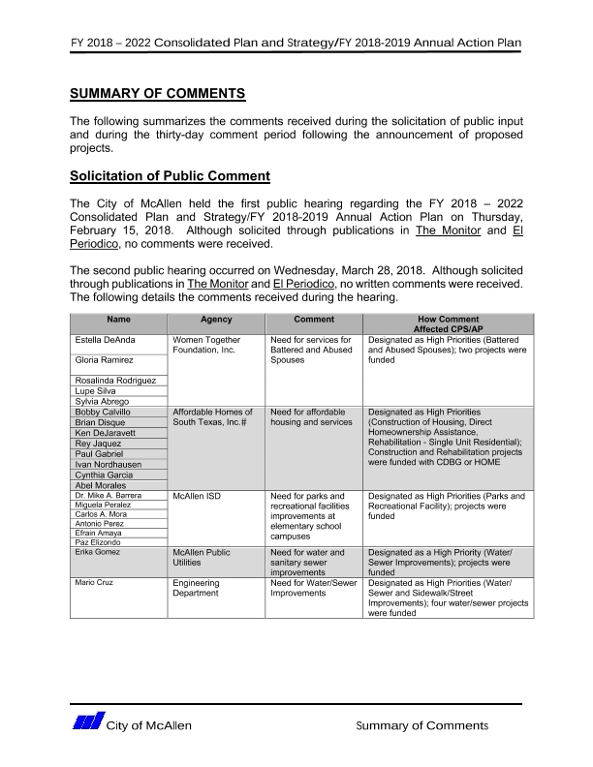
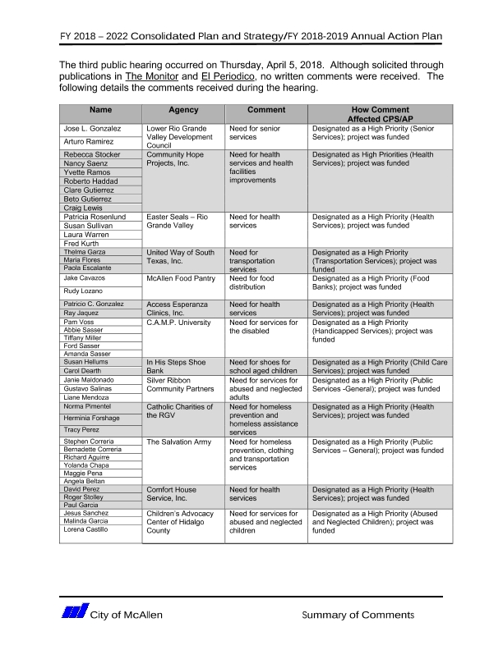
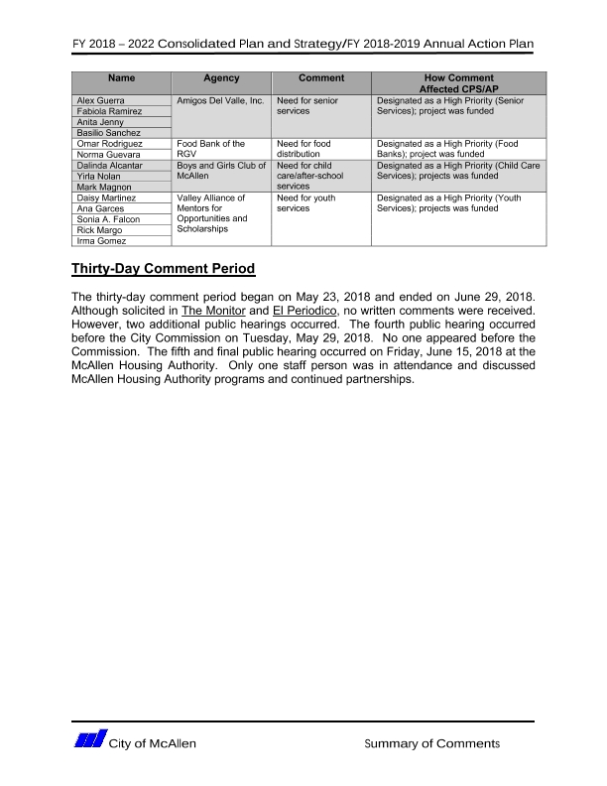

Grantee Unique Appendices
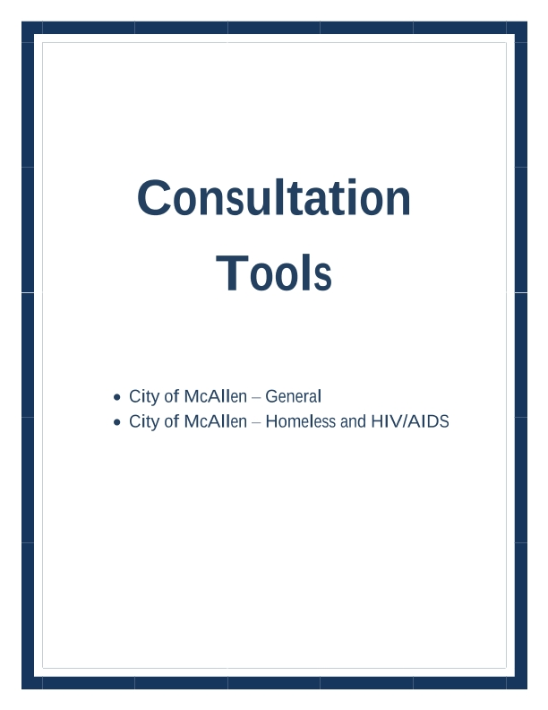
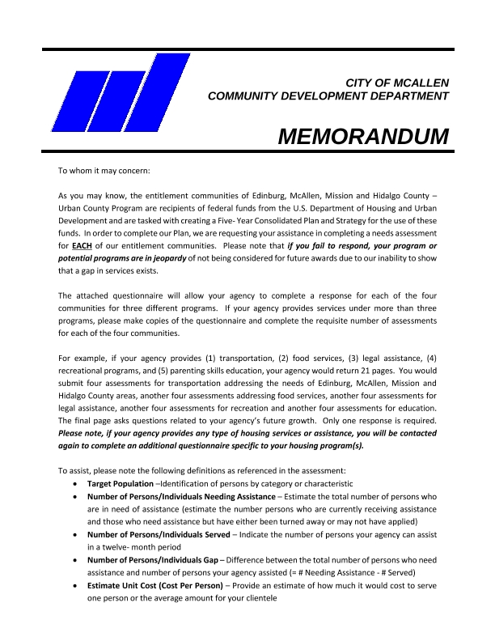
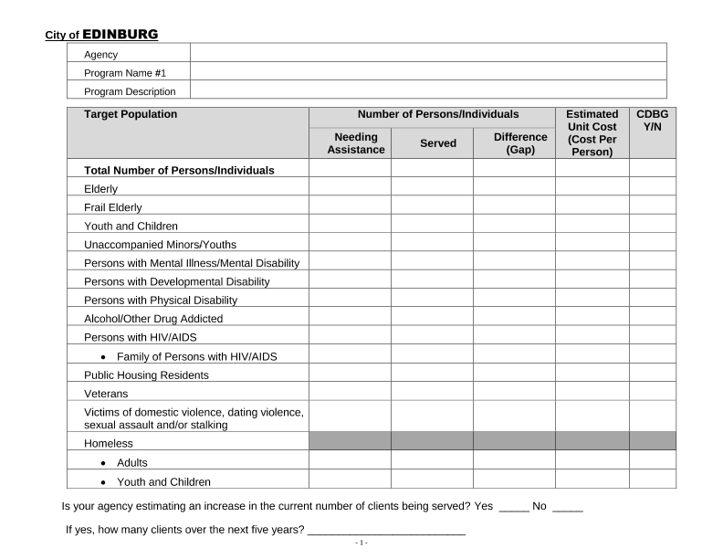
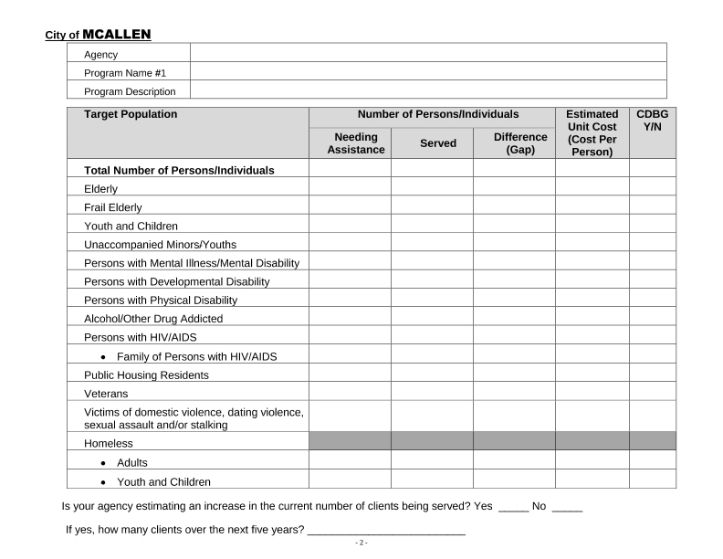
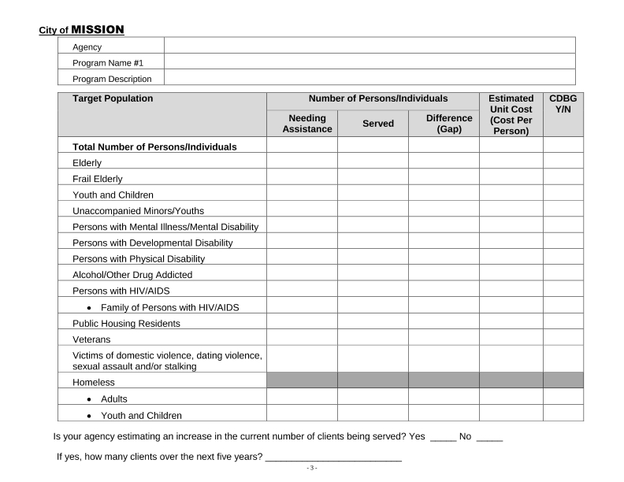
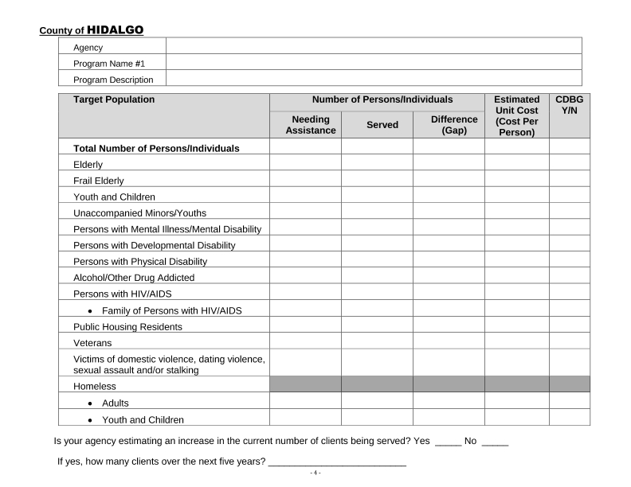
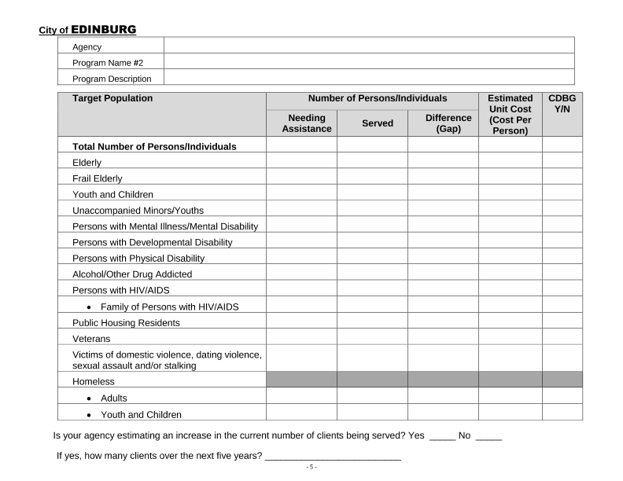
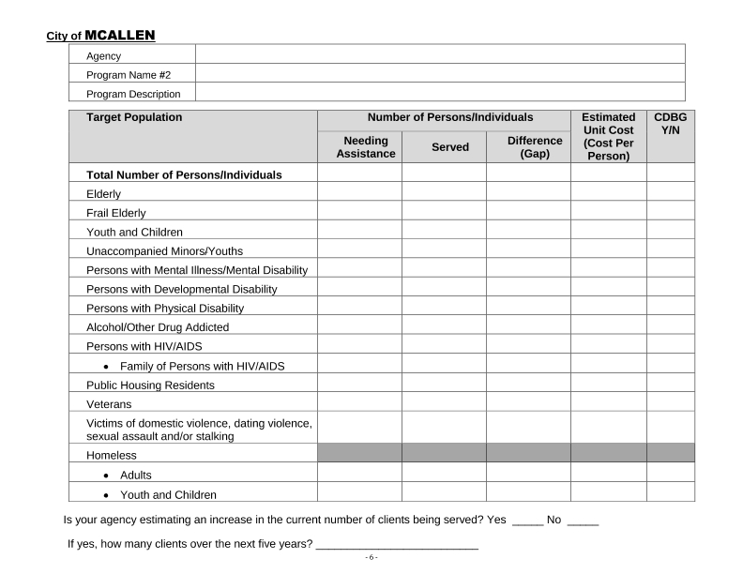
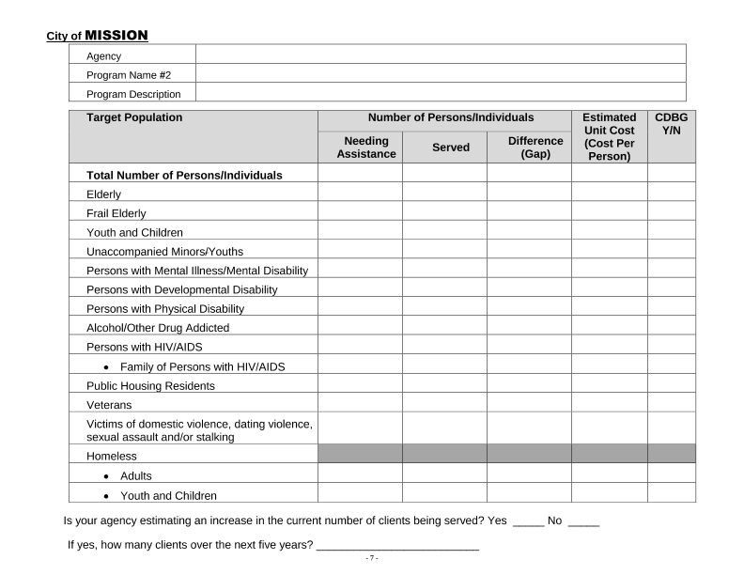
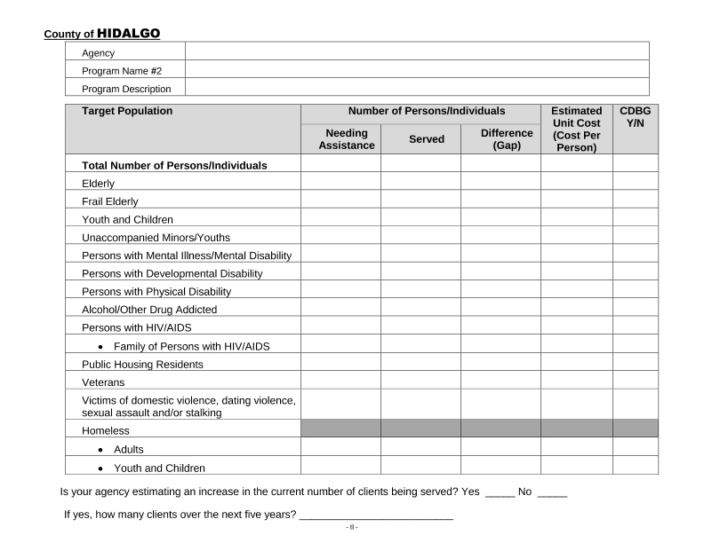
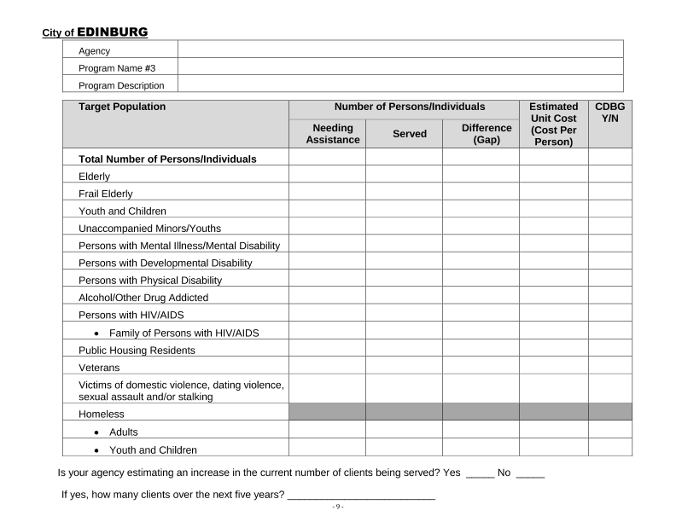
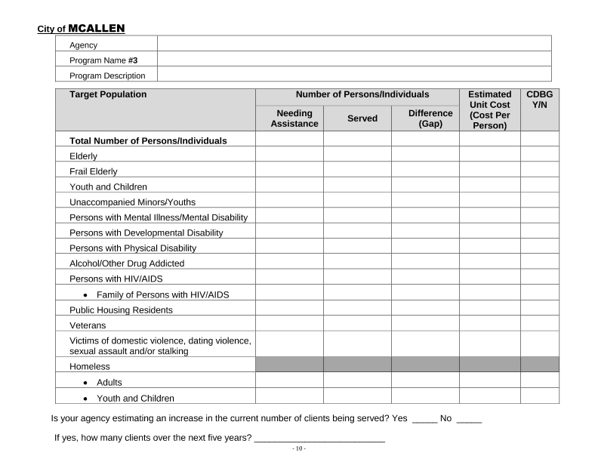
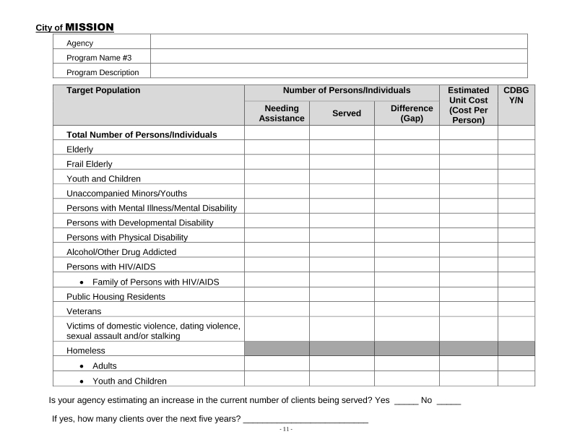
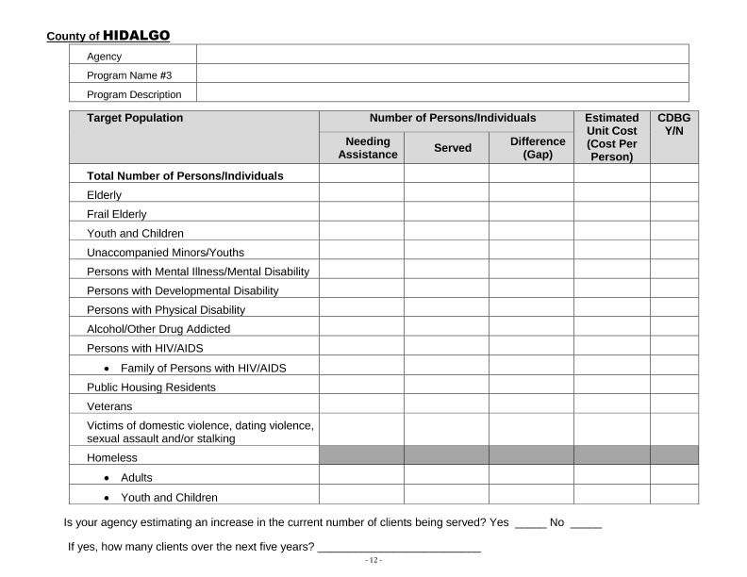
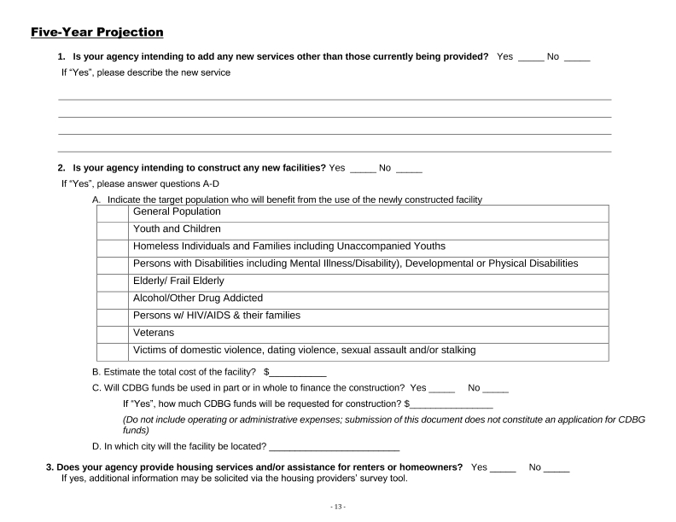
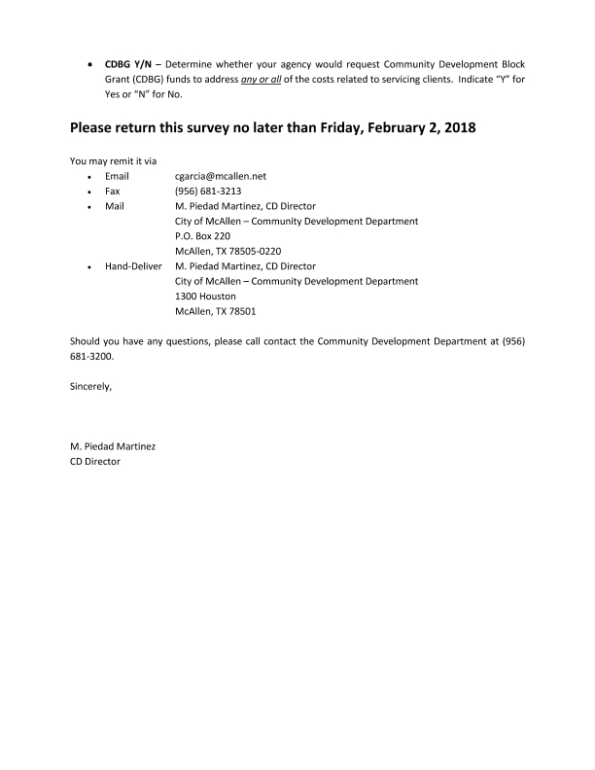
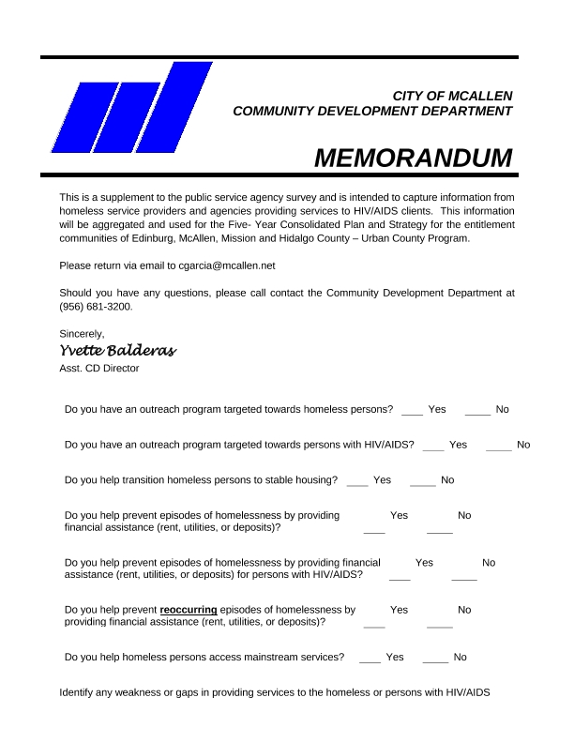
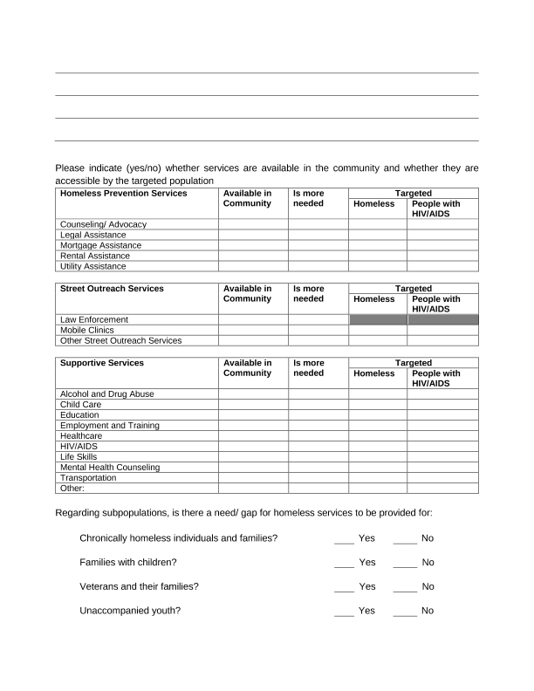
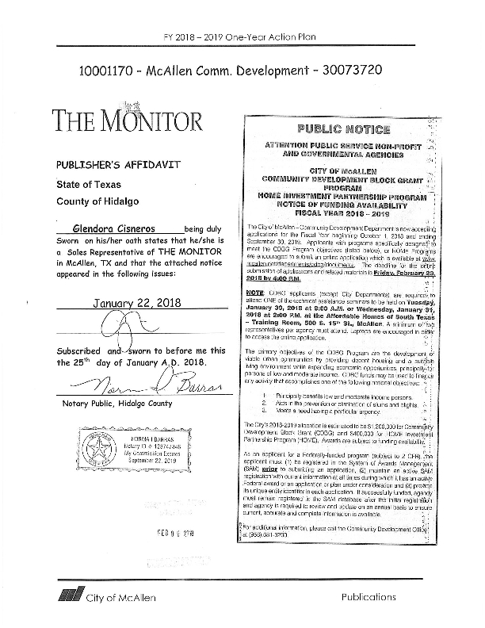
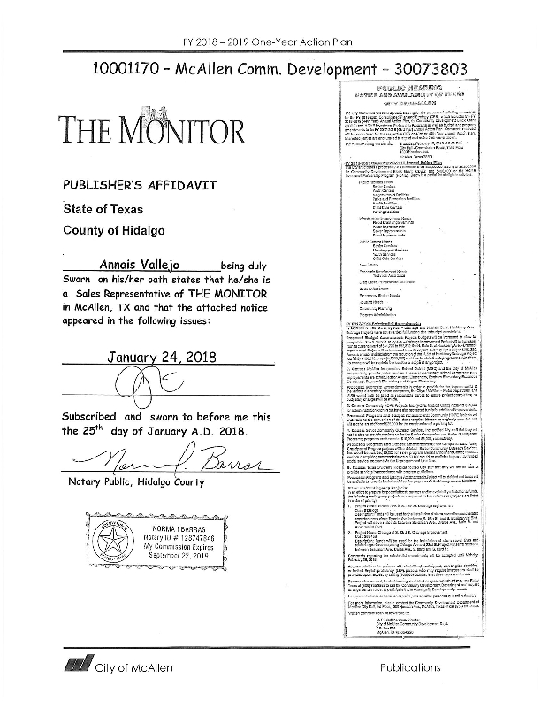
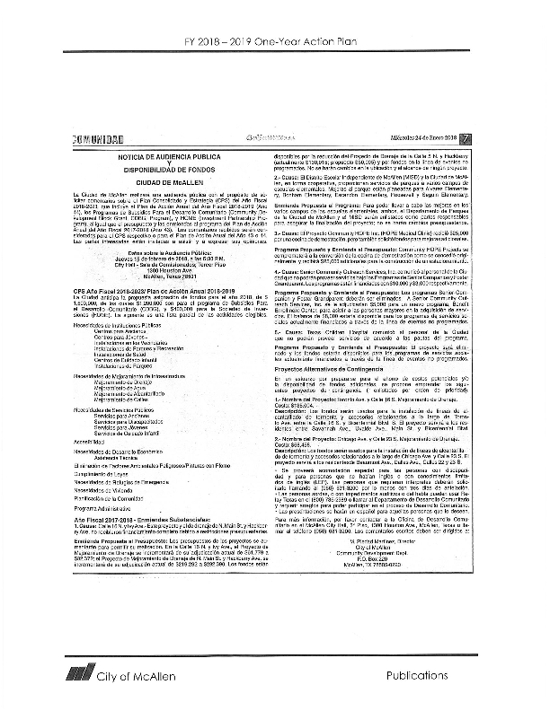
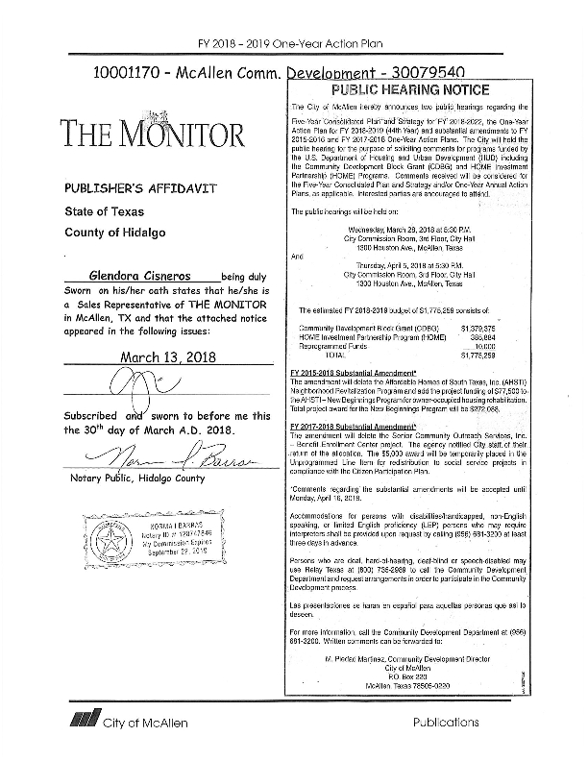
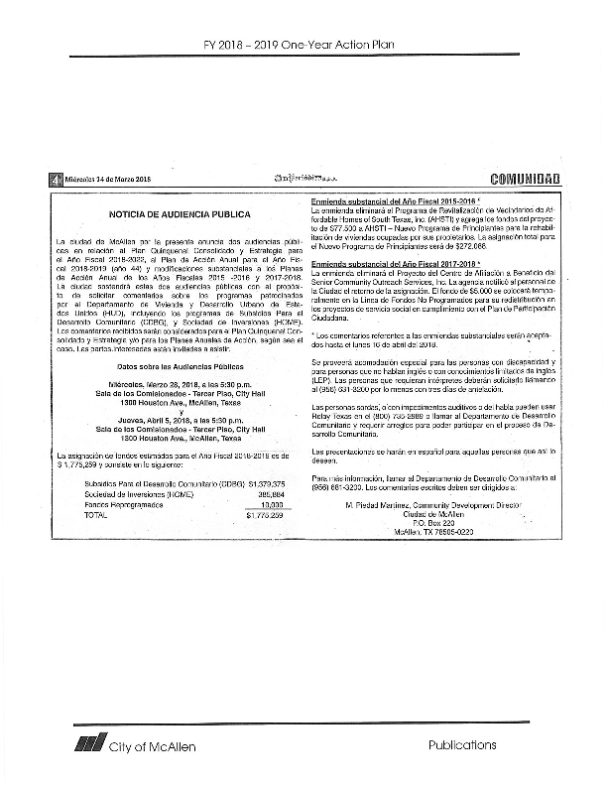
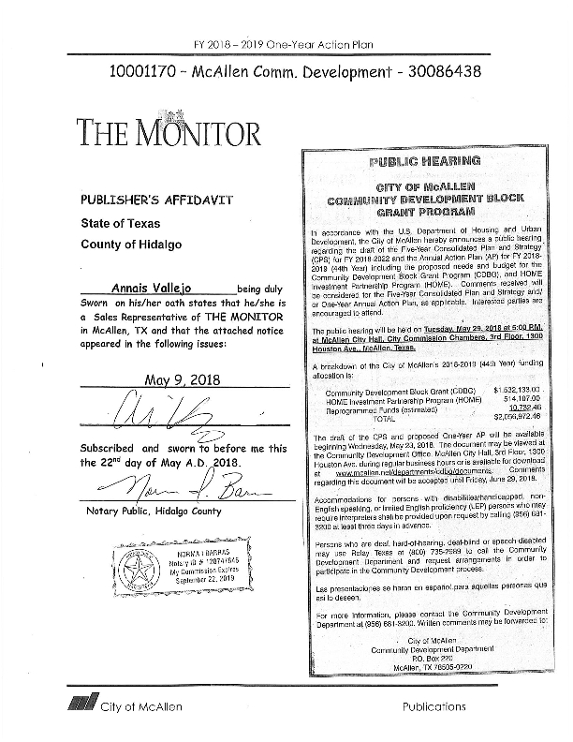
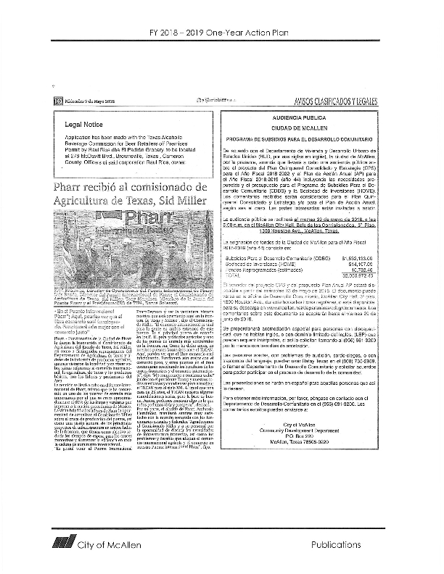
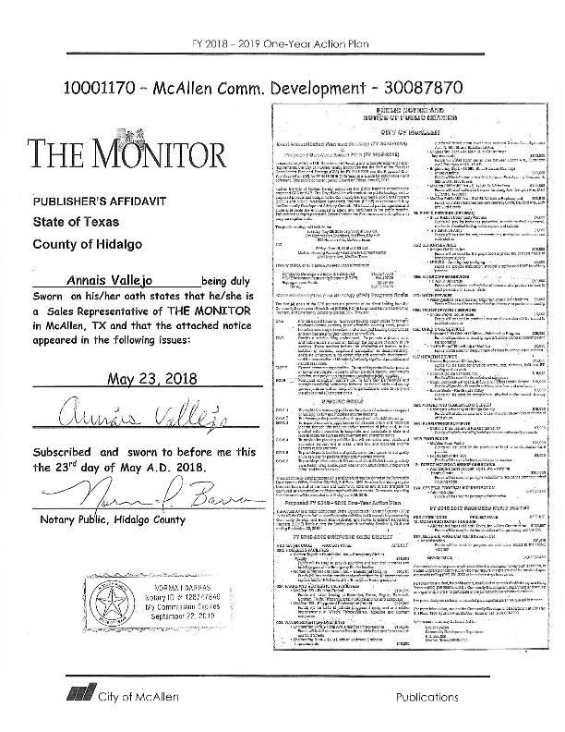
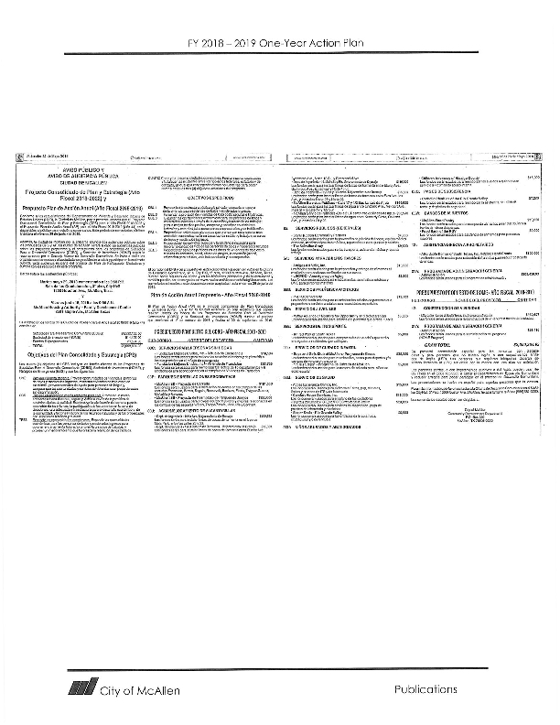
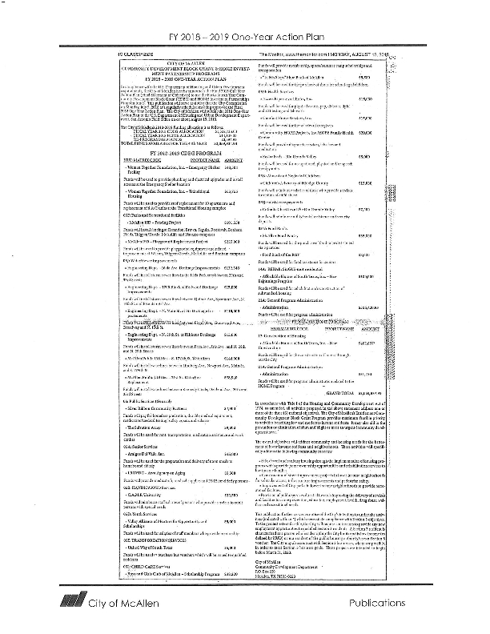
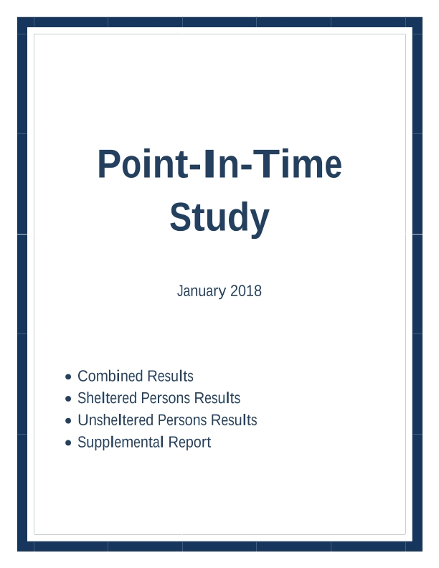
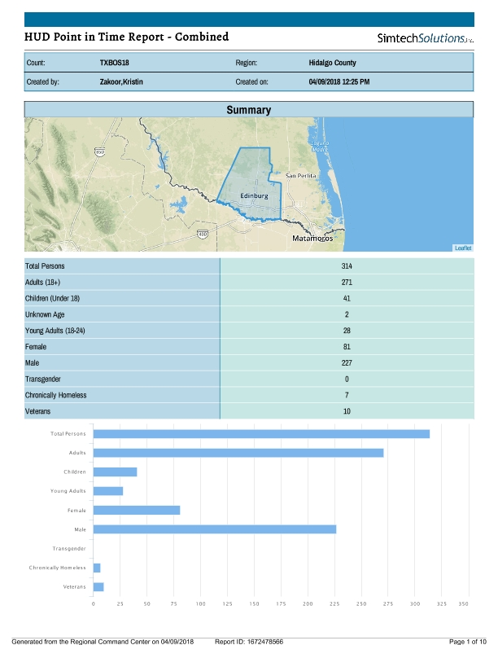
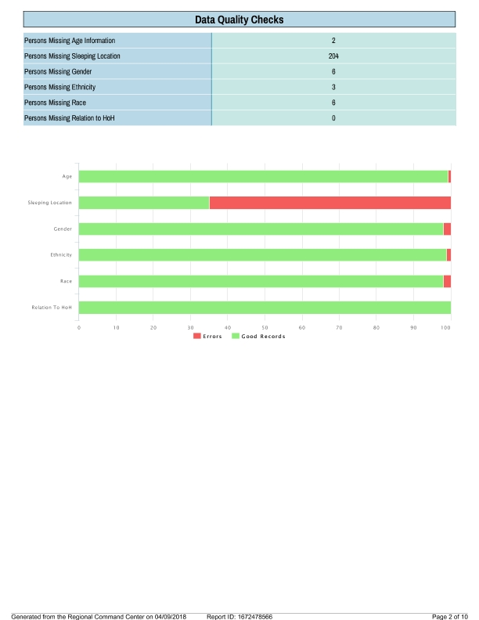
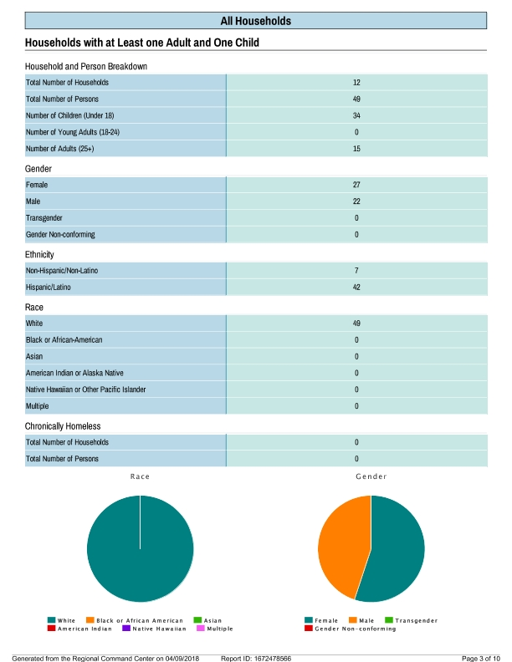
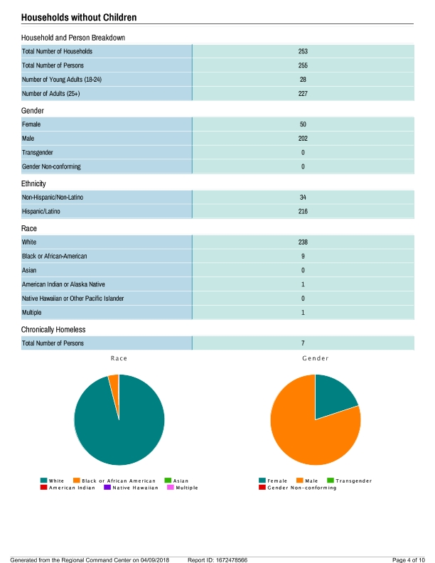
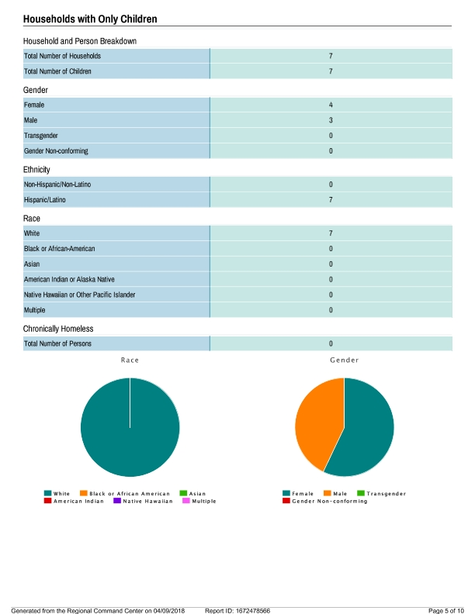
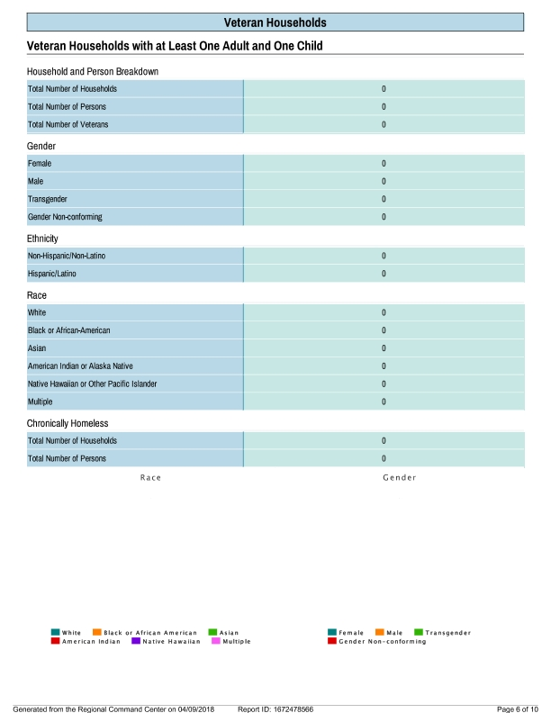
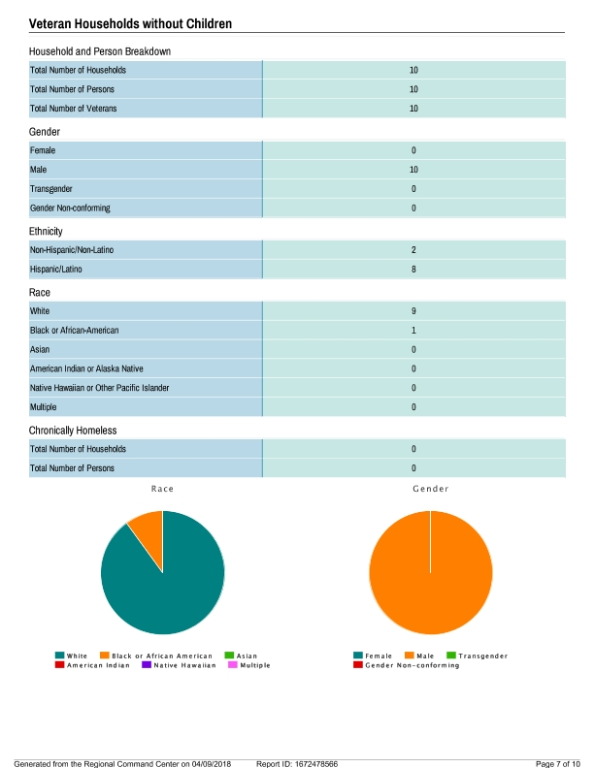
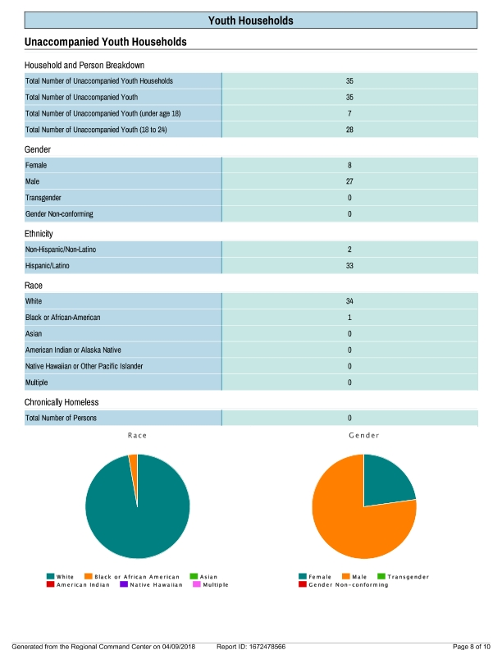
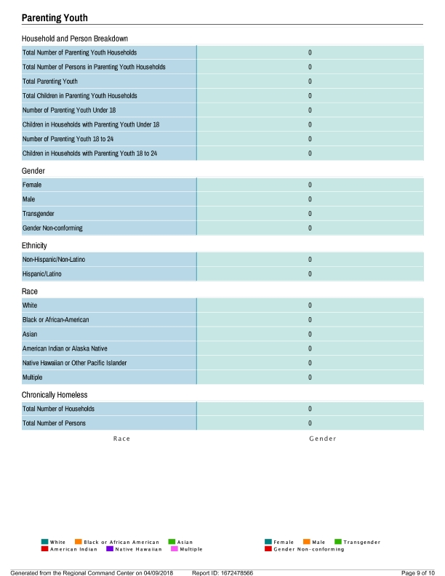
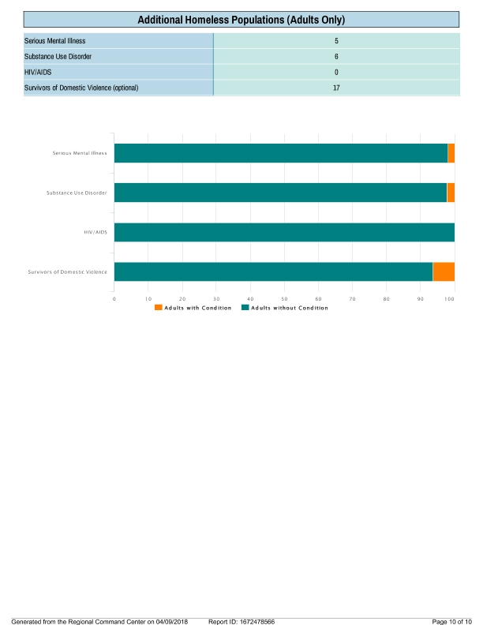
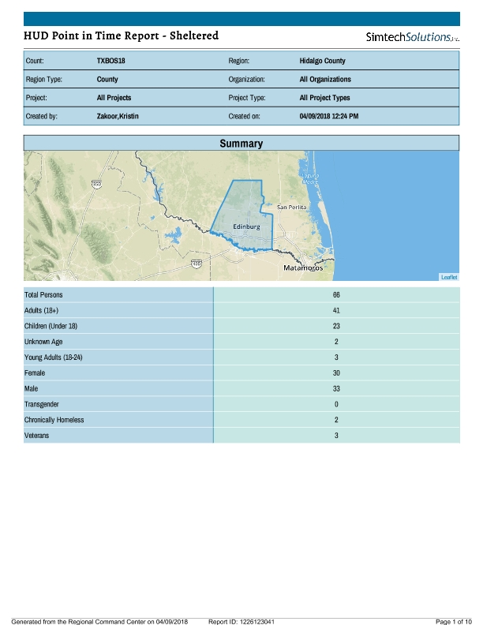
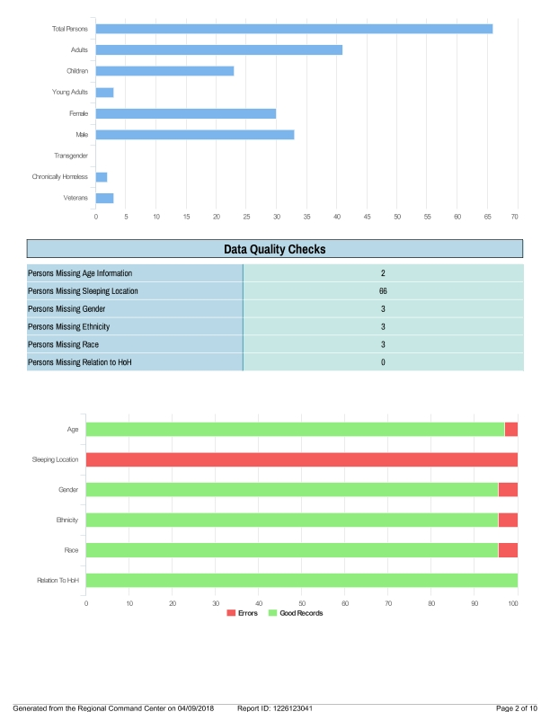
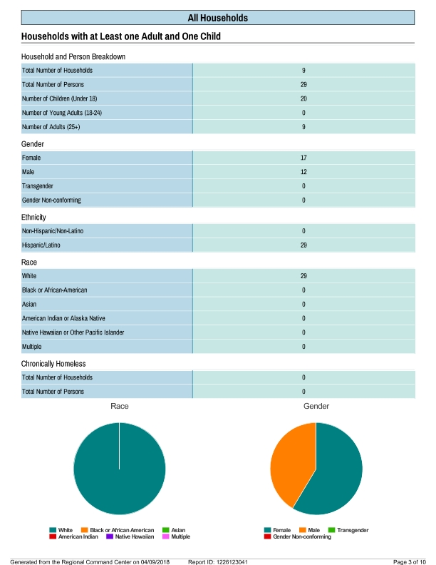
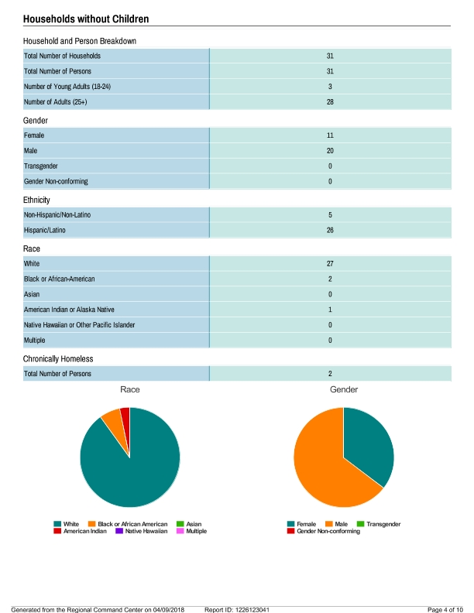
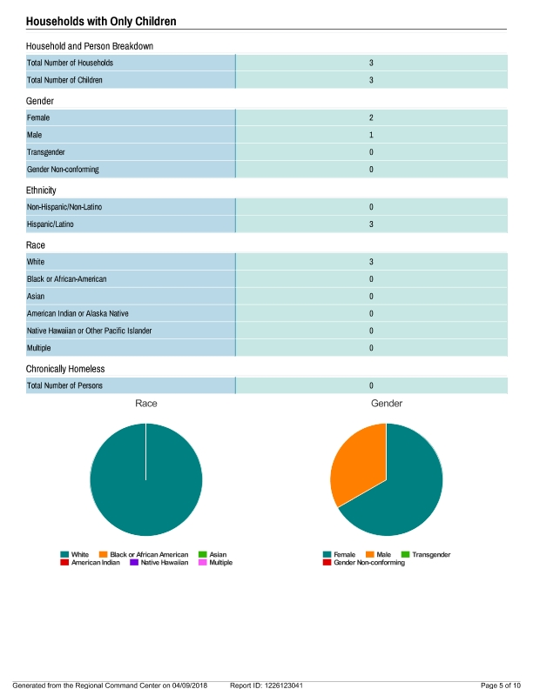
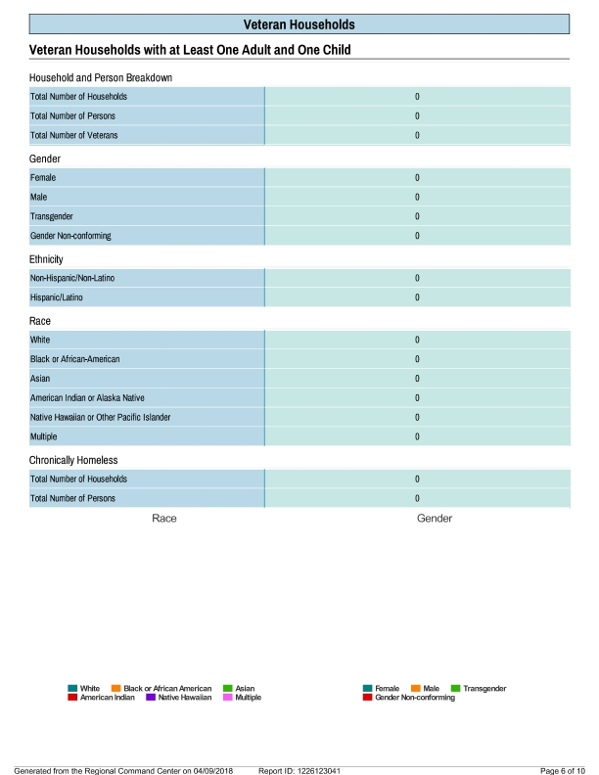
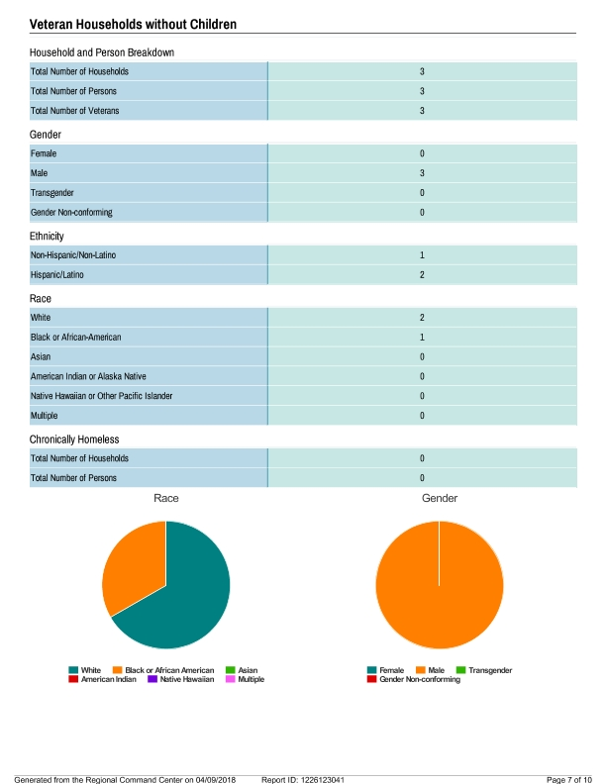
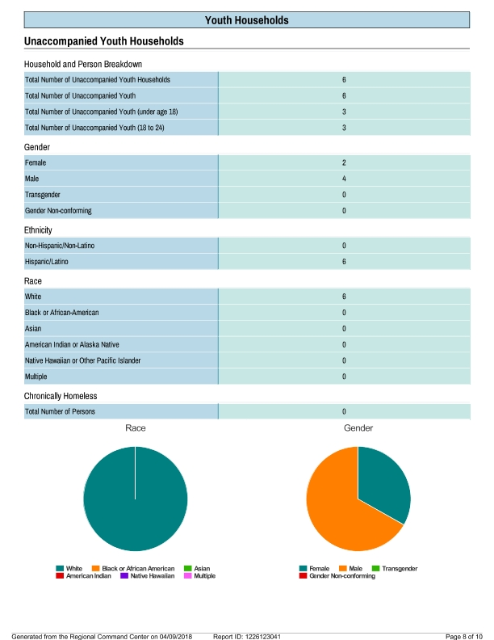
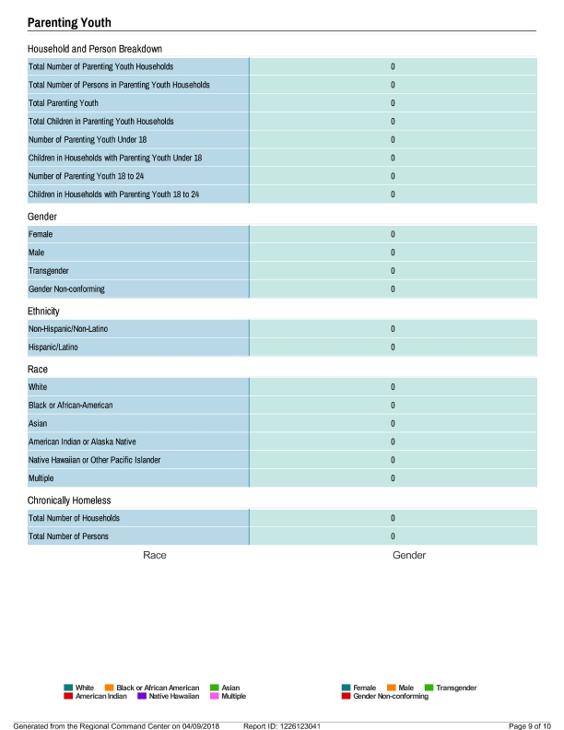
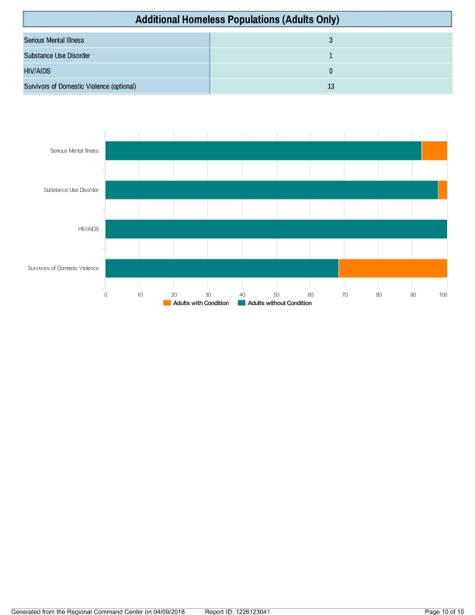
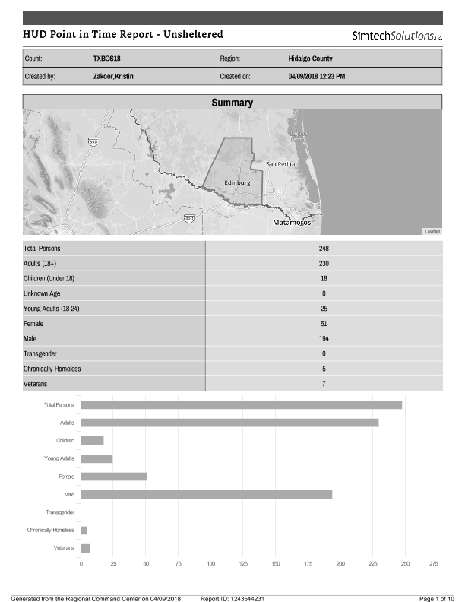
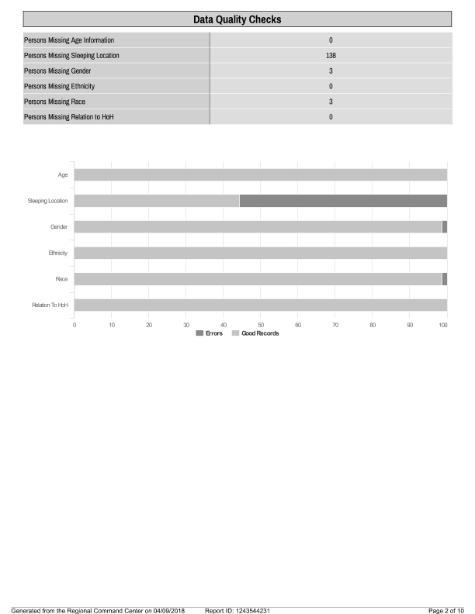
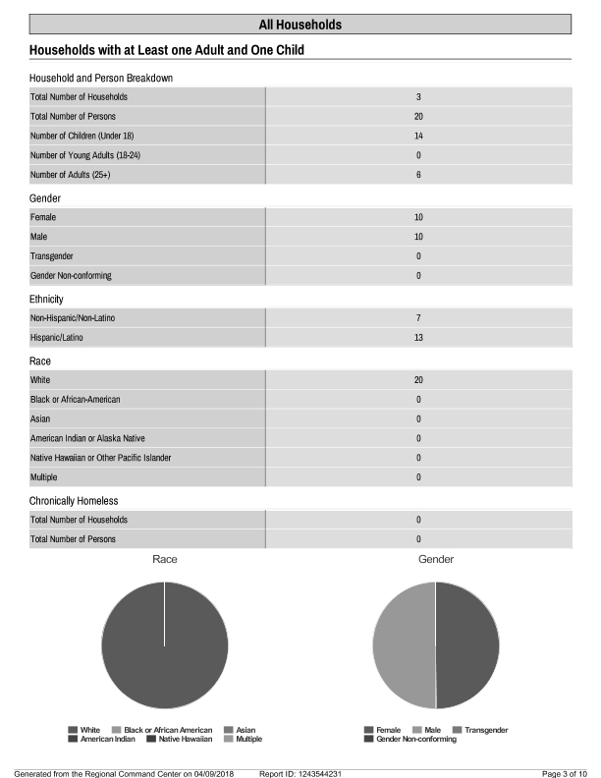
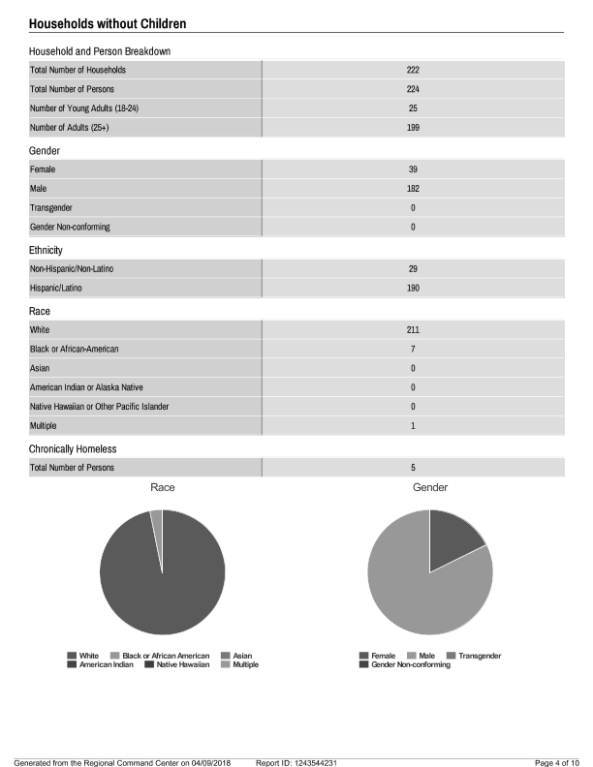
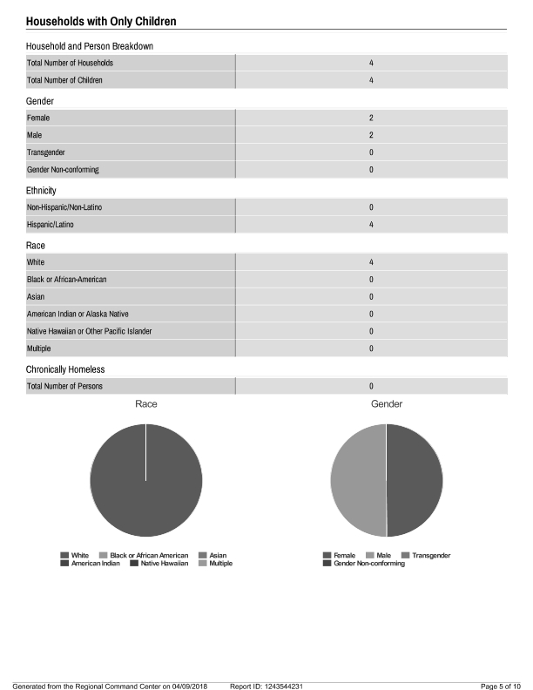
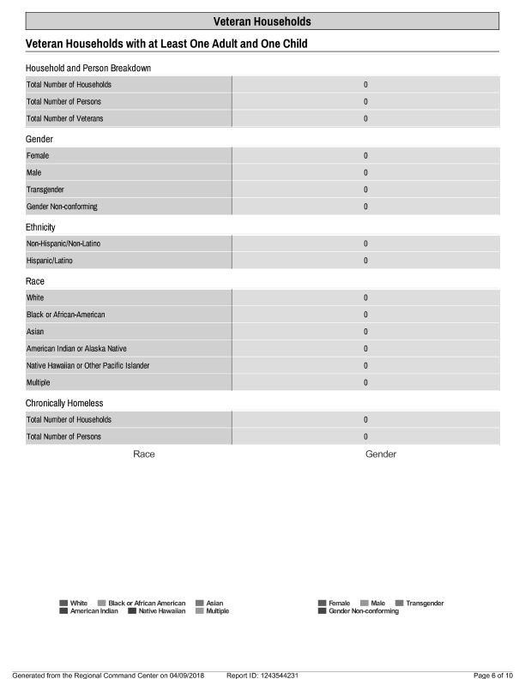
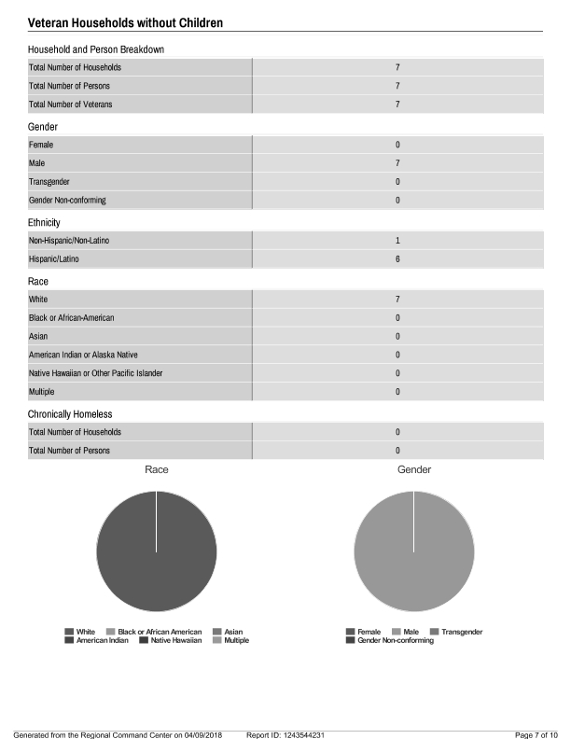
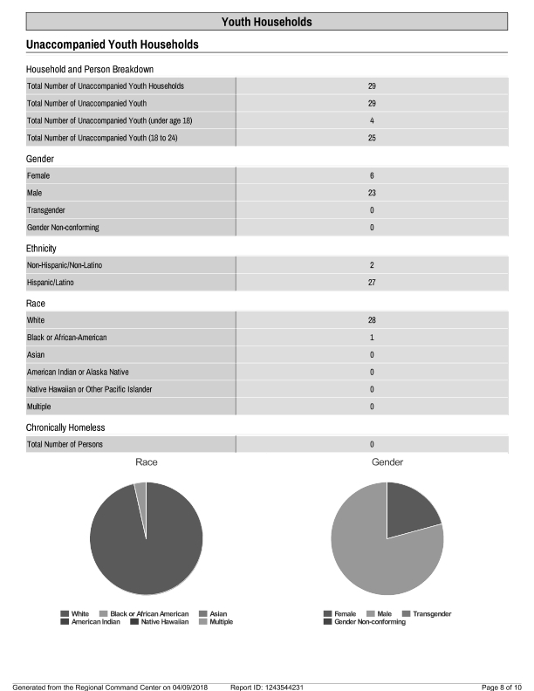
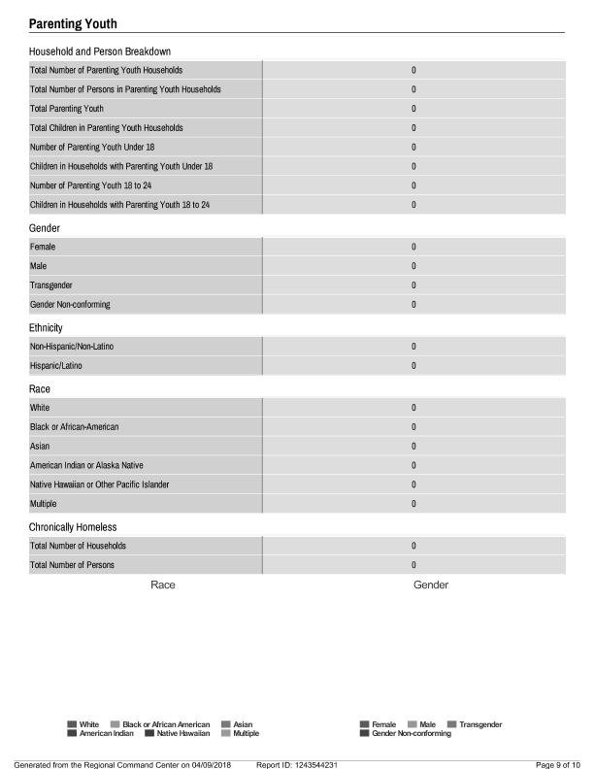
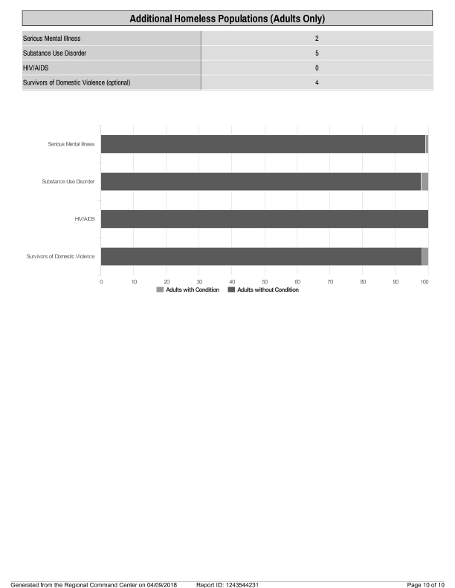
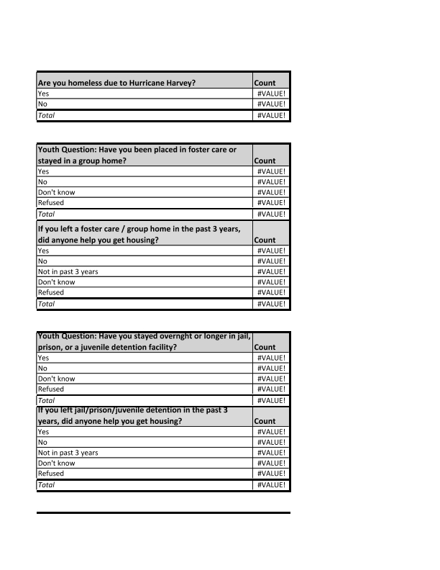
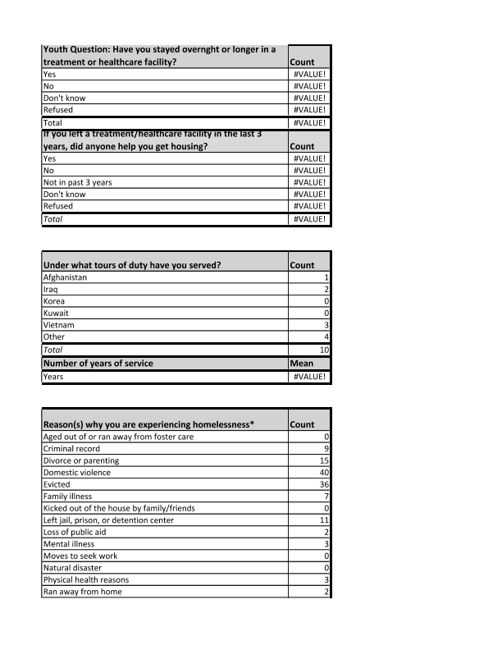
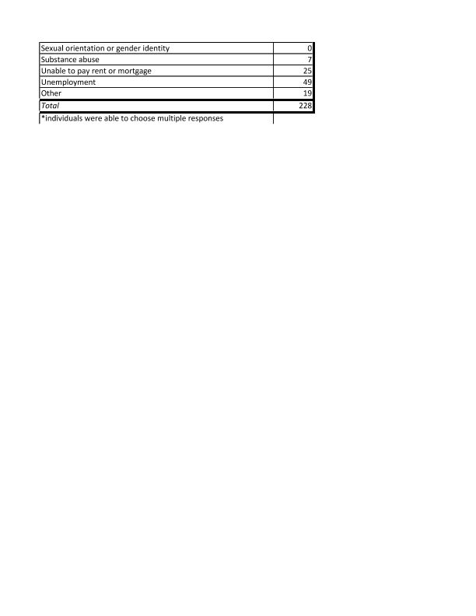
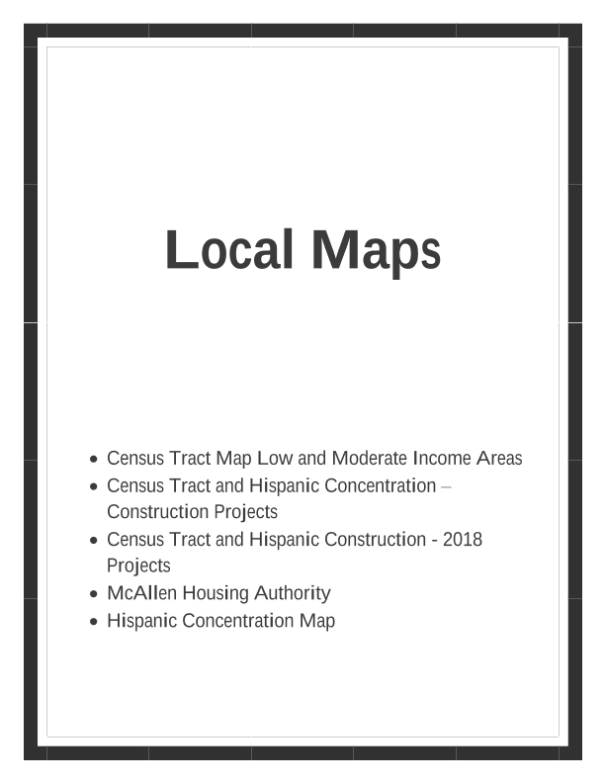
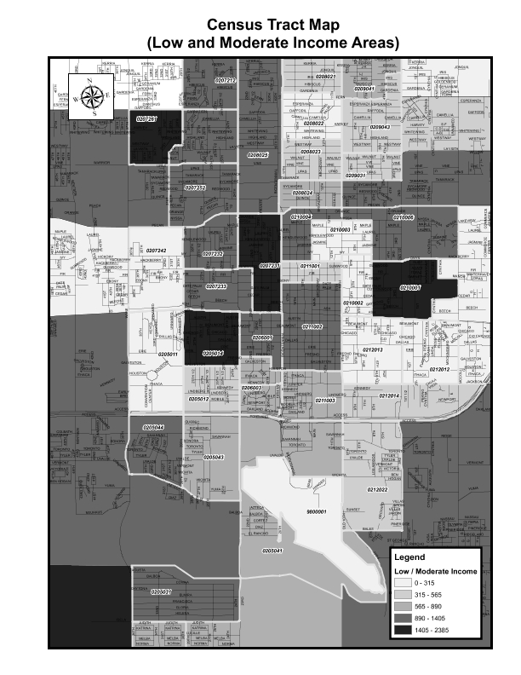
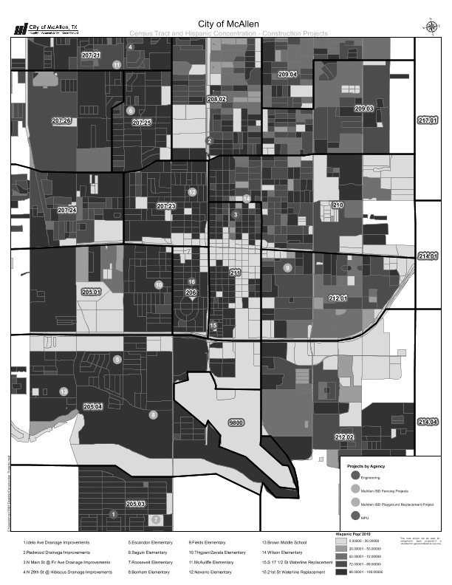
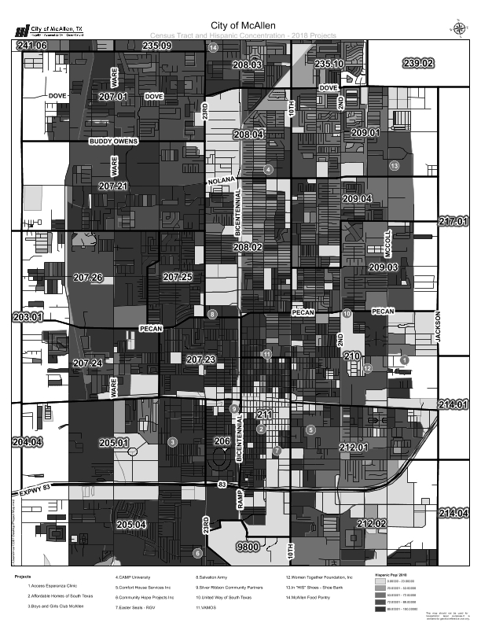
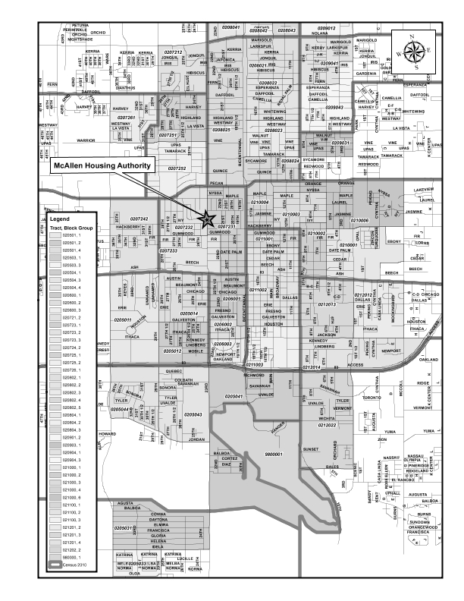
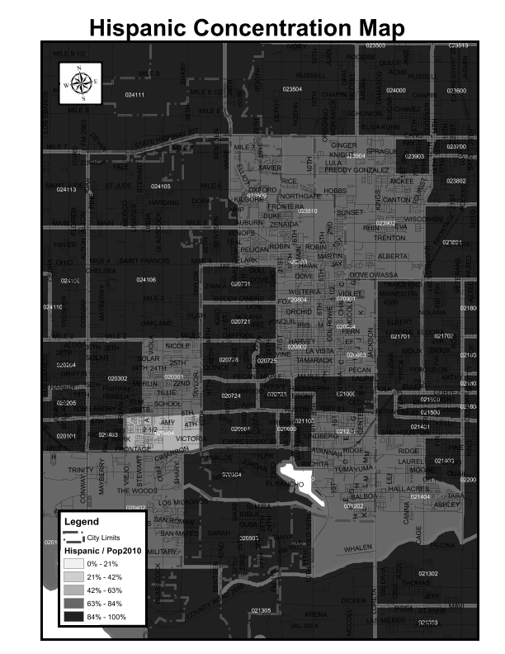
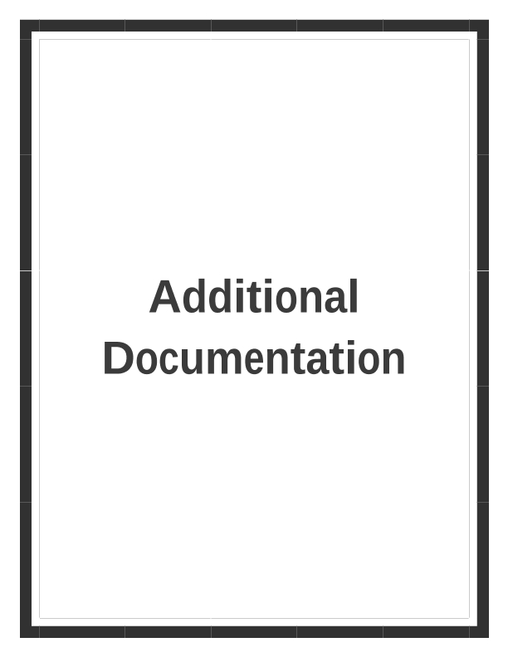
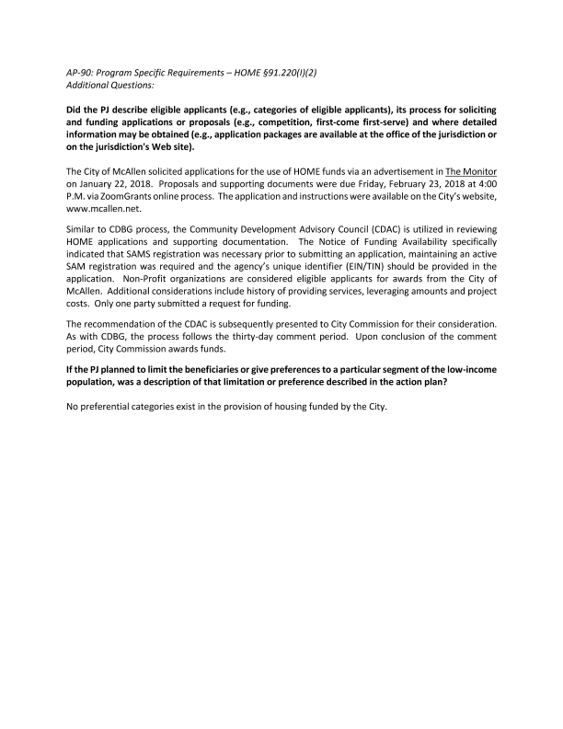
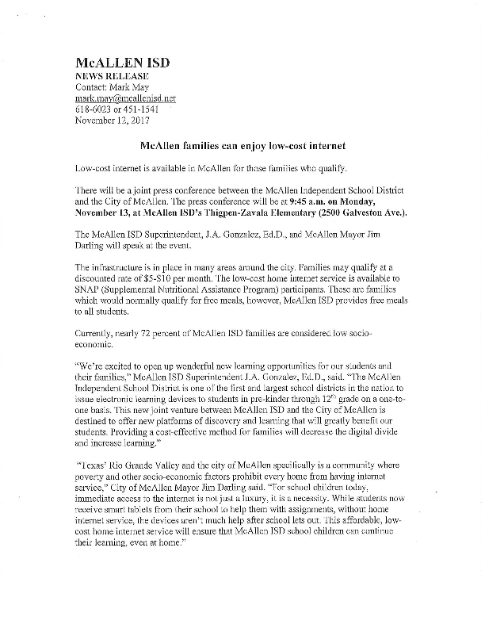
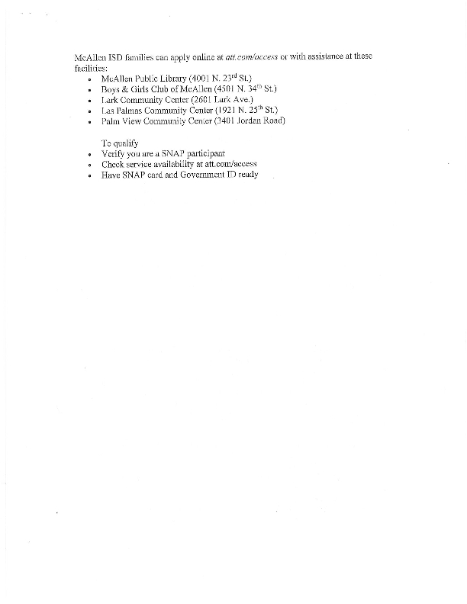
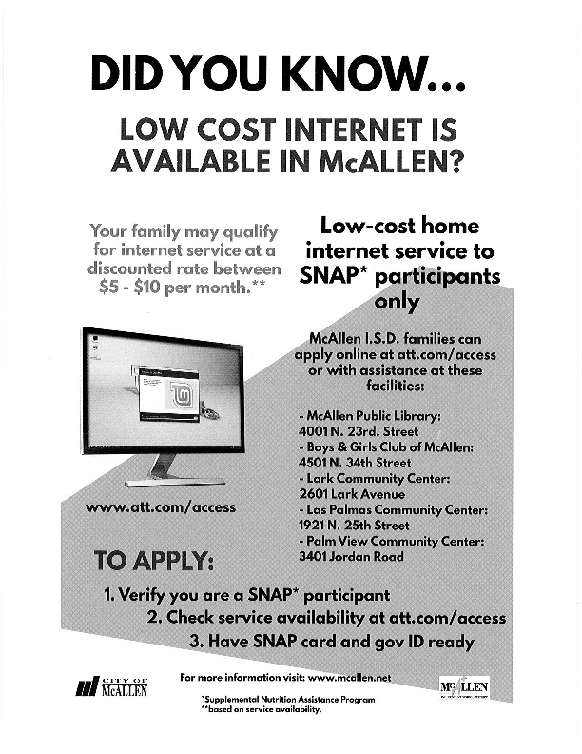
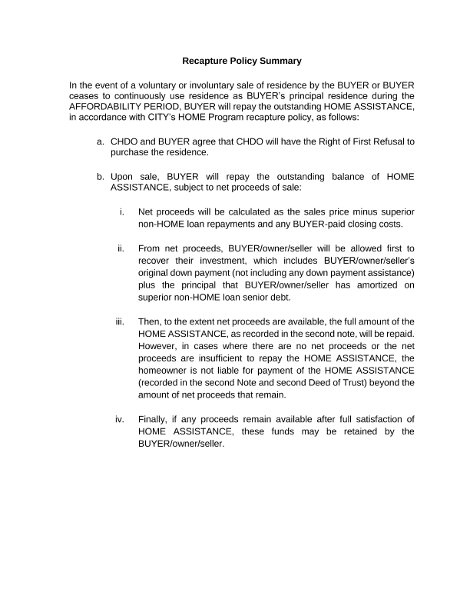

Grantee SF-424's and Certification(s)
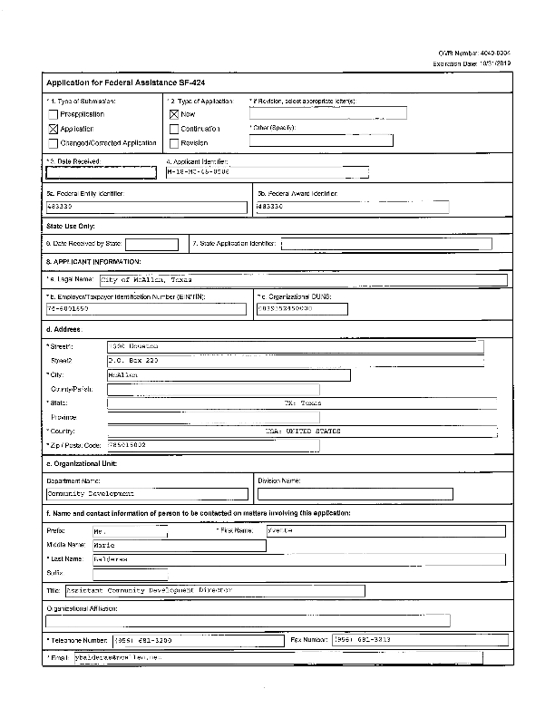
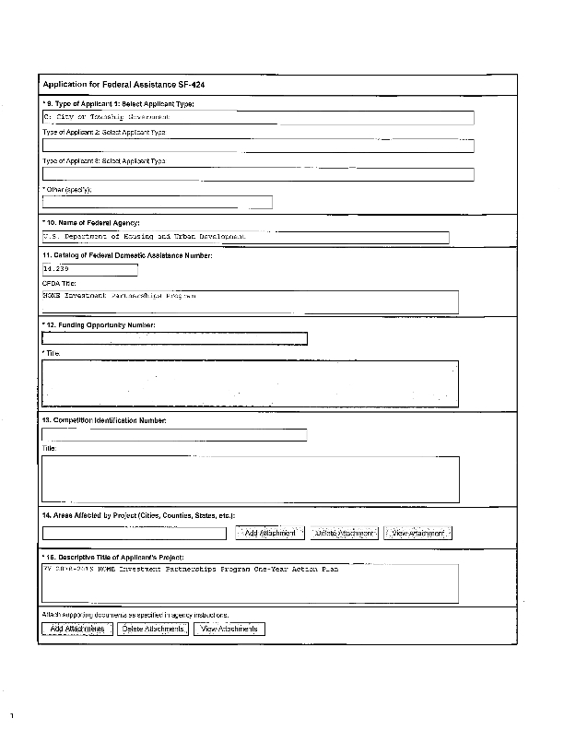
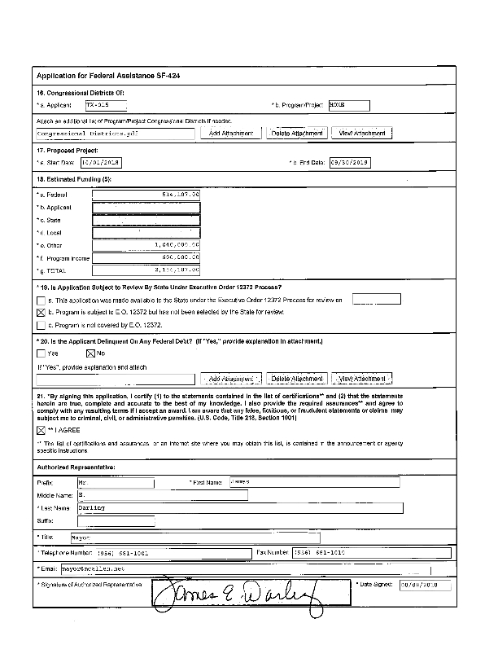
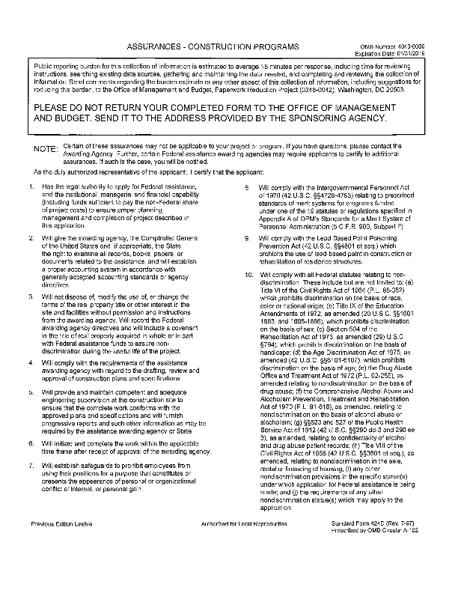
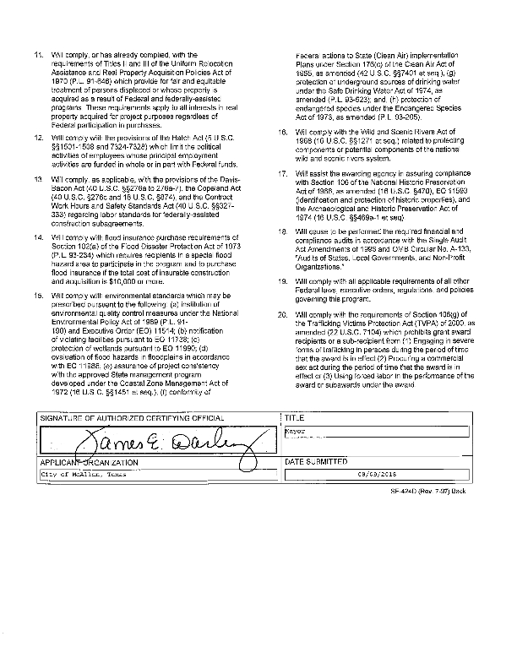
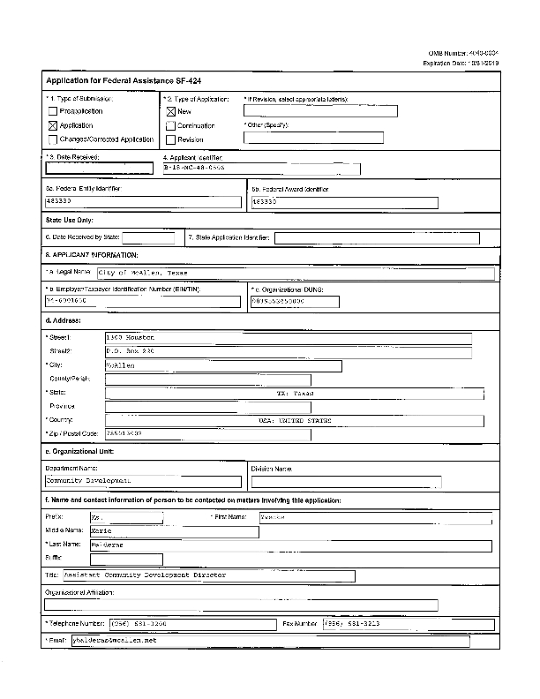
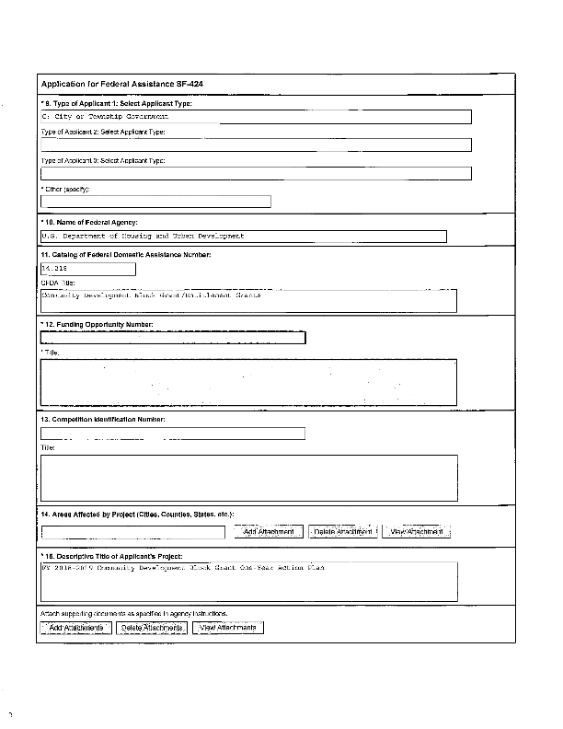
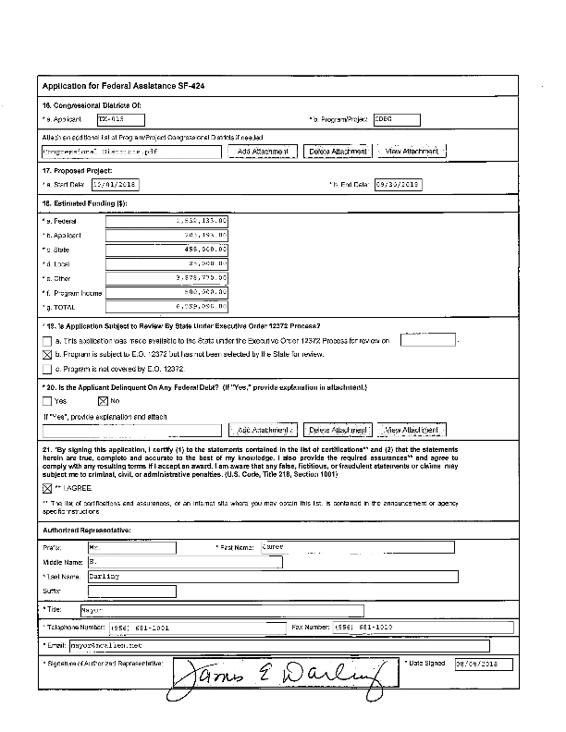
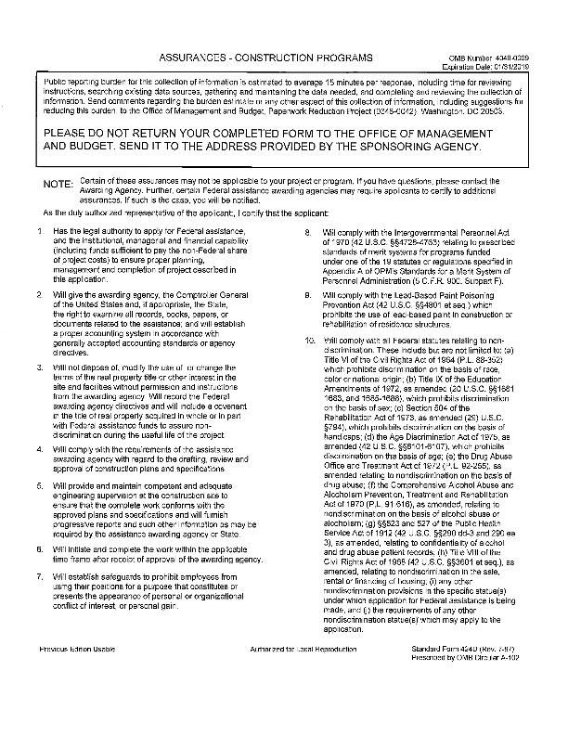
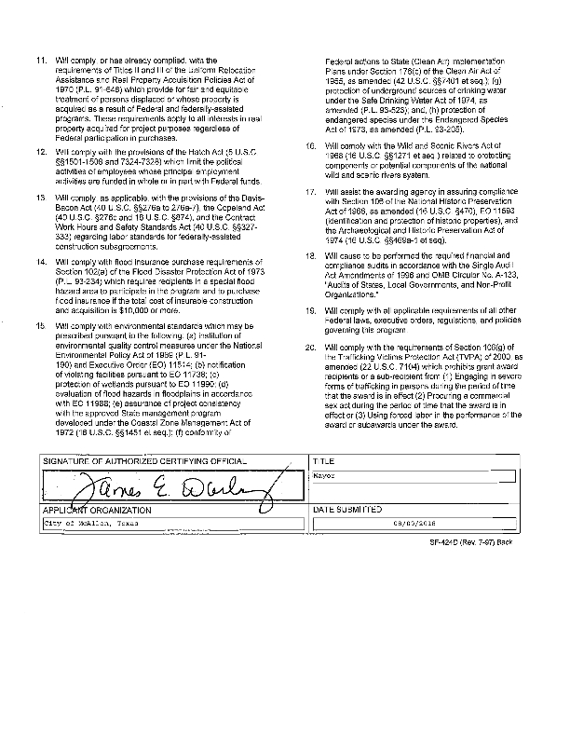
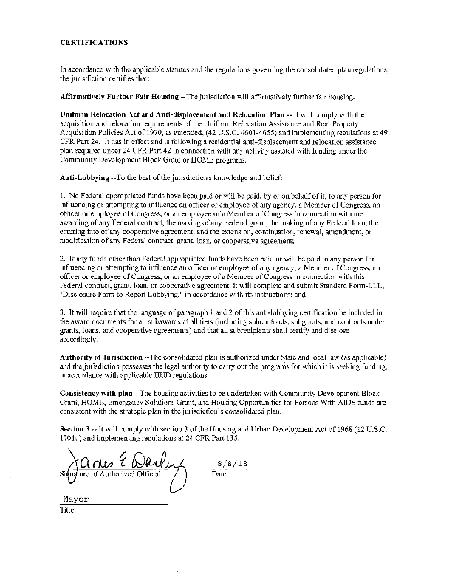
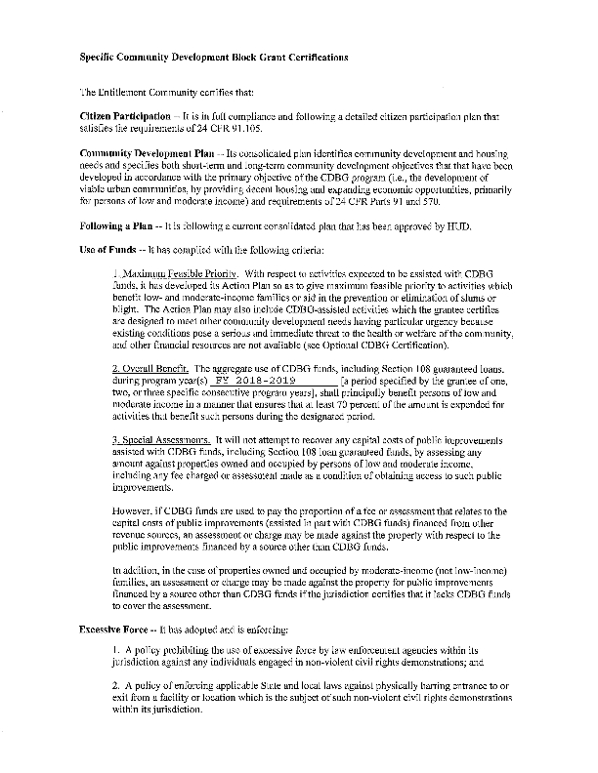
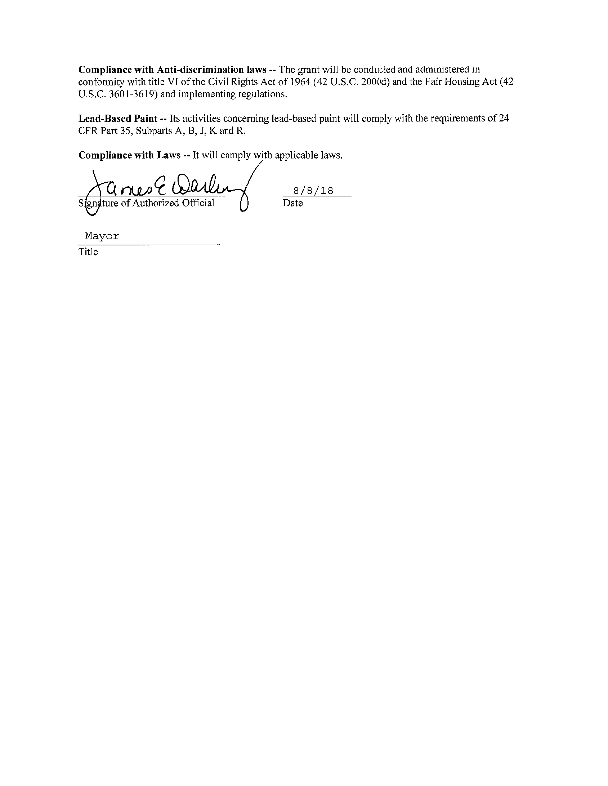
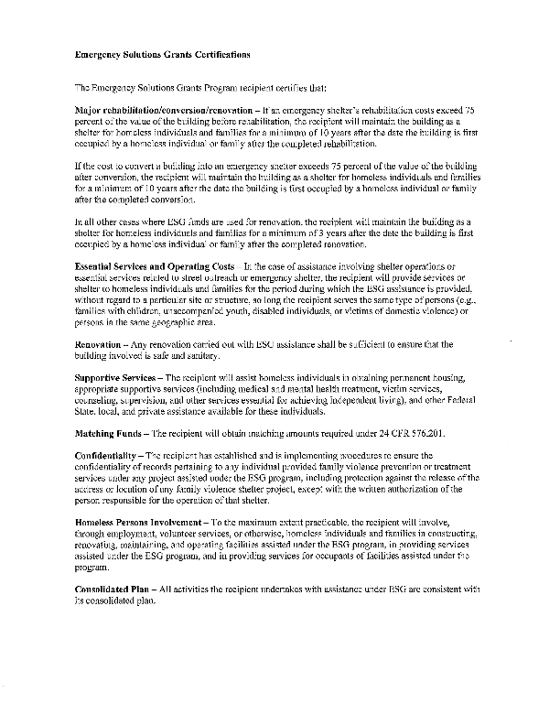
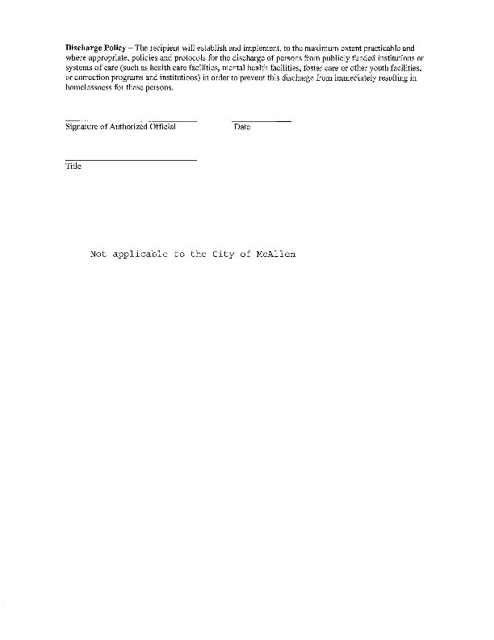
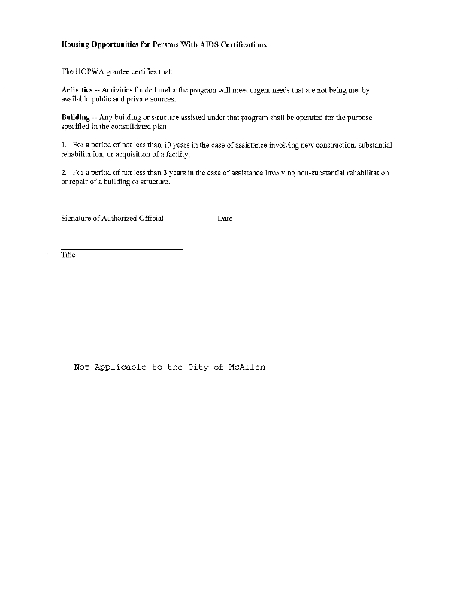
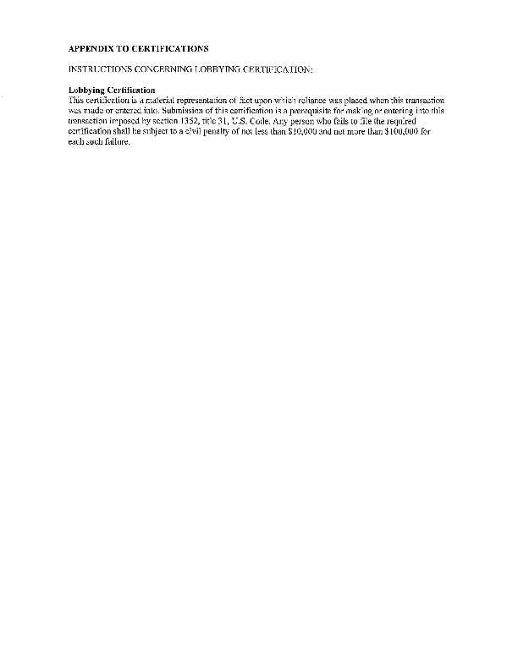

Appendixx - Alternate/Local Data Sources

1 | Data Source Name  RGVEC Analyis of Impediments
List the name of the organization or individual who originated the data set.
Eight Entitlement Communities in the Rio Grande Valley
Provide a brief summary of the data set.
Compiled by ICF Consulting, Inc.
What was the purpose for developing this data set?
Analysis of Housing Choice Impediments
How comprehensive is the coverage of this administrative data? Is data collection concentrated in one geographic area or among a certain population?
Deep South Texas, dual Counties
What time period (provide the year, and optionally month, or month and day) is covered by this data set?
Annually updated
What is the status of the data set (complete, in progress, or planned)?
Continuously reviewed

