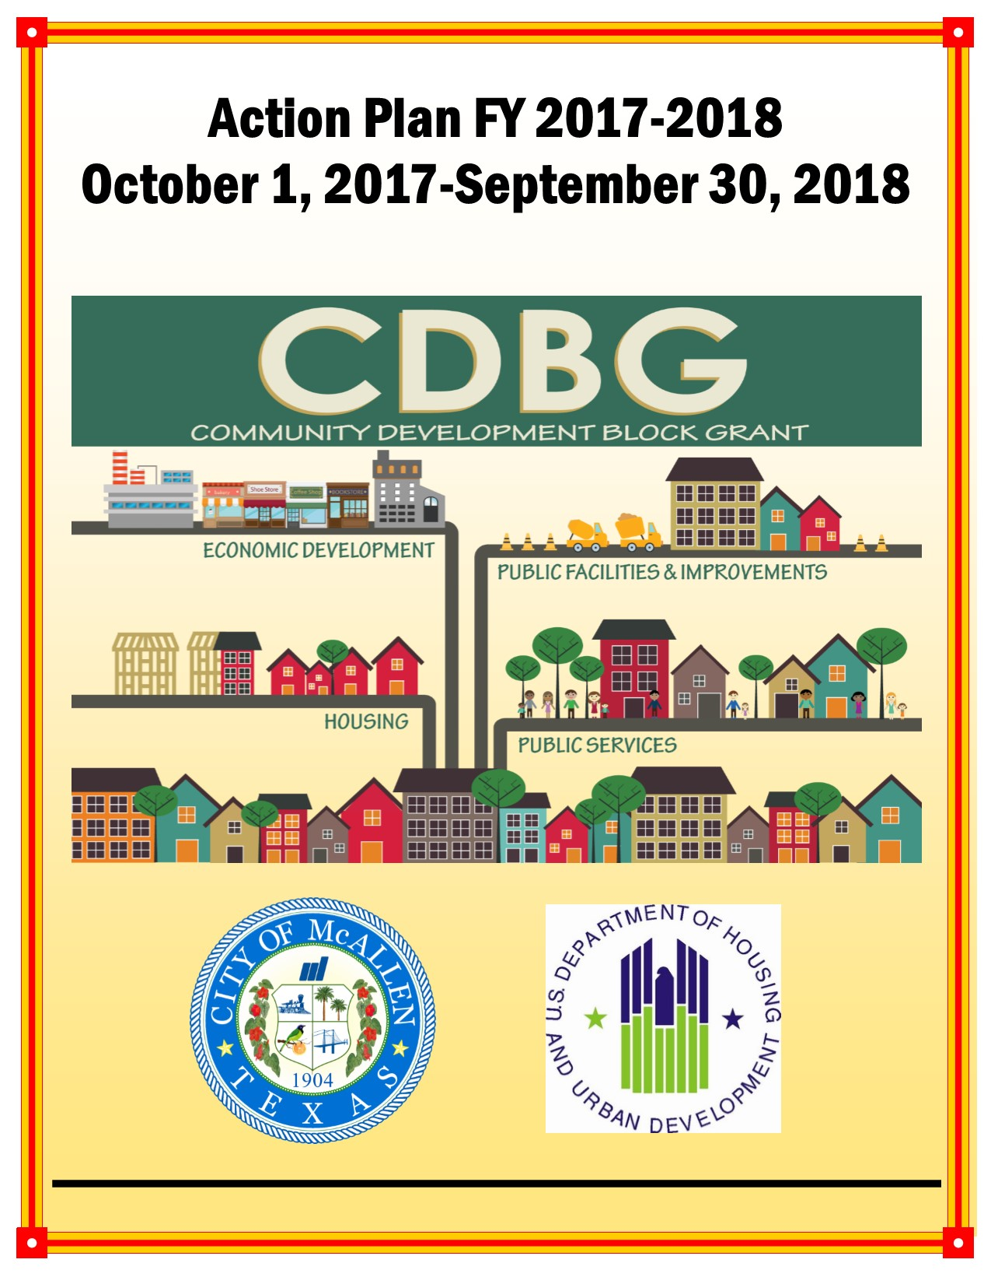

Executive Summary

AP-05 Executive Summary - 24 CFR 91.200(c), 91.220(b)
1. Introduction
The U.S. Department of Housing and Urban Development (HUD) requires local jurisdictions to prepare an Annual Action Plan (AP) in order to receive federal funds through the Community Development Block Grant (CDBG), HOME Investment Partnership Program (HOME), Emergency Solutions Grant (ESG) and Housing Opportunities for Persons with AIDS (HOPWA) formula programs. For FY 2017-2018, the City of McAllen will receive entitlement funds for the CDBG and HOME Programs.
This AP process allows the public and interested parties an opportunity to shape a variety of housing and community development programs funded by CDBG and HOME into effective and coordinated neighborhood, community, and regional development strategies. The City’s AP outlines the activities the City will undertake in the pursuit of HUD objectives and outcomes for low- and moderate-income individuals and families, including:
Objectives
- Creating suitable living environments,
- Providing decent affordable housing, or
- Creating economic opportunities
Outcomes
- Availability/Accessibility,
- Affordability, or
- Sustainability
Each of the funded activities, public facilities and improvements, infrastructure, affordable housing, and public service activities, not only serve to promote HUD’s objectives and outcomes but are an integral component in furthering the goals the City established in the FY 2013-2017 Consolidated Plan and Strategy (CPS). The primary means toward this end is to extend and strengthen partnerships among all levels of government and the private sector, including for-profit and non-profit organizations, in addressing housing and community development needs.
This AP describes the programs and services that will occur during the funding period beginning October 1, 2017 through September 30, 2018. Specifically, it details projects to be undertaken, the populations that will be served, and private, local, state and federal resources that will be leveraged over the next year to address the goals during the last of the five years covered by the CPS.
2. Summarize the objectives and outcomes identified in the Plan
This could be a restatement of items or a table listed elsewhere in the plan or a reference to another location. It may also contain any essential items from the housing and homeless needs assessment, the housing market analysis or the strategic plan.
HUD has established a listing of Matrix Codes for projects funded with Consolidated Plan dollars. These Matrix Codes are prioritized at the local level based on a community needs assessment. Matrix Codes are categorized as either "High" or "Low" priorities.
In summary, the following broadly defined activities are "High" priorities:
- Housing - Construction, Counseling, Rehabilitation of Single-Units, Homeowner Assistance and Public Housing Modernization
- Infrastructure - Street and Water/Sewer Improvements, Sidewalk Construction and Flood/Drain Improvements
- Public Facilities - Youth Centers, Senior Centers, Homeless Facilities/Operating Costs, Neighborhood Facilities, Parks and Recreational Facilities, Fire Stations/Equipment and Health Centers
- Public Services - Services for individuals and families including services for seniors, youth, general population, handicapped persons, abused and neglected children and battered and abused spouses as well as transportation, health services and subsistence payments
- Economic Development - Financial resources/infrastructure upgrades to improve businesses including micro-enterprise loans, revolving loan funds and/or building acquisition, construction or rehabilitation
By funding "High" Priority activities, the City is striving to address HUD's national goals/objectives of (1) creating a suitable living environment , (2) providing decent housing and (3) expanding economic opportunities, to principally benefit extremely low-, low-, and moderate-income individuals and families. Funded projects must also address one of the HUD outcomes: (1) Availability/Accessibility, (2) Affordability and (3) Sustainability.
Most projects will address Objective #1 and Outcome #1:
- Access Esperanza Clinic
- Amigos Del Valle
- Boys and Girls Club of McAllen
- C.A.M.P. University
- Children’s Advocacy Center of Hidalgo County
- Community HOPE Projects, Inc. (Medical Services and Facility Improvements)
- CASA of Hidalgo County
- Easter Seals of the Rio Grande Valley
- Engineering Dept. – N. 5th St., N. Main St. and N. 16th St. Drainage Improvements
- FUMC – "In His Steps" Shoe Bank of McAllen
- LRGVDC - Area Agency on Aging
- McAllen Food Pantry
- McAllen I.S.D. - City/(Elementary) School Park Improvements
- Senior Community Outreach Services, Inc. (Senior Companion Program and Foster Grandparent Program Activities)
- Silver Ribbon Community Partners
- Texas Children's Hospital
- The Salvation Army
- United Way of South Texas
- Women Together Foundation, Inc.
Affordable Homes of South Texas, Inc. (AHSTI) – Helping Hands Grants and HOME Programs cite Objective #2 and Outcome #2 as goals. AHSTI – New Beginnings and Catholic Charities of the Rio Grande Valley use Objective #2 and Outcome #3 . No projects use Objective #3.
3. Evaluation of past performance
This is an evaluation of past performance that helped lead the grantee to choose its goals or projects.
Past accomplishements assisted in determining whether funding should be awarded/continued in FY 2017-2016 because:
- The Consolidated Plan and Strategy ennumerated the number of proposed beneficiaries over a Five-Year period and, for many goals, this ennumeration has not been met.
- The area has not seen significant economic changes such that the needs identified in previous plans continue, particularly for the clientele of social service agencies
- No changes to the priority of projects identified in the Consolidated Plan and Strategy occurred; as such, projects in FY 2017-2018 remain "High" priorities because the need continues based on consultations.
- The United Way (Transportation Services) pilot project proved successful in closing a gap in services by assisting individuals to move throughout the community, increasing access to jobs, providing an avenue to make medical visits as well as allowing for transportation to grocery stores and other daily errands.
- Older areas of town need assistance of replacement of aging infrastructure; replacement of drainage lines helps to assure the safety of residents as well as property. As such, additional drainage projects are proposed in FY 2017-2018.
- Interest, inquiry and applications for housing activities provided by Affordable Homes, Inc. have not lessened. Rehabilitation or reconstruction of homes, specifically for the elderly and persons with special needs, helps the City address sustainability as well as increase the quality of life for homeowners.
Further, in order to ascertain whether individual (One-Year) or cumulative (Five-Year) goals were met, a Consolidated Annual Performance and Evaluation Report (CAPER) is annually composed, available for public comment and remitted to HUD for review and approval. The most recent CAPER data was compared against the FY 2013 – 2017 Consolidated Plan. For convenience, the following table compares FY 2015-2016 proposed accomplishments with actual accomplishments.
Matrix Code | Category | Proposed | Actual | Unit of Measurement
03D | Youth Centers | 2 | 2 | Public Facility
03F | Parks and Recreational Facilities | 2 | 2 | Public Facility
03J | Water and Sewer Improvements | 20,346 | 4,562* | Persons
05 | Public Services (General) | 49 | 60 | Persons
05A | Senior Services | 42 | 59 | Persons
05B | Handicapped Services | 14 | 13 | Persons
05D | Youth Services | 624 | 366 | Persons
05E | Transportation Services | 300 | 100 | Persons
05G | Battered and Abused Spouses | 150 | 62 | People
05M | Health Services | 425 | 224 | Persons
05N | Abused and Neglected Children | 115 | 185 | Persons
050 | Mental Health Services | 41 | 31 | Persons
05Q | Subsitence Payments | 20 | 22 | Persons
05W | Food Banks | 10,000 | 4,996 | Persons
12 | Construction of Housing | 34 | 17* | Housing Units
13 | Direct Homeownerhip Assistance | 64 | 12* | Households
14A | Rehabiliation: Single-Unit Residential | 20 | 8* | Housing Units
21A | General Administration | 2 | 2 | Other
 | *Programs continue in FY 2016-2017
Table 1 - FY 2015-2016 Accomplishments
4. Summary of Citizen Participation Process and consultation process
Summary from citizen participation section of plan.
As an entitlement community, a Citizen Participation Plan (CPP) has been adopted by the City of McAllen. Adherence to its particulars is detailed within this document in the sections entitled "AP -10 Consultation” and “AP-12 Participation”. Of note, the CPP was revised February 2017. The new CPP mandates a minimum 14-day notification prior to holding a public hearing. The previous CPP required a 10-day notification.
The City conducted five public hearings throughout the development of this document; all public hearing notifications complied with the applicable CPP. Notices were placed in the newspaper of greatest general circulation, The Monitor, in a Spanish language newspaper, El Periodico, on the City's website and/or posted outside City Hall.
In addition, this document was made available for public review for no less than 30-days. The City's comment period began on Wednesday, May 24, 2017 and expired at close of business on Wednesday, June 28, 2017.
A summary of the efforts to broaden citizen participation including the listing of public hearings and comments received are further detailed in "AP-12 Participation" and within the attached appendices.
5. Summary of public comments
This could be a brief narrative summary or reference an attached document from the Citizen Participation section of the Con Plan.
In order to solicit input, various public hearings were held by the Community Development Advisory Council, Community Development Staff and the City Commission. As previously stated, McAllen held five public hearings within its jurisdiction during the period of January - June 2017. Three public hearings were held before the Community Development Advisory Council, one was held during a regularly scheduled City Commission meeting and the final was held at the McAllen Public Housing Authority. Nearly one hundred persons attended the various hearings. All comments were considered and their affect on the Action Plan may be viewed in the Section entitled "AP-10 Consultation". A summary of comments made and how they affected the plan is provided in the appendices.
The draft of the Action Plan was made available for public comment on Wednesday, May 24, 2017 through an announcement in The Monitor, the newspaper of largest circulation, and in El Periodico, a Spanish-written newspaper. The comment period expired on Wednesday, June 28, 2017.
Posting of notices occurred in McAllen's outside bulletin board which is readily accessible 24-hours a day. Further, it should be noted that the public hearings held in conjunction with the solicitaion of public comment occurred in handicapped accessible facilities.
6. Summary of comments or views not accepted and the reasons for not accepting them
The jurisdiction accepts all comments; however, with limited resources, not all comments/projects can be funded. Nonetheless, all comments contribute to project's priority designation.
7. Summary
This Action Plan includes a summary of proposed accomplishments which will address the objectives listed in the Five-Year Consolidated Plan and Strategy (CPS). The AP is comprised of the following sections:
- PR-05 Lead & Responsible Agencies – 91.200(b)
- AP-10 Consultation – 91.100, 91.200(b), 91.215(l)
- AP-12 Participation – 91.105, 91.200(c)
- AP-15 Expected Resources – 91.220(c) (1, 2)
- AP-20 Annual Goals and Objectives - 91.420, 91.220(c)(3)&(e)
- AP-35 Projects – 91.220(d)
- AP-38 Projects Summary
- AP-50 Geographic Distribution – 91.220(f)
- AP-55 Affordable Housing – 91.220(g)
- AP-60 Public Housing – 91.220(h)
- AP-65 Homeless and Other Special Needs Activities – 91.220(i)
- AP-75 Barriers to affordable housing – 91.220(j)
- AP-85 Other Actions – 91.220(k)
- AP-90 Program Specific Requirements – 91.220(l)(1,2,4)
- Grantee's Unique Appendices

PR-05 Lead & Responsible Agencies – 91.200(b)
1. Agency/entity responsible for preparing/administering the Consolidated Plan
Describe the agency/entity responsible for preparing the Consolidated Plan and those responsible for administration of each grant program and funding source.
Agency Role | Name | Department/Agency
Lead Agency | MCALLEN

CDBG Administrator | MCALLEN | Community Development
HOPWA Administrator
HOME Administrator | MCALLEN | Community Development
ESG Administrator
HOPWA-C Administrator | MCALLEN | Community Development
Table 1 – Responsible Agencies

Narrative (optional)
The City of McAllen - Community Development (CD) Department is responsible for the development of the Annual Action Plan (AP) document. The CD Department administers the housing and community development programs covered by the Consolidated Plan and Strategy including those funded by Community Development Block Grant (CDBG), and HOME Investment Partnership Program (HOME) awards. CD staff developed the AP with input from a broad range of stakeholders, including a thirteen member panel (maximum board composition is 14) which serve as the Community Development Advisory Council (CDAC). The CDAC is tasked with evaluating proposed projects, establishing timelines, conducting public hearings and broadly reviewing project expenditures. The CD Department and CDAC, in order to obtain input and solicit from interested parties, public agencies and community organizations, held several public hearings. Public notices were announced in the newspaper, posted on the City's notice board (physical and electronic) and the draft of the Action Plan was made available for the minimum 30-day comment period.
Consolidated Plan Public Contact Information

AP-10 Consultation – 91.100, 91.200(b), 91.215(l)
1. Introduction
The City of McAllen determined the priority ranking of its housing and community development needs through a consultation process with public agencies, community organizations and residents. The complete list of the City's consultations for priority rankings may be found in the FY 2013-2017 Consolidated Plan and Strategy (CPS). Even so, the consultations with interested parties and comments received during the development of the FY 2017-2018 Action Plan served to corraborate the needs listed in the CPS.
Provide a concise summary of the jurisdiction’s activities to enhance coordination between public and assisted housing providers and private and governmental health, mental health and service agencies (91.215(l))
The City of McAllen - Community Development Department coordinates its activities with a variety of organizations involved in the delivery of housing, homeless, non-homeless special needs, and community development activities. They include a designated Community Housing Development Organization (CHDO) (Affordable Homes of South Texas, Inc.), the local Public Housing Authority (McAllen Public Housing Authority), and various other community organizations whose fields of interest and services include but are not limited to: senior services, handicapped services, health/mental health services, domestic violence/prevention services, youth services, HIV/AIDS services and homeless services. Approximately 100 people representing the various service providers and/or interested parties attended one of the five public hearings related to the development of this document.
McAllen continues to nurture relationships with public and private health and social service agencies in an effort to identify gaps in essential services. The City often receives requests for letters of support from the various agencies in attempts to leverage HUD funds. Further, the Department has an on-going relationship with personnel from U.S. Department of Health and Human Services and the U.S. Census Bureau. Collaboration between the two groups has focused on informing service providers about affordable healthcare for clients, assuaging the needs of immigrants entering the area and strategizing for Census 2020.
Further, although the eight entitlement communities in the Rio Grande Valley opted to not create a third regional Consolidated Plan and Strategy, the staff of all communities often assist one another in the development of programs and operations. Commitment and coordination among different levels of local government, community organizations, and the public are essential to addressing the needs identified in the CPS.
In addition, the City along with the other four entitlement communities and all housing authorities in Hidalgo County have entered into an interlocal agreement for the develoment of the Assessment of Fair Housing (AFH). While the AFH document does not preclude the submission of this FY 2017-2018 Annual Action Plan, its development is necessary for the following year's submission of the FY 2018-2022 Consolidated Plan and Strategy as well as the Year 1 (FY 2018-2019) Annual Action Plan.
Describe coordination with the Continuum of Care and efforts to address the needs of homeless persons (particularly chronically homeless individuals and families, families with children, veterans, and unaccompanied youth) and persons at risk of homelessness.
Hidalgo County (including the City of McAllen) is served by the Texas Homeless Network's (THN) Balance of State (BoS) for Continuum of Care (CoC) services. THN has a subcommittee designed to provide a review of CoC activities for the areas served under the BoS.
CDBG subrecipient agencies that provide shelter, homeless prevention activities or homeless services provided information on the needs of homeless individuals and families as well as persons at risk of homelessness. In addition, meetings with interested parties were held in conjunction with the annual Point-In-Time study. These service organizations were asked to help ascertain gaps in services and provide descriptive characteristics of the homeless population in the area. Meetings were led by staff from the Hidalgo County - Urban County Program (UCP).
There is a single emergency shelter for the general population in Hidalgo County. It is operated by The Salvation Army and located within the City of McAllen. An emergency shelter and a transitional housing complex exist for female victims of domestic violence and their children. They are operated by Women Together Foundation, Inc. Catholic Charities of the Rio Grande Valley does not operate a shelter but provides homeless prevention activities, funded either through the City or UCP. Staff from these three organizations and United Charitable - Heroes Haven, a veteran's organization, commented during the March 23, 2017 public hearing.
The Point-in-Time count is conducted in January as requested by HUD. It is coordinated at the state level by THN. Based on the January 26, 2017 count, 349 surveys were completed, representing 424 people. The 2017 report indicates:
- 81.4% of respondents were living in places not meant for human habitation
- 11.5% of respondents were households with a child/children present (at least one adult and one child)
- 4% of respondents were from households with only children ("unaccompanied youth")
- 8.2% of respondents were veterans
- 60.4% of respondents became homeless for the first time within the last 3 years
- 18.7% of respondents were "chronically homeless"
- Median length of homelessness was 1 year
- 74.1% of respondents were male
- 95.3% of respondents were White
- 83.3% of respondents were Hispanic
Due to the fact that ESG funds were not awarded to the City as part of the entitlement program, the majority of services for homeless persons and those threatened with homelessness are funded by City of McAllen CDBG or through non-profit organizations as part of their ESG award from Hidalgo County - Urban County Program. Services may include homeless prevention and homeless assistance activities that are directed at homeless individuals and families and/or those who are precariously housed.
Non-U.S. residents, including unaccompanied youth, continue to arrive in the region. Due to language barriers and potential lack of guardianship, they are the hardest to assist. These individuals may not seek assistance for fear of deportation or other legal consequences. Still, efforts are undertaken to stabilize this population.
Describe consultation with the Continuum(s) of Care that serves the jurisdiction's area in determining how to allocate ESG funds, develop performance standards for and evaluate outcomes of projects and activities assisted by ESG funds, and develop funding, policies and procedures for the operation and administration of HMIS
As previously noted, the City is not be a recipient of ESG funds for FY 2017-2018. As such, no consultation on distribution of ESG occurred.
It should be noted that the Homeless Management Information System (HMIS) operated by the Texas Homeless Network provides the most accurate assessment of unduplicated homeless persons/families and persons threatened with homelessness to date. While not all homeless service providers have access to the system or are required to use the system, the City required the use of HMIS for homeless service providers using City ESG funds, exclusive of those serving victims of domestic violence. Costs associated with maintaining HMIS were eligible for reimbursement with ESG funds to the extent that they are available.
Because the oversight of HMIS falls on THN, the City implemented THN's policies and procedures for the use of HMIS. In particular, City staff and ESG recipients must execute user agreements which outline rules of behavior for the use of HMIS. HMIS will remain the primary means to maintain client and agency level data regarding homeless issues. Nonetheless, the City does not require the use of HMIS when providing homeless services funded through CDBG.
The City maintains communication with staff at THN in an effort to continue to support the goals and programs of the agency.
2. Describe Agencies, groups, organizations and others who participated in the process and describe the jurisdiction’s consultations with housing, social service agencies and other entities

Table 2 – Agencies, groups, organizations who participated
1 | Agency/Group/Organization | City of McAllen
 | Agency/Group/Organization Type | Other government - Local  Planning organization  Business and Civic Leaders  Grantee Department  Major Employer
 | What section of the Plan was addressed by Consultation? | Infrastructure Needs
 | Briefly describe how the Agency/Group/Organization was consulted. What are the anticipated outcomes of the consultation or areas for improved coordination? | Municipal department provided input during public hearings. Outcomes: Water/Sewer Improvements - High Priority; provide a suitable living environment by increasing availability/accessibility of water/sewer improvements; City staff included local flood plain manager as well as code enforcement staff (informed by the State on local lead based paint issues) and personnel from Building Permits and Inspections Department (regarding Lead Based Paint in housing stock)
2 | Agency/Group/Organization | McAllen Public Utilities
 | Agency/Group/Organization Type | Other government - Local  Business and Civic Leaders  Grantee Department
 | What section of the Plan was addressed by Consultation? | Infrastructure Needs
 | Briefly describe how the Agency/Group/Organization was consulted. What are the anticipated outcomes of the consultation or areas for improved coordination? | Municipal Public Utilities Department provided input during public hearings. Outcomes: Water/Sewer Improvements - High Priority; provide a suitable living environment by increasing availability/accessibility of water/sewer improvements; entity is responsible for water/water management issues
3 | Agency/Group/Organization | Access Esperanza Clinics, Inc.
 | Agency/Group/Organization Type | Services-Persons with HIV/AIDS  Services-homeless  Services-Health  Health Agency
 | What section of the Plan was addressed by Consultation? | Non-Homeless Special Needs  Anti-poverty Strategy  Public Service Assessment
 | Briefly describe how the Agency/Group/Organization was consulted. What are the anticipated outcomes of the consultation or areas for improved coordination? | Agency provided input during public hearings. Outcomes: Health Services - High Priority; provide a suitable living environment by increasing availability/accessibility of health services
4 | Agency/Group/Organization | AFFORDABLE HOMES OF SOUTH TEXAS, INC.
 | Agency/Group/Organization Type | Housing  Services - Housing  Services-Elderly Persons  Services-Persons with Disabilities  Service-Fair Housing  Regional organization  Community Development Financial Institution  Neighborhood Organization
 | What section of the Plan was addressed by Consultation? | Housing Need Assessment  Non-Homeless Special Needs  Market Analysis  Anti-poverty Strategy  Lead-based Paint Strategy  Public Services
 | Briefly describe how the Agency/Group/Organization was consulted. What are the anticipated outcomes of the consultation or areas for improved coordination? | Agency provided input during public hearings. Outcomes: Housing (Construction of Housing, Rehabilitation: Single-Unit Residential and Direct Homeownership Assistance) - High Priorities; provide decent affordable housing by increasing availability/accessibility, and sustainability of affordable housing stock
5 | Agency/Group/Organization | AMIGOS DEL VALLE, INC.
 | Agency/Group/Organization Type | Housing  Services - Housing  Services-Elderly Persons  Services-Persons with Disabilities  Service-Fair Housing  Regional organization  Business and Civic Leaders
 | What section of the Plan was addressed by Consultation? | Housing Need Assessment  Non-Homeless Special Needs  Anti-poverty Strategy  Public Services
 | Briefly describe how the Agency/Group/Organization was consulted. What are the anticipated outcomes of the consultation or areas for improved coordination? | Agency provided input during public hearings. Outcomes: Senior Services - High Priority; provide a suitable living environment by increasing availability/accessibility of senior services
6 | Agency/Group/Organization | BOYS AND GIRLS CLUB OF MCALLEN
 | Agency/Group/Organization Type | Services-Children  Services-Persons with Disabilities  Services-Education  Business and Civic Leaders  Neighborhood Organization
 | What section of the Plan was addressed by Consultation? | Non-Homeless Special Needs  Anti-poverty Strategy  Public Service Assessment
 | Briefly describe how the Agency/Group/Organization was consulted. What are the anticipated outcomes of the consultation or areas for improved coordination? | Agency provided input during public hearings. Outcomes: Youth Services - High Priority; provide a suitable living environment by increasing availability/accessibility of youth services
7 | Agency/Group/Organization | C.A.M. P. University
 | Agency/Group/Organization Type | Services-Persons with Disabilities
 | What section of the Plan was addressed by Consultation? | Non-Homeless Special Needs  Public Service Assessment
 | Briefly describe how the Agency/Group/Organization was consulted. What are the anticipated outcomes of the consultation or areas for improved coordination? | Agency provided input during public hearings. Outcomes: Handicapped Services - High Priority; provide a suitable living environment by increasing availability/accessibility of handicapped services
8 | Agency/Group/Organization | Catholic Charities of RGV
 | Agency/Group/Organization Type | Housing  Services - Housing  Services-Children  Services-Elderly Persons  Services-Persons with Disabilities  Services-Persons with HIV/AIDS  Services-Victims of Domestic Violence  Services-homeless  Services-Health  Services-Education  Services-Employment  Services - Victims  Regional organization
 | What section of the Plan was addressed by Consultation? | Housing Need Assessment  Homeless Needs - Chronically homeless  Homeless Needs - Families with children  Homelessness Needs - Veterans  Homelessness Needs - Unaccompanied youth  Homelessness Strategy  Non-Homeless Special Needs  Anti-poverty Strategy  Public Service Assessment
 | Briefly describe how the Agency/Group/Organization was consulted. What are the anticipated outcomes of the consultation or areas for improved coordination? | Agency provided input during public hearings. Outcomes: Homeless Services (prevention and subsistence payments) - High Priorities; provide decent housing by increasing affordability of housing stock and provide a suitable living environment by increasing availability/accessibility of public services
9 | Agency/Group/Organization | Children's Advocacy Center of Hidalgo County -Estrella's House
 | Agency/Group/Organization Type | Services-Children  Services-Victims of Domestic Violence  Services - Victims  Child Welfare Agency
 | What section of the Plan was addressed by Consultation? | Non-Homeless Special Needs  Public Service Assessment
 | Briefly describe how the Agency/Group/Organization was consulted. What are the anticipated outcomes of the consultation or areas for improved coordination? | Agency provided input during public hearings. Outcomes: Abused and Neglected Children Services - High Priority; provide suitable living environment by increasing availability/accessibility of services for abused and neglected children
10 | Agency/Group/Organization | Community Hope Projects, Inc. dba Hope Family Health Center
 | Agency/Group/Organization Type | Services-Children  Services-Elderly Persons  Services-Persons with Disabilities  Services-homeless  Services-Health  Health Agency
 | What section of the Plan was addressed by Consultation? | Homeless Needs - Chronically homeless  Homeless Needs - Families with children  Homelessness Needs - Unaccompanied youth  Homelessness Strategy  Non-Homeless Special Needs  Anti-poverty Strategy  Public Service Assessment
 | Briefly describe how the Agency/Group/Organization was consulted. What are the anticipated outcomes of the consultation or areas for improved coordination? | Agency provided input during public hearings. Outcomes: Public Facilities and Improvements and Health Services - High Priorities; provide a suitable living environment by increasing availability/accessibility of public facilities and health services
11 | Agency/Group/Organization | CASA of Hidalgo County, Inc.
 | Agency/Group/Organization Type | Services-Children  Services-Victims of Domestic Violence  Services-homeless  Services - Victims  Child Welfare Agency  Publicly Funded Institution/System of Care
 | What section of the Plan was addressed by Consultation? | Housing Need Assessment  Homelessness Needs - Unaccompanied youth  Non-Homeless Special Needs  Anti-poverty Strategy  Public Service Assessment
 | Briefly describe how the Agency/Group/Organization was consulted. What are the anticipated outcomes of the consultation or areas for improved coordination? | Agency provided input during public hearings. Outcomes: Abused and Neglected Children Services - High Priority; provide suitable living environment by increasing availability/accessibility of services for abused and neglected children including foster care children
12 | Agency/Group/Organization | EASTER SEALS RGV
 | Agency/Group/Organization Type | Services-Children  Services-Persons with Disabilities  Services-Health  Regional organization
 | What section of the Plan was addressed by Consultation? | Non-Homeless Special Needs  Public Service Assessment
 | Briefly describe how the Agency/Group/Organization was consulted. What are the anticipated outcomes of the consultation or areas for improved coordination? | Agency provided input during public hearings. Outcomes: Health Services - High Priority; provide a suitable living environment by increasing availability/accessibility of health services
13 | Agency/Group/Organization | First United Methodist Church Shoe Bank
 | Agency/Group/Organization Type | Housing  Services - Housing  Services-Children  Services-Elderly Persons  Services-homeless  Services-Education
 | What section of the Plan was addressed by Consultation? | Non-Homeless Special Needs  Public Service Assessment
 | Briefly describe how the Agency/Group/Organization was consulted. What are the anticipated outcomes of the consultation or areas for improved coordination? | Agency provided input during public hearings. Outcomes: Youth Services - High Priority; provide a suitable living environment by increasing accessibility/availability of youth services
14 | Agency/Group/Organization | LRGVDC Area Agency on Aging
 | Agency/Group/Organization Type | Housing  Services - Housing  Services-Elderly Persons  Services-Persons with Disabilities  Services-homeless  Services-Health  Services-Education  Services-Employment  Other government - State  Regional organization  Planning organization  Business and Civic Leaders
 | What section of the Plan was addressed by Consultation? | Housing Need Assessment  Non-Homeless Special Needs  Economic Development  Public Service Assessment
 | Briefly describe how the Agency/Group/Organization was consulted. What are the anticipated outcomes of the consultation or areas for improved coordination? | Agency provided input during public hearings. Outcomes: Senior Services - High Priority; provide a suitable living environment by providing senior services
15 | Agency/Group/Organization | MCALLEN FOOD PANTRY
 | Agency/Group/Organization Type | Services-Children  Services-Elderly Persons  Services-Persons with Disabilities  Services-homeless
 | What section of the Plan was addressed by Consultation? | Homeless Needs - Chronically homeless  Homeless Needs - Families with children  Homelessness Needs - Veterans  Homelessness Strategy  Non-Homeless Special Needs  Anti-poverty Strategy  Public Service Assessment
 | Briefly describe how the Agency/Group/Organization was consulted. What are the anticipated outcomes of the consultation or areas for improved coordination? | Agency provided input during public hearings. Outcomes: Public Services (General) and Food Banks - High Priorities; provide a suitable living environment by increasing availability/accessibility of general public services and food distribution services
16 | Agency/Group/Organization | MCALLEN HOUSING AUTHORITY
 | Agency/Group/Organization Type | Housing  PHA  Services - Housing  Services-Children  Services-Elderly Persons  Services-Persons with Disabilities  Services-homeless  Service-Fair Housing
 | What section of the Plan was addressed by Consultation? | Housing Need Assessment  Public Housing Needs  Anti-poverty Strategy
 | Briefly describe how the Agency/Group/Organization was consulted. What are the anticipated outcomes of the consultation or areas for improved coordination? | Agency provided information on public housing/services. Outcomes: Housing (multi-family, public housing modernization) and Public Services (General) - High Priorities; provide decent housing by increasing availability/accessibility and sustainability of public housing and provide a suitable living environment by increasing availability/accessibility of general public services
17 | Agency/Group/Organization | McAllen Independent School District
 | Agency/Group/Organization Type | Services-Children  Services-Education  Other government - Local  Major Employer
 | What section of the Plan was addressed by Consultation? | Non-Homeless Special Needs  Public Service Assessment
 | Briefly describe how the Agency/Group/Organization was consulted. What are the anticipated outcomes of the consultation or areas for improved coordination? | Agency provided input during public hearings. Outcomes: Parks and Recreational Facilities and Youth Services - High Priorities; provide a suitable living environment by increasing availability/accessibility of parks and recreational facilities and youth services
18 | Agency/Group/Organization | Senior Community Outreach Services, Inc.
 | Agency/Group/Organization Type | Services-Children  Services-Elderly Persons  Services-Persons with Disabilities  Regional organization
 | What section of the Plan was addressed by Consultation? | Non-Homeless Special Needs  Public Service Assessment
 | Briefly describe how the Agency/Group/Organization was consulted. What are the anticipated outcomes of the consultation or areas for improved coordination? | Agency provided input during public hearings. Outcomes: Youth and Senior Services - High Priorities; provide a suitable living environment by increasing availability/accessibility of youth and senior services
19 | Agency/Group/Organization | Silver Ribbon Community Partners
 | Agency/Group/Organization Type | Housing  Services - Housing  Services-Elderly Persons  Services-Persons with Disabilities  Services-homeless  Services-Health  Services - Victims
 | What section of the Plan was addressed by Consultation? | Housing Need Assessment  Homeless Needs - Chronically homeless  Homeless Needs - Families with children  Homelessness Needs - Veterans  Homelessness Strategy  Non-Homeless Special Needs  Anti-poverty Strategy  Public Service Assessment
 | Briefly describe how the Agency/Group/Organization was consulted. What are the anticipated outcomes of the consultation or areas for improved coordination? | Agency provided input during public hearings. Outcomes: Homeless Services (prevention and subsistence payments) , Health Services, Senior Services and General Public Services - High Priorities; provide decent housing by increasing availability/accessibility, affordability and sustainability of housing stock and provide a suitable living environment by increasing availability/accessibility of public services, health services, and senior services
20 | Agency/Group/Organization | Texas Children's Hospital
 | Agency/Group/Organization Type | Services-Children  Services-Health  Health Agency
 | What section of the Plan was addressed by Consultation? | Non-Homeless Special Needs  Public Service Assessment
 | Briefly describe how the Agency/Group/Organization was consulted. What are the anticipated outcomes of the consultation or areas for improved coordination? | Agency provided input during public hearings. Outcomes: Health Services - High Priority; provide a suitable living environment by increasing availability/accessibility of health services
21 | Agency/Group/Organization | THE SALVATION ARMY
 | Agency/Group/Organization Type | Housing  Services - Housing  Services-Children  Services-Elderly Persons  Services-Persons with Disabilities  Services-Persons with HIV/AIDS  Services-homeless  Services-Employment  Regional organization
 | What section of the Plan was addressed by Consultation? | Housing Need Assessment  Homeless Needs - Chronically homeless  Homeless Needs - Families with children  Homelessness Needs - Veterans  Homelessness Needs - Unaccompanied youth  Homelessness Strategy  Non-Homeless Special Needs  Anti-poverty Strategy  Public Service Assessment
 | Briefly describe how the Agency/Group/Organization was consulted. What are the anticipated outcomes of the consultation or areas for improved coordination? | Agency provided input during public hearings. Outcomes: Housing (homeless facilities) operating costs of homeless and HIV/AIDS facilities, homeless services (prevention and subsistence payments), and other public services - High Priorities; provide decent housing by increasing availability/accessibility, affordability and sustainability of housing stock and provide a suitable living environment by increasing availability/accessibility of operational costs, and general public services
22 | Agency/Group/Organization | United Way of South Texas
 | Agency/Group/Organization Type | Housing  Services - Housing  Services-Children  Services-Elderly Persons  Services-Persons with Disabilities  Services-Persons with HIV/AIDS  Services-Victims of Domestic Violence  Services-homeless  Services-Health  Services-Education  Services-Employment  Services - Victims  Regional organization  Planning organization  Business and Civic Leaders  Foundation
 | What section of the Plan was addressed by Consultation? | Homeless Needs - Chronically homeless  Homeless Needs - Families with children  Homelessness Needs - Veterans  Homelessness Needs - Unaccompanied youth  Homelessness Strategy  Non-Homeless Special Needs  Anti-poverty Strategy  Public Service Assessment
 | Briefly describe how the Agency/Group/Organization was consulted. What are the anticipated outcomes of the consultation or areas for improved coordination? | Agency provided input during public hearings. Outcomes: Transportation Services - High Priority; provide a suitable living environment by increasing availability/accessibility of transportation services
23 | Agency/Group/Organization | THE VANNIE E COOK JR CANCER FOUNDATION
 | Agency/Group/Organization Type | Services-Children  Services-Health  Health Agency
 | What section of the Plan was addressed by Consultation? | Non-Homeless Special Needs  Public Service Assessment
 | Briefly describe how the Agency/Group/Organization was consulted. What are the anticipated outcomes of the consultation or areas for improved coordination? | Agency provided input during public hearings. Outcomes: Health Services - High Priority; provide a suitable living environment by increasing availability/accessibility of health services
24 | Agency/Group/Organization | Women Together Foundation, Inc.
 | Agency/Group/Organization Type | Housing  Services - Housing  Services-Children  Services-Victims of Domestic Violence  Services-homeless  Services-Education  Services - Victims
 | What section of the Plan was addressed by Consultation? | Homeless Needs - Families with children  Homelessness Strategy  Non-Homeless Special Needs  Anti-poverty Strategy  Public Service Assessment
 | Briefly describe how the Agency/Group/Organization was consulted. What are the anticipated outcomes of the consultation or areas for improved coordination? | Agency provided input during public hearings. Outcomes: Housing (homeless facilities) Operating Costs of Homeless and HIV/AIDS Facilities, Homeless Services (prevention and subsistence payments), Services for Battered and Abused Spouses - High Priorities; provide decent housing by increasing availability/accessibility, and sustainability of emergency and transitional housing for battered and abused spouses
25 | Agency/Group/Organization | EDINBURG
 | Agency/Group/Organization Type | Housing  Services - Housing  Other government - Local
 | What section of the Plan was addressed by Consultation? | Housing Need Assessment  Non-Homeless Special Needs  Market Analysis  Economic Development  Lead-based Paint Strategy
 | Briefly describe how the Agency/Group/Organization was consulted. What are the anticipated outcomes of the consultation or areas for improved coordination? | Staff of the City of Edinburg discussed employment, education, poverty, environmental health, transportation, publicly supported housing, disabilities and access, housing and disproportionate housing needs. The outcome of such coordination will be development of the Assessment of Fair Housing document.
26 | Agency/Group/Organization | MISSION
 | Agency/Group/Organization Type | Housing  Services - Housing  Other government - Local
 | What section of the Plan was addressed by Consultation? | Housing Need Assessment  Non-Homeless Special Needs  Market Analysis  Economic Development  Lead-based Paint Strategy
 | Briefly describe how the Agency/Group/Organization was consulted. What are the anticipated outcomes of the consultation or areas for improved coordination? | Staff of the City of Mission discussed employment, education, poverty, environmental health, transportation, publicly supported housing, disabilities and access, housing and disproportionate housing needs. The outcome of such coordination will be development of the Assessment of Fair Housing document.
27 | Agency/Group/Organization | PHARR
 | Agency/Group/Organization Type | Housing  Services - Housing  Other government - Local
 | What section of the Plan was addressed by Consultation? | Housing Need Assessment  Non-Homeless Special Needs  Market Analysis  Economic Development  Lead-based Paint Strategy
 | Briefly describe how the Agency/Group/Organization was consulted. What are the anticipated outcomes of the consultation or areas for improved coordination? | Staff of the City of Pharr discussed employment, education, poverty, environmental health, transportation, publicly supported housing, disabilities and access, housing and disproportionate housing needs. The outcome of such coordination will be development of the Assessment of Fair Housing document.
28 | Agency/Group/Organization | HIDALGO COUNTY
 | Agency/Group/Organization Type | Housing  Services - Housing  Other government - County
 | What section of the Plan was addressed by Consultation? | Housing Need Assessment  Non-Homeless Special Needs  Market Analysis  Economic Development  Anti-poverty Strategy  Lead-based Paint Strategy
 | Briefly describe how the Agency/Group/Organization was consulted. What are the anticipated outcomes of the consultation or areas for improved coordination? | Staff of the County of Hidalgo discussed employment, education, poverty, environmental health, transportation, publicly supported housing, disabilities and access, housing and disproportionate housing needs. The outcome of such coordination will be development of the Assessment of Fair Housing document.

Identify any Agency Types not consulted and provide rationale for not consulting
No agencies were intentionally not consulted during the development of this plan. Public notices were posted on the municipal bulletin board, within the newspaper of largest general circulation and within a Spanish-written newspaper soliciting comments from interest parties and the general public.

Other local/regional/state/federal planning efforts considered when preparing the Plan
Name of Plan | Lead Organization | How do the goals of your Strategic Plan overlap with the goals of each plan?
Continuum of Care | Texas Homeless Network | Community needs assessment related to housing (emergency, transitional, and/or permanent supportive) and homeless services. Priorities are given to homeless and precariously housed population
RGVEC Analysis of Impediments | Rio Grande Valley Entitlement Communities | Community needs assessment related to fair housing/choice and impediments; housing needs
2017 Point-in-Time Survey Results | Texas Homeless Network | Homeless needs assessment related to the January 26, 2017 ennumeration of homeless individuals in the County
Table 3 – Other local / regional / federal planning efforts

Narrative (optional)

AP-12 Participation – 91.105, 91.200(c)
1. Summary of citizen participation process/Efforts made to broaden citizen participation
Summarize citizen participation process and how it impacted goal-setting

The City of McAllen has adopted a Citizen Participation Plan which will:
- Provide for and encourage citizen participation, with particular emphasis on participation by persons of low and moderate income, residents of slum and blight areas and/or residents of low and moderate income neighborhoods;
- Provide citizens with reasonable and timely access to local meetings, information and records relating to the City's proposed use of HUD funds;
- Provide for technical assistance to groups, representatives or persons of low and moderate income that request assistance in developing proposals;
- Provide for public hearings to obtain citizen views and to respond to proposals and questions at all stages of the community development program, including the development/identification of needs, the review of proposed activities and review of program performance;
- Provide for a timely written responses to written complaints and grievances; and
- Identify how the needs of the non-English speaking residents will be met where a significant number of non-English speaking residents can be reasonably expected to participate.
During the composition of the Action Plan, the City conducted five public hearings. Notices were placed in the The Monitor, in El Periodico (Spanish language), on the City's website and/or posted outside City Hall. In addition, this document was made available for public review. from Wednesday, May 24, 2017 until Wednesday, June 28, 2017. Comments included need for:
- Food DistributionGeneral Public Services
- Handicapped Services
- Health Services and Facilities
- Homeless and Homeless Prevention Services
- Housing - Single Family Assistance
- Parks and Recreational Facilities
- Senior Services
- Services for Abused and Neglected Children
- Services for Battered and Abused Spouses
- Sidewalks
- Subsistence Payments
- Transportation Services
- Water/Sewer Improvements
- Youth Services
All comments supported the "High" priorities identified in the FY 2013-2017 Consolidated Plan and Strategy. Comments are summarized and attached in the Grantee's Unique Appendices. As previously noted, public notices are posted outside of McAllen's City Hall in a location accessible 24- hours a day. Further, public hearings were held in facilities which were handicap accessible.
The jurisdiction accepted all comments; however, with limited resources, not all comments/projects can be funded. Nonetheless, all comments contributed to project's priority designation.

Citizen Participation Outreach
Sort Order | Mode of Outreach | Target of Outreach | Summary of  response/attendance | Summary of  comments received | Summary of comments not accepted and reasons | URL (If applicable)
1 | Public Hearing | Minorities  Non-English Speaking - Specify other language: Spanish  Persons with disabilities  Non-targeted/broad community | Community Development Advisory Council (CDAC) held a public hearing on January 19, 2017. Notice published in The Monitor on January 5, 2017 and in El Periodico on January 4, 2017. No one attended. | N/A | N/A | www.mcallen.net; www.mypublicnotices.com/TheMonitor
2 | Public Hearing | Minorities  Non-English Speaking - Specify other language: Spanish  Persons with disabilities  Non-targeted/broad community | CDAC held a public hearing on March 9, 2017. Notice published in The Monitor on February 21, 2017 and El Periodico on February 22, 2017; twenty-seven persons attended. | Requests for consideration of medical services and facilities, parks and recreational facilities, housing, water/sewer improvement and sidewalk projects | N/A | www.mcallen.net; www.mypublicnotices.com/TheMonitor
3 | Public Hearing | Minorities  Non-English Speaking - Specify other language: Spanish  Persons with disabilities  Non-targeted/broad community | CDAC held a public hearing on March 23, 2017. Notice published in The Monitor on February 21, 2017 and El Periodico on February 22, 2017; sixty-six persons attended. | Requests for consideration of senior services, services for abused and neglected children, health services, youth services, food distribution, homeless programs (prevention and subsistence payments), handicapped services, other public services, services for battered and abused spouses and transportation services; no written comments were received. | N/A | www.mcallen.net; www.mypublicnotices.com/TheMonitor
4 | Newspaper Ad | Minorities  Non-English Speaking - Specify other language: Spanish  Persons with disabilities  Non-targeted/broad community | Draft document available beginning May 24, 2017 upon publication in The Monitor and in El Periodico. Comment period through June 28, 2017. | None received. | N/A | www.mcallen.net; www.mypublicnotices.com/TheMonitor
5 | Public Hearing | Minorities  Non-English Speaking - Specify other language: Spanish  Persons with disabilities  Non-targeted/broad community  Residents of Public and Assisted Housing | Community Development Staff held a public hearing on June 23, 2017. Notice published in The Monitor and in El Periodico on May 24, 2017; two persons attended | Continued partnership between McAllen Housing Authority and the City of McAllen | N/A | www.mypublicnotices.com/TheMonitor
6 | Public Hearing | Minorities  Non-English Speaking - Specify other language: Spanish  Persons with disabilities  Non-targeted/broad community | City Commission held a public hearing during their regularly scheduled meeting on June 26, 2017. Notice posted in The Monitor and in El Periodico on May 24, 2017. Agenda was also posted on City website. | Need for affordable housing, services for abused and neglected children and health services | N/A | www.mcallen.net; www.mypublicnotices.com/TheMonitor
Table 4 – Citizen Participation Outreach

Expected Resources

AP-15 Expected Resources – 91.220(c)(1,2)
Introduction
Activities funded by Consolidated Plan Programs not only serve to promote HUD’s objectives but are often used as leverage for public and private funded ventures. The primary means toward this end is to extend and strengthen partnerships among all levels of government and the private sector, including for-profit and non-profit organizations, in addressing housing and community development issues.
Anticipated Resources
Program | Source of Funds | Uses of Funds | Expected Amount Available Year 1 |  |  |  | Expected Amount Available Remainder of ConPlan  $ | Narrative Description
 |  |  | Annual Allocation: $ | Program Income: $ | Prior Year Resources: $ | Total:  $
CDBG | public - federal | Acquisition  Admin and Planning  Economic Development  Housing  Public Improvements  Public Services | 1,379,375 | 790,000 | 35,002 | 2,204,377 | 0 | Improvement of physical and social environment
HOME | public - federal | Acquisition  Homebuyer assistance  Homeowner rehab  Multifamily rental new construction  Multifamily rental rehab  New construction for ownership  TBRA | 385,884 | 600,000 | 0 | 985,884 | 0 | Provision of affordable housing
ESG | public - federal | Conversion and rehab for transitional housing  Financial Assistance  Overnight shelter  Rapid re-housing (rental assistance)  Rental Assistance  Services  Transitional housing | 0 | 0 | 0 | 0 | 0 | N/A
Table 1 - Expected Resources – Priority Table

Explain how federal funds will leverage those additional resources (private, state and local funds), including a description of how matching requirements will be satisfied
The City of McAllen encourages non-profit subrecipients and municipal departments to leverage HUD funds with other resources. For FY 2017-2018, CDBG funds are expected to leverage approximately $5 for every HUD dollar awarded to the City. The largest source of leverage is expected from federal programs, including other HUD funds.
In summary, the SF-424 details the amounts to be used this fiscal year to address Community Develoment Activities as:
- Federal (Award) - $1,379,375
- Applicant (City of McAllen) - $144,029
- State (Texas) - $513,434
- Local (McAllen ISD) - $19,400
- Other (Other HUD funds, Federal Grants and Private Sources) - $4,751,104
- TOTAL: $6,807,342
Specifically, the leveraged funds include:
- Other HUD Funds - $294,500
- Federal Funds - $2,315,049
- State of Texas Funds - $513,434
- Local (City of McAllen/MISD) Funds - $163,429
- Private Funds - $2,141,555
With the HOME Program, the City will use no other forms of investment other than those described in 24 CFR Part 82.205(b). As an economically distressed area, the City has been waived 50% from its HOME match requirement for FY 2017-2018.

If appropriate, describe publically owned land or property located within the jurisdiction that may be used to address the needs identified in the plan
Publicly-owned land, specifically parks, may be rehabilitated or improved with CDBG funds in order to increase the amount of green or open space within the City. For FY 2017-2018, five City/Elementary School park projects are scheduled to be improved with CDBG funds. Improvements to these publicly-owned facilities/properties help to address community development needs.
Discussion
The City's budget for FY 2017-2018 is a total award of $1,800,261 (including reprogrammed funds) with a leverage of $5,427,967 comprised of:
- Community Development Block Grant Funds
- Allocation: $1,379,375
- Re-programmed Funds: $35,002
- Leverage: $5,427,967
- CBDO Proceeds: $790,000 (Noted on the Priority Table in the Program Income Field)
- Total funds dedicated towards housing and community development needs: $7,632,344
- HOME Investment Partnership Program
- Allocation:$385,884
- Leverage: $790,304
- CHDO Proceeds: $600,000 (Noted on the Priority Table in the Program Income Field)
- Total funds dedicated towards affordable housing needs: $1,776,188
CBDO and CHDO Proceeds are funds which have been generated from the use of previous CDBG or HOME funded activities. These funds remain with Affordable Homes of South Texas, Inc. for the continuation of affordable housing within the City.
NOTE: Printed version indicates that the charted information is related to "Expected Amount Available Year 1". As previously indicated, this Action Plan serves as the final year of the FY 2013 - 2017 Consolidated Plan and Strategy.

Annual Goals and Objectives

AP-20 Annual Goals and Objectives
Goals Summary Information
Sort Order | Goal Name | Start Year | End Year | Category | Geographic Area | Needs Addressed | Funding | Goal Outcome Indicator
1 | 03F: Parks and Recreational Facilities | 2013 | 2017 | Non-Homeless Special Needs  Non-Housing Community Development | CDBG ELIGIBLE CENSUS TRACTS | Public Facilities | CDBG: $310,600 | Public Facility or Infrastructure Activities other than Low/Moderate Income Housing Benefit: 22025 Persons Assisted
2 | 03J: Water/Sewer Improvements | 2013 | 2017 | Non-Housing Community Development | CDBG ELIGIBLE CENSUS TRACTS | Infrastructure | CDBG: $411,086 | Public Facility or Infrastructure Activities other than Low/Moderate Income Housing Benefit: 4870 Persons Assisted
3 | 03P: Health Facilities | 2013 | 2017 | Non-Housing Community Development |  | Public Facilities | CDBG: $25,000 | Public Facility or Infrastructure Activities other than Low/Moderate Income Housing Benefit: 525 Persons Assisted
4 | 05: Other Public Services | 2013 | 2017 | Non-Housing Community Development |  | Public Services | CDBG: $17,000 | Public service activities other than Low/Moderate Income Housing Benefit: 13 Persons Assisted  Homelessness Prevention: 15 Persons Assisted
5 | 05A: Senior Services | 2013 | 2017 | Non-Homeless Special Needs  Non-Housing Community Development |  | Public Services | CDBG: $27,500 | Public service activities other than Low/Moderate Income Housing Benefit: 51 Persons Assisted
6 | 05B: Handicapped Services | 2013 | 2017 | Non-Homeless Special Needs  Non-Housing Community Development |  | Public Services | CDBG: $7,500 | Public service activities other than Low/Moderate Income Housing Benefit: 17 Persons Assisted
7 | 05D: Youth Services | 2013 | 2017 | Non-Housing Community Development |  | Public Services | CDBG: $21,500 | Public service activities other than Low/Moderate Income Housing Benefit: 598 Persons Assisted
8 | 05E: Transportation Services | 2013 | 2017 | Non-Homeless Special Needs  Non-Housing Community Development |  | Public Services | CDBG: $5,000 | Public service activities other than Low/Moderate Income Housing Benefit: 100 Persons Assisted
9 | 05G: Services for Battered and Abused Spouses | 2013 | 2017 | Homeless  Non-Homeless Special Needs  Non-Housing Community Development |  | Public Services | CDBG: $2,000 | Public service activities other than Low/Moderate Income Housing Benefit: 630 Persons Assisted
10 | 05M: Health Services | 2013 | 2017 | Homeless  Non-Homeless Special Needs  Non-Housing Community Development |  | Public Services | CDBG: $48,000 | Public service activities other than Low/Moderate Income Housing Benefit: 401 Persons Assisted
11 | 05N: Services for Abused and Neglected Children | 2013 | 2017 | Non-Homeless Special Needs  Non-Housing Community Development |  | Public Services | CDBG: $19,000 | Public service activities other than Low/Moderate Income Housing Benefit: 130 Persons Assisted
12 | 05Q: Subsistence Payments | 2013 | 2017 | Affordable Housing  Homeless  Non-Homeless Special Needs |  | Public Services | CDBG: $7,500 | Homelessness Prevention: 10 Persons Assisted
13 | 05W: Food Banks | 2013 | 2017 | Homeless  Non-Homeless Special Needs  Non-Housing Community Development |  | Public Services | CDBG: $35,000 | Public service activities other than Low/Moderate Income Housing Benefit: 5000 Persons Assisted
14 | 12: Construction of Housing | 2013 | 2017 | Affordable Housing |  | Housing | HOME: $347,296 | Homeowner Housing Added: 12 Household Housing Unit
15 | 13: Direct Homeownership Assistance | 2013 | 2017 | Affordable Housing |  | Housing | CDBG: $120,000 | Direct Financial Assistance to Homebuyers: 10 Households Assisted
16 | 14A: Rehab: Single-Unit Residential | 2013 | 2017 | Affordable Housing |  | Housing | CDBG: $81,816 | Homeowner Housing Rehabilitated: 6 Household Housing Unit
17 | Administration | 2013 | 2017 | Administration |  | Administration | CDBG: $275,875  HOME: $38,588 | Other: 2 Other
Table 2 – Goals Summary

Goal Descriptions

1 | Goal Name | 03F: Parks and Recreational Facilities
 | Goal Description | - McAllen ISD - Alvarez Elementary City/School Park Improvements: $70,150; 4,320 Persons  - McAllen ISD - Bonham Elementary City/School Park Improvements: $30,000; 5,600 Persons  - McAllen ISD - Escandon Elementary City/School Park Improvements: $70,150; 3,510 Persons  - McAllen ISD - Roosevelt Elementary City/School Park Improvements: $70,150; 1,035 Persons  - McAllen ISD - Seguin Elementary City/School Park Improvements: $70,150; 7,560 Persons
2 | Goal Name | 03J: Water/Sewer Improvements
 | Goal Description | - Engineering Dept. - N. 5th St. at Hackberry Drainage Improvements: $130,015; 2,075 Persons  - Engineering Dept. - N. Main St. at Cedar Ave. Drainage Improvements: $219,292; 1,190 Persons  - Engineering Dept. - N. 16th St. at Ivy Ave. Drainage Improvements: $61,779; 1,605 Persons
3 | Goal Name | 03P: Health Facilities
 | Goal Description | - Community HOPE Projects, Inc. - Building Improvements: $25,000; 525 Persons
4 | Goal Name | 05: Other Public Services
 | Goal Description | - Silver Ribbon Community Partners: $5,000; 10 Persons  - The Salvation Army: $12,000; 18 Persons
5 | Goal Name | 05A: Senior Services
 | Goal Description | - Amigos Del Valle, Inc.: $12,000; 11 Persons  - Lower Rio Grande Valley Development Council (LRGVDC) - Area Agency on Aging: $5,500; 22 Persons  - Senior Community Outreach Services, Inc. (SCOS) - Senior Companion Program: $10,000; 18 Persons
6 | Goal Name | 05B: Handicapped Services
 | Goal Description | - C.A.M.P. University: $7,500; 17 Persons
7 | Goal Name | 05D: Youth Services
 | Goal Description | - Boys and Girls Club of McAllen: $12,500; 350 Persons  - First United Methodist Church (FUMC) - In His Steps Shoe Bank of McAllen: $6,000; 240 Persons  - Senior Community Outreach Services, Inc. (SCOS) - Foster Grandparent Program: $3,000: 8 Persons
8 | Goal Name | 05E: Transportation Services
 | Goal Description | - United Way of South Texas: $5,000; 100 Persons
9 | Goal Name | 05G: Services for Battered and Abused Spouses
 | Goal Description | - Women Together Foundation, Inc. - Emergency Shelter Improvements: $2,000; 630 Persons
10 | Goal Name | 05M: Health Services
 | Goal Description | - Access Esperanza: $10,000; 55 Persons  - Community HOPE Projects, Inc. - Medical Services: $20,000; 350 Persons  - Easter Seals of the RGV: $8,000; 5 Persons  - Texas Children's Hospital: $10,000; 1 Person
11 | Goal Name | 05N: Services for Abused and Neglected Children
 | Goal Description | - Children's Advocacy Center of Hidalgo County: $15,000; 70 Persons  - Court Appointed Special Advocates (CASA) of Hidalgo County: $4,000; 60 Persons
12 | Goal Name | 05Q: Subsistence Payments
 | Goal Description | Catholic Charities of the RGV: $7,500; 10 Persons
13 | Goal Name | 05W: Food Banks
 | Goal Description | McAllen Food Pantry: $35,000; 5,000 People
14 | Goal Name | 12: Construction of Housing
 | Goal Description | Affordable Homes of South Texas, Inc. - HOME Program: $347,296; 12 Housing Units
15 | Goal Name | 13: Direct Homeownership Assistance
 | Goal Description | Affordable Homes of South Texas, Inc. (AHSTI) - Helping Hand Grants: $120,000; 10 Households
16 | Goal Name | 14A: Rehab: Single-Unit Residential
 | Goal Description | - Affordable Homes of South Texas, Inc. (AHSTI) - New Beginnings: $81,816; 6 Housing Units
17 | Goal Name | Administration
 | Goal Description | - General CDBG Program Administration: $275,875  - General HOME Program Administration: $38,588

Projects

AP-35 Projects – 91.220(d)
Introduction
In order to obtain input from municipal departments and community organizations, the City held five public hearings to allocate funds for the FY 2017 - 2018 projects. The following list summarizes the funded projects:
- Water and Sewer Line Improvements
- Parks and Recreational Facilities
- Health Facilities
- Housing Opportunities
- General Public Services
- Senior Services
- Handicapped Services
- Youth Services
- Services for Victims of Domestic Violence
- Health Services
- Transportation Services
- Homeless Prevention Activities/Subsistence Payments
- Food Distribution
- Sevices for Abused and Neglected Children
Detailed information regarding these projects is provided in "AP-38 Projects Summary".

Projects
# | Project Name
1 | Engineering Dept. - N. 5th St. at Hackberry Drainage Improvements
2 | Engineering Dept. - N. Main St. at Cedar Ave. Drainage Improvements
3 | Engineering Dept. - N. 16th St. at Ivy Ave. Drainage Improvements
4 | McAllen ISD - Alvarez Elementary City/School Park Improvements
5 | McAllen ISD - Bonham Elementary City/School Park Improvements
6 | McAllen ISD - Escandon Elementary City/School Park Improvements
7 | McAllen ISD - Roosevelt Elementary City/School Park Improvements
8 | McAllen ISD - Seguin Elementary City/School Park Improvements
9 | AHSTI - New Beginnings
10 | AHSTI - Helping Hands Grants
11 | Community HOPE Services, Inc. - Building Improvements
12 | Access Esperanza
13 | Amigos Del Valle, Inc.
14 | Boys and Girls Club of McAllen
15 | C.A.M.P. University
16 | Catholic Charities of the RGV
17 | Children's Advocacy Center of Hidalgo County
18 | Community HOPE Services, Inc. - Medical Services
19 | Court Appointed Special Advocates (CASA) of Hidalgo County
20 | Easter Seals of the RGV
21 | FUMC - Shoe Bank of McAllen
22 | LRGVDC - Area Agency on Aging
23 | McAllen Food Pantry
24 | SCOS - Foster Grandparent Program
25 | SCOS - Senior Companion Program
26 | Silver Ribbon Community Partners
27 | Texas Children's Hospital
28 | The Salvation Army
29 | United Way of South Texas
30 | Women Together Foundation, Inc.
31 | General CDBG Administration
32 | AHSTI - HOME Program
33 | General HOME Administration
Table 3 - Project Information

Describe the reasons for allocation priorities and any obstacles to addressing underserved needs
During the Action Plan development, CD staff coordinated their consultations with public agencies and community organizations. As a result of public input, the City will attempt to expend public funds in a manner that helps ensure funds make the most significant impact according to the issues brought forward during the community-wide consultation and citizen participation processes.
In order to address financial obstacles, the City will direct their scarce resources toward projects that will leverage the commitment of other public and private sector support, whenever possible. For FY 2017-2018, the CDBG allocation of $1,379,375 will be expected to leverage $5,427,967 in public and private funds and $790,000 in CBDO proceeds. In addition, the HOME allocation of $385,884 will be expected to leverage $790,304 in private funds and $600,000 in CHDO Proceeds. While the City received a 50% reduction from the HOME match requirement, matching funds still becomes a slight obstacle.
A ongoing concern to addressing underserved needs is the consistent number of persons crossing the border illegally. The area has seen an influx of illegal border crossers, many of whom are underaged and, often, unaccompanied minors. This phenomenon has stretched local service providers and government resources.

AP-38 Project Summary
Project Summary Information

1 | Project Name | Engineering Dept. - N. 5th St. at Hackberry Drainage Improvements
 | Target Area | CDBG ELIGIBLE CENSUS TRACTS
 | Goals Supported | 03J: Water/Sewer Improvements
 | Needs Addressed | Infrastructure
 | Funding | CDBG: $130,015
 | Description | Funds will be used for the installation of storm sewer lines along Hackberry Ave. between 4th and 6th Streets
 | Target Date | 3/31/2019
 | Estimate the number and type of families that will benefit from the proposed activities | 2,075 Persons; all types of households; area benefit where a minimum of 51% of residents must be of low and moderate income
 | Location Description | Hackberry Ave. between 4th and 6th Streets; Census Tract 210 Blcok Group 6 with 53.49% of residents being of low and moderate income
 | Planned Activities | Installation of storm sewer lines
2 | Project Name | Engineering Dept. - N. Main St. at Cedar Ave. Drainage Improvements
 | Target Area | CDBG ELIGIBLE CENSUS TRACTS
 | Goals Supported | 03J: Water/Sewer Improvements
 | Needs Addressed | Infrastructure
 | Funding | CDBG: $219,292
 | Description | Funds will be used for the installation of storm sewer lines along Main St. from Ash to Cedar Avenues
 | Target Date | 3/31/2019
 | Estimate the number and type of families that will benefit from the proposed activities | 1,190 Persons; all types of households; area benefit where a minimum of 51% of residents must be of low and moderate income
 | Location Description | Main St. from Ash to Cedar Avenues; Census Tract 211 Block Group 2
 | Planned Activities | Installation of storm sewer lines
3 | Project Name | Engineering Dept. - N. 16th St. at Ivy Ave. Drainage Improvements
 | Target Area | CDBG ELIGIBLE CENSUS TRACTS
 | Goals Supported | 03J: Water/Sewer Improvements
 | Needs Addressed | Infrastructure
 | Funding | CDBG: $61,779
 | Description | Funds will be used for the installation of storm sewer lines along Ivy Ave. from 15th to 17th Streets
 | Target Date | 3/31/2019
 | Estimate the number and type of families that will benefit from the proposed activities | 1,605 Persons; all types of households; area benefit where a minimum of 51% of residents must be of low and moderate income
 | Location Description | Ivy Ave. from 15th to 17th Streets; Census Tract 210 Block Group 4
 | Planned Activities | Installation of storm sewer lines
4 | Project Name | McAllen ISD - Alvarez Elementary City/School Park Improvements
 | Target Area | CDBG ELIGIBLE CENSUS TRACTS
 | Goals Supported | 03F: Parks and Recreational Facilities
 | Needs Addressed | Public Facilities
 | Funding | CDBG: $70,150
 | Description | Funds will be used for the purchase and installation of playground amenities
 | Target Date | 3/31/2019
 | Estimate the number and type of families that will benefit from the proposed activities | 4,320 Persons; all types of households; area benefit where a minimum of 51% of residents must be of low and moderate income
 | Location Description | 2606 Gumwood Ave.; Census Tract 207.23 Block Groups 2 and 3 and Census Tract 207.24 Block Group 2
 | Planned Activities | Installation of playground amenities
5 | Project Name | McAllen ISD - Bonham Elementary City/School Park Improvements
 | Target Area | CDBG ELIGIBLE CENSUS TRACTS
 | Goals Supported | 03F: Parks and Recreational Facilities
 | Needs Addressed | Public Facilities
 | Funding | CDBG: $30,000
 | Description | Funds will be used for the purchase and installation of playground amenities
 | Target Date | 3/31/2019
 | Estimate the number and type of families that will benefit from the proposed activities | 5,600 Persons; all types of households; area benefit where a minimum of 51% of residents must be of low and moderate income
 | Location Description | 2400 Jordan Rd.; Census Tract 205.04 Block Groups 2, 3 and 4
 | Planned Activities | Installation of playground amenities
6 | Project Name | McAllen ISD - Escandon Elementary City/School Park Improvements
 | Target Area | CDBG ELIGIBLE CENSUS TRACTS
 | Goals Supported | 03F: Parks and Recreational Facilities
 | Needs Addressed | Public Facilities
 | Funding | CDBG: $70,150
 | Description | Funds will be used for the purchase and installation of playground amenities
 | Target Date | 3/31/2019
 | Estimate the number and type of families that will benefit from the proposed activities | 3,510 Persons; all types of households; area benefit where a minimum of 51% of residents must be of low and moderate income
 | Location Description | 2901 Colbath; Census Tract 205.04 Block Group 3 and 4
 | Planned Activities | Installation of playground amenities
7 | Project Name | McAllen ISD - Roosevelt Elementary City/School Park Improvements
 | Target Area | CDBG ELIGIBLE CENSUS TRACTS
 | Goals Supported | 03F: Parks and Recreational Facilities
 | Needs Addressed | Public Facilities
 | Funding | CDBG: $70,150
 | Description | Funds will be used for the purchase and installation of playground amenities
 | Target Date | 3/31/2019
 | Estimate the number and type of families that will benefit from the proposed activities | 1,035 Persons; all types of households; area benefit where a minimum of 51% of residents must be of low and moderate income
 | Location Description | 4801 S. 26th St; Census Tract 205.03 Block Group 4
 | Planned Activities | Installtion of playground amenities
8 | Project Name | McAllen ISD - Seguin Elementary City/School Park Improvements
 | Target Area | CDBG ELIGIBLE CENSUS TRACTS
 | Goals Supported | 03F: Parks and Recreational Facilities
 | Needs Addressed | Public Facilities
 | Funding | CDBG: $70,150
 | Description | Funds will be used for the purchase and installation of playground amenities
 | Target Date | 3/31/2019
 | Estimate the number and type of families that will benefit from the proposed activities | 7,560 Persons; all types of households; area benefit where a minimum of 51% of residents must be of low and moderate income
 | Location Description | 2200 N. 29th St; Census Tract 207.25 Block Groups 1 and 2 and Census Tract 207.26 Block Group 1
 | Planned Activities | Installation of playground amenities
9 | Project Name | AHSTI - New Beginnings
 | Target Area
 | Goals Supported | 14A: Rehab: Single-Unit Residential
 | Needs Addressed | Housing
 | Funding | CDBG: $81,816
 | Description | Funds will be used for the rehabilitation or reconstruction of substandard owner-occupied housing
 | Target Date | 3/31/2019
 | Estimate the number and type of families that will benefit from the proposed activities | 6 Households; all types of households with particular focus on elderly and special needs population; beneficiaries must be income-qualified
 | Location Description | Office: 1420 Erie Ave.
 | Planned Activities | Rehabilitation or reconstruction of single-family homeowner dwellings
10 | Project Name | AHSTI - Helping Hands Grants
 | Target Area
 | Goals Supported | 13: Direct Homeownership Assistance
 | Needs Addressed | Housing
 | Funding | CDBG: $120,000
 | Description | Funds will be used for principle reduction assistance to reduce housing costs
 | Target Date | 3/31/2019
 | Estimate the number and type of families that will benefit from the proposed activities | 10 Households; all types of households; beneficiaries must be income-qualified
 | Location Description | Office: 1420 Erie
 | Planned Activities | Financial assistance for homebuyers; Project was awarded $120,000 in CDBG funds. CBDO Proceeds (noted as Program Income) in the amount of $790,000 will be generated throughout the fiscal year and used for low-income housing activities.
11 | Project Name | Community HOPE Services, Inc. - Building Improvements
 | Target Area
 | Goals Supported | 03P: Health Facilities
 | Needs Addressed | Public Facilities
 | Funding | CDBG: $25,000
 | Description | Funds will be used to construct a demonstration kitchen to promote healthy eating
 | Target Date | 3/31/2019
 | Estimate the number and type of families that will benefit from the proposed activities | 525 Persons; minimum of 51% of beneficiaries must be of low to moderate income
 | Location Description | 2332 Jordan Rd.
 | Planned Activities | Construction of a demonstration kitchen
12 | Project Name | Access Esperanza
 | Target Area
 | Goals Supported | 05M: Health Services
 | Needs Addressed | Public Services
 | Funding | CDBG: $10,000
 | Description | Funds will be used for physical exams, pap, diabetes, lipid and STI testing and lab work
 | Target Date | 9/30/2018
 | Estimate the number and type of families that will benefit from the proposed activities | 55 Persons; minimum of 51% of beneficiaries must be of low to moderate income
 | Location Description | 916 E. Hackberry Ave.
 | Planned Activities | Provision of health services
13 | Project Name | Amigos Del Valle, Inc.
 | Target Area
 | Goals Supported | 05A: Senior Services
 | Needs Addressed | Public Services
 | Funding | CDBG: $12,000
 | Description | Funds will be used for the delivery of hot noon meals to homebound elderly residents
 | Target Date | 9/30/2018
 | Estimate the number and type of families that will benefit from the proposed activities | 11 Elderly Persons; clients are presumed to be of low income
 | Location Description | Office: 4138 Crosspoint Blvd., Edinburg
 | Planned Activities | Provision of Senior Services
14 | Project Name | Boys and Girls Club of McAllen
 | Target Area
 | Goals Supported | 05D: Youth Services
 | Needs Addressed | Public Services
 | Funding | CDBG: $12,500
 | Description | Funds will be used for sports and summer camp scholarships for qualifying youth
 | Target Date | 9/30/2018
 | Estimate the number and type of families that will benefit from the proposed activities | 350 Youth; minimum of 51% of beneficiaries must be of low to moderate income
 | Location Description | 2620 Galveston Ave.
 | Planned Activities | Provision of youth services
15 | Project Name | C.A.M.P. University
 | Target Area
 | Goals Supported | 05B: Handicapped Services
 | Needs Addressed | Public Services
 | Funding | CDBG: $7,500
 | Description | Funds will be used for staff salaries for persons who provide services to special needs adults
 | Target Date | 9/30/2018
 | Estimate the number and type of families that will benefit from the proposed activities | 17 Special Needs Adults; clients are presumed to be of low income
 | Location Description | 508 W. Harvey
 | Planned Activities | Provision of handicapped services
16 | Project Name | Catholic Charities of the RGV
 | Target Area
 | Goals Supported | 05Q: Subsistence Payments
 | Needs Addressed | Public Services
 | Funding | CDBG: $7,500
 | Description | Funds will be used for homeless prevention services for veterans and their families
 | Target Date | 9/30/2018
 | Estimate the number and type of families that will benefit from the proposed activities | 10 Veterans or Family Members; minimum of 51% of beneficiaries must be of low to moderate income
 | Location Description | 700 N. Virgen de San Juan, San Juan
 | Planned Activities | Provision of subsistence payments
17 | Project Name | Children's Advocacy Center of Hidalgo County
 | Target Area
 | Goals Supported | 05N: Services for Abused and Neglected Children
 | Needs Addressed | Public Services
 | Funding | CDBG: $15,000
 | Description | Funds will be used to reimburse the salaries of personnel who provide services to child victims of neglect or assault
 | Target Date | 9/30/2018
 | Estimate the number and type of families that will benefit from the proposed activities | 70 Child Victims of Abuse or Neglect; clients are presumed to be of low income
 | Location Description | 525 W. Wisconsin Rd., Edinburg
 | Planned Activities | Provision of services for abused and neglected children
18 | Project Name | Community HOPE Services, Inc. - Medical Services
 | Target Area
 | Goals Supported | 05M: Health Services
 | Needs Addressed | Public Services
 | Funding | CDBG: $20,000
 | Description | Funds will be used to provide medical services for clinic patients
 | Target Date | 9/30/2018
 | Estimate the number and type of families that will benefit from the proposed activities | 350 Persons; minimum of 51% of beneficiaries must be of low to moderate income
 | Location Description | 2332 Jordan Rd.
 | Planned Activities | Provision of health services
19 | Project Name | Court Appointed Special Advocates (CASA) of Hidalgo County
 | Target Area
 | Goals Supported | 05N: Services for Abused and Neglected Children
 | Needs Addressed | Public Services
 | Funding | CDBG: $4,000
 | Description | Funds will be used for the salaries of persons who provide services to children who have been made the wards of the court
 | Target Date | 9/30/2018
 | Estimate the number and type of families that will benefit from the proposed activities | 60 Child Victims of Abuse or Neglect; clients are presumed to be of low income
 | Location Description | 1001 S. 10th St., Edinburg
 | Planned Activities | Provision of services for abused and neglected children
20 | Project Name | Easter Seals of the RGV
 | Target Area
 | Goals Supported | 05M: Health Services
 | Needs Addressed | Public Services
 | Funding | CDBG: $8,000
 | Description | Funds will be used to provide physical, occupational or speech/language therapy units
 | Target Date | 9/30/2018
 | Estimate the number and type of families that will benefit from the proposed activities | 5 Persons; minimum of 51% of beneficiaries must be of low to moderate income
 | Location Description | Office: 1217 Houston Ave.
 | Planned Activities | Provision of health services
21 | Project Name | FUMC - Shoe Bank of McAllen
 | Target Area
 | Goals Supported | 05D: Youth Services
 | Needs Addressed | Public Services
 | Funding | CDBG: $6,000
 | Description | Funds will be used to provide school aged children a pair of properly fitting athletic shoes
 | Target Date | 9/30/2018
 | Estimate the number and type of families that will benefit from the proposed activities | 240 Youth; minimum of 51% of beneficiaries must be of low to moderate income
 | Location Description | Office: 4200 N. McColl Rd.
 | Planned Activities | Provision of youth services
22 | Project Name | LRGVDC - Area Agency on Aging
 | Target Area
 | Goals Supported | 05A: Senior Services
 | Needs Addressed | Public Services
 | Funding | CDBG: $5,500
 | Description | Funds will be used to provide medication and medical supplies for the elderly
 | Target Date | 9/30/2018
 | Estimate the number and type of families that will benefit from the proposed activities | 22 Elderly Person; clients are presumed to be of low income
 | Location Description | Office: 301 W. Railroad, Weslaco, Texas
 | Planned Activities | Provision of senior services
23 | Project Name | McAllen Food Pantry
 | Target Area
 | Goals Supported | 05W: Food Banks
 | Needs Addressed | Public Services
 | Funding | CDBG: $35,000
 | Description | Funds will be used for purchase and distribution of food
 | Target Date | 9/30/2018
 | Estimate the number and type of families that will benefit from the proposed activities | 5,000 People; minimum of 51% of beneficiaries must be of low to moderate income
 | Location Description | Office: 2201 Martin Ave.
 | Planned Activities | Provision of food distribution
24 | Project Name | SCOS - Foster Grandparent Program
 | Target Area
 | Goals Supported | 05D: Youth Services
 | Needs Addressed | Public Services
 | Funding | CDBG: $3,000
 | Description | Funds will be used to provide stipends for elderly persons who mentor at-risk youth
 | Target Date | 9/30/2018
 | Estimate the number and type of families that will benefit from the proposed activities | 8 Youth; minimum of 51% of beneficiaries must be of low to moderate income
 | Location Description | Office: 840 W. Austin Ave., Alamo
 | Planned Activities | Provision of youth services
25 | Project Name | SCOS - Senior Companion Program
 | Target Area
 | Goals Supported | 05A: Senior Services
 | Needs Addressed | Public Services
 | Funding | CDBG: $10,000
 | Description | Funds will be used for the stipends of active elderly persons who provide companionship to homebound elderly persons
 | Target Date | 9/30/2018
 | Estimate the number and type of families that will benefit from the proposed activities | 18 Elderly Persons; clients are presumed to be of low income
 | Location Description | Office :840 W. Austin Ave., Alamo
 | Planned Activities | Provision of senior services
26 | Project Name | Silver Ribbon Community Partners
 | Target Area
 | Goals Supported | 05: Other Public Services
 | Needs Addressed | Public Services
 | Funding | CDBG: $5,000
 | Description | Funds will be used to provide services to clients of Adult Protective Services
 | Target Date | 9/30/2018
 | Estimate the number and type of families that will benefit from the proposed activities | 10 Persons; minimum of 51% of beneficiaries must be of low to moderate income
 | Location Description | 1919 Austin Ave.
 | Planned Activities | Provision of general public services
27 | Project Name | Texas Children's Hospital
 | Target Area
 | Goals Supported | 05M: Health Services
 | Needs Addressed | Public Services
 | Funding | CDBG: $10,000
 | Description | Funds will be used to provide health care to children with cancer or other blood diseases
 | Target Date | 9/30/2018
 | Estimate the number and type of families that will benefit from the proposed activities | 1 Child with Cancer or Other Blood Disorder; minimum of 51% of beneficiaries must be of low to moderate income
 | Location Description | 101 W. Expressway 83
 | Planned Activities | Provision of health services
28 | Project Name | The Salvation Army
 | Target Area
 | Goals Supported | 05: Other Public Services
 | Needs Addressed | Public Services
 | Funding | CDBG: $12,000
 | Description | Funds will be used for shelter client service, long distance transportation and homeless prevention activities
 | Target Date | 9/30/2018
 | Estimate the number and type of families that will benefit from the proposed activities | 18 Persons; minimum of 51% of beneficiaries must be of low to moderate income
 | Location Description | 1600 N. 23rd St.
 | Planned Activities | Provision of general public services
29 | Project Name | United Way of South Texas
 | Target Area
 | Goals Supported | 05E: Transportation Services
 | Needs Addressed | Public Services
 | Funding | CDBG: $5,000
 | Description | Funds will be used for transportation vouchers
 | Target Date | 9/30/2018
 | Estimate the number and type of families that will benefit from the proposed activities | 100 Persons; minimum of 51% of beneficiaries must be of low to moderate income
 | Location Description | Office: 113 W. Pecan Ave.
 | Planned Activities | Provision of transporation services
30 | Project Name | Women Together Foundation, Inc.
 | Target Area
 | Goals Supported | 05G: Services for Battered and Abused Spouses
 | Needs Addressed | Public Services
 | Funding | CDBG: $2,000
 | Description | Funds will be used for furniture and appliances for use at the emergency shelter
 | Target Date | 9/30/2018
 | Estimate the number and type of families that will benefit from the proposed activities | 630 Victims of Domestic Violence and their Children; clients are presumed to be of low income
 | Location Description | Site Secure
 | Planned Activities | Provision of services for battered and abused spouses
31 | Project Name | General CDBG Administration
 | Target Area
 | Goals Supported | Administration
 | Needs Addressed | Administration
 | Funding | CDBG: $275,875
 | Description | Funds will be used for general program costs
 | Target Date | 12/31/2018
 | Estimate the number and type of families that will benefit from the proposed activities | N/A
 | Location Description | 1300 Houston Ave.
 | Planned Activities | Administration activities
32 | Project Name | AHSTI - HOME Program
 | Target Area
 | Goals Supported | 12: Construction of Housing
 | Needs Addressed | Housing
 | Funding | HOME: $347,296
 | Description | Funds will be used for the construction of single-family dwellings.
 | Target Date | 3/31/2019
 | Estimate the number and type of families that will benefit from the proposed activities | 12 Households; all types of households; beneficiaries must be income-qualified
 | Location Description | Office: 1420 Erie
 | Planned Activities | Construction of housing; Project was awarded $385,884 in CDBG funds. CHDO Proceeds (noted as Program Income) in the amount of $600,000 will be generated throughout the fiscal year and used for HOME-eligible activities.
33 | Project Name | General HOME Administration
 | Target Area
 | Goals Supported | Administration
 | Needs Addressed | Administration
 | Funding | HOME: $38,588
 | Description | Funds will be used for general program costs of the HOME Program
 | Target Date | 12/31/2018
 | Estimate the number and type of families that will benefit from the proposed activities | N/A
 | Location Description | 1300 Houston Ave.
 | Planned Activities | Administration activities

AP-50 Geographic Distribution – 91.220(f)
Description of the geographic areas of the entitlement (including areas of low-income and minority concentration) where assistance will be directed
All Census Tracts within the City contain a preponderance of minorities. Nonetheless, CDBG resources are more narrowly focused on low income areas within the City, particularly areas south of Pecan Blvd. A map indicating low income areas is found in the attachments. Project maps are also included as attachments. These locally-created maps will overlay project sites with traditionally low income Census Tracts.
Geographic Distribution
Target Area | Percentage of Funds
CDBG ELIGIBLE CENSUS TRACTS | 51
Table 4 - Geographic Distribution

Rationale for the priorities for allocating investments geographically
CDBG regulations stipulate that projects which have an area-wide impact must primarily benefit low-income persons. The City uses 2010 Census Tracts and Block Groups to identify projects' geographic boundaries. Then, the City uses IDIS to compute the percentage of low income households. FY 2017 - 2018 projects were determined using the American Community Survey (ACS) data which was dated as "LMISD 6/30/2016". Projects were re-assessed before the Action Plan was submitted using "LMISD 8/4/2017" to assure continued eligibility.
The FY 2017-2018 projects that was deemed eligible using area-wide benefit are:
- Engineering Dept. - N. 5th St. at Hackberry Ave. Drainage Improvement
- Engineering Dept. - N. Main St. at Cedar Ave. Drainage Improvement
- Engineering Dept. - N. 16th St. at Ivy Ave. Drainage Improvement
- McAllen ISD - Alvarez Elementary City/School Park Improvements
- McAllen ISD - Bonham Elementary City/School Park Improvements
- McAllen ISD - Escandon Elementary City/School Park Improvements
- McAllen ISD - Roosevelt Elementary City/School Park Improvements
- McAllen ISD - Seguin Elementary City/School Park Improvements
Discussion
CDBG funds are more narrowly focused within qualified Census Tracts/Block Groups, areas where more than 51% of residents are of low and moderate income. In addition, many non-profit organizations also operate from low income Census Tracts or have satellite offices within the eligible areas. Because American Community Survey data is gathered annually, it is possible that currently-qualified Census Tracts/Block Groups may cease to remain qualified. While it is possible that changes to eligibility may occur, it is anticipated that area benefit projects will remain eligible through the funding period.

Affordable Housing

AP-55 Affordable Housing – 91.220(g)
Introduction
Affordable Housing is a "High" priority need for the City of McAllen. CDBG, HOME and ESG funds are the primary mechanism used to address the housing needs faced by the general low income population, persons with special needs, the elderly, and homeless individuals and families. Of note, any ESG funds provided to homeless services providers will be on behalf of Hidalgo County - Urban County Program as the City of McAllen did not receive ESG funds for FY 2017 - 2018.
One Year Goals for the Number of Households to be Supported
Homeless | 0
Non-Homeless | 32
Special-Needs | 11
Total | 43
Table 6 - One Year Goals for Affordable Housing by Support Requirement

One Year Goals for the Number of Households Supported Through
Rental Assistance | 25
The Production of New Units | 12
Rehab of Existing Units | 6
Acquisition of Existing Units | 0
Total | 43
Table 7 - One Year Goals for Affordable Housing by Support Type

Discussion
Emergency shelter/transitional housing services will be provided by The Salvation Army and Women Together Foundation, Inc. Homeless prevention services will be undertaken on behalf of Catholic Charities of the Rio Grande Valley, Silver Ribbon Community Partners and The Salvation Army.
Permanent housing activities will primarily be undertaken by Affordable Homes of South Texas. Their goals are assisting:
- Ten homebuyers with principal reduction assistance. It is estimated that 80% will be of moderate income, 10% will be low income and 10% will be of extremely low income.
- Six owner-occupied households will be rehabilitated. It is estimated that four households will have an income between 0-30% of Area Median and two households will have an income between 30-50% of Area Median.
- Twelve homes will be constructed via Community Housing Development Organization (CHDO) HOME activities. It is estimated that seven households will be of moderate income, four households will be of low income and one household will be of extremely low income.

AP-60 Public Housing – 91.220(h)
Introduction
Staff of the McAllen Housing Authority (MHA) was consulted during the development of the FY 2017 -2018 Action Plan. MHA staff provided an overview of their current portfolio, waiting lists, handicapped units and waitlist for traditional and handicap compliant units utilizing the public housing and Section 8 programs.
In addition, as previously noted, the City and MHA as well as seventeen other organizations have executed an interlocal agreement for the development of the Assessment of Fair Housing (AFH). The AFH is expected to be remitted to HUD on or before October 4, 2017.
Actions planned during the next year to address the needs to public housing
No CDBG or HOME funds will be provided directly to the McAllen Housing Authority; however, other HUD funds will be utilized to assist residents maintain decent, safe and sanitary housing. Nonetheless, City staff assists the housing authority prepare environmental reviews, as necessary, for the use of federal funds. The City continues to stay actively involved in public housing concerns because the Mayor appoints persons to MHA Board of Directors. MHA is one partner organization in the City's newly formed housing coalition.
In addition, City staff continues to collaborate with MHA staff for the improvement of the facility and resident initiatives. City staff and MHA will prepare the AFH document along side the other entitlement communities and public housing authorities in Hidalgo County. Contributing Factors identified in the AFH will help guide City and Housing Authority programs and policies.
Actions to encourage public housing residents to become more involved in management and participate in homeownership
Management of the public housing authority coordinates meetings with residents to discuss operations of the housing authority. The MHA Resident Advisory Board meets monthly to discuss resident initiatives and enact policies. Further, McAllen Housing Authority and Affordable Homes of South Texas, Inc. (AHSTI) began a successful program utilizing Section 8 vouchers for homeownership in 2004. Information on acquiring/purchasing affordable homes from AHSTI is readily available at the housing authority. The City's HOME funds are used to assist these Section 8 Homeownership Recipients transition into homeownership.
If the PHA is designated as troubled, describe the manner in which financial assistance will be provided or other assistance
N/A
Discussion
The McAllen Housing Authority has 138 fully-occupied Public Housing units. Of which, fourteen (14) units are 504 compliant. The June 2017 Public Housing wait list is 202 households, including 40-elderly and 26-handicaped or disabled unit requests. The McAllen Housing Authority manages 1,259 Section 8 Tenant Based Housing Choice Vouchers and 10 Veterans Affairs Supportive Housing–Housing Choice Vouchers. All 1,269 vouchers are currently utilized. The Section 8 waiting list is 436 families, including 110-elderly and 25-handicapped/disabled households. In addition to these two federal programs, the McAllen Housing Authority, through its affiliates, owns and managers six (6) housing developments that offer an additional 338 affordable rental units in within the community.

AP-65 Homeless and Other Special Needs Activities – 91.220(i)
Introduction
The City of McAllen did not receive Emergency Solutions Grant (ESG) funds for FY 2017 -2018. ESG funds are the primary mechanism to provide services for homeless individuals and families as well as prevent homelessness. As previously mentioned, the sole ESG recipient in the area is Hidalgo County - Urban County Program. However, Community Development Block Grant (CDBG) funds will be used to assist homeless individuals and families and prevent households from becoming homeless. Services to benefit persons with special needs also utilize CDBG program funds.
Describe the jurisdictions one-year goals and actions for reducing and ending homelessness including
Reaching out to homeless persons (especially unsheltered persons) and assessing their individual needs
The City will continue to serve as a referral service to agencies funded by CDBG. Three agencies will undertake the majority of services provided to homeless individuals using CDBG awarded funds:
- Catholic Charities of the Rio Grande Valley will provide homeless prevention and rapid rehousing services for 10 people.
- The Salvation Army will use funds to also provide homeless prevention services and transportation vouchers to relocate persons with their families while also assisting shelter clients with clothing. The project will assist eighteen homeless and non-homeless individuals.
- Women Together Foundation, Inc. will use funds to address the needs of residents residing Emergency Shelter facility. More than 600 women and children who are victims of domestic violence will benefit from the project.
Unsheltered homeless individuals represent one of the hardest cases to address. These individuals often have substance abuse, mental illness or other significant concerns which contribute to their homeless status. Most unsheltered homeless will seek assistance from The Salvation Army. It is anticipated they will have the highest number of persons assisted with rapid rehousing which is primarily funded by the Emergency Solutions Grant from Hidalgo County - Urban County Program.
Non-U.S. resident adults and unaccompanied minors further represent some of the hardest cases to address. Their experiences with their governments and aid workers have often left them concerned about seeking assistance. The City and other non-profit groups have struggled to provide services for these undocumented individuals. Passage of legislation regarding citizenship may further prevent this group of people from seeking assistance. Nonetheless, efforts to stabilize these individuals and provide safe housing continue.
Addressing the emergency shelter and transitional housing needs of homeless persons
CDBG funds will be used to fund the single emergency shelter for the general population in Hidalgo County. It is operated by The Salvation Army and located within the City of McAllen. An emergency shelter and a transitional housing complex exists for victims of domestic violence. They are operated by Women Together Foundation, Inc. and are both found within the City's limits. The Women Together Emergency Shelter will receive CDBG assistance for FY 2017 - 2018.
Nonetheless, a transitional housing complex remains needed for the general population; however, with limited resources, no homeless service provider has actively sought construction of a transitional housing facility.
Helping homeless persons (especially chronically homeless individuals and families, families with children, veterans and their families, and unaccompanied youth) make the transition to permanent housing and independent living, including shortening the period of time that individuals and families experience homelessness, facilitating access for homeless individuals and families to affordable housing units, and preventing individuals and families who were recently homeless from becoming homeless again
Victims of domestic violence who utilize the transitional housing complex are the most likely group of formerly homeless individuals who are able to obtain and maintain permanent housing. Many of these transitional housing residents use the services provided by Affordable Homes of South Texas, Inc. in order to purchase their own homes. Conversely, and as expected, chronically homeless individuals and unaccompanied youth have less success in obtaining and maintaining permanent housing.
Nonetheless, because of the success of the American Recovery Reinvestment Act (ARRA) of 2009-funded Homeless Prevention and Rapid Re-housing Program (HPRP), the City and agencies were able to identify quality affordable rental units and units who would quickly process applications for homeless persons or those threatened with homelessness. This information presumably shortens the time persons experience homelessness. When necessary, these units and landlords are contacted in an attempt to reduce the time a person or families are homeless. In addition, ARRA put into place the use of the Homeless Management Information System (HMIS) which allows agency staff to track not only the time families utilize homeless services but also enter case notes to assist households obtain mainstream services and address any potential relapses into homelessness. HMIS is operated under the auspices of the Texas Homeless Network. The Salvation Army and Catholic Charities of the RGV utilize HMIS to track client homelessness, provide data entry regarding mainstream programs and assist individuals and families transition from homelessness.
Of note, for FY 2017 - 2018, Catholic Charities of the Rio Grande Valley is specifically targeting veterans and their families with homeless prevention activities.
Helping low-income individuals and families avoid becoming homeless, especially extremely low-income individuals and families and those who are: being discharged from publicly funded institutions and systems of care (such as health care facilities, mental health facilities, foster care and other youth facilities, and corrections programs and institutions); or, receiving assistance from public or private agencies that address housing, health, social services, employment, education, or youth needs.
A portion of CDBG funds have been targeted towards precariously housed populations, those threatened with homelessness. Homeless prevention programs which address delinquent rent and/or utilities are provided by several agencies and are funded through the City's FY 2017 -2018 CDBG allocation. The City continues to rely on non-profit and other governmental agencies to provide homeless prevention and homeless service activities. Nearly 30 agencies have been identified within the City's Anti-Poverty Strategy, an effort to address the needs of persons whose income falls between 0-30% of area median.
Further, the City, in conjunction with the other entitlement communities in the Rio Grande Valley, developed a discharge policy plan. It is an attempt to inform publicly funded institutions of services so that persons are not discharged into homelessness. Services that assist in preventing homelessness for persons discharging from publicly funded institutions include Catholic Charities of the RGV, The Salvation Army and United Way of South Texas. Catholic Charities of the RGV and The Salvation Army are awarded Community Development funds for the prevention of homelessness.
As indicated above, one of the closely monitored tools to address the needs of homeless individuals and families or percariously housed persons is the use of HMIS. HMIS allows users to monitor the number and length of times assistance was provided by the various homeless providers as well as review case notes regarding mainstream benefits, goals or other concerns.
Lastly, CD staff encourages agencies who assist individuals and families who are currently receving CDBG services obtain a verification letter from the intital service provider as proof of eligibility for other CDBG-funded activities. This "shortcut" helps agencies and families reduce the wait time in providing services.
While the City has not been the primary contact for persons discharging from publicly funded institutions, CDBG-funded subrecipients are often points of contact. In many instances, however, case notes and/or files requesting reimbursement may provide summary of individual's situation and how the social service agency assuaged housing and support service needs.
Discussion
Addressing the needs of the homeless or persons threatened with homelessness is a "High" priority. As the municipality that houses both emergency shelters and the transitional housing complex within the County, the City has a stake in assuring that quality services are rendered by homeless service providers. The City will endeavor to expend some of the CDBG allocation in a manner to maximize the benefit for homeless persons or those precariously housed.
Service providers for persons with alcohol or other drug addictions, persons with HIV/AIDS and their families as well as the public housing authority did not request CDBG funds in order to provide services; even so, persons who may fall into these categories are not specifically prohibited from receiving CDBG-funded housing or social services.
Nonetheless, during FY 2017-2018, the City will undertake the following actions in order to address housing and supportive services for non-homeless persons with special needs:
- Through the AHSTI - New Beginnings Program, funds will be used for the rehabilitation or reconstruction of six housing units focused on the elderly or persons with special needs
- Amigos Del Valle, Inc. will provide home delivered meals to eleven homebound (frail) elderly individuals and their spouses
- C.A.M.P. University will provide services to 17 adults with special needs who have aged out of the school setting. Services include instruction on tasks of daily living, recreation and arts and crafts are provided
- Easter Seals of the RGV will provide outpatient physical therapy, occupational therapy and speech/language pathology to five persons
- LRGVDC – Area Agency on Aging will provide prescription assistance, medical supplies for 22 elderly individuals
- Senior Community Outreach Services, Inc. pairs an active elderly person with a homebound elderly person in order to provide companionship and respite for family members and caregivers. Eighteen frail elderly persons are proposed to benefit
- Silver Ribbon Community Service provides a variety of services to adults who are clients of the State of Texas Adult Protective Services. Ten persons (mostly elderly or persons with mental or physical disabilities) are proposed to benefit
- Women Together Foundation, Inc. will assist 630 women and children fleeing domestic violence

AP-75 Barriers to affordable housing – 91.220(j)
Introduction:
The City of McAllen identifies barriers to affordable housing in its Analysis of Impediments (AI). The development of the AI was intended to meet HUD requirements in addition to providing a detailed account of actions and activities that limit access to affordable housing. Additionally, strategies to overcome these obstacles are addressed. The AI is available for review at the City of McAllen’s Community Development Office.
The City and surrounding entitlement communities as well as the local public housing authorities are beginning the composition of a regional Assessment of Fair Housing document. It is anticipated that a completed document will be available by October 2017. The compilation of this document will list contributing factors to persons accessing quality housing and areas of opportunity as well as strategies to alleviate these contributing factors.
Actions it planned to remove or ameliorate the negative effects of public policies that serve as barriers to affordable housing such as land use controls, tax policies affecting land, zoning ordinances, building codes, fees and charges, growth limitations, and policies affecting the return on residential investment
The following list summarizes the constraints identified in the AI that may impede access to affordable housing.
A. Land Costs - The increasing scarcity of land serves only to increase the ultimate cost of the housing unit.
B. Construction Costs - Labor and material add substantially to the cost of housing. The price of building materials has continued to increase, making homes more expensive.
C. Financing Costs - Financing costs, for the most part, are not subject to local influence. The control of interest rates is largely determined by national policies and economic conditions. Interest rates greatly influence the housing market for homebuyers and indirectly for renters. Construction financing also results in much higher housing costs to the consumer.
D. Underwriting Guidelines – Stiffer underwriting guidelines have been implemented and this action limits the ability of lower-income persons to access conventional mortgage rates.
The City of McAllen uses the afore-mentioned building codes and fees to ensure the construction of decent and safe housing for McAllen residents. The City does not believe that local building codes and fees are excessive barriers to fair and affordable housing. These regulations or policies cannot be considered excessive, exclusionary, discriminatory or duplicative. It is not unreasonable for local cities with jurisdictional authority to regulate building standards and charge fees for development, especially pertaining to land preparation costs. Although impediments to affordable housing, these building codes and fees will continue to be enforced in an effort to create and maintain safe living standards.
However, it does need to be acknowledged that for the development of affordable housing, these costs can be potentially prohibitive. Whenever possible, the City of McAllen will partner with Affordable Homes of South Texas, Inc. to reduce or supplement the cost of building codes and fees in order to develop more affordable housing. This could serve as an additional incentive to develop affordable housing and ensure that such developments are completed.
In addition, the City of McAllen may investigate and adopt new and innovative measures for overcoming regulatory barriers to provide affordable housing to low- and moderate-income households.
Discussion:
In order to raise awareness regarding barriers to affordable housing, the City will proclaim April as “Fair Housing Month”. During the event, the Mayor or a City Commissioner will provide information, explain types of discrimination and describe the courses of action that renters or homebuyers may take. HUD authorized pamphlets regarding the federal fair housing law are also available at the Community Development Office.
Additionally, City staff will provide assistance to any McAllen resident filing a federal fair housing discrimination complaint. Staff will provide intake services to the resident and forward the complaint to the appropriate HUD office. The complainant will receive notification from the HUD office regarding the status of the case. To date, the City of McAllen has not assisted anyone in filing a fair housing discrimination complaint. As such, the status and/or disposition of any filed complaints are not part of the City’s records.
Further, during the month of June, the City, in conjunction with Affordable Homes of South Texas, Inc., will continue to participate in/co-sponsor the Homebuyers’ Fair in order to disseminate information on housing opportunities. Information at the Homebuyers’ Fair will be provided in both English and Spanish.
Affordable housing remains a "High" Priority and will continue to be addressed using FY 2017-2018 CDBG and HOME funds. The City will attempt to ameliorate, to the extent feasible, any conditions that serve as barriers to construction, maintenance, development or sustainability of affordable housing units.

AP-85 Other Actions – 91.220(k)
Introduction:
As a fast-growing area, the City must balance a diverse array of housing and community development issues. Present needs far outweigh the amount of federal, state, and local government funding available to address them. However, the City encourages subrecipients to leverage any HUD-awarded funds (CDBG and/or HOME) with private and public dollars.
Actions planned to address obstacles to meeting underserved needs
The following obstacles to meeting underserved needs were identified:
- McAllen is located in one of the fastest growing regions in the country, and its population growth threatens to outstrip the existing capacity of local housing and community development organizations. With ongoing cutbacks to public services, individuals and families will be hard pressed to meet their needs for affordable housing and other community development assistance.
- McAllen percentage of households living in poverty was 26.1%, based on 2015 American Community Survey (ACS) 5-year Estimates.
- As a result of the City’s lower income levels, few extremely low- and low-income residents can afford a median priced home, or the rent for a market-rate two-bedroom apartment. A family of four earning 50 percent of the area median income could only afford to pay $678 per month for an apartment without being cost-burdened. However, the fair market rent for a two-bedroom apartment in the McAllen-Edinburg-Mission MSA was $734 a month for FY 2017 (HUDuser.gov).
- The region continues to struggle with high unemployment. The June 2017 non-seasonally adjusted unemployment rate for the McAllen-Mission-Edinburg MSA was 8.4%; Texas levels were 4.7% (Bureau of Labor Statistics).
- A major contributor to the region’s high unemployment and poverty rates is its low educational attainment levels. According to the ACS 5-year Estimate, 73.5% of residents in McAllen have at least a high school diploma, compared to 81.9% statewide. However, the percent of McAllen’s residents who have a bachelor’s degree or higher are comparable with state levels, 27.9% and 27.6%, respectively.
In order to overcome the identified obstacles, the City of McAllen has designated social services, housing and infrastructure, public facilities and economic development activities as “High" priorities. As such, HUD-awarded funds will be utilized to further these types of activities for the benefit of low- and moderate- income persons and circumvent the obstacles of meeting underserved needs.
Particularly as it relates to underserved needs, CDBG funds are used to:
- Promote job training and self sufficiency for persons of special needs through the C.A.M.P. University program
- Assist help working class families with child care. Boys and Girls Club of McAllen scholarship program provides after-school care, including help with homework, recreational activities as well as summer camps.
- Allow safety checks for homebound elderly persons through the Amigos Del Valle, Inc. program
- Suport victims of domestic violence and abuse through Women Together Foundation, Inc., Children's Advocacy Center of Hidalgo County and Court Appointed Special Advocactes (CASA) programs.
- Prevent homelessness through rental (Catholic Charities of the RGV, Silver Ribbon Community Partners, and The Salvation Army) and homeownership (Affordable Homes of South Texas, Inc.) programs

Actions planned to foster and maintain affordable housing
The City awarded funds to Affordable Homes of South Texas, Inc. (AHSTI) in order to provide affordable housing to its residents. AHSTI is annually certified as the City’s Community Housing Development Organization (CHDO), a requirement to use HOME funds for new construction. In addition, AHSTI will continue to provide rehabilitation/reconstruction services with a special focus on persons with special needs and the elderly. For FY 2017-2018, the goals include construction of 12 new homes and rehabilitation or reconstruction of 6 owner-occupied units.
Actions planned to reduce lead-based paint hazards
In recognition of the dangers posed by lead-based paint, the City/Housing Provider Staff test homes that were constructed prior to January 1, 1978 for the presence of lead. The specific homes tested are those that are under consideration for housing rehabilitation and reconstruction assistance under the CDBG program, specifically Affordable Homes of South Texas, Inc.'s - New Beginning Program. The appropriate abatement or interim control methods are employed if lead is found in the home. The City will model its Lead Based Paint Policy after the guidance issued in by EPA and HUD. This policy will be included it as part of the Standard Operating Procedures for the housing rehabilitation program in an effort to comply with the Lead Based Paint Requirements – HUD Lead Safe Housing Rule 24 CFR Part 35, Subpart J Rehabilitation Section 35.900.
In summary of the policy, the following are the levels of intervention and action:
- Rehabilitation activities less than $5,000 – Safe work practices and work site clearance
- Rehabilitation activities between $5,000 and $25,000 – Risk assessment and interim controls
- Rehabilitation activities over $25,000 – Risk Assessment and abatement
Any contractor/subcontractor attempting to work on federally funded projects in which lead-based paint is a concern is subject to compliance with the regulation.
In addition to CDBG-funded activities, the City provides local funds to continue to address substandard housing, including lead-based paint concerns. These funds are used to promote rehabilitation or reconstruction services, revitalize older (Pre-1978) neighborhoods as well as provide the means to distribute literature including information on the prevention of lead based paint poisoning.
Actions planned to reduce the number of poverty-level families
The City's Anti-Poverty Strategy focuses on the most vulnerable population segments: extremely low-income households (incomes 0 to 30 % of the median family income); individuals and families living in public or assisted housing; and homeless individuals and families. Extremely low-income households are more frequently threatened with homelessness. Persons living in public or assisted housing are dependent upon public subsidies to maintain their residences and may have added security in retaining their housing should a setback occur. These segments of the population have the highest incidence of poverty and possess limited economic enrichment opportunities.
The most prominent agencies in assisting extremely low- and low-income individuals/families find housing and/or supportive services (where applicable, how CDBG funds will be utilized during FY 2017-2018 to help reduce the number of poverty-level families is noted):
- Access Esperanza Clinics, Inc. - provide medical services for women
- Affordable Homes of South Texas, Inc. (Foreclosure Prevention)
- Affordable Homes of South Texas, Inc. (New Beginnings Program) - provide rehabilitation of substandard housing
- American Red Cross
- Amigos Del Valle, Inc. - provide safety checks and nutrition for homebound elderly persons
- Boys and Girls Club of McAllen (USDA Nutritional Program/After school Care)
- Catholic Charities of the RGV - provide homeless prevention activities
- Comfort House Services, Inc.
- Community HOPE Projects, Inc. - provide medical services free of charge
- Hidalgo County – Community Service Agency
- LRGV Community Health Management Corp., Inc. - dba El Milagro Clinic
- LRGVDC - Area Agency on Aging - provide medicine assistance for the elderly
- McAllen Metro – Municipal Transportation System
- McAllen Food Pantry - provide food at fixed intervals to assuage hunger for residents
- McAllen Housing Finance Corp.
- McAllen I.S.D. – Free Lunch Program
- McAllen Public Housing Authority
- Palmer Drug Abuse Program
- Senior Community Outreach Services - provides care for homebound elderly residents via visits from active elderly persons
- Silver Ribbon Community Partners - provides case management of Adult Protective Service clients as well as homeless prevention activities
- Texas Department of Health and Human Services
- Texas Rural Legal Aid
- The Salvation Army - provides clothing, job training, transportation and homeless prevention activities
- Tropical Texas Mental Health and Mental Retardation Center
- Valley AIDS Council (VAC)
- Women Together Foundation, Inc. - provides emergency shelter for victims of domestic violence and their families
Actions planned to develop institutional structure
The City of McAllen’s municipal government is a Commissioner-Mayor form of government. The Mayor and six Commissioners serve as McAllen’s legislative body.
The City’s Community Development Department is responsible for oversight of housing and community development funds received from the U.S. Department of Housing and Urban Development (HUD). Excluding the administration portion of its award, the City contracts all CDBG and HOME funds to social service agencies and municipal departments for the implementation of eligible projects. The City uses the following departments to undertake projects:
- Engineering Department - design and construction management of infrastrucuture and/or public facilities
- Parks and Recreation Department - analysis of green space, open space and recreation programs
- Finance Department - issuance of payments and liaision with external auditors
- Internal Auditing Department - monitoring of subrecipient and department procedures
- Purchasing and Contracting Department - provides technical assistance related to purchasing policies applicable to municipal and subrecipient agencies
- Office of Management and Budget - budget analysis, reconciliation and confirmation of federal financial accounting systems
To further strengthen the institutional structure of the region, the City undertook a collaborative approach to the development of the Consolidated Plan and Strategy. Commitment and coordination among different levels of local government, community organizations, and the public has been essential, and has resulted in a broad-based approach to putting HUD funds to work throughout Hidalgo County.
In addition, the City Commission has appointed a fourteen-member advisory council to review and recommend HUD-awarded funds to non-profit and City department projects. The advisory council holds several public hearings, tours the proposed construction sites and visits with applicants prior to recommending funding.
These processes are intended to remain while developing programs using CDBG and HOME funds.
Actions planned to enhance coordination between public and private housing and social service agencies
The City works with a variety of organizations involved in the delivery of housing, homeless, non-homeless special needs, and community development activities – including many of the public agencies and community organizations consulted during the development of the One-Year Action Plan. These include the Public Housing Authority (PHA), the Community Housing Development Organization (CHDO), and community organizations whose fields of interest and service include but are not limited to: social services, youth services, elderly services, handicapped services, abused children’s services, health services, homeless services and domestic violence assistance/crisis management.
The strength of the City’s CDBG program structure is derived from the variety of public agencies and community organizations in the area that are working diligently toward one common goal: to provide affordable housing, supportive services, and community development assistance to benefit low- and moderate-income individuals and families. Local agencies, community-based organizations, and social service providers must coordinate their activities in response to the region’s urgent needs. Each stakeholder in the delivery system contributes valuable resources and expertise.
Although not funded by CDBG, economic development in the community is primarily undertaken by the McAllen Economic Development Corpation and the McAllen Chamber of Commerce. General Funds and Development Corporation of McAllen dollars are used to supplement the organizations budgets in an effort to continue to support economic development in the City.
In an effort to enhance coordination between public and private housing and social service agencies:
- The City coordinates its subrecipient orientation so that CDBG-funded entities have an opportunty to meet one another
- The City has posted its resource book online which contains information on the various CDBG funded services
- The City maintains a booth at the annual homebuyer fair to distribute information to residents
- The City, through local funds, supports other varied non-profit organizations
- The City provides all subrecipients with a complete list of current projects for reference when case management necessitates additional services
- The McAllen Cable Network films segments related to CDBG-funded activities
- Staff from the McAllen Cable Network utilize social media to provide relevant information for residents

Discussion:
The City of McAllen determined the priority ranking of its housing and community development needs through a consultation process with public agencies, community organizations and residents during the composition of the FY 2013-2017 Consolidated Plan and Strategy (CPS). The comments heard during the FY 2017-2018 Action Plan process continue to support the priorities identified in the CPS.

Program Specific Requirements
AP-90 Program Specific Requirements – 91.220(l)(1,2,4)
Introduction:
In the Action Plan, the City describes the programs and services that it will undertake during the period beginning October 1, 2017 until September 30, 2018. The Action Plan details the populations that will be served, projects to be undertaken, and various local, state, federal and private resources that will be used over the next year to address the lastof the five years covered by the Consolidated Plan and Strategy.
Community Development Block Grant Program (CDBG)
Reference 24 CFR 91.220(l)(1)
Projects planned with all CDBG funds expected to be available during the year are identified in the Projects Table. The following identifies program income that is available for use that is included in projects to be carried out.

1. The total amount of program income that will have been received before the start of the next program year and that has not yet been reprogrammed | 0
2. The amount of proceeds from section 108 loan guarantees that will be used during the year to address the priority needs and specific objectives identified in the grantee's strategic plan. | 0
3. The amount of surplus funds from urban renewal settlements | 0
4. The amount of any grant funds returned to the line of credit for which the planned use has not been included in a prior statement or plan | 0
5. The amount of income from float-funded activities | 0
Total Program Income: | 0

Other CDBG Requirements
1. The amount of urgent need activities | 0

2. The estimated percentage of CDBG funds that will be used for activities that benefit persons of low and moderate income.Overall Benefit - A consecutive period of one, two or three years may be used to determine that a minimum overall benefit of 70% of CDBG funds is used to benefit persons of low and moderate income. Specify the years covered that include this Annual Action Plan. | 100.00%

HOME Investment Partnership Program (HOME)
Reference 24 CFR 91.220(l)(2)
- A description of other forms of investment being used beyond those identified in Section 92.205 is as follows:
With the HOME program, the City will use no other forms of investment other than those described in 24 CFR 92.205(b).
As an economically distressed area, the City has been waived 50% from its HOME matching requirement for FY 2016-2017; however, the City was waived 100% of its match requirement in FY 2015-2016. The FY 2015-2016 100% match waiver supercedes the FY 2016-2017 50%requirement. Nonetheless, the Affordable Homes of South Texas, Inc. will leverage $790,304 in private funds and $600,000 in CHDO Proceeds in order to undertake its housing program.

- A description of the guidelines that will be used for resale or recapture of HOME funds when used for homebuyer activities as required in 92.254, is as follows:
The City has adopted a recapture policy that serves to address the continued affordability of housing units acquired and/or constructed with HOME funds. When HOME funds are used, restrictions will be placed on the unit to ensure compliance with the recapture requirements described in 24 CFR 92.254(a)(5)(ii).
The City has selected the “Owner Investment Returned First” recapture option for its HOME Program. If net proceeds are available, the owner will receive their investment before the HOME note is repaid. An equal amount (based on length of affordability) will be reduced on the anniversary of closing. The difference between the HOME investment and any reduction is due the City to the extent net proceeds are available. Such is outlined in the Homebuyer Assistance Contract. The City will maintain the original Homebuyer Contracts and will subsequently receive the City's executed original note and deed of trust for its investment in the HOME-built units.
The City has also opted to allow for the presumption of affordability, an effort to allow secondary homebuyers the opportunity to assume the mandatory HOME period of affordability if no additional HOME funds are invested.

- A description of the guidelines for resale or recapture that ensures the affordability of units acquired with HOME funds? See 24 CFR 92.254(a)(4) are as follows:
As detailed above, the City has adopted a recapture policy to address the continued affordability of housing units acquired and/or constructed with HOME funds. In summary, the City has selected the “Owner Investment Returned First” recapture option for its HOME Program. If net proceeds are available, the owner will receive their investment before the HOME note is repaid. An equal amount (based on length of affordability) will be reduced on the anniversary of closing. The difference between the HOME investment and any reduction is due the City to the extent net proceeds are available. Nonetheless, the City has also included the provision to allow a second borrow to continue the period of affordability should no additional HOME assistance be necessary and the subsequent buyer qualifies as low-income.

- Plans for using HOME funds to refinance existing debt secured by multifamily housing that is rehabilitated with HOME funds along with a description of the refinancing guidelines required that will be used under 24 CFR 92.206(b), are as follows:
The City does not intend to refinance any existing debt secured by multi-family housing that is or has been rehabilitated with HOME funds under 24 CFR 92.206(b).

Emergency Solutions Grant (ESG)
Reference 91.220(l)(4)

- Include written standards for providing ESG assistance (may include as attachment)
N/A
- If the Continuum of Care has established centralized or coordinated assessment system that meets HUD requirements, describe that centralized or coordinated assessment system.
The Texas Homeless Network's (THN) Balance of State (BoS) Continuum of Care (CoC) has begun a coordinated assessment system for communities.
THN, as the collaborative applicant, invites interested parties to the monthly BoS CoC board meetings. Along with this invite is the agenda and the Board Committee Co-chairs’ initiatives as discussed during committee meetings held throughout the month.
Hidalgo County participates with the Texas Homeless Network “Continuum of Care Program”. Hidalgo County also funds the HMIS category to ESG subrecipients. The City may endeavor to become more active in THN Committees, time permitting.
- Identify the process for making sub-awards and describe how the ESG allocation available to private nonprofit organizations (including community and faith-based organizations).
N/A The City is not a recipient of ESG funds for FY 2017 - 2018.
- If the jurisdiction is unable to meet the homeless participation requirement in 24 CFR 576.405(a), the jurisdiction must specify its plan for reaching out to and consulting with homeless or formerly homeless individuals in considering policies and funding decisions regarding facilities and services funded under ESG.
N/A The City is not a recipient of ESG funds for FY 2017 - 2018.

- Describe performance standards for evaluating ESG.
N/A The City is not a recipient of ESG funds for FY 2017 - 2018.

The City of McAllen will attempt to expend public funds in a manner that best meets local needs--particularly among low- and moderate-income families and individuals--while addressing "High" priorities. This process helps ensure that McAllen makes the most significant impact according to the issues brought forward by public agencies, community organizations, and residents during the community-wide consultation and citizen participation processes.

Attachments

Citizen Participation Comments
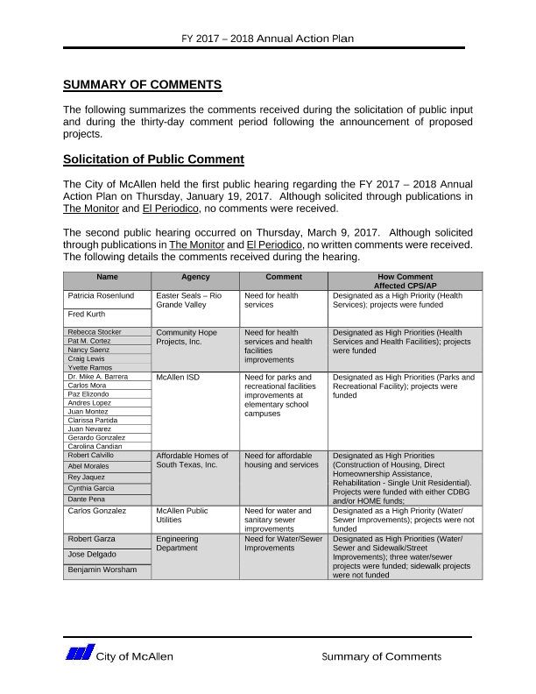
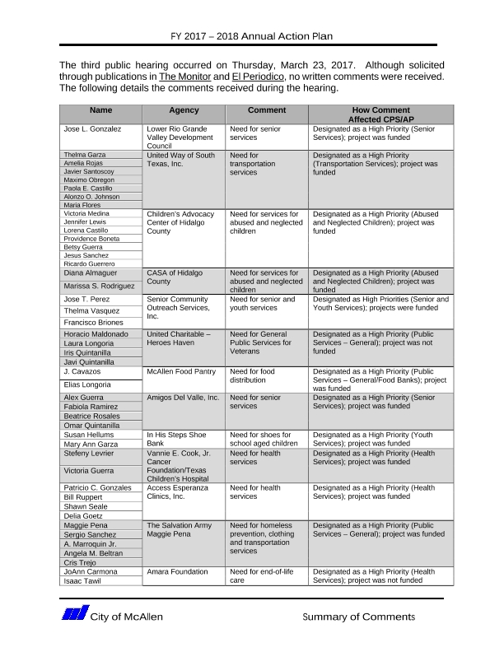
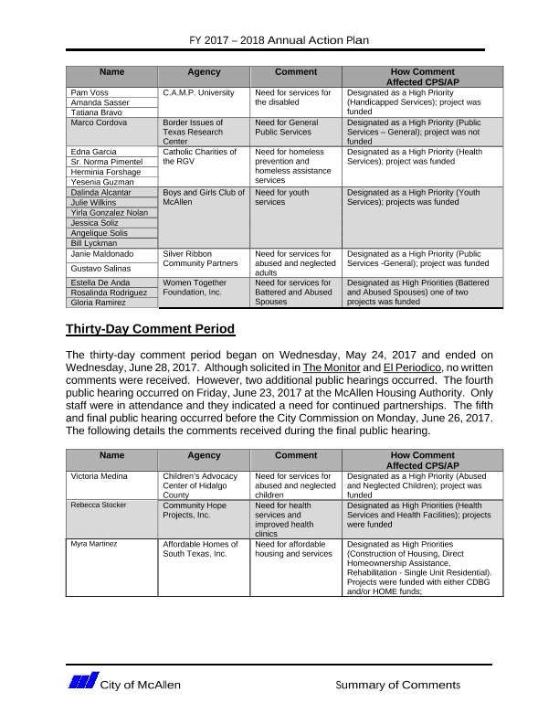

Grantee Unique Appendices
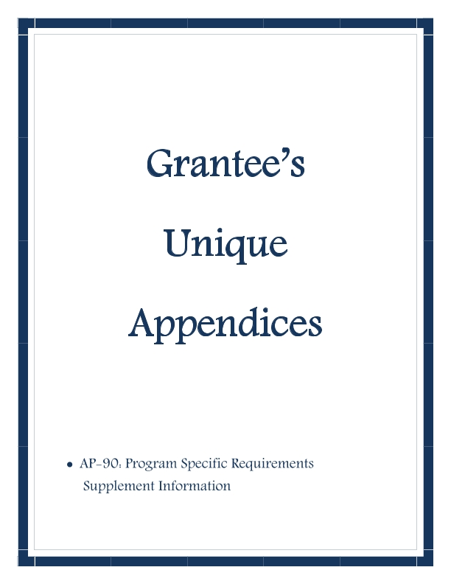
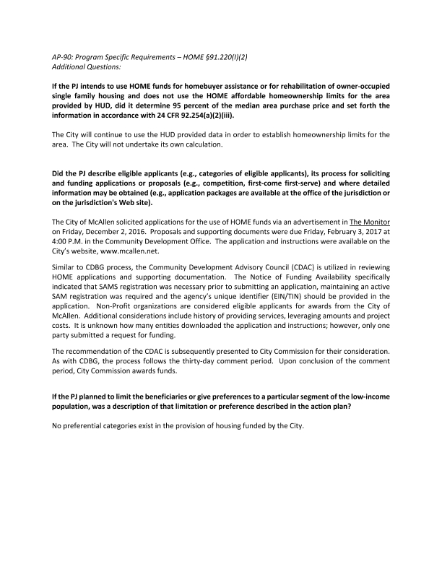
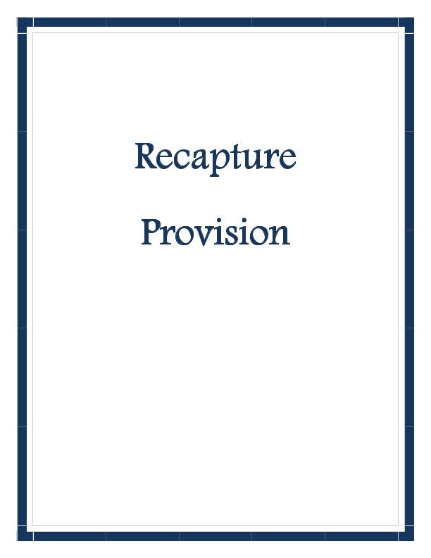
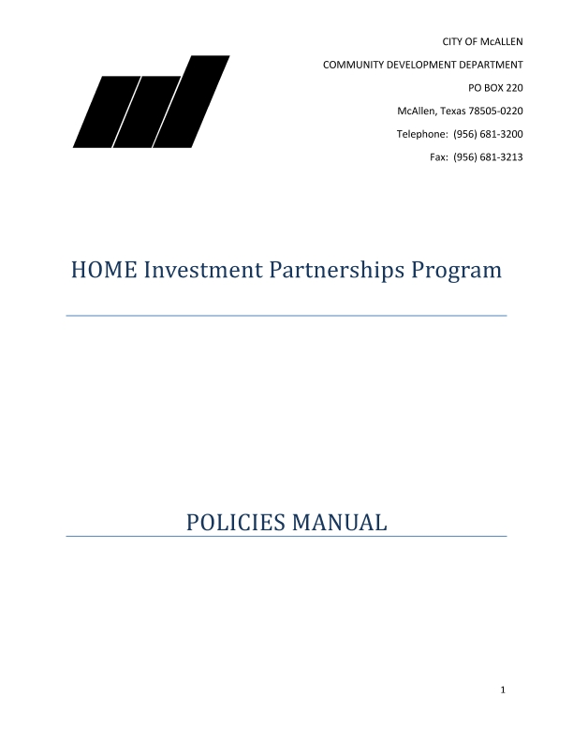
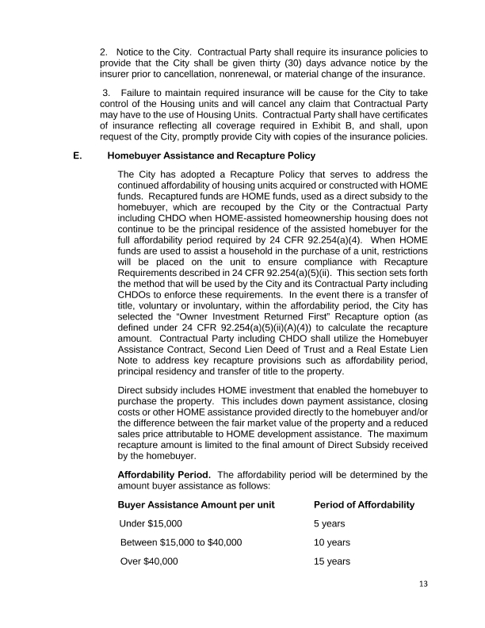
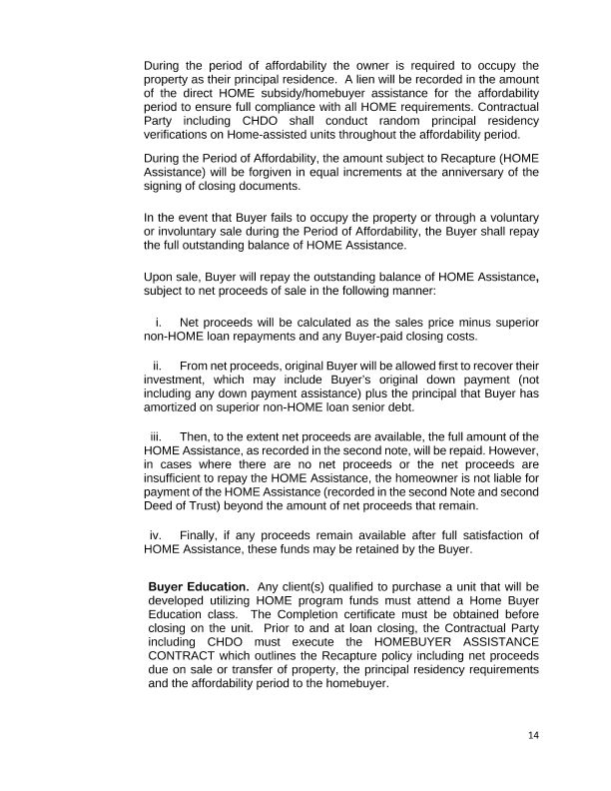
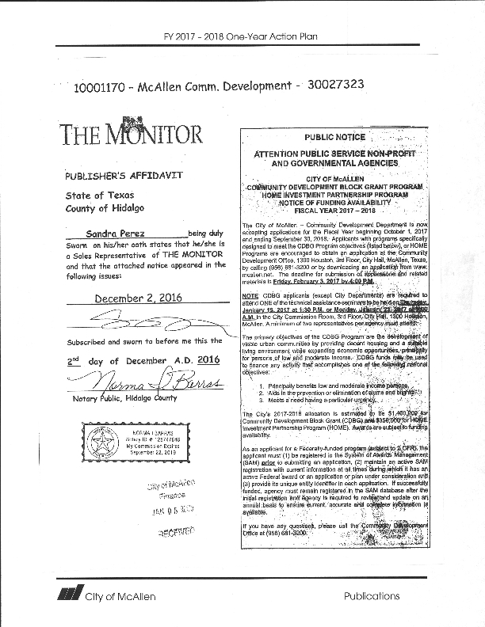
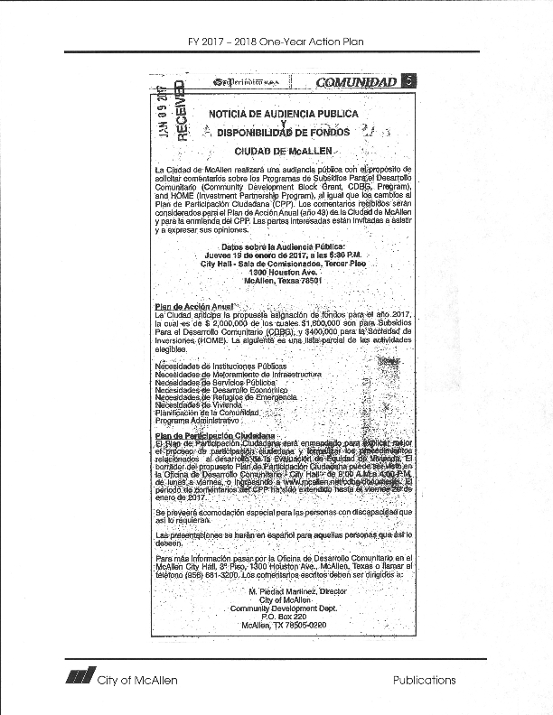
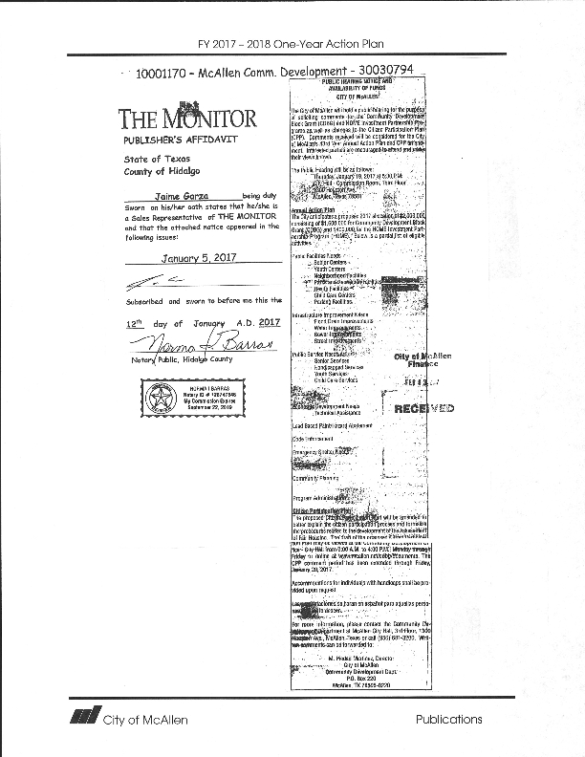
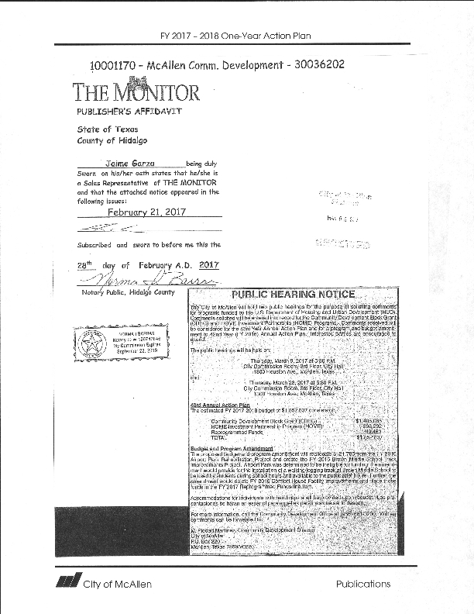
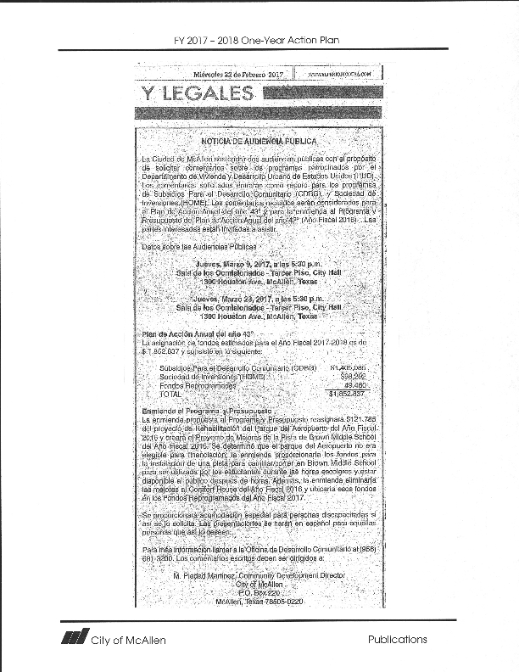
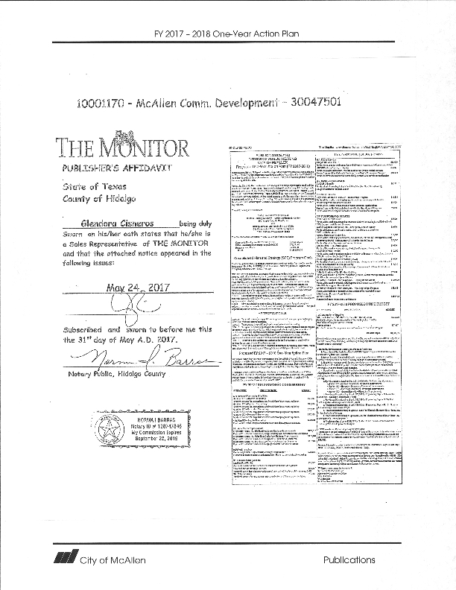
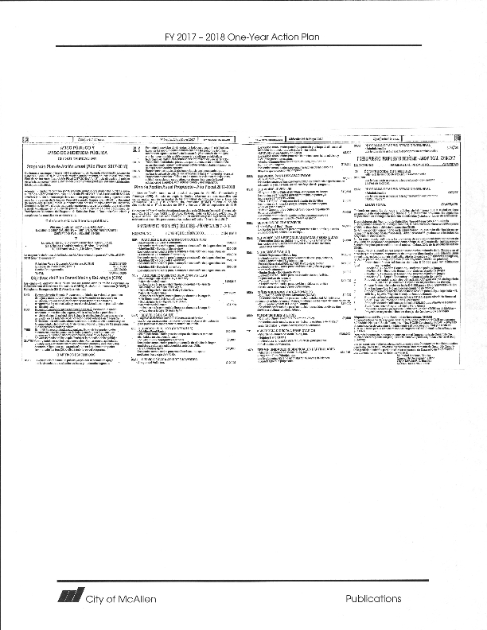
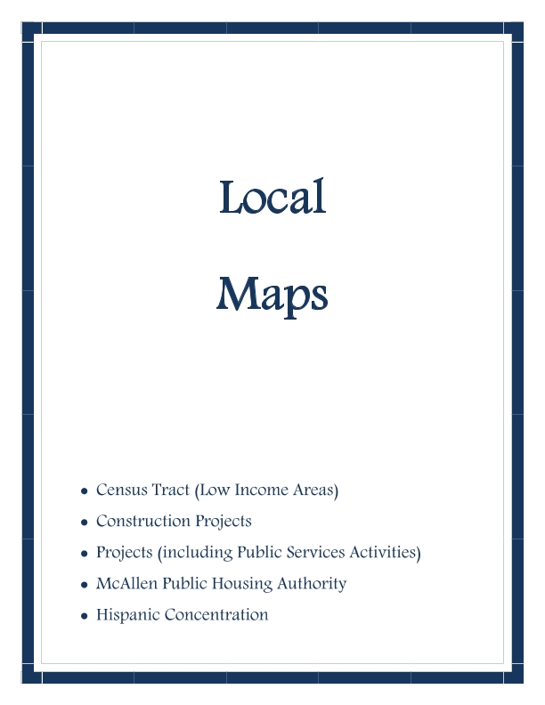
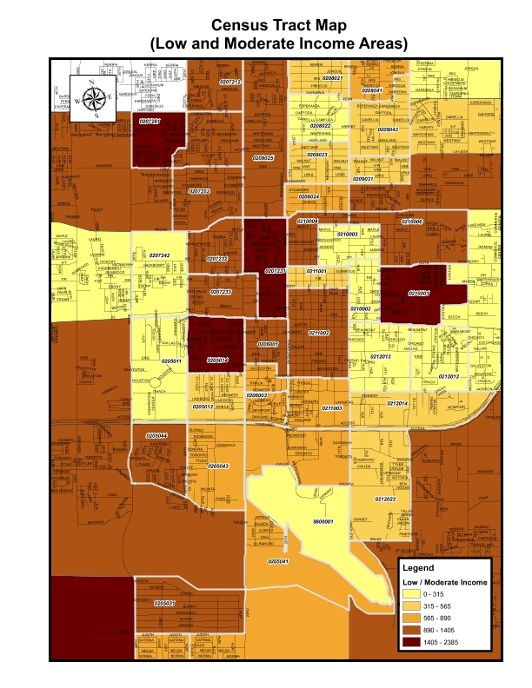
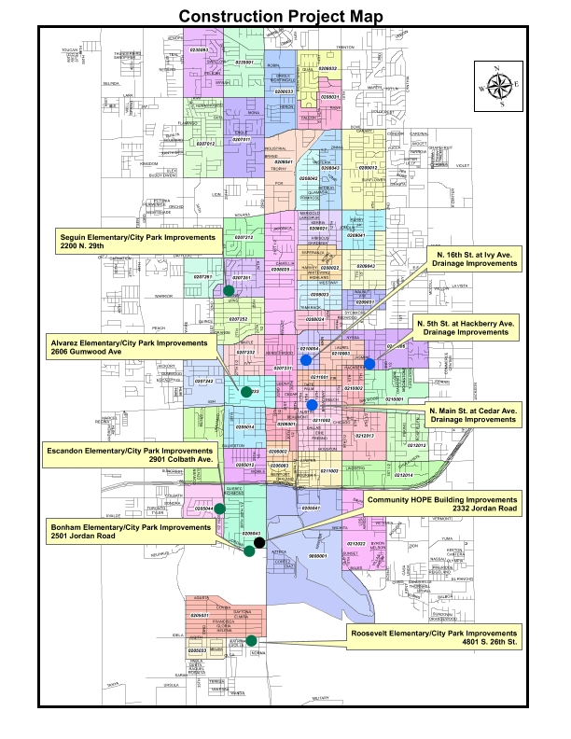
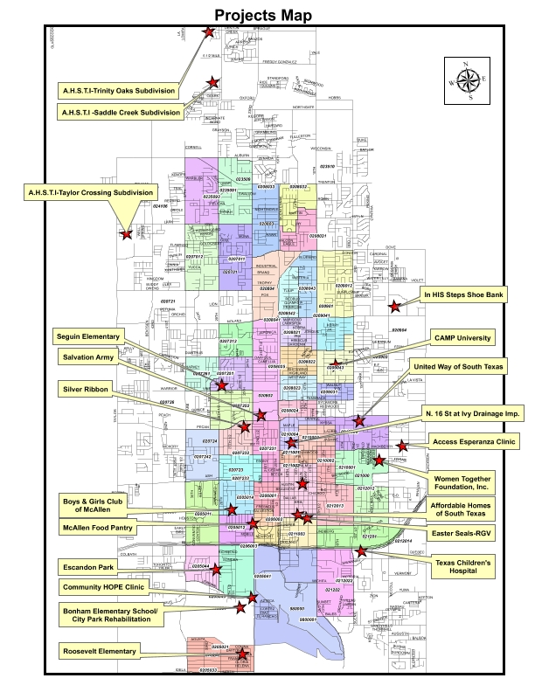
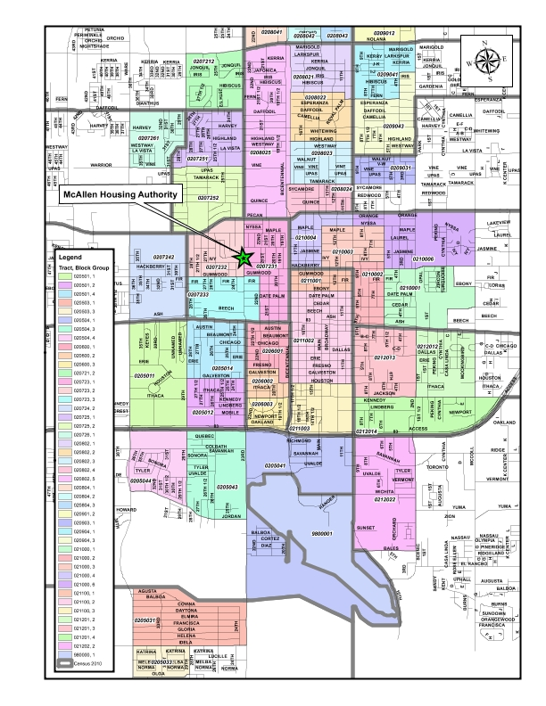
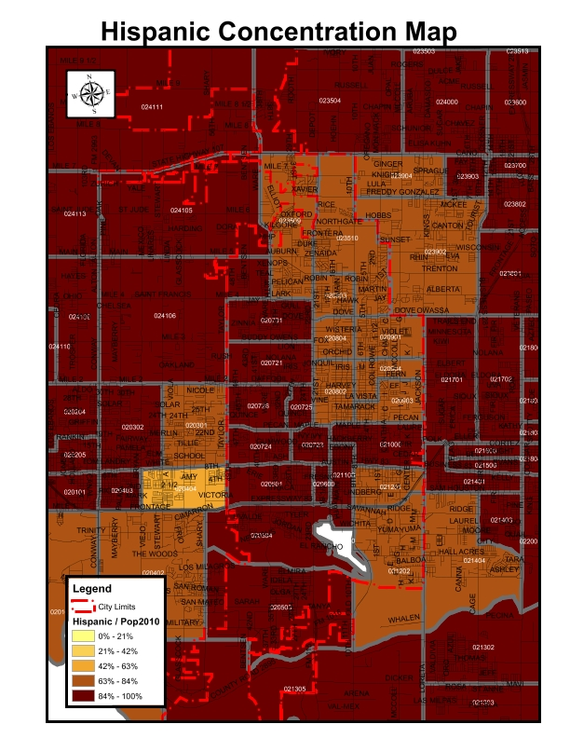

Grantee SF-424's and Certification(s)
